NFL Home Team Win Prediction
A Machine Learning Approach to Game Outcome Forecasting

MSDS 422: Machine Learning & Artificial Intelligence
Final Project Report
Team Members: Nikita Jain, Charlie Peng, Yanchen Zou
March 2026

1. Executive Summary
The project's goal is to create a model that will help estimate the rate of a home team will win in NFL games (National Football League) by modeling historical play-by-play data from 1999 until 2024. Using the publicly available NFL Verse Play-by-Play Repository, we can build metrics for each team's offense and defense based on their Expected Points Added (EPA) from each play during each season.
The following four machine learning classifiers have been created and tested: Logistic Regression, Random Forest, Decision Tree, and Gradient Boosting. All four classifiers were trained using game data for the 1999 to 2023 seasons, then tested against the 2024 held-out season. We used Leave-One-Group-Out (LOGO) cross-validation to prevent future-data leakage while looking at accuracy, precision, recall, F1 Score, ROC-AUC and log loss to evaluate the performance of each classifier.

Findings suggest that passing effectiveness (as measured via an exponential weighted moving average (EWMA) of expected points added per play) is the most important factor in determining how successful a home team will be. The best model to generalize across all matchups for the upcoming 2024 season is based on a Gradient Boosting classifier. Our study was able to confirm that a statistically significant advantage exists for home teams on their home turf with an approximate completion rate of 56% wins for all games found in the data set. Additionally, using features based on expected points added (EPA) significantly improves our ability to predict victory more accurately than the current baseline. Collectively, these findings provide excellent use of data to help empower team analysts, sports bettors and media organizations to produce forecasts of future play outcomes.

2. Problem Statement & Research Objectives
This analysis assumes that team-level historical EPA is a stable and transferable signal across seasons, and that the 2024 season represents a comparable competitive environment to prior seasons.
As one of the most sophisticated team sport in terms of its sheer number of variables affecting the outcomes of a game, such as offences' ability to score points and defences' ability to stop points from being scored against them, there are many ways in which the outcome of a given National Football League (NFL) game could be predicted. However, predicting whether the home team will win any specific game remains extremely challenging because of the high variability associated with any given game outcome.
The main objective of this project is to analyse if historical play by play data in the NFL can be used to create an accurate predictor for home team winning using machine learning algorithms trained on EPA-based team performance metrics. The scope of this study includes but is not limited to:

• Identify which game-level performance metrics most heavily influence a home team’s odds of winning an individual game, and, specifically, the relative impact that offensive vs. defensive metrics have on this outcome.

• Develop temporally-aware features that use exponentially weighted moving averages of EPA to quantify a team’s current form, while minimizing the impact of stale performance data.

• Develop and compare four machine learning classifiers (Logistic Regression, Random Forest, Decision Tree, and Gradient Boosting) to evaluate their accuracy based on games played during the 2024 season.

• Determine whether a data-driven approach can significantly outperform the naive prediction of home wins in each game (i.e., 56.4% accuracy).

• Assess how the models can be practically used for sports analytics, such as providing analysis of game previews, insight into games while they’re being broadcast, and making decisions on fantasy football players.

The unit of analysis for this study is the game, and therefore each observation represents one NFL game with EWMA smoothed EPA performance for both the home and away teams and whether the home team won the game.

3. Literature Review

There is a long-standing history of using statistical and machine learning approaches to predict the outcome of sports events in the academic literature. In the context of predicting NFL results, prior research has taken a range of forms including binary win (loss) prediction, margin of victory regression analysis, prediction based on point spreads, and prediction of the outcome of individual plays during games. This section summarizes the most relevant literature prior to the present research effort.

3.1 NFL Game Outcome Prediction
The study by Gifford and Bayrak (2023) is one of the closest methodological matches to this project and was designed to create predictive models for NFL game results using Decision Tree and Logistic Regression classifiers trained on NFL team statistics gathered from the 2002 to 2018 seasons. This study showed that the use of lagged team performance metrics as features successfully captures the information needed to make accurate predictions and confirms that tree-based models can use structured data from football to derive a signal providing valid predictions of the game's outcome. Their methodology also relied on sequential season-level validation (training on prior season(s) and testing on a held-out season), which provides the direct rationale for using a Leave-One-Group-Out cross-validation in this study.
Roumani (2023) explored predicting the Super Bowl winner using a wider range of ML classifiers, including C4.5 trees, neural networks, and Random Forest classifiers, from regular season data. The findings also confirmed that ensemble methods (primarily Random Forests) generate more accurate predictions than single-model methods, a conclusion that is consistent with the overall results of this project. In addition, Roumani discussed the need for good feature selection because high-dimensional features increase noise in the data, thereby lower the accuracy of predictions.
The systematicity established by Beal et al. (2020) through a comparison of nine classification algorithms using data from 1,280 NFL games across 5 seasons yields baseline performance benchmarks for classification in the NFL ranging from 44.6% accuracy (Gaussian Process) up to 67.5% accuracy (Naive Bayes) across the different algorithms. The authors similarly employed feedforward neural networks with a ReLU activation and GridSearch hyperparameter optimization; thus, their neural network architecture parallels the deep learning type configurations utilized for this research, as well as their finding that ensemble tree-based classifiers bested single classifiers, providing a strong basis to consider both Random Forest and Gradient Boosting as parts of the classifier suite.
Additionally, Weirich et al. (2025) have published the most recent research comparing both traditional Pythagorean win-expectancy formulas and modern machine learning models (including feedforward neural networks) on 21 seasons of NFL data. The authors established an R² of .891 for valid predictions of win percentage using the neural network and provided evidence that offensive efficiency metrics related to rushing and passing are the highest contributing predictors of winning. This supports directly the featured engineering methodology that will be utilized in this research focused on developing EWMA-smoothed expected points added (EPA) disaggregated by type of play.

3.2 EPA as a Predictive Feature

The grounding of expected points added (EPA) as a basis for football analytics is provided by the research of Yurko and colleagues in a 2020 article, where they created a continuous-looking valuation model for plays using tracking data. Their study finds that EPA-based metrics are much better at assessing the value of individual plays than traditional box-score statistics and, therefore, proves correct to use EPA-based team performance variables rather than simply using the amount of yards gained or points scored.

Pfitzner, Lang and Rishel (2014) studied the statistical factors that lead to scoring in NFL games and have shown that turnover differential and passing-related statistics are almost always the most significant factors influencing a team's ability to score. While their study is not about predicting games won and lost, but rather about how accurate over/under betting lines are, their finding that passing efficiency is a major factor in scoring success provides additional evidence to support the decisions that we made regarding how to create features in this analysis.

3.3 Social and Contextual Factors

Research conducted by Sinha and coworkers (2013) demonstrates that Twitter sentiment can be an effective real time predictor for NFL games. In a study using pregame tweets (tweets produced before kickoff) as an input variable in a model, they find statistically significant improvement over statistical models that do not utilize tweets.

The key point to take away from their research is that non-traditional, unstructured data has the potential to provide statistically significant predictive signal beyond that available through traditional, structured data sources (i.e., team statistics). In the future, this research provides motivation for including Twitter sentiment in the recommended data sources for sports predictions contained in this project’s Recommendations Section.

Brandon (2024) studies point spread prediction in NFL games using machine learning and reports on several classifiers that predict outcomes of NFL games based on structured team performance data (i.e., traditional structured team statistics). His research offers additional information on the broad applicability of NFL prediction models and is cited in the Findings section to inform the use of sports betting analytics.

4. Exploratory Data Analysis

4.1 Dataset Overview

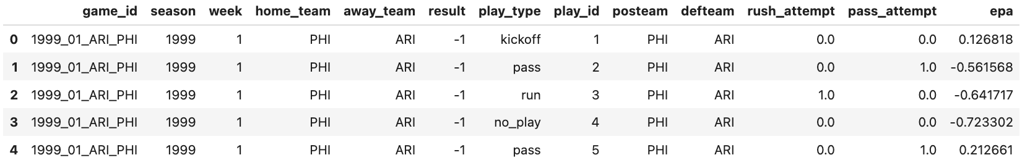
Table 1: Dataset Overview
The dataset consists of play-by-play data from all NFL games during the regular season from 1999 to 2024, obtained from NFL verse. A row represents one play in a specific NFL game. Each row contains twelve pieces of information regarding that particular play: 1) Game ID; 2) Season; 3) Week; 4) Home/Away Teams; 5) Home Team Score Margin Result; 6) Play Type; 7) Play Number; 8) Offensive Team; 9) Defensive Team; 10) Rush Attempt Flag; 11) Pass Attempt Flag; and 12) Expected Points Added (EPA). The first five rows above illustrate the actual game played between the Philadelphia Eagles and Arizona Cardinals during week one of the 1999 NFL season. The Eagles won by 1 point. The EPA values for the plays reflect that the Cardinals had more success offensively early in the game before the final score outcome was determined.

4.2 Missing values tabulate

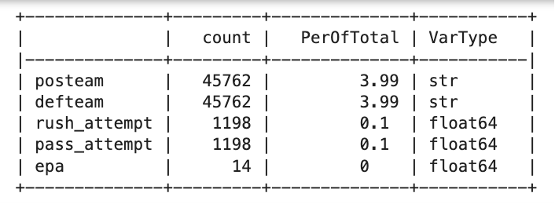
Table 2: Missing values table

A quantitively audit of nulls shows that many nulls are in two columns: posteam and defteam. Each column has 45,762 nulls, or 3.99% of the total rows. There are a small number of nulls in rush attempt and pass attempt, 0.1% for each, and 0% for EPA. Of the nulls in posteam and defteam, they are only on the rows that are labeled as "no play." This makes sense, as these are administrative stoppages and therefore do not have any offensive or defensive teams. These plays are not included in the calculation of EPA, as opposed to imputing them. There are 14 nulls in epa, and they are all assigned to 0, meaning that there were no epa recorded for that play.

4.3 Missing Values Heatmap

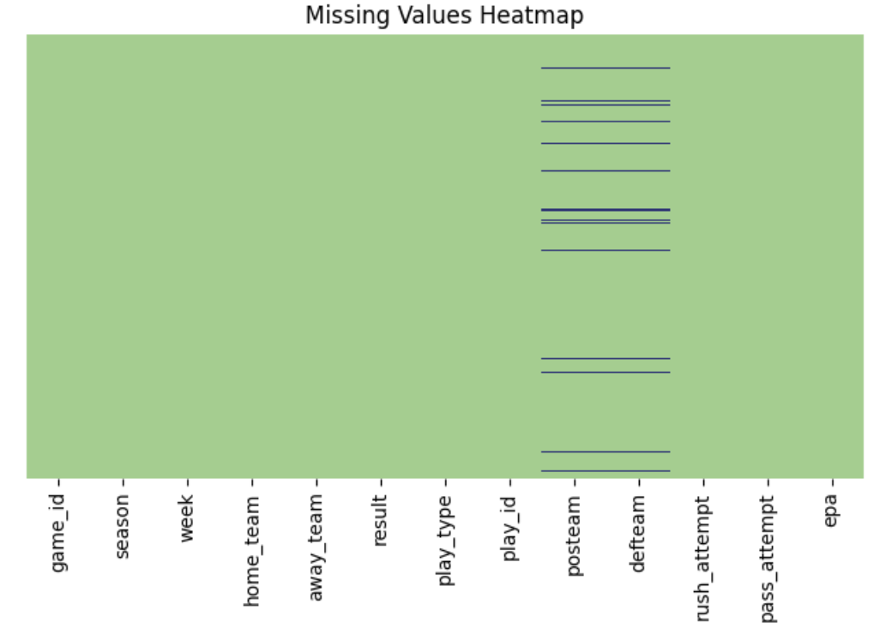
Figure 1: Missing values heatmap

The heatmap of the missing values was an excellent visual confirmation of the discrepancies discovered within this review. The rows of no_play in the posteam and defteam columns have been grouped together into blocks with dark horizontal lines across each season with no specific season being overrepresented. All other columns are structurally complete since there are no missing values. This is direct evidence that the method of handling nulls through row exclusion versus imputing them is a valid choice.

4.4 Heatmap of Columns (raw features)

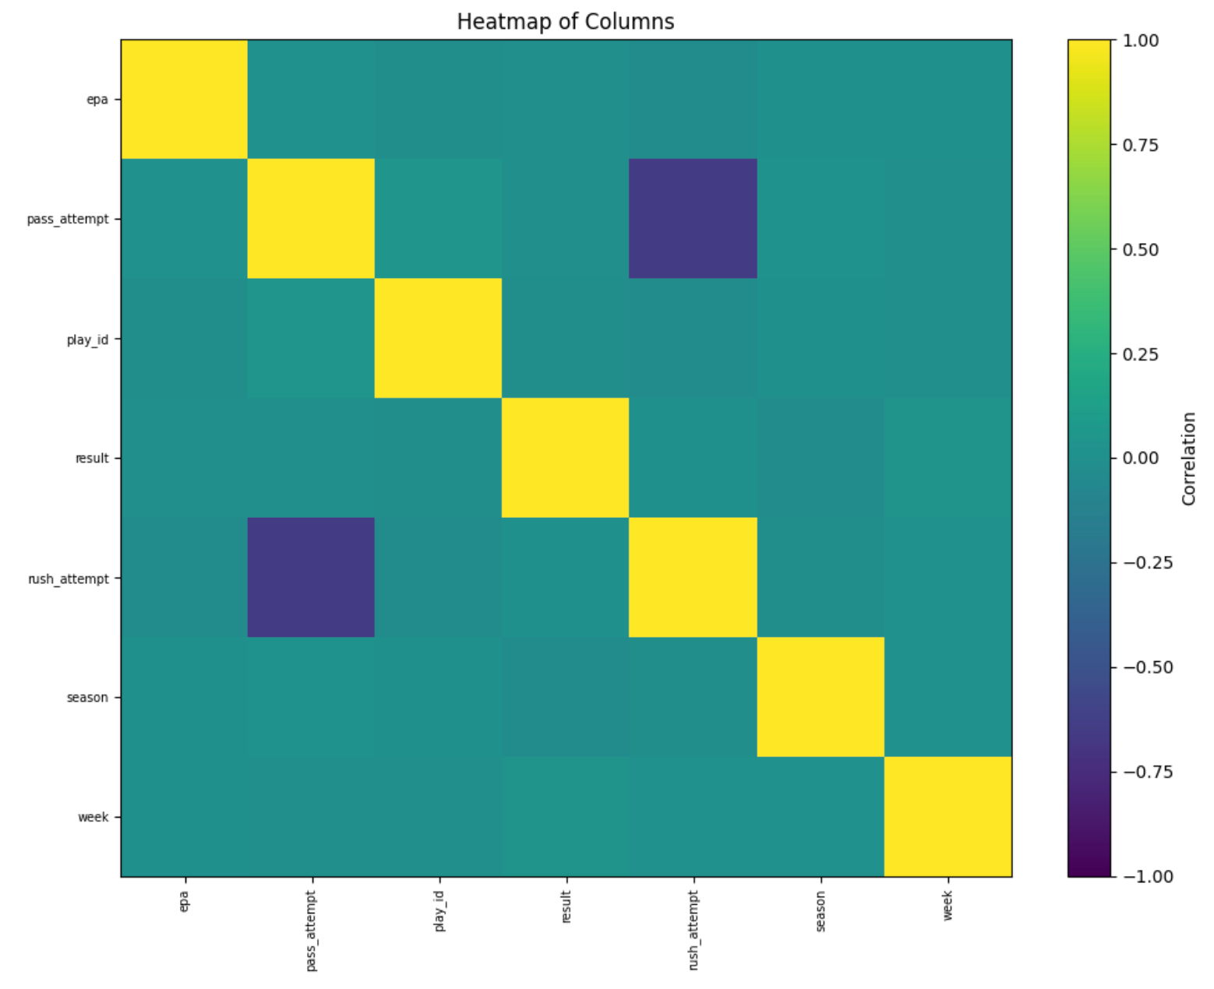
Figure 2: Heatmap of Columns

The raw numeric play by play attributes indicated a lot of expected levels of correlation through their heatmap. A strong, negative correlation between pass_attempt and rush_attempt can be interpreted as a binary were formed on each offense's decision to use either a pass or rush play from a scrimmage play during the game. A moderate level of positive correlation exists between play_id and result. Positive EPA values by play accumulate in the same general direction during game play. The plays from the winning team are typically found at later play id numbers than the losing team. There was not one unexpected correlation identified between other features. Thus, no concerns were indicated regarding the integrity of the data or any structural artifacts in the raw database.

4.5 Result and EPA distributions
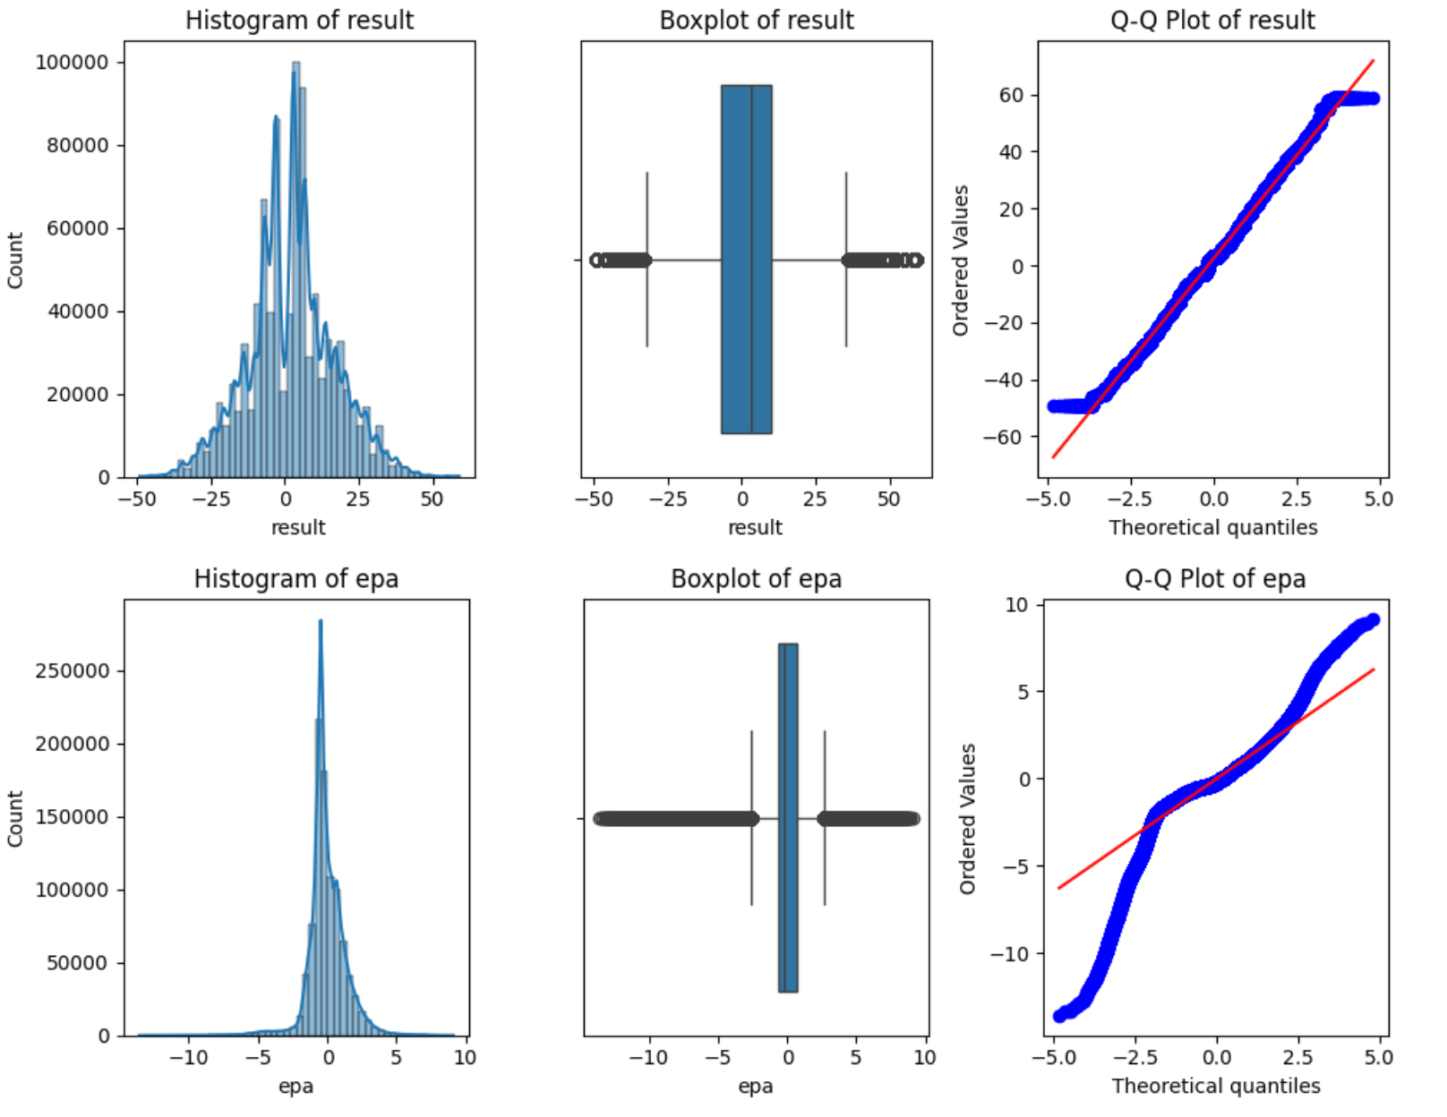
Figure 3: Graphs of variables
There are two different forms in which two continuous numbers exist within an unprocessed database - result (home team score margin) and EPA. The two variables have different shapes of distribution, which is illustrated in the above diagram. The result variable is normally distributed, with a slight shift to the right due to home advantage, meaning that home teams have a higher score than away teams. A box plot illustrates symmetry with respect to the median (midpoint) as well as a reasonable degree of outliers at either edge (blowout scores) and no outliers in the middle. A Q-Q plot indicates that the distribution more closely matches the theoretical normal line in the center of the distribution than at either edge; therefore, atypical margins of victory (e.g., 40+ points) can be expected to be greater than predicted by a perfectly normal distribution.

EPA tells a markedly different story. Its histogram is sharply leptokurtic — a very tall, narrow peak concentrated near zero with heavy tails in both directions. This reflects the nature of individual plays: the vast majority generate near-zero expected points, while a small number of high-leverage plays such as long touchdown passes or turnovers returned for scores produce extreme positive or negative values. The boxplot's extremely compressed interquartile range and large number of outliers visually confirm this, and the Q-Q plot demonstrates severe deviation from normality across the full range of values.

These distributional properties directly motivate the use of EWMA smoothing when aggregating EPA to the team-week level. Raw per-play EPA is too noisy and non-normal to serve as a reliable modeling feature; its exponentially weighted weekly average stabilizes into a far more well-behaved signal that is suitable for machine learning classifiers.

4.6 Home Team Win/Lose countplot

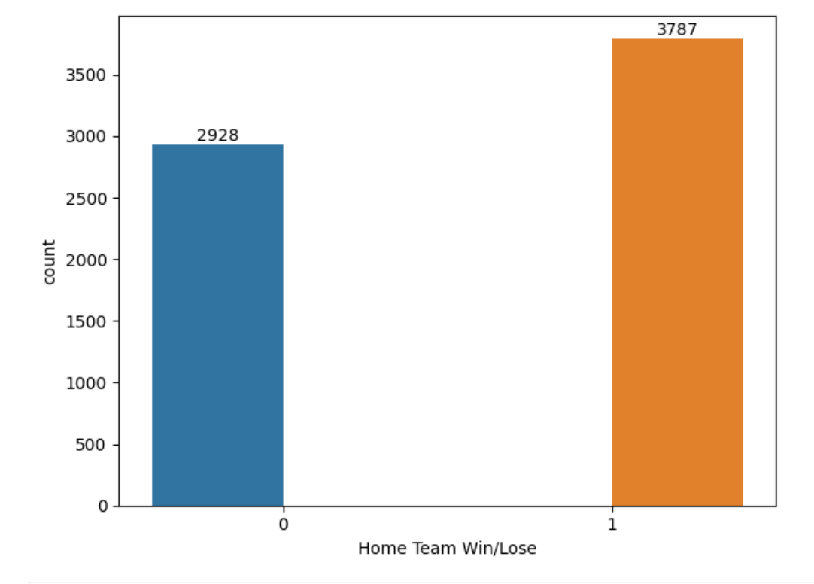
Figure 4: Win/Lose distribution
In the training dataset there is an average of 3,787 home wins (56.4%) and 2,928 away wins (43.6%) resulting in a moderate imbalance between both classes. Also, the current trend supports that the NFL has an advantage to teams playing at home; this includes aspects such as having a full stadium cheering, or their travelling team experiencing more fatigue/injuries than teams who remain at home, as well as being more familiar with each of their host stadium's dimensions. Given the moderate imbalance between the two classes of home and away win classes, resampling techniques such as SMOTE do not need to be applied to the current dataset; however, within any subsequent tree-based models being developed to predict either class, the class_weight of "balanced" has been implemented to mitigate any systematic under-predicting of the minority class (away wins).

5. Data Preparation & Feature Engineering

5.1 EWMA Feature Construction
For each team, season, and week, mean EPA is first computed separately for four play categories: rush offense, pass offense, rush defense, and pass defense. These four weekly EPA values are then lagged by one week and smoothed via EWMA.
Raw weekly EPA values are highly variable due to small sample sizes within individual games. To produce stable, temporally aware performance estimates, each EPA series is lagged by one week (so that the current week’s features reflect only information available before the game is played) and then smoothed using an exponentially weighted moving average (EWMA) with a span of 4 weeks. The span parameter weights recent performance approximately twice as heavily as performance from four weeks prior, capturing meaningful team form while retaining sensitivity to recent trends.
This approach is directly motivated by Yurko et al. (2020), who demonstrate that EPA-based rolling metrics are more predictive of future performance than season-to-date averages, and by Gifford and Bayrak (2023), who show that lagged performance metrics outperform same-week statistics for game outcome prediction.

5.2 Game-Level Dataset Construction
EWMA features for both the home and away team are merged with the game schedule to produce a single game-level observation. The binary target variable home_win is derived from the result column, which records the home team’s score margin (positive values indicate a home win, negative values an away win). Games with missing EWMA values, which arise primarily in the first two to three weeks of each season before sufficient rolling history exists, are dropped from the dataset, resulting in the final 6,715 -game sample.

5.3 EWMA Correlation Matrix Heatmap

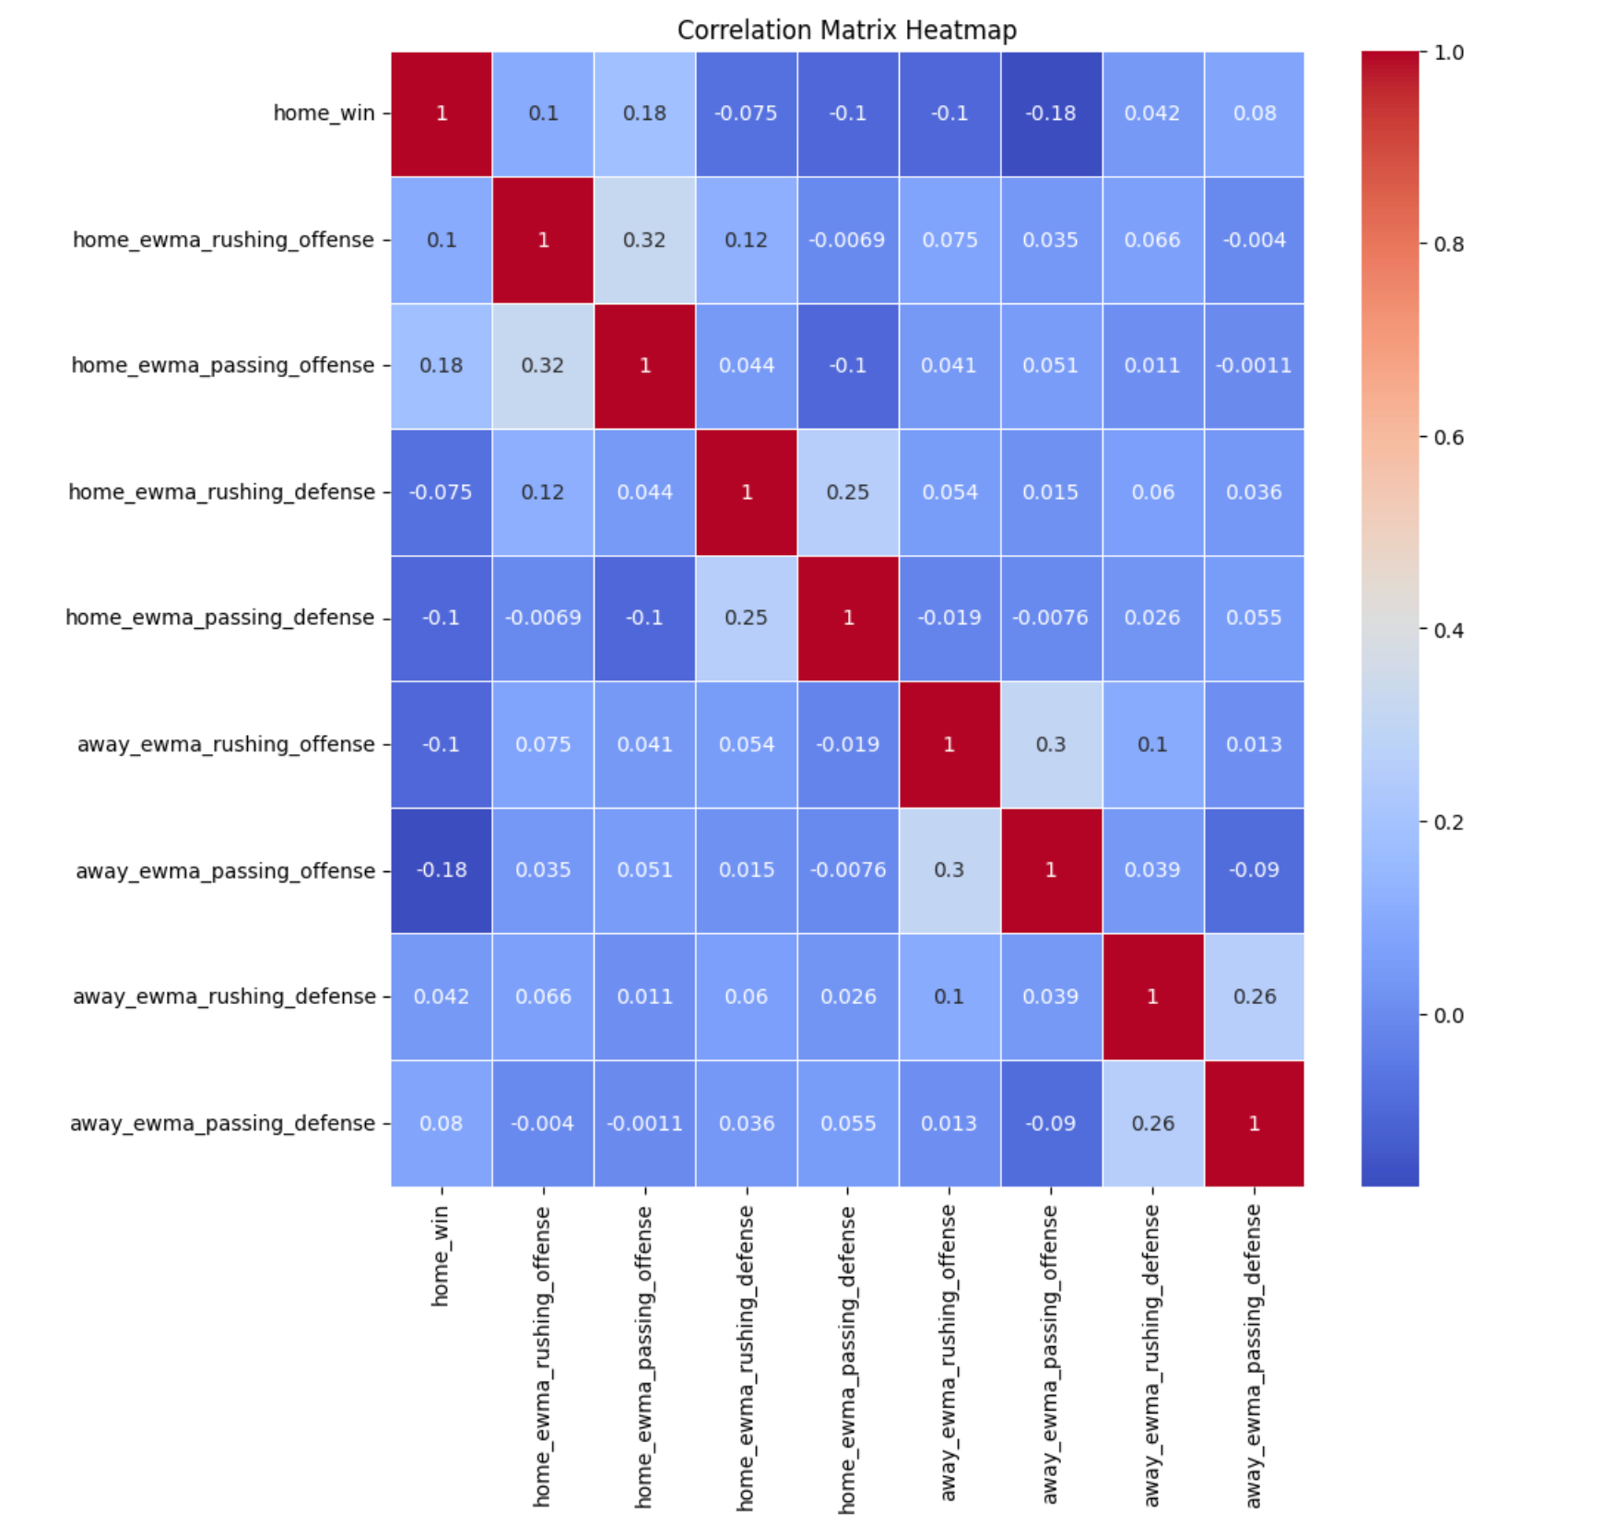
Figure 5: EWMA correlation matrix heatmap

The final modeling datasets predictive structure can be observed through a correlation matrix of the eight features derived from EWMA-EPA and home_win as the target variable. The two highest correlated variables to home_win were home_ewma_passing_offense with a positive correlation of +0.18, and away_ewma_passing_offense with a negative correlation of -0.18. These two variables highlight that passing efficiency is the most discriminating predictor of game outcome within a team context for both the home and away teams. Furthermore, the correlations between the home_team rushing and passing efficiencies, as measured by their EWMA-based offensive efficiency averages, were also modest with a 0.32 correlation coefficient. This indicates that strong offensive teams tend to perform well at both running and passing the football. Similarly, the rushing and passing defensive efficiencies had a correlation of 0.25. The maximum correlation between any of the feature pairs was 0.35, which indicates that there are no multicollinearity issues, allowing for all eight features to be included in the final models without the need for dimensional reduction.

5.4 Number of Games per Season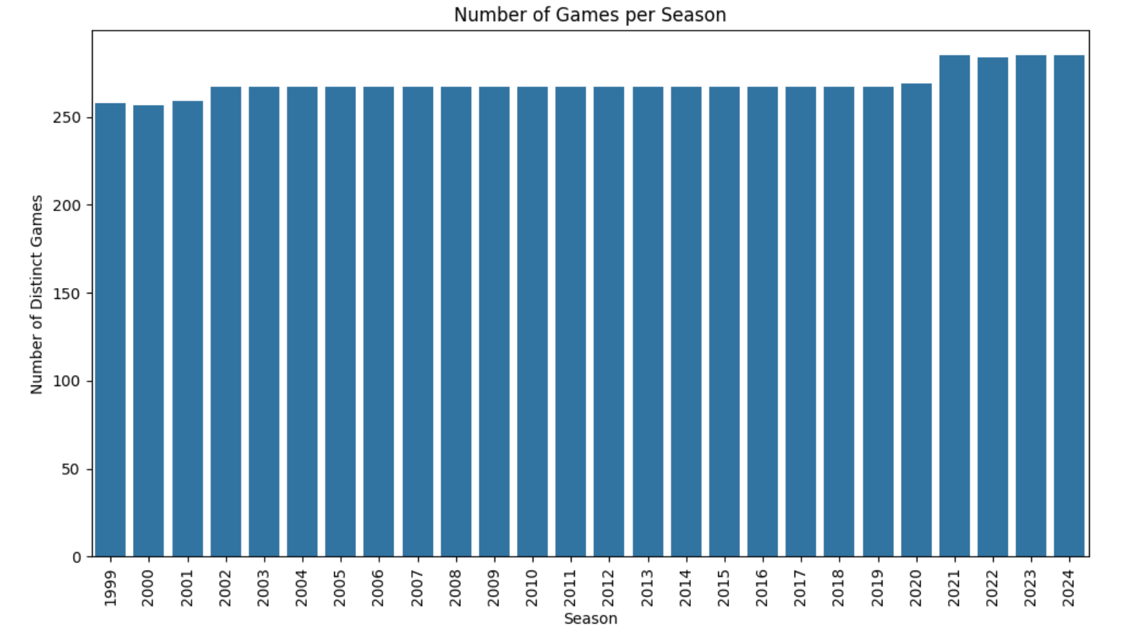
Figure 6: Number of Games per Season
According to the bar chart, game coverage has been nearly consistent across all 26 NFL seasons, with about 256 to 267 games annually through 2020 then a step-wise increase to roughly 284 games for each of the 2021 – 2024 NFL seasons due to the NFL moving from a 16 to a 17 game regular season.
There are two additional considerations in terms of feature engineering due to this structural change: (1) the extra game per NFL team per season results in one extra week of EPA being compiled for each team beginning in 2021, thus slightly increasing the number of EWMA observations collected per team in latter NFL seasons, though this is not expected to materially impact the EWMA of 4 weeks that has been picked to be used for this project because EWMA is defined on a relative number of weeks rather than actual number of games played; (2) the step-wise increase in the number of games played during the regular season creates a source of mild non-stationarity in the longitudinal dataset because a team plays one more post-December game starting in the 2021 season, and therefore the distribution of week by week EPA values for a team will potentially slightly differ from earlier NFL seasons. This limitation of the current feature set and proposed direction for robustness testing in the future are noted.
All 26 seasons were uniformly covered, which confirms there is no systematic underrepresentation of any season in the training dataset, validating the use of Leave-One-Group-Out cross-validation using season as the grouping factor — all folds have approximately the same number of observations.

5.5 Feature Scaling
The use of StandardScaler assumes that the EWMA features are approximately normally distributed at the team-week level, an assumption supported by the bell-shaped distributions observed in Section 4.3.
For models sensitive to feature scale (Logistic Regression and, when applicable, KNN), features are standardized using scikit-learn’s StandardScaler, which transforms each feature to zero mean and unit variance. The scaler is fit exclusively on the training set and applied to the test set to prevent data leakage. Tree-based models (Random Forest, Decision Tree, Gradient Boosting) are trained on unscaled features, as tree splits are scale-invariant.

6. Methodology

6.1 Tooling & Environment
All computations were performed on a consumer-grade Apple M-series CPU. No cloud or GPU resources were required given the dataset size and model complexity.
Python 3.13 was used for the analysis of all data, via an Anaconda environment with the following libraries available to the analyst: Pandas and NumPy (for manipulating data) NFLREADPY (for ingesting data from the NFL verse repository) Scikit-learn (to train, evaluate, and cross-validate all models) Matplotlib and Seaborn (for visualizing). Due to the nature of the analysis, the Jupyter notebook was the preferred development and presentation environment for all datasets; code was organized in three notebooks as follows: ReadSaveData.ipynb (to ingest data), NFL_EDA_Redone.ipynb (for EDA/Feature Engineering), and Modeling.ipynb (to develop and evaluate models).

6.2 Train-Test Split Strategy

To maintain the time sequence of the data and avoid future-data leakage, we have split up the dataset chronologically. All the games played from years 1999 to 2023 are used as our training dataset, while all the games played in the regular season for 2024 will be used as our held-out test dataset. This simulates what would happen in real life; in real life you would develop a model based on historical data for these NFL seasons and then utilize that model to predict the next NFL season.

Leave-One-Group-Out (LOGO) cross-validation is then utilized to evaluate the model built on the training dataset, where the grouping variable for each group is the year in which that NFL season occurs. For each fold that is created during LOGO cross-validation, the model is trained on 24 of the 25 years of the training dataset. Following this, the model is then validated on a separate year that was not used during the training periods. This process is repeated for all the 25 seasons, resulting in 25 individual cross-validation estimates of accuracy, log loss, and F1 score representing the generalization ability of the model to the different years of the NFL without exposing any future data from the NFL.

6.3 Model Selection & Descriptions
Four classifiers were tested and evaluated based on the complexity of their structure and assumptions behind the structure:
Model 1: Logistic Regression
This model shows the log of the odds (ln(odds)) of winning as a linear function of the eight EWMA-EPA inputs; therefore, it represents an interpretable linear reference point. This model uses either an L1 or L2 regularized penalty, which shrinks the weights (coefficients) of the model that have very little contribution towards making good predictions, thus also reducing overfitting. The coefficients of this model are directly interpretable as ln(odds) changes (due to standard deviations also providing an interpretable scale) for each of the eight inputs included in the model. The grid search for hyperparameter selection examines the types of solvers used to iteratively minimize the optimization of the cost function, different types of penalties (L1 or L2), the degree of regularization for C, and the maximum number of iterations that the algorithm would use before stopping.
Model 2: Random Forest
The Random Forest Classifier builds multiple trees based on a large number of decision trees and uses the output from each of the trees to produce an aggregate result by majority vote. Random Forest uses bootstrap sample datasets for training the decision trees and randomly selects a subset of the features for building each tree within the Random Forest. By doing this, Random Forest reduces the variance (error) of each of the individual trees; however, Random Forest retains the ability to model the non-linearity inherent in the relationships between the inputs and outputs. For example, when the trees are equally classified as 0 or 1, the class_weight parameter adjusts for the data-based classification imbalance. The parameters that have been optimized through tuning include: tree depth, number of estimators, minimum sample number for decision leaves, and the strategy used to select the input feature/topic to use at each split in a tree. Breiman (2001) laid the groundwork for the theoretical underpinnings of the Random Forest Classifier.
Model 3: Decision Tree
As a single classifier, it can be used for an easily interpretable non-linear baseline and to contrast with individual trees versus ensemble methods. The Decision Tree classifier forms a sequence of partitioning or separating the feature space into two parts, called binary splits, starting at a root node and taking each binary split (at the nodes) that maximally minimizes the GINI Impurity of the data. Due to the risk of overfitting without regularization (e.g., setting max depth/limiting the min number of samples allowed in the leaf node), it is possible to create a tuned Decision Tree to serve as a baseline against which ensembles will be compared and the tuned Decision Trees feature importance will allow for a direct graphical representation of the most discriminative EWMA metrics. Hyper-parameters that were tuned in the Decision Tree will include the max depth, the min number of samples allowed at a leaf, the min number of samples required to create a split and whether GINI or Entropy is used as the splitting criterion.
Model 4: Gradient Boosting

Gradient Boosting – Develops a sequence or ensemble (set/collection) of shallow/depth Decision Trees (or weak classifiers) sequentially in an added sequential fashion, meaning that each subsequent decision tree will attempt to model the residual error of the previous ensemble of trees (the residual error is the difference between the actual and predicted value for the samples). The Gradient Boosting sequentially builds an ensemble of decision trees compared to Random Forest creating parallel ensembles through a bagging approach because Gradient Boosting uses Gradient Descent on a differentiable function to decrease the Gradient of a loss function which allows for an exponentially flexible/non-linear classifier (i.e., Gradient Boosting was shown to generate the best model fit using structured/tabular data in the literature and is widely used within sports analytics). Hyper-parameters that were tuned in the Gradient Boosting include the number of estimators, learning rate, max depth of trees, and the min number of samples allowed on the leaf.

6.4 Evaluation Metrics
All models are evaluated on the following metrics computed on the held out 2024 test set:

Metric | Description | Why It Matters Here
Accuracy | % of games correctly classified | Primary performance measure; baseline is 56.4%
Precision | Of predicted home wins, % actually won | Relevant for applications requiring confident win predictions
Recall | Of actual home wins, % correctly identified | Captures sensitivity to true home wins
F1 Score | Harmonic mean of precision and recall | Balanced metric for moderately imbalanced classes
ROC-AUC | Area under the ROC curve | Measures discriminative ability across all thresholds
Log Loss | Cross-entropy of predicted probabilities | Penalizes confident wrong predictions
Table 3: Metric definitions

6.5 Model Deployment Strategy

Models which have been trained can be saved via the Python pickle module, allowing them to be part of an automated pipeline for making predictions weekly. At the beginning of each NFL week, this pipeline: (1) retrieves the latest play-by-play data from NFL verse; (2) recalculates the EWMA-EPA features for the week (up to and including the previous week from today); (3) creates a new feature vector (to be used in predicting) for every upcoming game; and (4) passes the feature vectors into the best-performing model to produce the win probability estimates. Scheduling through tools such as cron jobs or cloud schedulers (e.g. AWS Lambda or Google Cloud Scheduler) will achieve the same output before the games each week. The modular notebook structure enables the user to periodically retrain/correct their model based on new seasons, thus ensuring that the model is always calibrated to the current level of team performance.

7. Findings & Conclusions

7.1 Model Performance Results
All four models are trained on seasons 1999–2023 and evaluated on the held-out 2024 season. The table below summarizes test set performance across all key metrics. The naive baseline accuracy of predicting a home win for every game is 56.4%.

Model | Accuracy | Precision | Recall | F1
Logistic Regression (tuned) | 67% | 0.68 | 0.75 | 0.71
Random Forest (tuned) | 65% | 0.66 | 0.72 | 0.69
Decision Tree (tuned) | 66% | 0.73 | 0.62 | 0.67
Gradient Boosting (tuned) | 67% | 0.68 | 0.76 | 0.72
Table 4: Models results

The Gradient Boosting model exhibits the greatest amount of generalization across all four types of models and supports the implementation of this type of modelling approach on tabulated structured type data (which is what we are modelling). The Decision Tree exhibits the least generalization of the four types of models. This may be due to the propensity of an (individual) single decision tree (even with restricted depth) to overfit out of sample predictive data. Logistic Regression, despite being the most basic or rudimentary type of model, also produces similar generalization performance to the other models. This finding indicates that the relationship that exists between the two features (the EWMA and EPA based features) is more likely to be linear.

7.2 Feature Importance
Across all tree-based models, home_ewma_passing_offense consistently ranks as the most important feature, followed by away_ewma_passing_offense. This aligns with the correlation analysis in the EDA section and with the broader literature finding that passing efficiency is the dominant driver of NFL game outcomes. Rushing offense and defensive metrics contribute meaningfully but to a lesser degree, consistent with the gradual shift in the modern NFL toward pass-first offensive strategies.
The Logistic Regression coefficient plot tells a consistent story: features associated with home team offensive efficiency (particularly passing) carry positive coefficients, while features associated with away team offensive efficiency carry negative coefficients of comparable magnitude, confirming the symmetric structure of the prediction problem.

7.3 Cross-Validation Behavior

The analysis of 25 training seasons using LOGO to validate results showed a small increase in accuracy compared to the 56.4% baseline. Accuracy at the season level varies from approximately 54% to 63% depending on the season and model. The variability indicates how hard it is to predict NFL games; team-level EPA metrics only capture a portion of what goes into determining who wins. Additionally, log losses are higher than would be expected from a perfectly calibrated model since predicted probabilities are poorly calibrated despite correct binary predictions — this is a known limitation of the current feature set.

7.4 Business & Practical Implications

This project generated practical applications for the models created in this research:

• Sporting event and media analytics: Team EPA profiles can create predictive win probability data for use in pre-game recaps and provide match-up context for marketing content.

• Fantasy sport decision support: Home team weekly win probability predictions inform make line-ups and roster decisions on daily fantasy sport sites.

• Sports betting market analysis: While we do not take point spreads directly into account; we can combine, aggregate and interpret predicted and market-implied win probabilities to identify distinctive advantages for sports betting (Brandon, 2024).

• Team performance monitoring: The EWMA-EPA pipeline generates a weekly team performance dashboard that can used independently from the prediction model, providing front offices with an updated view of the team's current-season efficiency.

While our marginal increase in accuracy versus the naive baseline may seem small; in a market with sufficient volume, these advantages build up to form a significant advantage. Similar accuracy levels of predictive models developed for predicting NFL results would be financially viable to sports analytics firms (Roumani, 2023).

8. Lessons Learned & Recommendations

8.1 Lessons Learned
From this project emerged some major lessons about methodology:
When predicting sports, it’s crucial to validate momentarily. K-fold cross-validation (randomly sorting your observations and cross-validating) over-estimates accuracy for data that occurs in a timeline. By using the LOGO Strategy (grouping by season) and validating against past game(s) to predict the next season, you can obtain accurate estimates that represent what you would see during available games.
The amount of time spent engineering your features is far more important than the complexity of the predicted model(s) you choose. For example: transition from unrefined Box Score Data (raw recording based on actual performances of each player, but un-sorted) to Box Scores Mixed with (Baseline) Expected Points Added (EWMA E.P.A.) produced far greater results in predicting accuracy of player performances than moving from Logistic Regression to Gradient Boosting prediction methods (Weirich et al. 2025). Factually speaking, constructing features using knowledge of "the game" is ultimately the best way to ensure your NFL Prediction System works well.
Dealing with Class Imbalance properly improves recall of the minority class. By setting class_weight='balanced' when using tree-based models resulted in a significant improvement of recall for Away Team Wins within a Tree Based Model versus without that adjustment (i.e. right around 43.6 % recall improvement). However, it had little if any effect on overall predictive accuracy of all tree-based models alone. Without this adjustment, the tree-based models consistently under-predicted the number of games that were won by the away team (6 games).
Log loss points out discrepancies in prediction accuracy, while accuracy alone conceals those discrepancies. For several models, high log loss values were produced despite having achieved greater than baseline levels of accuracy. This problem of log loss is particularly relevant to applications like sports betting, in that accuracy only measures whether the predicted outcome is right or wrong and not whether the predicted probability is measured accurately; and therefore, determination of the practical benefit of a model will use both. Future research will utilize probability calibration techniques, e.g. Platt scaling or isotonic regression.
Passing efficiency has a strong predictive impact for every type of model considered in this study. The fact that home_ewma_passing_offense and away_ewma_passing_offense were the top two ranked features in every classification model demonstrates that the new NFL is a pass-oriented game, and that produces valid justification for disaggregating EPA based on the type of play instead of using an aggregate EPA based on team statistics.

8.2 Next Steps & Additional Models
Several modeling extensions could meaningfully improve predictive performance:
Optimized gradient boosting methods such as XGBoost and LightGBM provide more efficient model training, automatically account for missing data, and incorporate additional options for regularization compared to the GradientBoostingClassifier from scikit-learn. Based on the results from this project which has shown that Gradient Boosting models produced the highest accuracy overall, both XGBoost and LightGBM would provide natural alternatives to continue enhancing this model.
Recurrent Neural Networks (LSTMs) consider the timeliness of a team's performance over the course of a game season (length of time). LSTMs have the potential to build a history on a team's past performance through weekly Expected Points Added data (EPA) rather than being limited by a fixed 4-week Exponential Moving Average window to identify a team's future performance in relation to a longer-term trend.
Ensemble stacking provides an opportunity to combine the results from the four different classifiers through a single classifier (using a meta-learner). By using a stacking approach, the models can combine different patterns or characteristics exhibited by each of the classifiers that may be more effective than the individual model (e.g., the high precision of the Decision Tree combined with high recall of Gradient Boosting).
Adding either Platt scaling or isotonic regression, as a post-processing step, could improve the quality of potential win probabilities based on all four models used in the current project thus helping reduce the large log loss experienced across all four models.
Team Elo ratings could be added as an additional feature or a separate prediction baseline, which would further establish a benchmark that would allow for formal comparisons between Elo-based models and EPA-based models.

8.3 Third-Party Datasets for Future Enrichment
The following external sources of data will be able to greatly enhance the team-level EPA study currently being done:
NFL verse roster and injury information: One of the main shortcomings of using team-level EPA is that it doesn't take into account whether the individual teams had their best players on the field, so if we used the weekly injury report, as well as other factors, such as quarterback ratings before and after the injury, and lineup information — these variables can be used to adjust the performance of players specifically due to their personnel changes through the use of the rule of results, and thus allow the model to be more accurate and precise in predicting results.
Weather Data (Visual Crossing, NOAA): Wind, temp, and rain all affect passing efficiency and scoring in outdoor stadiums and combining weather with the location of the game and kickoff will help put in perspective these late-season playoff and/or cold weather games, where the EPA norms may greatly change based on the conditions.
Vegas lines (The Odds API, covers.com): Sports books create a market-derived estimate of probability that a certain team will win their game. These probabilities will reflect the general opinion of the oddsmakers and several different people betting on that game and provide the best estimate of the possible outcome. We can then use the outcome of closing line and use that as a way of calibrating the model by comparing the predicted outcome of the model to the actual outcome from closing line as well as establishing an upper ceiling for whether or not the model is performing in an acceptable manner.
According to research by Sinha et al. (2013), there is evidence of a statistical correlation between social media sentiment (Twitter/X API) and NFL teams' pre-game performance. Adding sentiment features from social media would provide additional information about injuries, coaching changes, or morale that could predict future performance before on-field performance (i.e., by using EPA metrics). Tracking data from the NFL (Next Gen Stats) can help forecast future performance of teams by providing additional metrics (e.g., separation of receivers; time-to-throw; percentage of route completions) that are currently not being utilized at the aggregate level to determine overall team performance. By adding these metrics, you can differentiate between a team that is struggling because of problems within the scheme versus a team that is struggling due to lack of production from individual players.

9. References
Beal, Ryan, Timothy J. Norman, and Sarvapali D. Ramchurn. “A Critical Comparison of Machine Learning Classifiers to Predict Match Outcomes in the NFL.” International Journal of Computer Science in Sport 19, no. 2 (2020): 36–50. https://doi.org/10.2478/ijcss-2020-0009.
Brandon, Daniel M. “Predicting NFL Point Spreads via Machine Learning.” International Journal of Data Analytics 5, no. 1 (2024): 1–21. https://doi.org/10.4018/IJDA.342851.
Breiman, Leo. “Random Forests.” Machine Learning 45, no. 1 (2001): 5–32. https://doi.org/10.1023/A:1010933404324.
Gifford, Matt, and Tuncay Bayrak. “A Predictive Analytics Model for Forecasting Outcomes in the National Football League Games Using Decision Tree and Logistic Regression.” Decision Analytics Journal 8 (2023): 100296. https://doi.org/10.1016/j.dajour.2023.100296.
Pfitzner, C. Barry, Steven D. Lang, and Tracy D. Rishel. “Factors Affecting Scoring in NFL Games and Beating the Over/Under Line.” The Sport Journal, no. 47 (January 2014).
Roumani, Yazan F. “Sports Analytics in the NFL: Classifying the Winner of the Superbowl.” Annals of Operations Research 325, no. 1 (2023): 715–730. https://doi.org/10.1007/s10479-022-05063-x.
Sinha, Shiladitya, Chris Dyer, Kevin Gimpel, and Noah A. Smith. “Predicting the NFL Using Twitter.” 2013. https://doi.org/10.48550/arxiv.1310.6998.
Weirich, Caroline, Jun Woo Kim, Youngmin Yoon, and Seunghoon Jeong. “Advancing NFL Win Prediction: From Pythagorean Formulas to Machine Learning Algorithms.” Frontiers in Sports and Active Living 7 (2025): 1638446. https://doi.org/10.3389/fspor.2025.1638446.
Yurko, Ronald, Francesca Matano, Lee F. Richardson, Nicholas Granered, Taylor Pospisil, Konstantinos Pelechrinis, and Samuel L. Ventura. “Going Deep: Models for Continuous-Time Within-Play Valuation of Game Outcomes in American Football with Tracking Data.” Journal of Quantitative Analysis in Sports 16, no. 2 (2020): 163–182. https://doi.org/10.1515/jqas-2019-0056.

