**Use the following covid_vaccine_statewise.csv dataset and perform following analytics on the given dataset**

Mini Project Report submitted to Savitribai Phule Pune University, Pune



In partial Fulfillment for the awards of Degree of Engineering in

Computer Engineering BE(Computer)

**Submitted by**

Miss. Kadam Nikita (Roll No. 32)

Miss. Karanjule Kishori (Roll No. 34)

Miss. Kirloskar Mansi (Roll No. 38)

Miss. Rokade Smruti (Roll No.58)

**Under the Guidance of**

**Prof. Rupali Wagh**



# Department of Computer Engineering

Parvatibai Genba Moze College Of Engineering, Wagholi, Pune

(2022-23)

# Certificate



This is to certify that, Miss Rokade Smruti , Miss. Kadam Nikita, Miss Karanjule Kishori, Miss Kirloskar Mansi. have successfully completed the Mini project entitled **“Use the following covid_vaccine_statewise.csv dataset and perform following analytics on the given dataset’’** under my guidance in partial fulfillment of the requirements for the Third Year of Engineering in Computer Engineering under the Savitribai Phule Pune University during the academic year 2022- 2023

|  |  |
| --- | --- |
| **Prof. Rupali Wagh** | **Prof. Shrikant Dhamdhere** |
| **Project Guide** | **Head Of Department** |

**Date : / /**

**Place :** Pune

# Acknowledgements

With deep sense of gratitude we would like to thank all the people who have lit our path with their kind guidance. We are very grateful to these intellectuals who did their best to help during our project work.

It is our proud privilege to express a deep sense of gratitude to **Prof. Dr. M . G.**

**Jadhav,** Principal of Parvatibai Genba Moze College Of Engineering, Wagholi, Pune for his comments and kind permission to complete this project. We remain indebted to **Prof. Shrikant Dhamdhere,** H.O.D. Computer Engineering Department for his timely suggestion and valuable guidance. The special gratitude goes to (**Prof. Rupali wagh**) excellent and precious guidance in completion of this work .We thanks to all the colleagues for their appreciable help for our working project. With various industry owners or lab technicians to help, it has been our endeavor throughout our work to cover the entire project work.

We are also thankful to our parents who provided their wishful support for our project completion successfully .And lastly we thank our all friends and the people who are directly or indirectly related to our project work.

Miss. Kadam Nikita (Roll No. 32)

Miss. Karanjule Kishori (Roll No. 34)

Miss. Kirloskar Mansi (Roll No. 38)

Miss. Rokade Smruti (Roll No.58)

# Abstract

For many years, democracies worldwide stuck with paper ballots and later moved on to electronic voting machines. These machines are not tamper- proof despite system checks, safeguard procedures, and election protocols. Critics believe that the proprietary code by which the electronic voting machines operate can be manipulated. As a result, governments around the world have been exploring blockchain as a medium to make general elections tamper-proof and transparent in an effort to implement a system where everyone trusts data and counterfeiting is not possible.

**Table of Contents**

**Acknowledgements ..........................................................................................** 3

**Abstract .............................................................................................................** 4

**Chapter1................................................................................. 6**

**Introduction ...................................................................................................... 6**

1.1.Introduction ..................................................................................... 6

1.2.Objective .......................................................................................... 6

1.3.Aim/Motivation ............................................................................ 6

**Chapter2 ............................................................................................. 8**

2.1 What is Dataset? ...................................................................................

2.2 Describe the dataset ......................................................................................... 9

**Chapter 3 .............................................................................................. 10**

3.1 Case Study ....................................................................... 10.

**Chapter4 ...................................................................................... 11**

**Software Requirements Specifications ............................................ 11**

4.1 Hardware Requirements ............................................................................

4.2 software Requirement ................................................................... 11 **Chapter 5 ............................................................................................. 12**

5.1 Working of Dataset ............................................... 12

**Chapter6 ......................................................................................... 13**

6.1Summar.......................................................................................13 **Chapter7 .............................................................................................. 14**

7.1Conclusion ...................................................................................... 14

7.2 Scope ........................................................................................... 14 **References ............................................................................. 15**

# Chapter 1:

# What Is data set?

* A data set is a collection of related, discrete items of related data that may be accessed individually or in combination or managed as a whole entity.
* A data set is organized into some type of [data structure](https://searchsqlserver.techtarget.com/definition/data-structure). In a [database](https://searchsqlserver.techtarget.com/definition/database), for example, a data set might contain a collection of business data (names, salaries, contact information, sales figures, and so forth). The database itself can be considered a data set, as can bodies of data within it related to a particular type of information, such as sales data for a particular corporate department.
* The term data set originated with [IBM](https://www.techtarget.com/searchitchannel/definition/IBM-International-Business-Machines), where its meaning was similar to that of [file](https://www.techtarget.com/whatis/definition/file). In an IBM mainframe [operating system](https://www.techtarget.com/whatis/definition/operating-system-OS), a data set s a named collection of data that contains individual data units organized (formatted) in a specific, IBM-prescribed way and accessed by a specific access method based on the data set organization. Types of data set organization include sequential, relative sequential, indexed sequential, and partitioned. Access methods include the Virtual Sequential Access Method ([VSAM](https://www.techtarget.com/searchdatacenter/definition/VSAM)) and the Indexed Sequential Access Method ([ISAM](https://www.techtarget.com/searchdatacenter/definition/ISAM)).

## Chapter 2

### 2.1 What is Kaggle Dataset

Kaggle allows users to find datasets they want to use in building AI models, publish datasets, work with other data scientists and machine learning engineers, and enter competitions to solve data science challenges.

**2.2 what is kaggle and how to use it**

# 

# Kaggle is an online community platform for data scientists and machine learning enthusiasts. Kaggle allows users to collaborate with other users, find and publish datasets, use GPU integrated notebooks, and compete with other data scientists to solve data science challenges.

# Chapter 3

**3.1** Kaggle is an online community platform for data scientists and machine learning enthusiasts. Kaggle allows users to collaborate with other users, find and publish datasets, use GPU integrated notebooks, and compete with other data scientists to solve data science challenges.

**Software Requirements Specification**

**4.1. Hardware Requirements**

* Higher Processor of 2.4 GHZ speed
* 8GB RAM maximum
* 80GB maximum disk space

**4.2. Software Requirements**

* Operating System (Windows 10 or later)
* Visual Studio
* Mac / Linux

## Chapter 5.

1. Describe the dataset

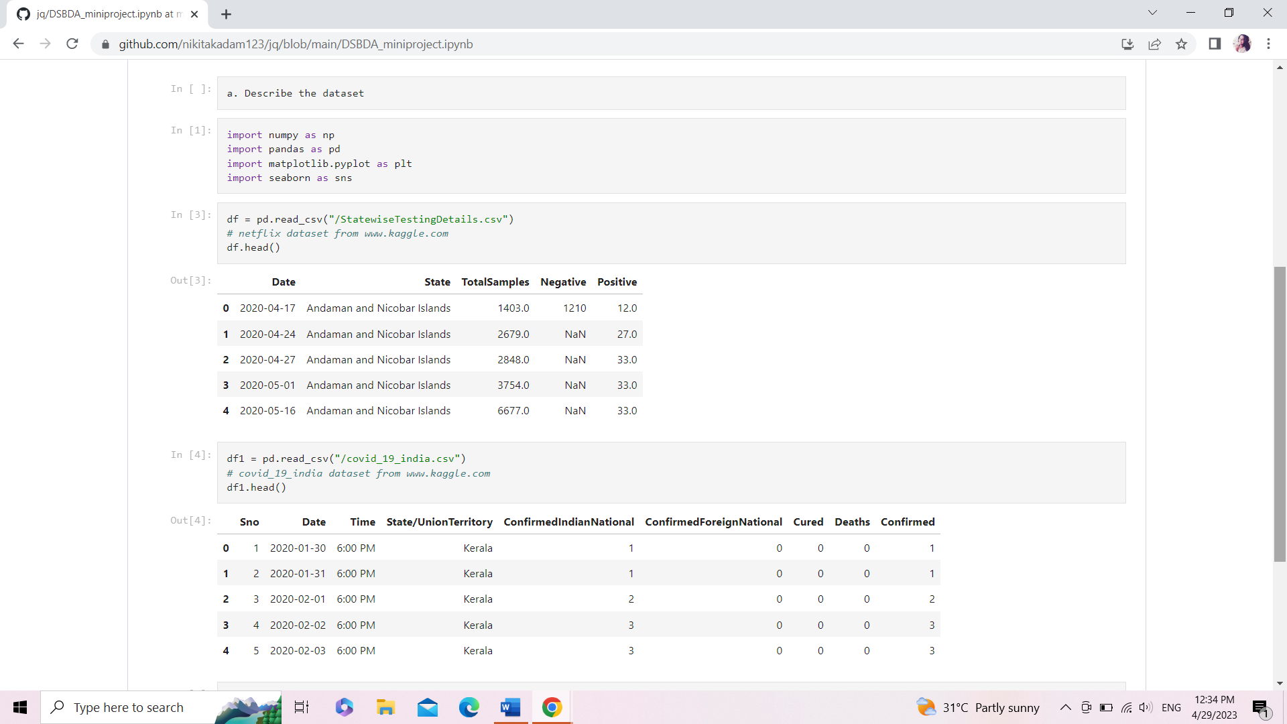

1. Number of persons state wise vaccinated for first dose in India
2. 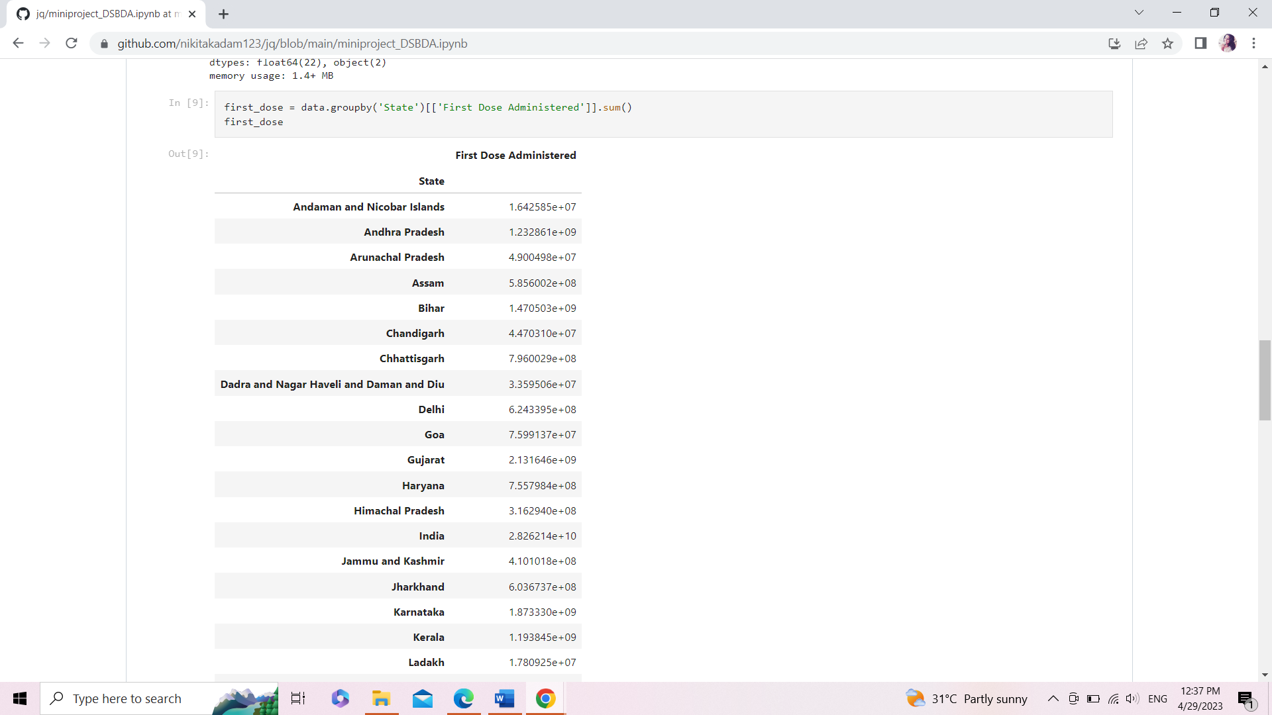
3. **Number of persons state wise vaccinated for second dose in India:**

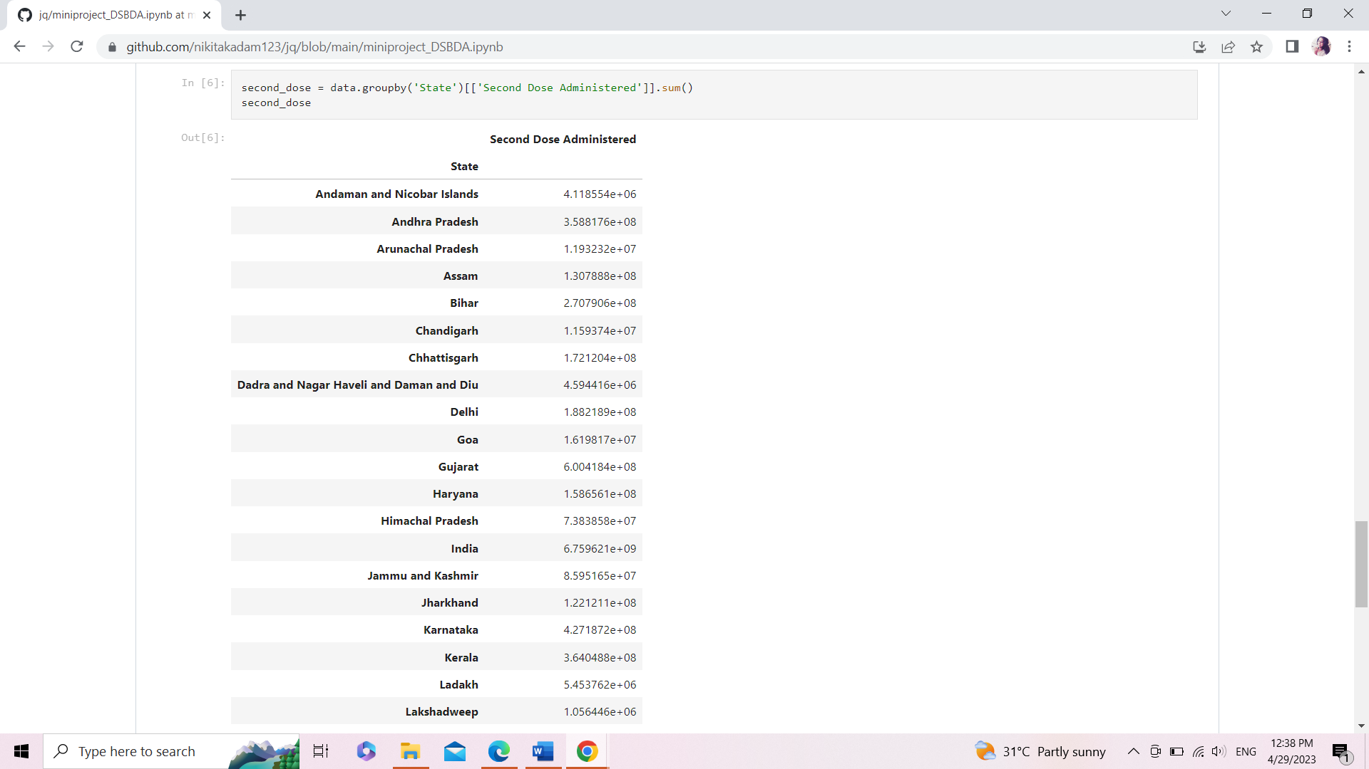

**d. Number of Males vaccinated**

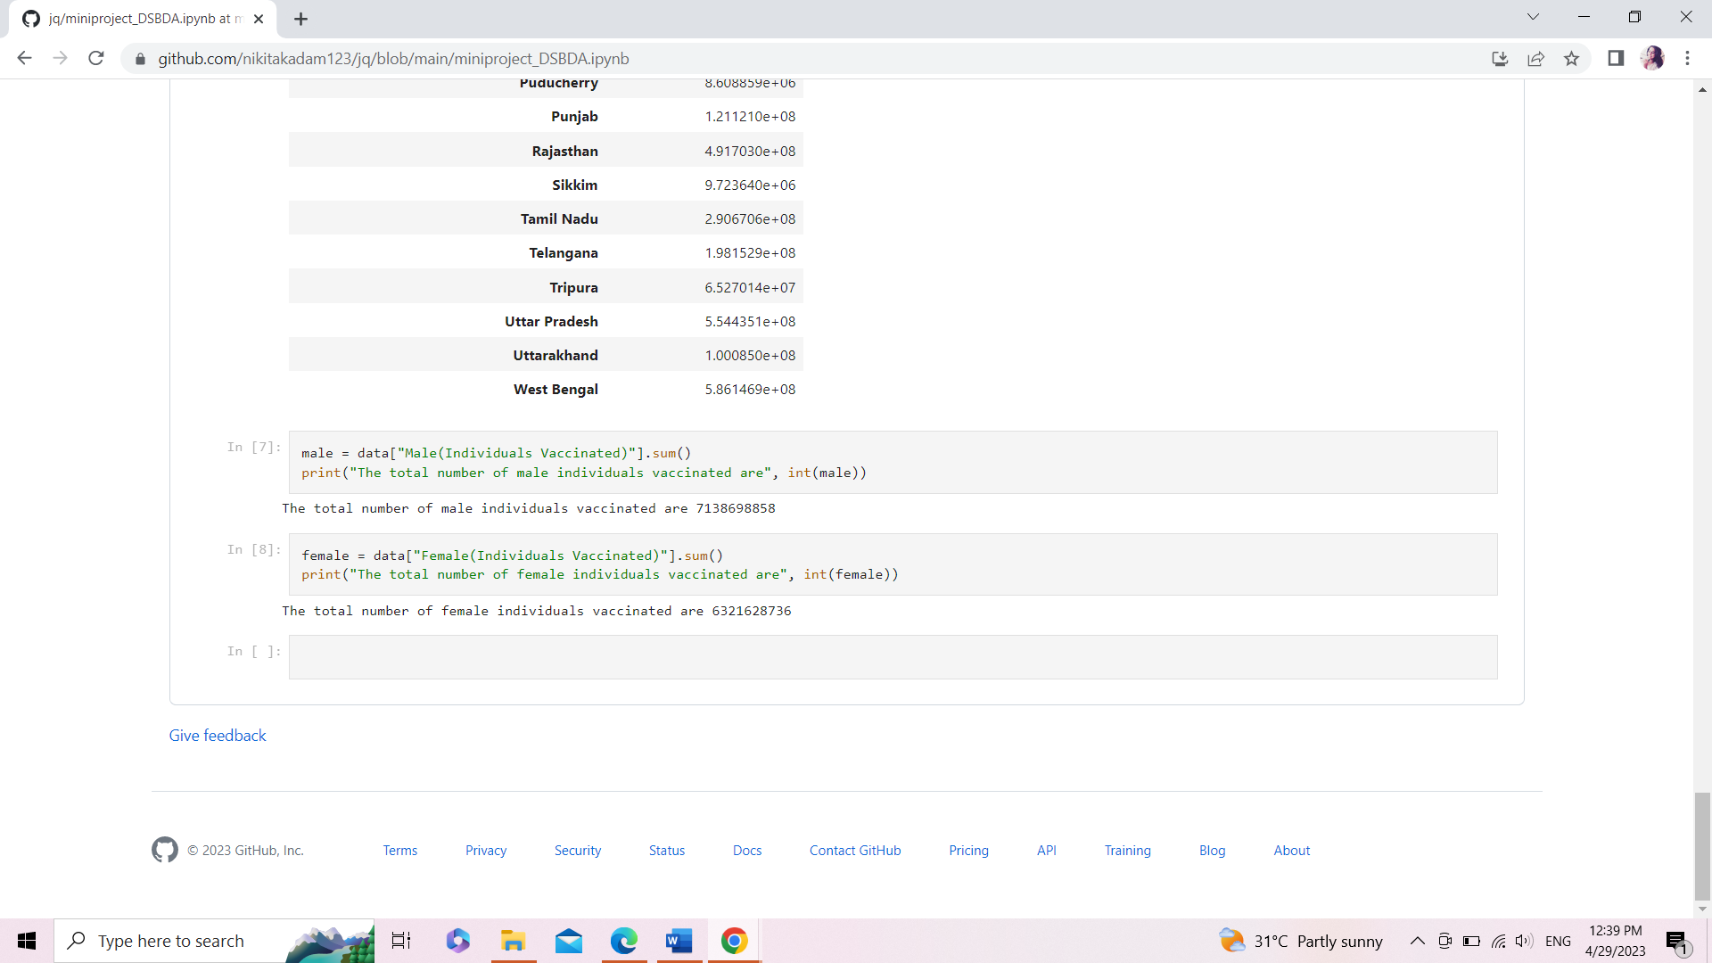

**E.Number of Females vaccinated :**

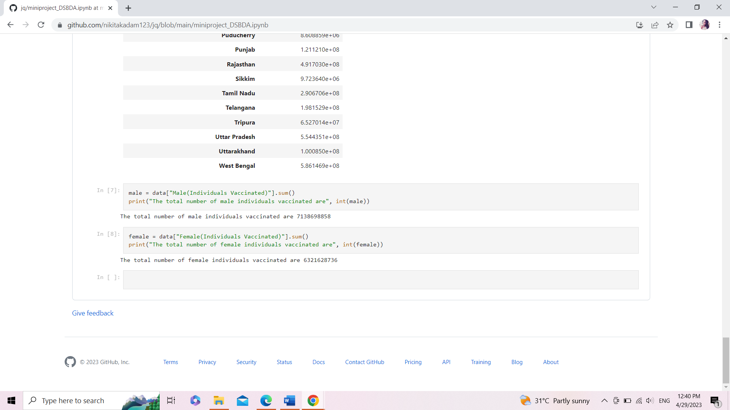

**Chapter 7**

**Summary**

**Time Complexity:**

* The average and best-case running time of the Rabin-Karp algorithm is O(n+m), but its worst-case time is O(nm).
* The worst case of the Rabin-Karp algorithm occurs when all characters of pattern and text are the same as the hash values of all the substrings of txt[] match with the hash value of pat[].
* The best case of Naive algorithm for Pattern Searching is:
* The best case occurs when the first character of the pattern is not present in the text at all.
* The number of comparisons in the best case is O(N).
* The worst case of Naive Pattern Searching occurs in the following scenarios.

* When all characters of the text and pattern are the same.

* Worst case also occurs when only the last character is different. .

# Chapter 8 Conclusion and Future Scope

**8.1 Conclusion**

We started with blockchain and the underlying mechanism of how it works and wrote our first smart contract and a case study around electronic voting using blockchain here. The blockchain along with the smart contracts provides a platform for the development of safer, cheaper, secure, more transparent, and easy-to-use e-voting systems. Due to its consistency and widespread use along with the provision of smart contracts logic, Ethereum and its network is one of the most suitable platforms for e- voting via the blockchain.

**8.2 Scope**

The following improvements can be made to the system,

* Adding Aadhar number verification system.
* Linking application with Government voting system data.
* Making the system more secure.
* Enhnacing the Graphical User Interface(GUI) of the ap- plication.
* Local languages can be included which will play a vital role for people living in rural areas as well as uneducated people.
* A Candidate’s earlier social work and candidate qualifi- cation’s can be added for a voter to have better choice.
* Also, adding suggestion system for voters that enables the public to give suggestions to the current winner.
* A complaint system can be included, that allows the people to file complaint against a candidate

# References

* <https://techblog.geekyants.com/e-voting-via-blockchain-a-case-study>
* <https://pubmed.ncbi.nlm.nih.gov/34502764/>
* [https://www.geeksforgeeks.org/decentralized-voting-system-using- blockchain/](https://www.geeksforgeeks.org/decentralized-voting-system-using-blockchain/)
* [https://www.goverticalworkshop.com/blockchain-2018- event/resources/ethereum-voting-app](https://www.goverticalworkshop.com/blockchain-2018-event/resources/ethereum-voting-app)
* [https://www.itm- conferences.org/articles/itmconf/pdf/2020/02/itmconf_icacc2020_03001 .pdf](https://www.itm-conferences.org/articles/itmconf/pdf/2020/02/itmconf_icacc2020_03001.pdf)
* <https://ieeexplore.ieee.org/document/8457919>