**Lab Assignment # 1**

**Ques1) Write a program that calculates and prints the n! for any n in the range [1...100].**

using System;

namespace Lab1

{

    class Program

    {

        static void Main(string[] args)

        {

            int fact=1;

            Console.WriteLine("Enter number:");

            int n = Convert.ToInt32(Console.ReadLine());

            if(n<1 || n>100){

                Console.WriteLine("INVALID" );

            }

            else{

                for(int i=1;i<=n;i++){

                    fact=fact*i;

                }

                Console.WriteLine("Factorial of "+n+"="+fact);

            }

        }

    }

}

**OUTPUT**

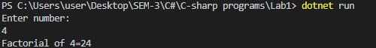

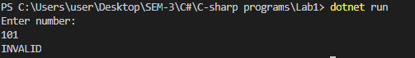

**Ques2 )Write a method that prints the digits of a given decimal number in a reversed order. For example 256, must be printed as 652.**

using System;

namespace LabQues2

{

    class Program

    {

        static void Main(string[] args)

        {

            int  n, reverse=0, rem;

            Console.Write("Enter a number: ");

            n= int.Parse(Console.ReadLine());

            while(n!=0)

            {

                rem=n%10;

                reverse=reverse*10+rem;

                n/=10;

            }

            Console.Write("Reversed Number: "+reverse);

        }

    }

}

**OUTPUT**

