**Lab #2 Assignment**

**Problem AP1:**

**Define a class Student, which contains the following information about students: full name, course,**

**subject, university, e-mail and phone number.**

**Problem AP2:**

**Add a method in the class Student, which displays complete information about the student.**

using System;

namespace LAB2_24_7

{

    class Student

    {

        public string full_name;

        public string course;

        public string subject;

        public string university;

        public string email;

        public string phone_number;

        public void getDetails(){

            Console.WriteLine("**********************");

            Console.WriteLine("Student Details");

            Console.WriteLine("Name :"+full_name);

            Console.WriteLine("Course :"+course);

            Console.WriteLine("Subject :"+subject);

            Console.WriteLine("University :"+university);

            Console.WriteLine("Email :"+email);

            Console.WriteLine("Phone Number :"+phone_number);

        }

        public void setDetails(){

            Console.WriteLine("Enter Name");

            full_name = Console.ReadLine();

            Console.WriteLine("Enter Course");

            course = Console.ReadLine();

            Console.WriteLine("Enter Subject");

            subject = Console.ReadLine();

            Console.WriteLine("Enter University");

            university = Console.ReadLine();

            Console.WriteLine("Enter Email");

            email = Console.ReadLine();

            Console.WriteLine("Enter Phone Number");

            phone_number = Console.ReadLine();

        }

    }

    class Program

    {

        static void Main(string[] args)

        {

            Student s=new Student();

            s.setDetails();

            s.getDetails();

        }

    }

}

**OUTPUT**

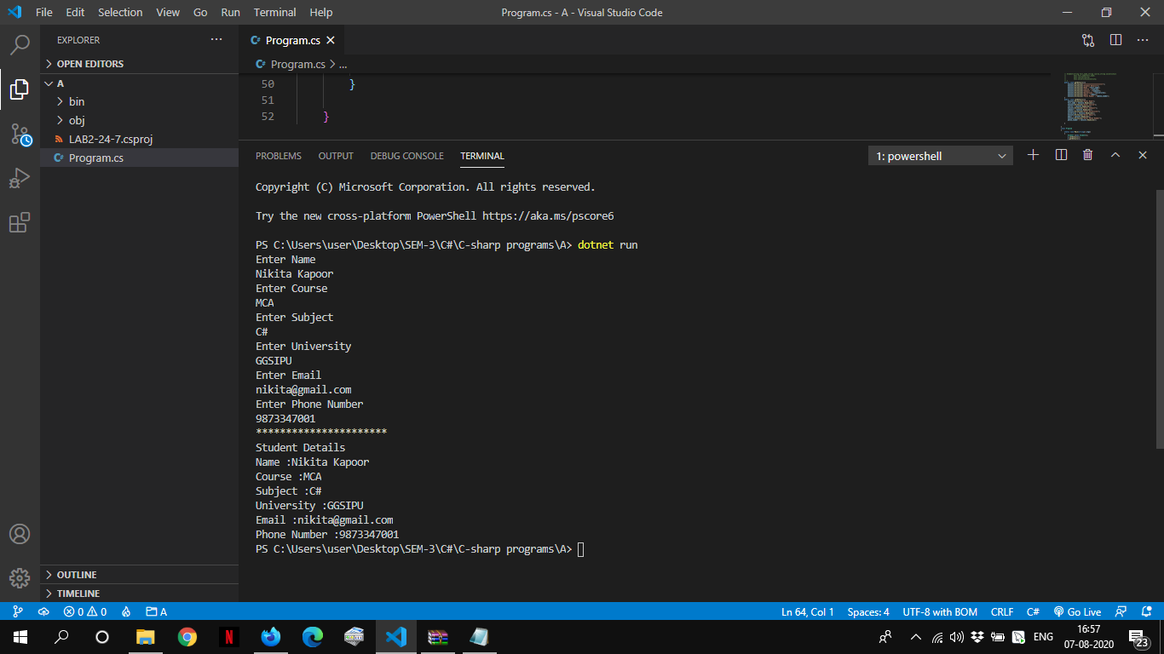

**Problem AA1:**

**A company pays its employees on a weekly basis. The employees are of four types:**

**1. Salaried employees are paid a fixed weekly salary regardless of the number of hours worked**

**2. . Hourly employees are paid by the hour and receive overtime pay for all hours worked in**

**excess of 40 hours**

**3. Commission employees are paid a percentage of their sales**

**4. Salaried-Commission employees receive a base salary plus a percentage of their sales.**

**For the current pay period, the company has decided to reward salaried-commission employees by**

**adding 10% to their base salaries. The company wants to implement a C# application that performs**

**its payroll calculations polymorphic way.**

**a. Design the class Diagram.**

**b. Implement the code to fulfil the requirement.**

**c. Calculation must be done with polymorphic way.**

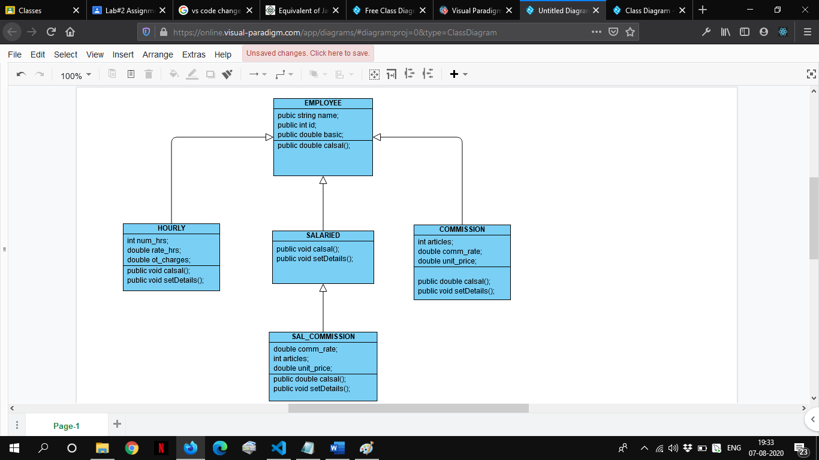

using System;

namespace AA1

{

 class Employee

    {

        public string name;

        public double basic;

        public int id;

        public double calsal(){

            return basic*2+basic*0.30; //basic+DA(100%)+HRA(30%)

        }

    }

    class Hourly:Employee

    {

        int num_hrs;

        double rate_hrs;

        double ot_charges;

        public void setDetails(){

            Console.WriteLine("Enter Name");

            name=(Console.ReadLine());

            Console.WriteLine("Enter Id");

            id=Convert.ToInt32(Console.ReadLine());

            Console.WriteLine("Enter Number of Hours");

            num_hrs=Convert.ToInt32(Console.ReadLine());

            Console.WriteLine("Enter Rate per Hour");

            rate_hrs=Convert.ToDouble(Console.ReadLine());

            Console.WriteLine("Enter OT charges");

            ot_charges=Convert.ToDouble(Console.ReadLine());

        }

        public double calsal()

        {

            if(num_hrs>40)

            {

                return (40*rate_hrs)+(num_hrs-40)*(rate_hrs*ot_charges);

            }

                return num_hrs*rate_hrs;

        }

    }

    class Salaried:Employee{

         public void setDetails(){

            Console.WriteLine("Enter Name");

            name=(Console.ReadLine());

            Console.WriteLine("Enter Id");

            id=Convert.ToInt32(Console.ReadLine());

            Console.WriteLine("Enter Basic Pay");

            basic=Convert.ToInt32(Console.ReadLine());

        }

        public double calsal()

        {

            return basic+basic*1.0+basic*0.30;

        }

    }

    class Commission:Employee

    {

        int articles;

        double comm_rate;

        double unit_price;

           public void setDetails(){

            Console.WriteLine("Enter Name");

            name=(Console.ReadLine());

            Console.WriteLine("Enter Id");

            id=Convert.ToInt32(Console.ReadLine());

            Console.WriteLine("Enter Articles");

            articles=Convert.ToInt32(Console.ReadLine());

            Console.WriteLine("Enter Commision Rate %");

            comm_rate=Convert.ToDouble(Console.ReadLine());

            Console.WriteLine("Enter Unit Price");

            unit_price=Convert.ToDouble(Console.ReadLine());

        }

        public double calsal(){

            return (articles*unit_price)*(comm_rate)/100;

        }

    }

    class Sal_Commission:Salaried{

        int articles;

        double comm_rate; //10

        double unit_price;

        public void setDetails(){

            Console.WriteLine("Enter Name");

            name=(Console.ReadLine());

            Console.WriteLine("Enter Id");

            id=Convert.ToInt32(Console.ReadLine());

            Console.WriteLine("Enter Basic Pay");

            basic=Convert.ToInt32(Console.ReadLine());

            Console.WriteLine("Enter Articles");

            articles=Convert.ToInt32(Console.ReadLine());

            Console.WriteLine("Enter Commision Rate %");

            comm_rate=Convert.ToDouble(Console.ReadLine());

            Console.WriteLine("Enter Unit Price");

            unit_price=Convert.ToDouble(Console.ReadLine());

        }

        public double calsal(){

            return ((articles*unit_price)*(comm_rate)/100)+(basic+basic*1.0+basic*0.30);

        }

    }

    class Program

    {

        static void Main(string[] args)

        {

            int choice;

            Salaried salaried=new Salaried();

            Sal_Commission sal_Commission=new Sal_Commission();

            Commission commission=new Commission();

            Hourly hourly=new Hourly();

            do{

                Console.WriteLine("Enter choice:");

                Console.WriteLine("1.Salaried Employee");

                Console.WriteLine("2.Hourly Employee");

                Console.WriteLine("3.Commission Employee");

                Console.WriteLine("4.Salaried Commission Employee");

                Console.WriteLine("5.Exit");

                choice=Convert.ToInt32(Console.ReadLine());

                switch(choice){

                    case 1:salaried.setDetails();

                            Console.WriteLine("Salary:"+salaried.calsal().ToString());

                            break;

                    case 2: hourly.setDetails();

                            Console.WriteLine("Salary:"+hourly.calsal().ToString());

                            break;

                    case 3: commission.setDetails();

                            Console.WriteLine("Salary:"+commission.calsal().ToString());

                            break;

                    case 4:sal_Commission.setDetails();

                            Console.WriteLine("Salary:"+sal_Commission.calsal().ToString());

                            break;

                }

            }while(choice!=5);

        }

    }

}

**OUTPUT**

