**Lab #3 Assignment**

**PROBLEM BP1:**

**Define a class, which contains information about a mobile phone: model, manufacturer, price, owner, and features of the battery (model, idle time and hours talk) and features of the screen (size and colors).**

**PROBLEM BA1:**

**Recent events in the stock market may seem remote to you, but they underscore the uncertainty of planning for the future. People who had been thinking of retiring in the next year or so may have to rethink those plans, as the value of their 401K accounts drops noticeably. Although retirement may seem a long way off for you, we are going to explore some simple ideas in accruing funds. We are going to start with a simple model of saving for retirement. Many Departments will contribute the equivalent of 5% of your salary to a retirement fund, and then will match any contribution that you add, Rupees for Rupees, up to an additional 5%. Thus, you can salt away up to 15% of your salary into a retirement account (10% which comes as a bonus from your employer). We can model a retirement fund with some simple equations. Assume your starting salary is represented by salary; that the percentage of your salary you put into a retirement fund is save; and that the annual growth percentage of the retirement fund is growthRate i.e. 2% initial. Then your retirement fund, represented by the list F, should increase as follows:**

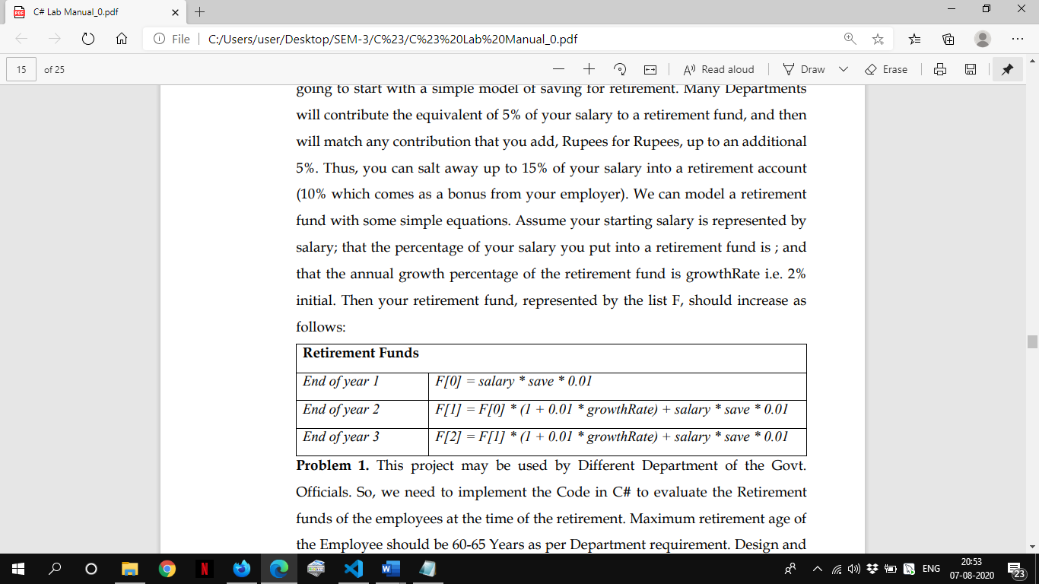

**Problem 1. This project may be used by Different Department of the Govt. Officials. So, we need to implement the Code in C# to evaluate the Retirement funds of the employees at the time of the retirement. Maximum retirement age of the Employee should be 60-65 Years as per Department requirement. Design and implement all the classes with full functionality to evaluate the retirement funds.**

using System;

namespace BA

{

class Employee{

        public int id;

        public string name;

        public int salary;

        public int contri;

        public int growthRate=2;

        public int age;

        public void setDetails(){

            Console.WriteLine("Enter Id");

            id=Convert.ToInt32(Console.ReadLine());

            Console.WriteLine("Enter Name");

            name=Console.ReadLine();

            Console.WriteLine("Enter Age");

            age=Convert.ToInt32(Console.ReadLine());

            Console.WriteLine("Enter Salary");

            salary=Convert.ToInt32(Console.ReadLine());

            Console.WriteLine("Enter Contribution %");

            contri=Convert.ToInt32(Console.ReadLine());

            Console.WriteLine("Enter Growth Rate %");

            growthRate=Convert.ToInt32(Console.ReadLine());

        }

         public void getDetails(){

            Console.WriteLine("Id"+id);

            Console.WriteLine("Name"+name);

             Console.WriteLine("Age"+age);

            Console.WriteLine("Salary"+salary);

            Console.WriteLine("Contribution %"+contri);

            Console.WriteLine("Growth Rate %"+growthRate);

        }

        public int getAge(){

            return age;

        }

        public double fundCalc(int currage,int retirementAge)

        {

            double F=0;

            int diff=retirementAge-currage;

            for (int i=0; i<diff; i++)

            {

                F+=(F*growthRate*0.01)+((salary)*(contri+contri+5)*0.01);

            }

            return F;

        }

    }

    class Deptt{

        public Employee e;

        public int retirementAge;

           public void setRetirementAge(){

            Console.WriteLine("Enter Retirement Age");

            retirementAge=Convert.ToInt32(Console.ReadLine());

        }

         public int getRetirementAge(){

           return retirementAge;

        }

    }

    class Program

    {

        static void Main(string[] args)

        {

            Employee employee=new Employee();

            employee.setDetails();

            Deptt deptt=new Deptt();

            deptt.e=employee;

            deptt.setRetirementAge();

            Console.Write(Math.Round(deptt.e.fundCalc(employee.getAge(),deptt.getRetirementAge()),2));

        }

    }

}

**OUTPUT**

