PARKING

MANAGER

UTILITY

**PROBLEM STATEMENT**

Parking Manager Utility is aimed to be a utility that can automate the managing of records of incoming and outgoing vehicles in the parking house.

The vehicles are categorised into 3 types : 2 wheeler(scooters, bicycles),4 wheeler light(cars),4 wheeler heavy(trucks, buses). The vehicles are registered on their arrival. Vehicles are not allowed to park for more than 8 hours. The vehicles can be parked normally or under the CCTV for security. There is a price chart available containing the per hour price for parking. One could view the details of the vehicles parked in the parking lot. The bill for the vehicle is generated according to the number of hours of stay.

Thus this utility enables drivers to reserve a parking space in the parking lot.

**SUBMODULES**

**1.Arrival of a vehicle**

In this module the vehicle details are saved and a parking space is allotted to the vehicle.

**2.Total no of vehicles arrived**

In this module the details of all the vehicles parked in the parking lot can be viewed

**3.Total parking charges of the vehicle**

In this module the bill of the vehicles are generated according to its number of hours of stay. The bill can be viewed by typing the vehicle number.

**4.Departure of the vehicle**

In this module the details of the vehicle is deleted from the file as soon as the car departs from the parking lot

**5.View price chart**

This module displays the parking price per hour for the vehicles for different categories.

**CODE**

**Vehicle.h**

**Parking.cpp**

**TESTING SCREENSHOTS**

**Password:** pass

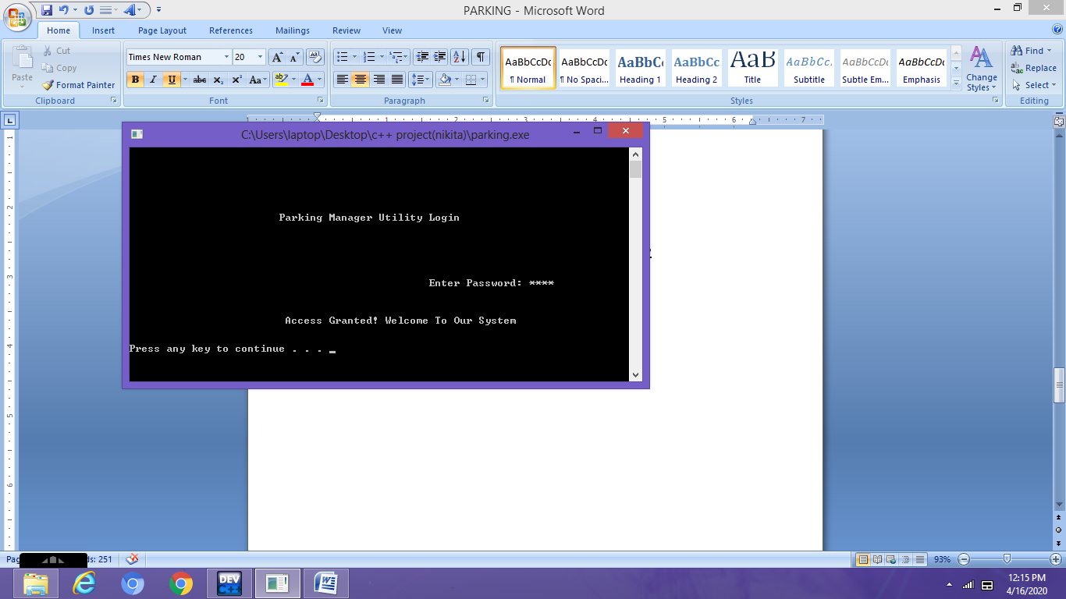

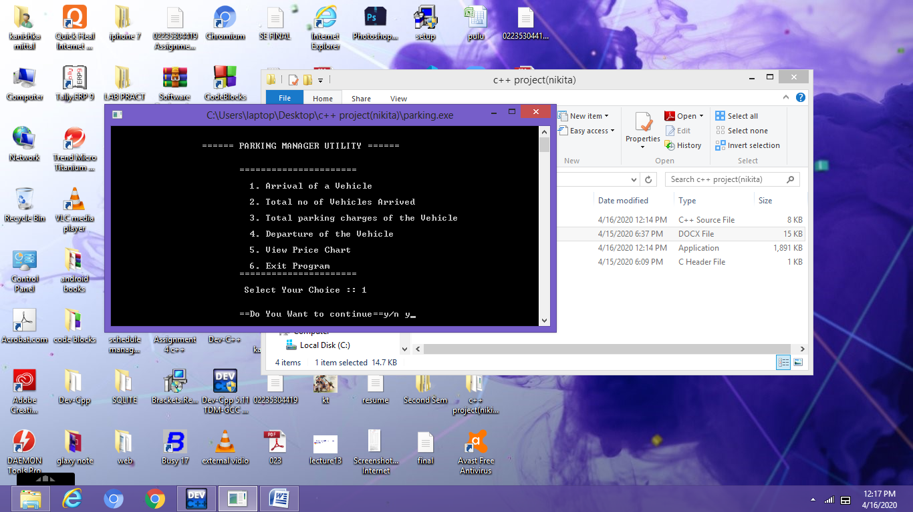

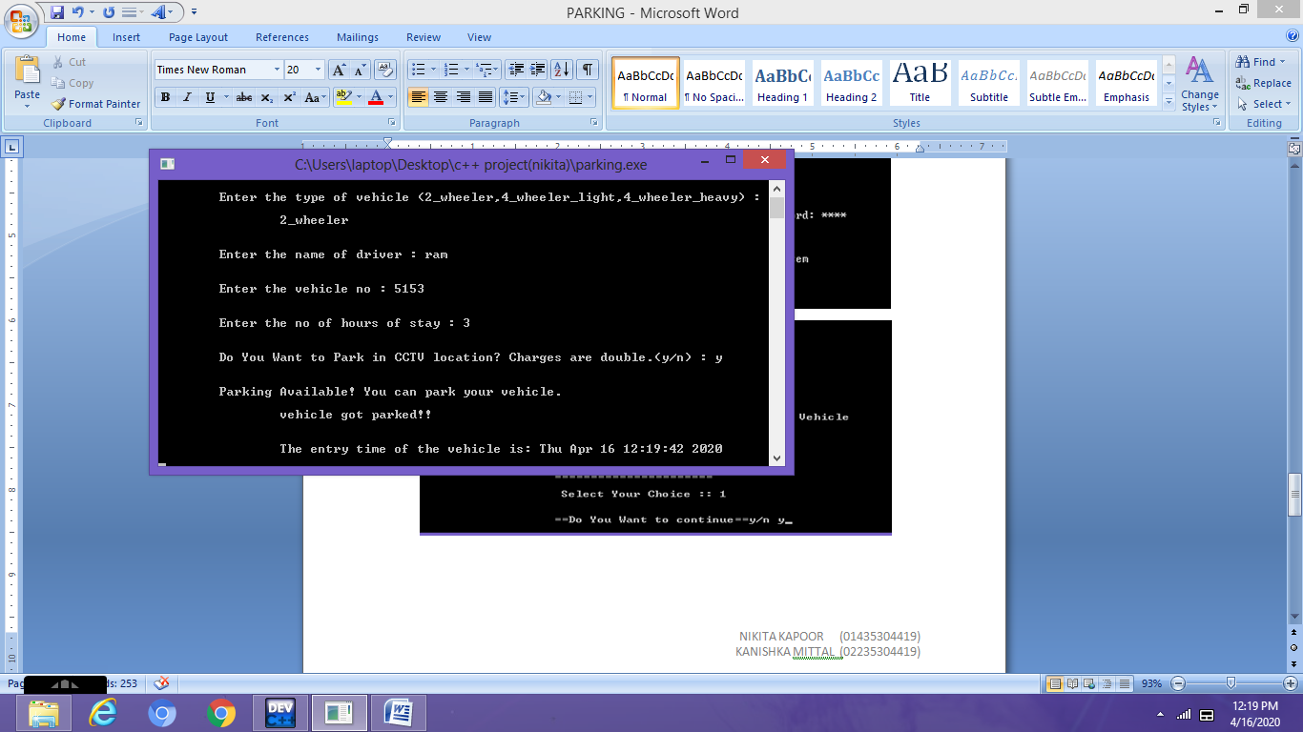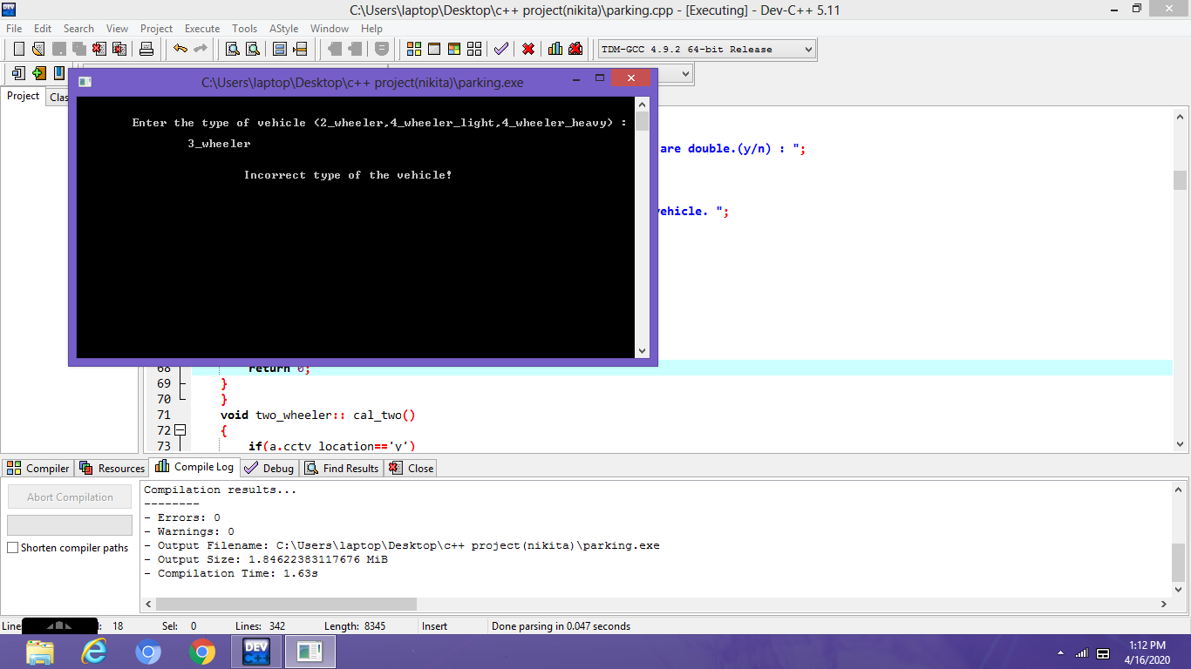

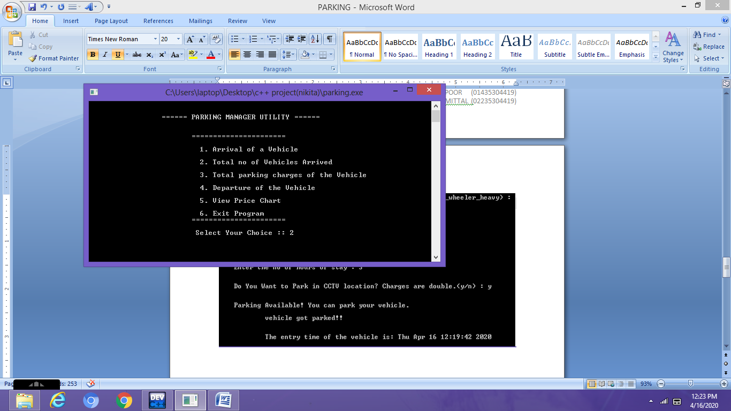

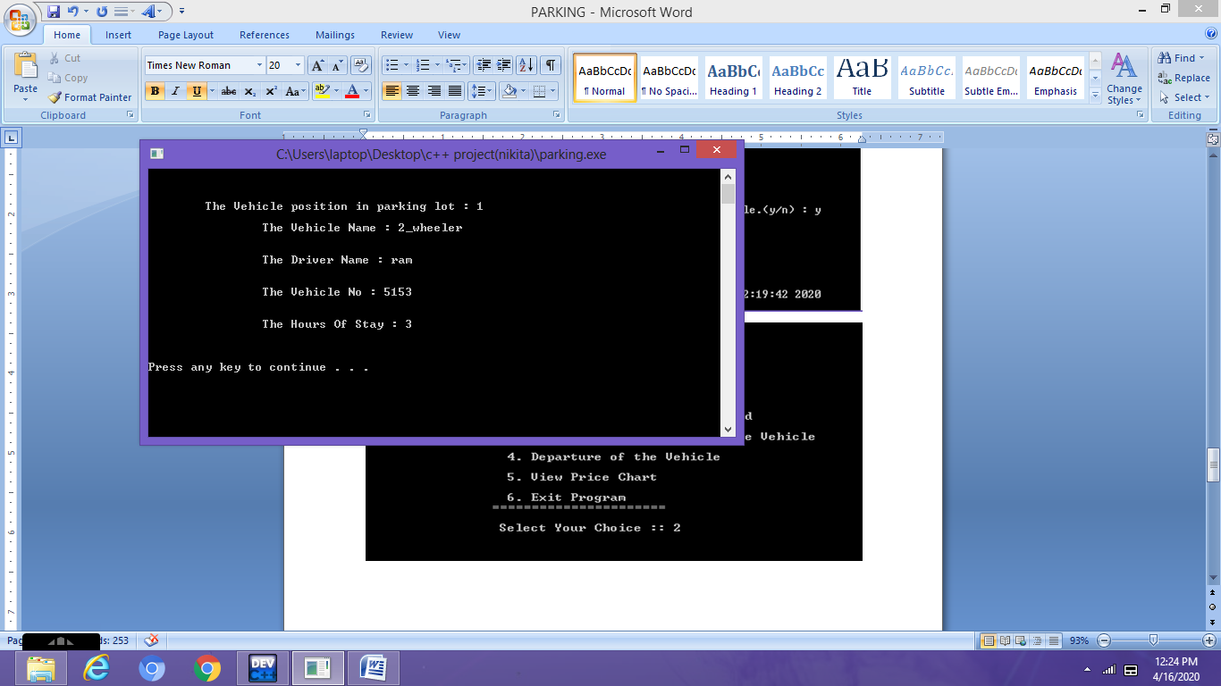

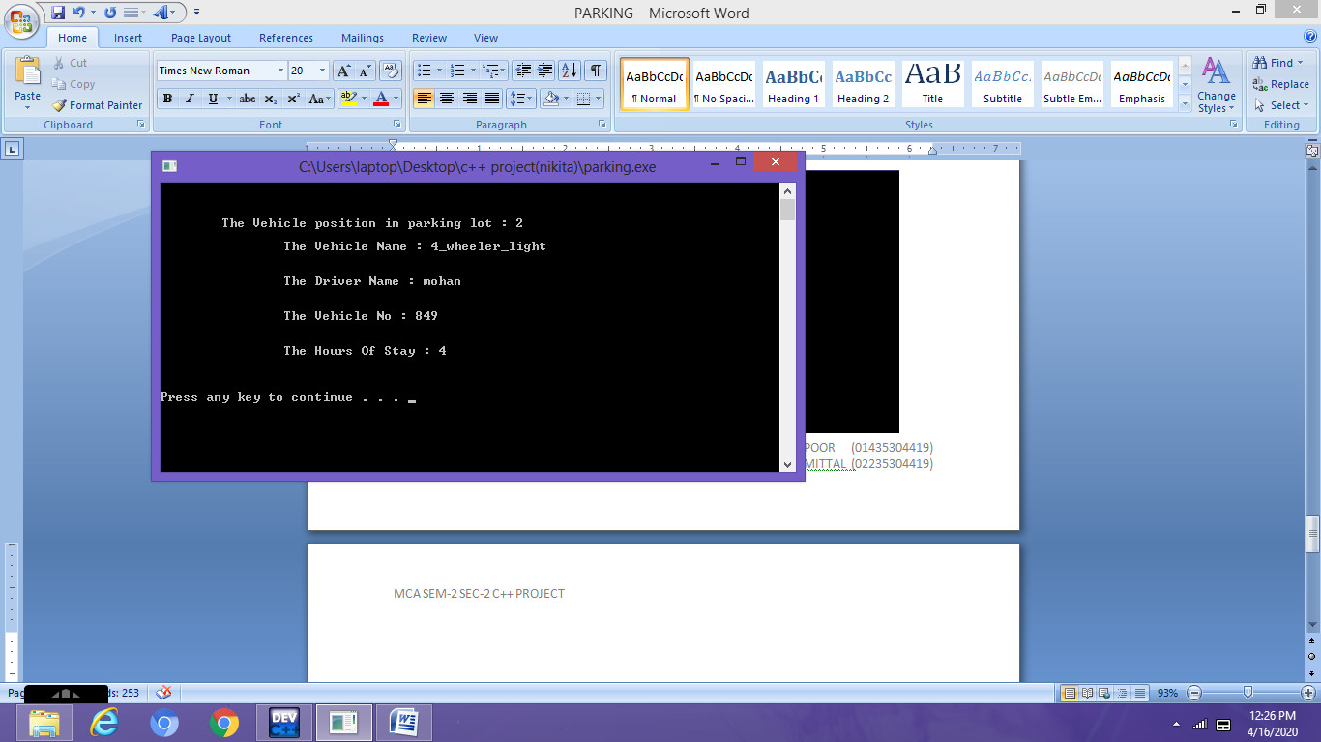

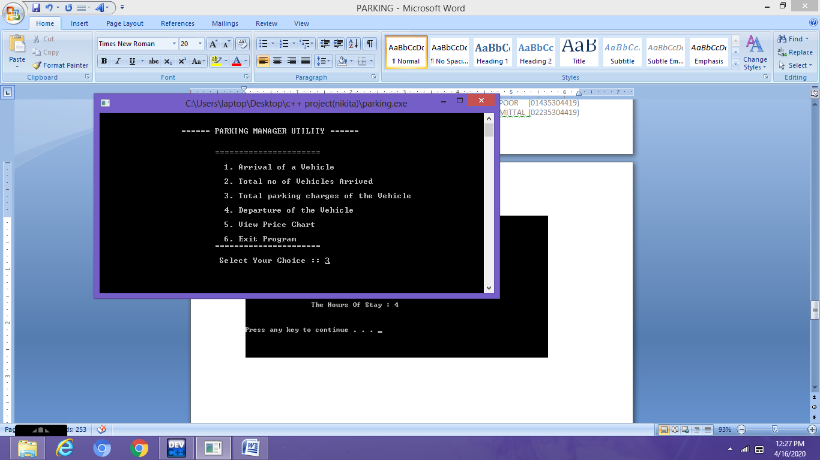

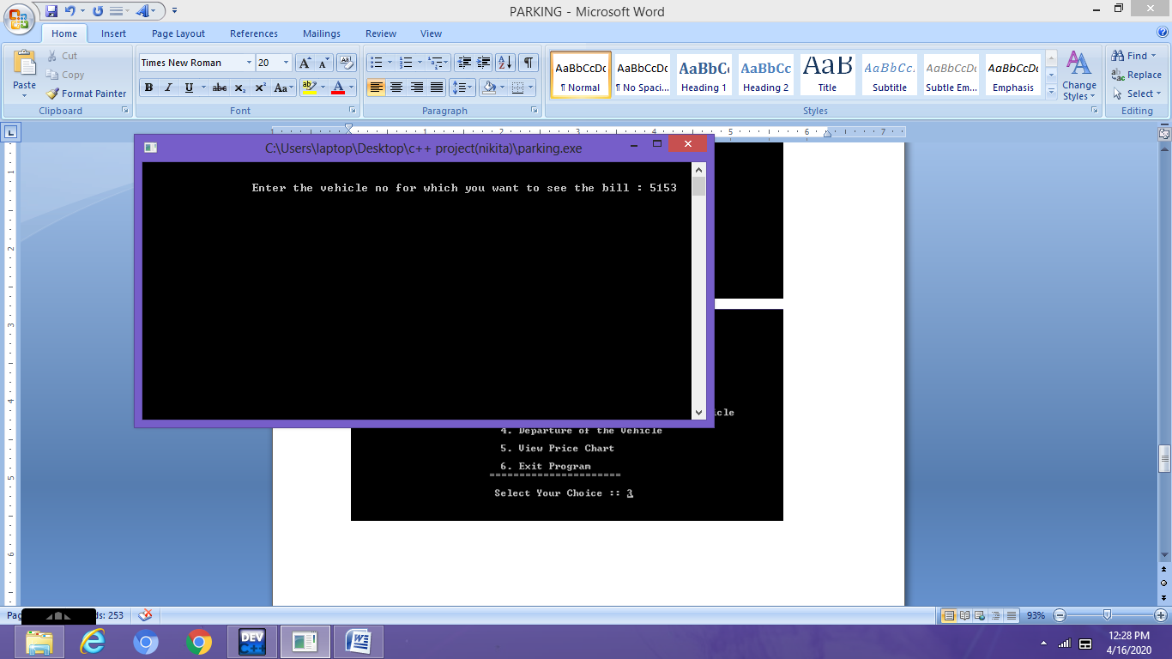

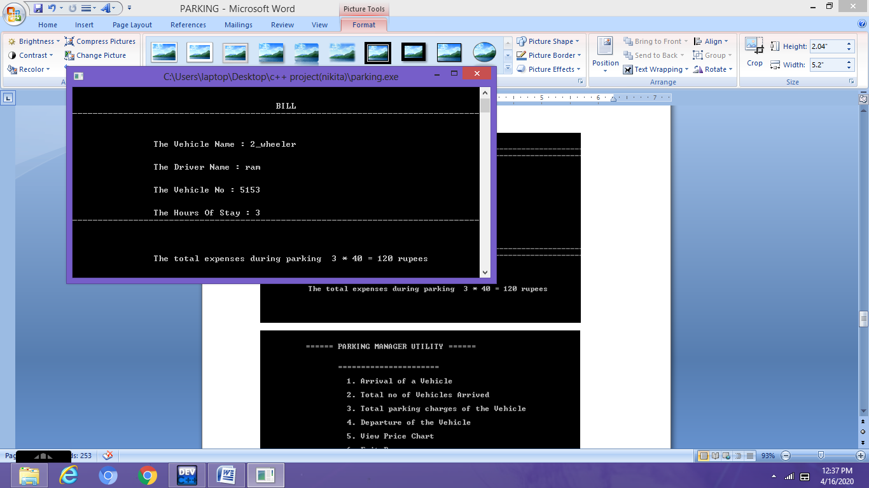

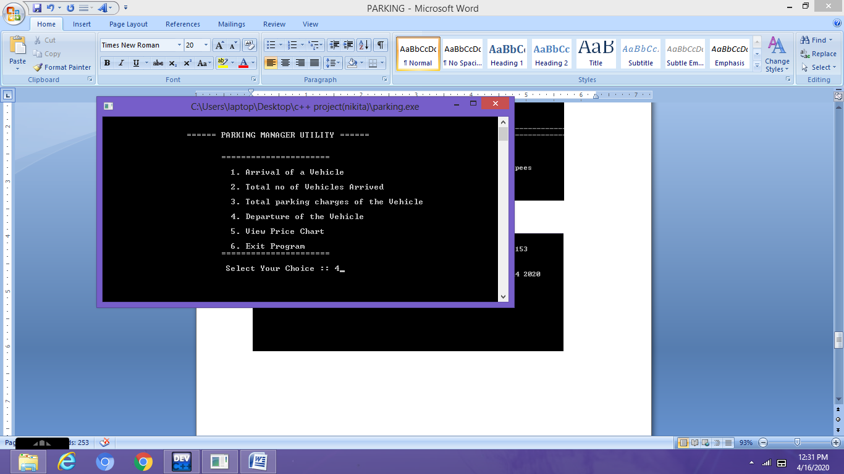

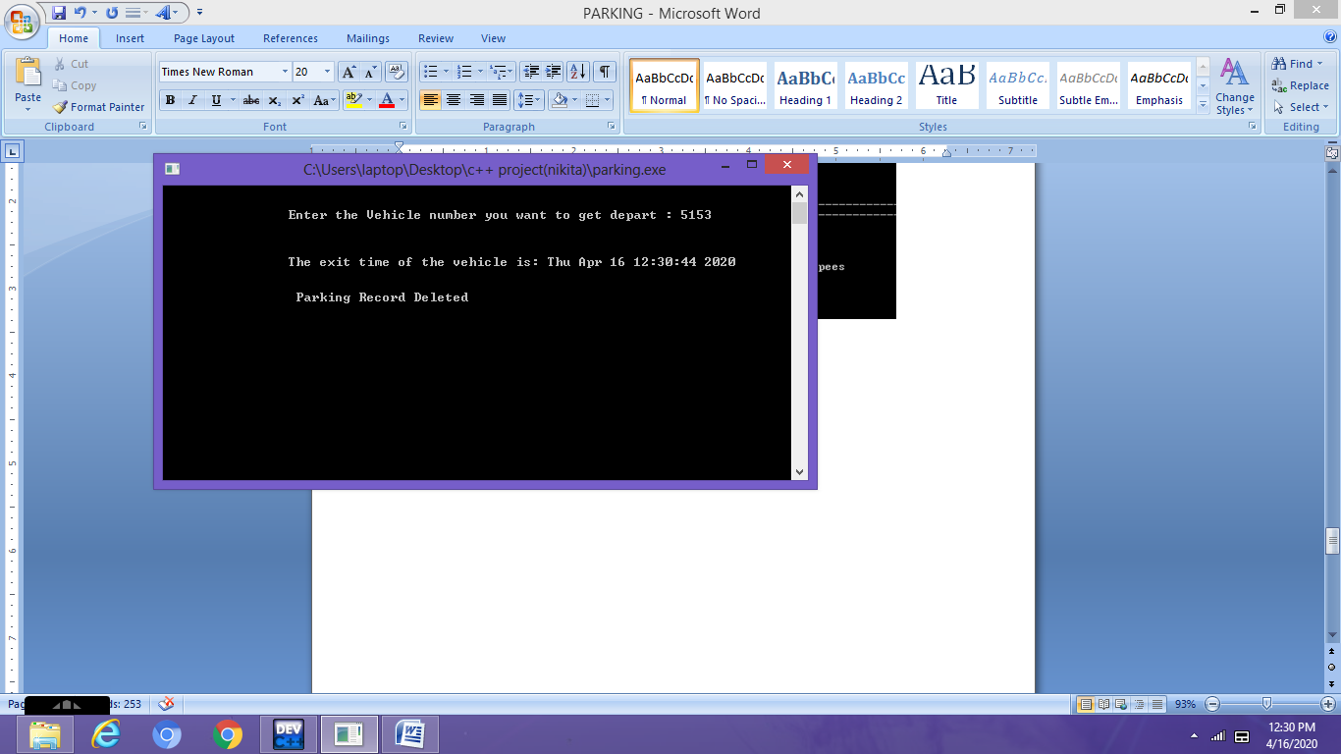

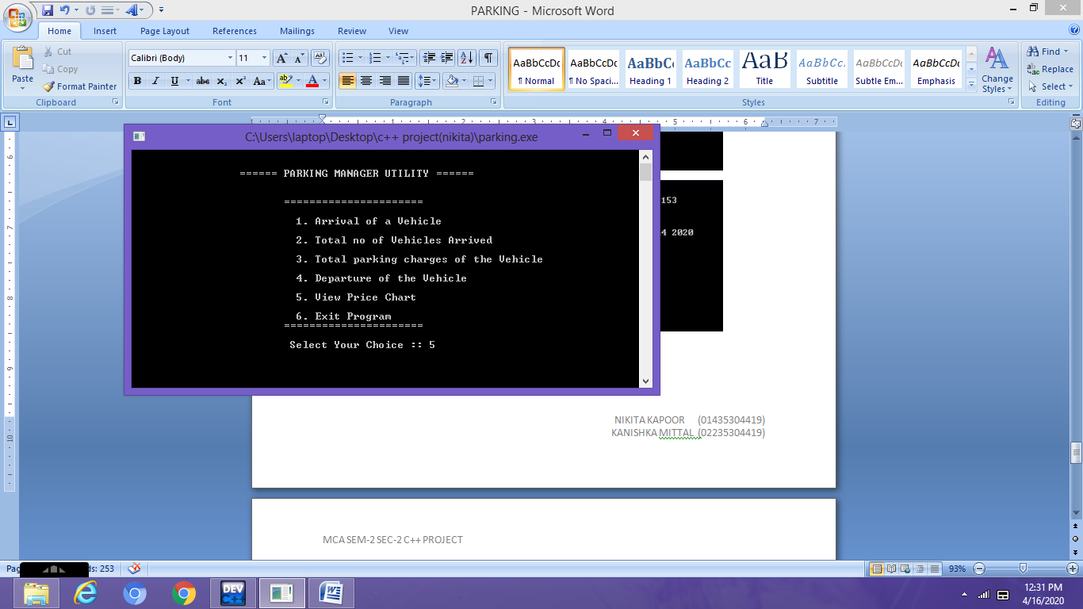

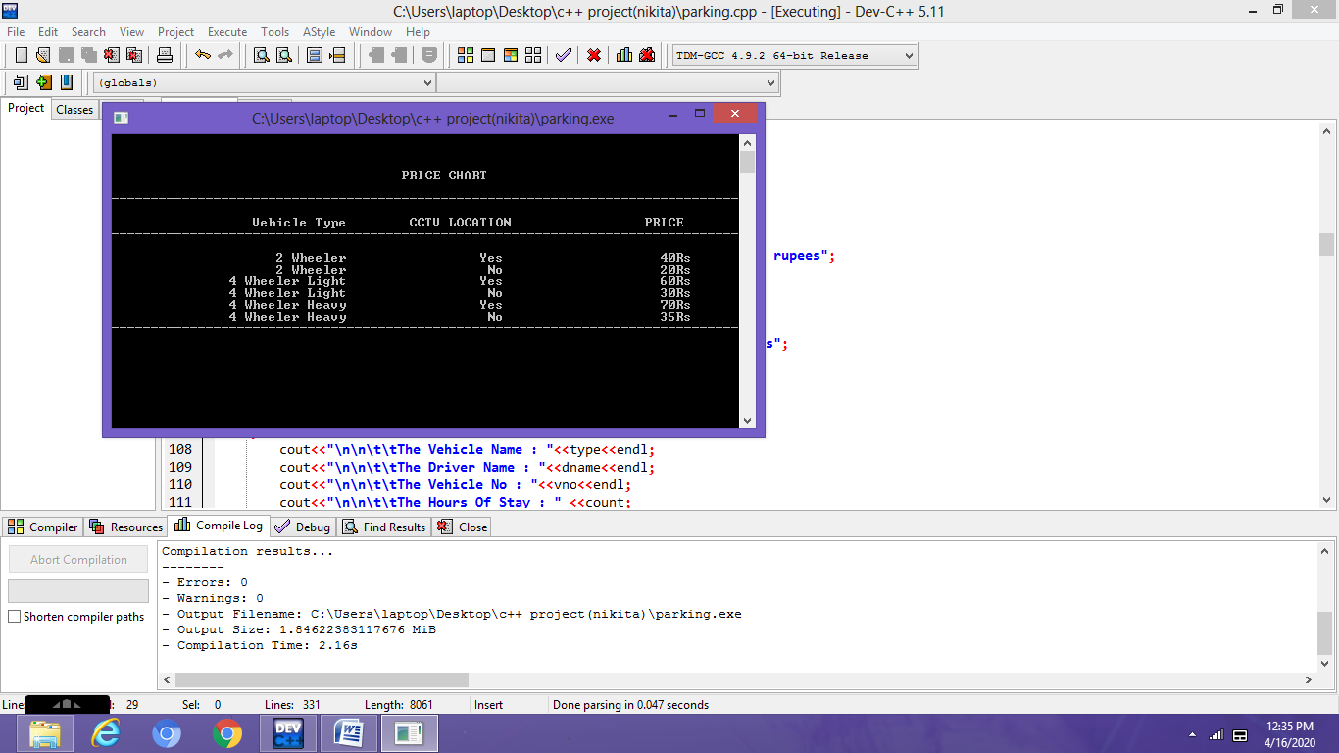

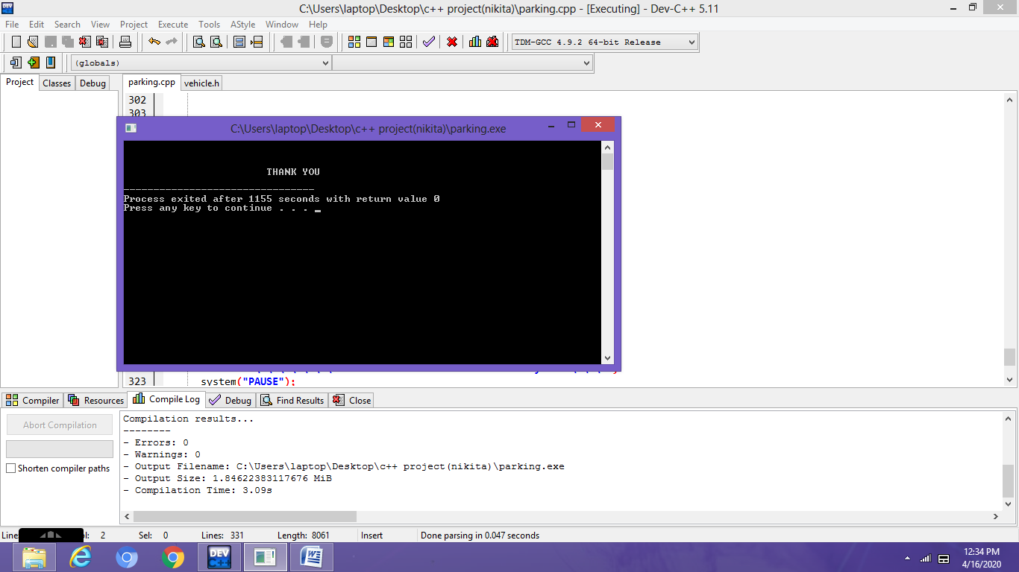

**CONCLUSION**

A successful implementation of this project would result in less traffic and chaos in crowded parking spaces like malls and business buildings where many people share a parking area.

As the Parking Manager Utility requires minimal manpower, there are minimum chances for human errors, increased security in addition to a swift and friendly car parking experience for drivers.

**FUTURE SCOPE**

Parking Manager Utility strategies would necessitate the installation of a parking guidance and information system.

The information on availability of parking space in each facility will be garnered based on the count of cars parked or from ticketing machines with the aid of sensors. The data would be sent to the central computer that will process and determine locations where parking spaces are available.