BRACT’s
Vishwakarma Institute of Technology, Pune
Practical Implementation Sheet
Department:- CSE-AI Semester:- 5 Academic Year:- 2026-27
Division:- C Batch:- 2 Practical No:- 1
Roll no:- 33 PRN No:-12413106 Name of Student:- Nikita Katewar

Subject Name : Deep Learning

Problem Statement :- Install and configure TensorFlow/Keras in Google Colab. Perform data preprocessing, normalization, train-test split, and visualization on a sample dataset.

Algorithm :-

- Import TensorFlow and Matplotlib libraries.
- Load the Fashion MNIST dataset using tf.keras.datasets.fashion_mnist.load_data().
- Split the dataset into training and testing datasets.
- Normalize the image pixel values.
- Display the shape of the training images, testing images, and labels.
- Create a Sequential neural network model.
- Train the model using the training dataset for 3 epochs.
- Evaluate the model using the testing dataset and display the test accuracy.
- Save the trained model as fashion_mnist_model.keras.

Code :-
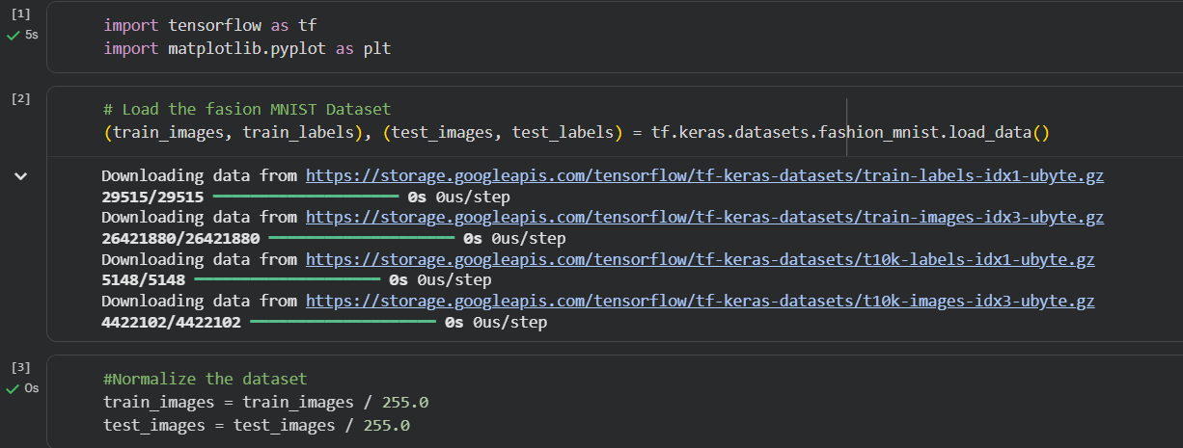
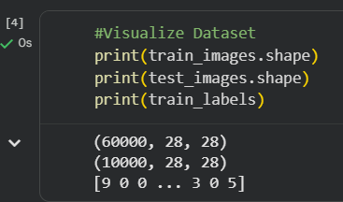
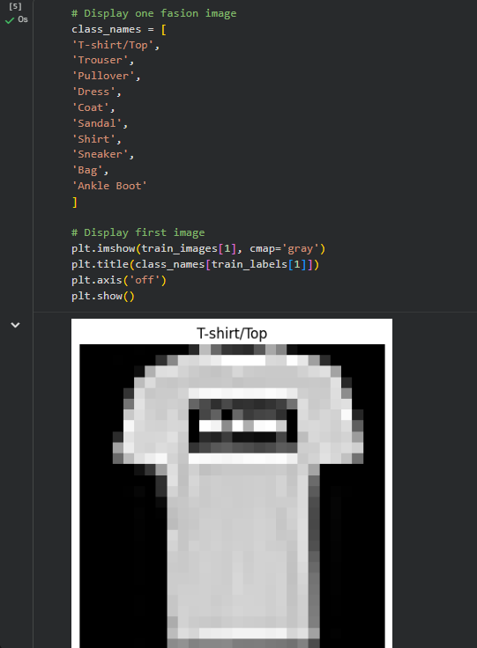
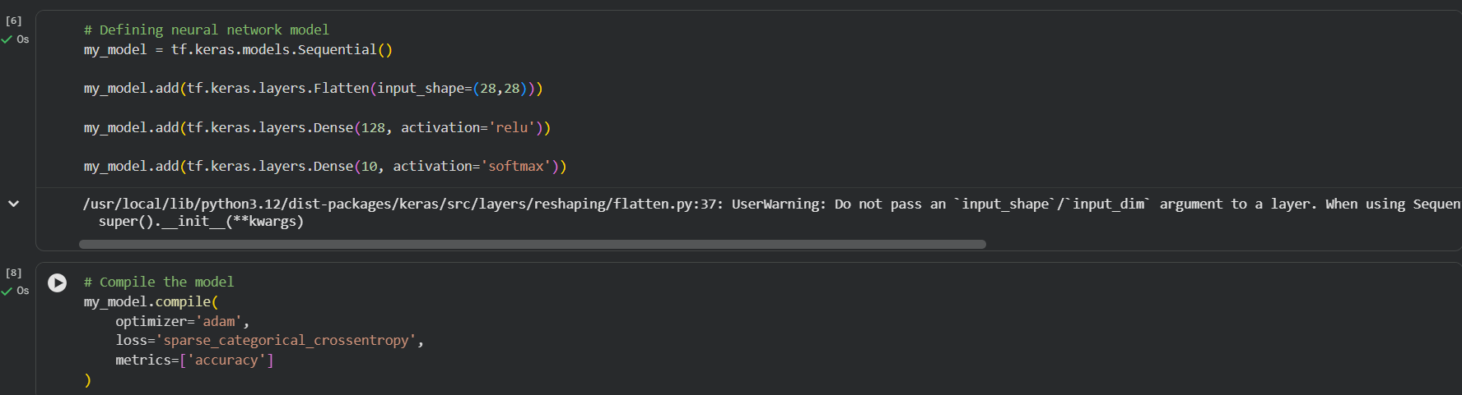
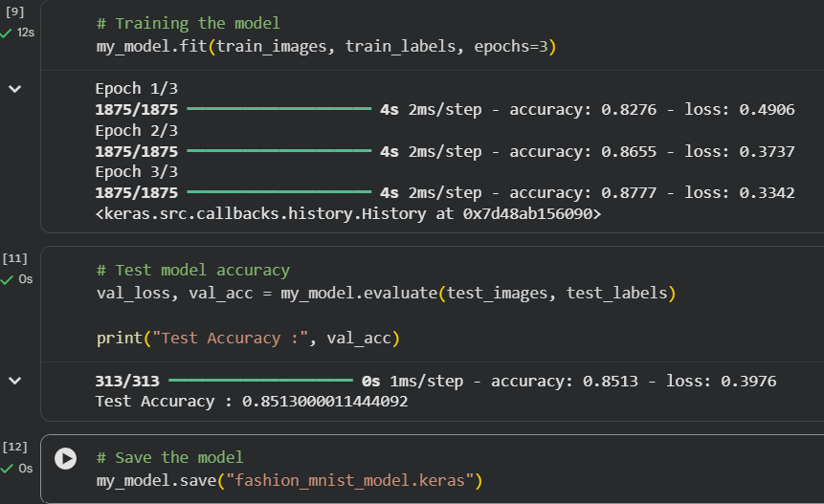

Output :

