BRACT’s
Vishwakarma Institute of Technology, Pune
Practical Implementation Sheet
Department: CSE-AI Semester: 5 Academic Year: 2026-27
Division:- C Batch :- 2 Practical No :- 6
Roll no :- 32 PRN No :- 12413106 Name of Student :- Nikita Katewar

Subject Name : Deep Learning

Problem Statement :- Design and implement a Convolutional Neural Network (CNN) for image classification using the Tomato or Soybean disease dataset.

Theory

1. What is CNN?
A Convolutional Neural Network (CNN) is a deep learning algorithm mainly used for image classification and image processing.
In this experiment, the CNN takes a tomato leaf image as input and predicts its disease class.

2. Convolution Layer
The convolution layer extracts important features from the input image using small filters called kernels.

3. ReLU Activation
ReLU stands for Rectified Linear Unit.
Formula:
ReLU(x) = max(0, x)
It converts negative values to zero and keeps positive values.
It helps the CNN learn complex patterns.

4. Max Pooling
Max pooling reduces the size of the feature map while retaining important information.
We use:
MaxPooling2D(2 × 2)

5. Softmax
The final output layer uses the Softmax activation function.
Since Tomato dataset contains 10 classes, we use:
Dense(10, activation='softmax')
Softmax gives a probability for each disease class.
For example:
Bacterial Spot 0.05
Early Blight 0.82
Healthy 0.03
Late Blight 0.06
...
The class with the highest probability becomes the predicted class.

Algorithm

Algorithm: CNN-Based Tomato Disease Classification
Step 1: Load the Tomato Disease Dataset containing training and validation images.
Step 2: Identify the different disease classes present in the dataset.
Step 3: Resize all input images to a fixed size, such as 128 × 128 pixels.
Step 4: Normalize the pixel values from 0–255 to 0–1.
Step 5: Load the training and validation datasets using TensorFlow/Keras.
Step 6: Create a CNN model.
Step 7: Add a convolution layer with 32 filters and apply ReLU activation.
Step 8: Add a 2 × 2 Max Pooling layer.
Step 9: Add a convolution layer with 128 filters and apply ReLU activation.
Step 10: Add a Dense layer containing 128 neurons with ReLU activation.
Step 11: Add a Dropout layer to reduce overfitting.
Step 12: Train the CNN using the training dataset for a specified number of epochs.
Step 13: Validate the model using the validation dataset.
Step 14: Calculate the validation accuracy and loss.
Step 15: Plot the training and validation accuracy and loss graphs.
Step 16: Generate a classification report containing precision, recall, and F1-score.

Evaluation Measures
The CNN performance is evaluated using:
1. Accuracy – Percentage of correctly classified images.
2. Loss – Measures the error between actual and predicted classes.
3. Confusion Matrix – Shows correct and incorrect predictions for each disease.
4. Precision – Measures how many predicted positive samples are actually correct.
5. Recall – Measures how many actual positive samples are correctly identified.
6. F1-score – Harmonic mean of precision and recall.

Code :-

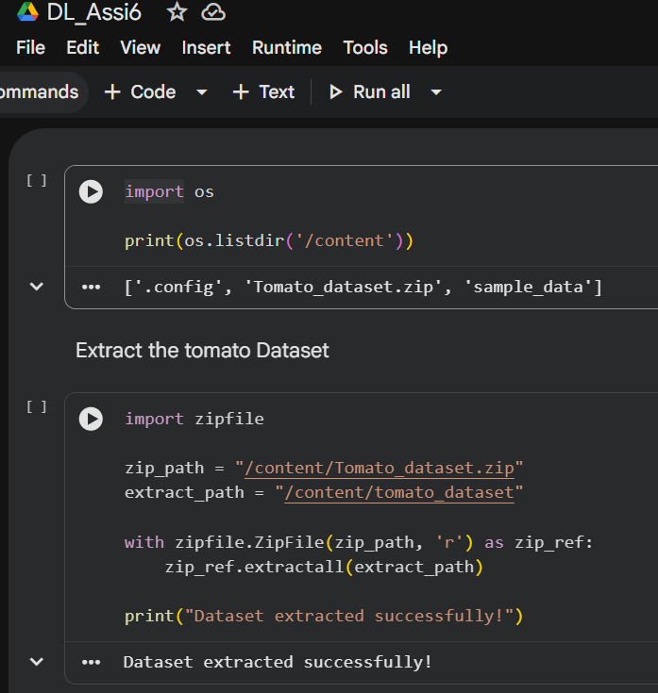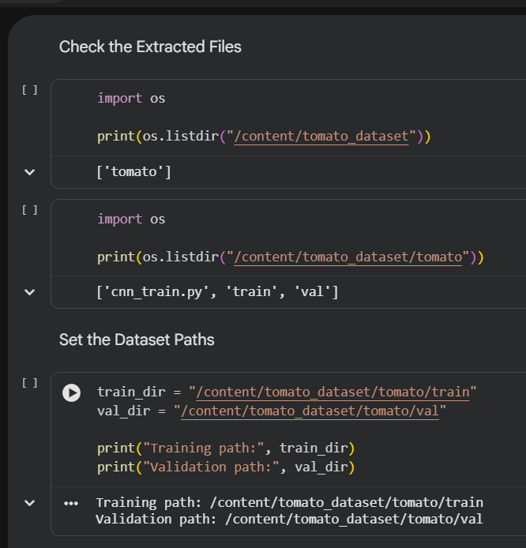

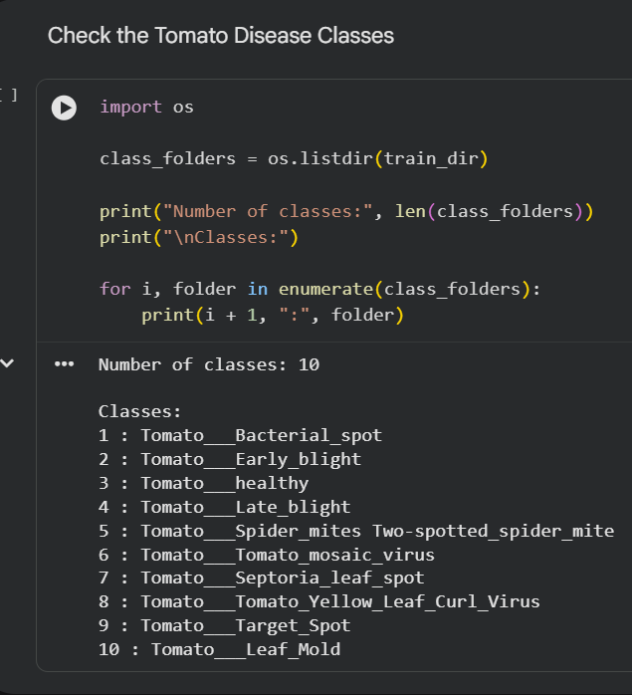
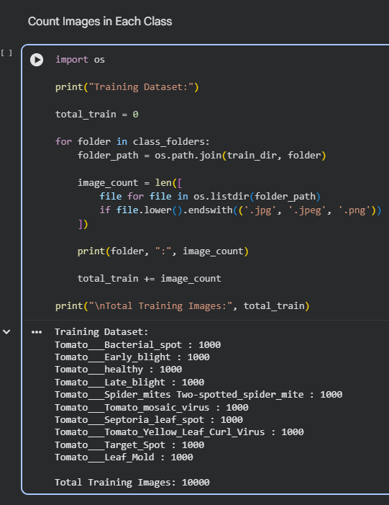
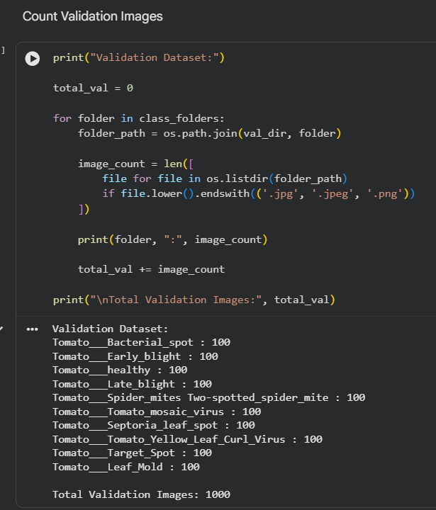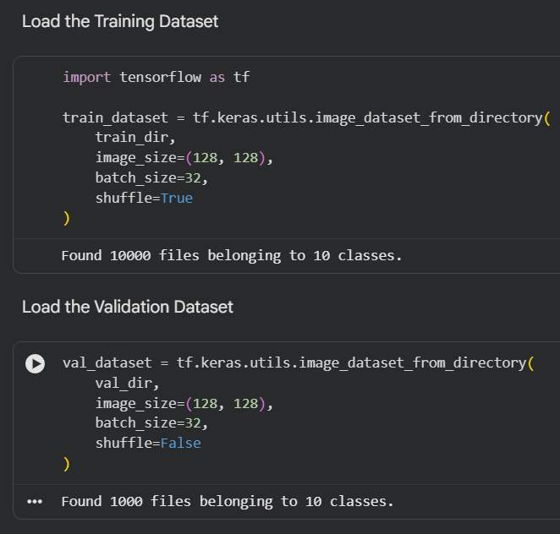

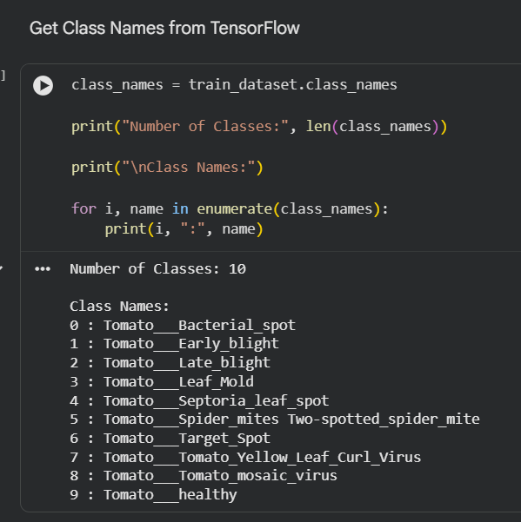
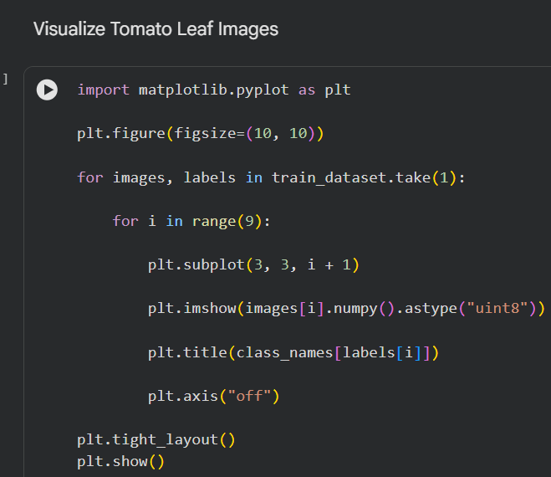
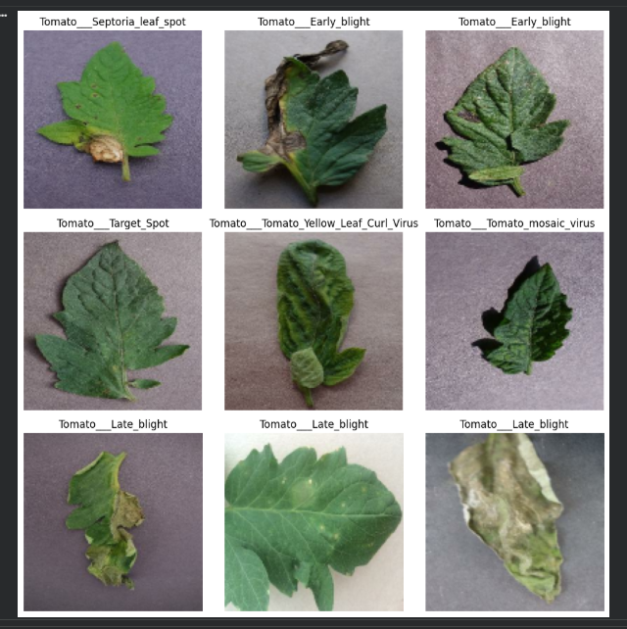
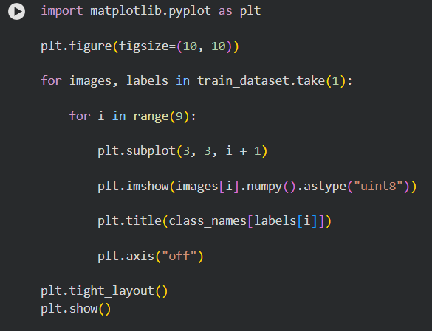
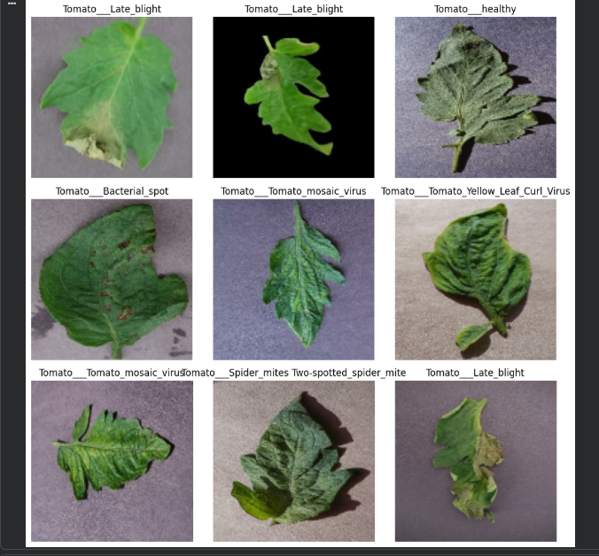
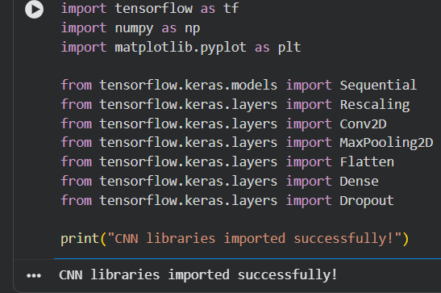
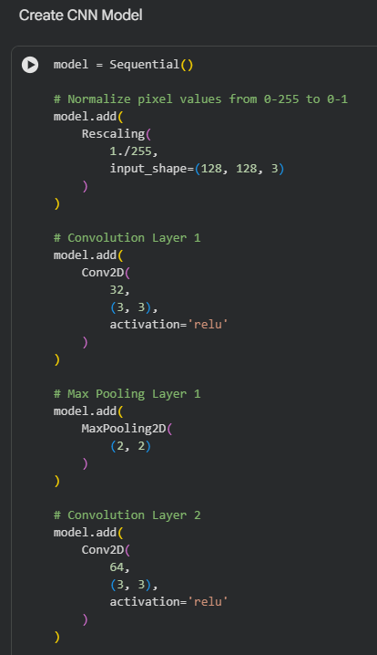
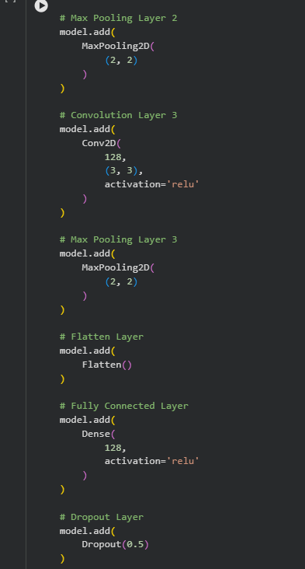
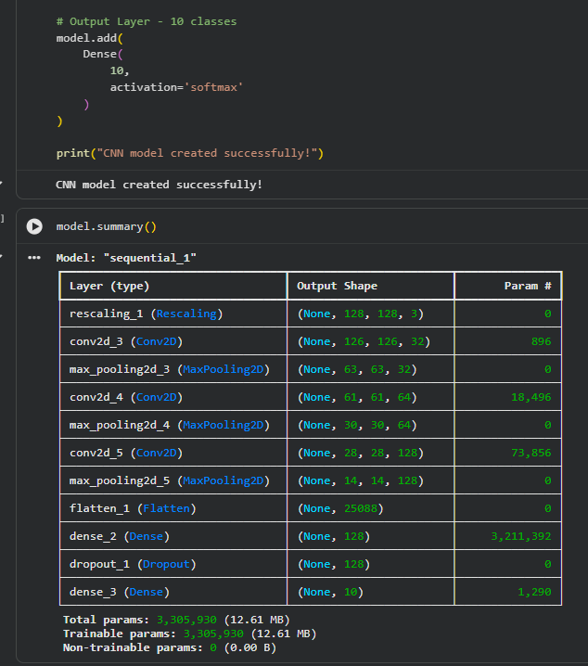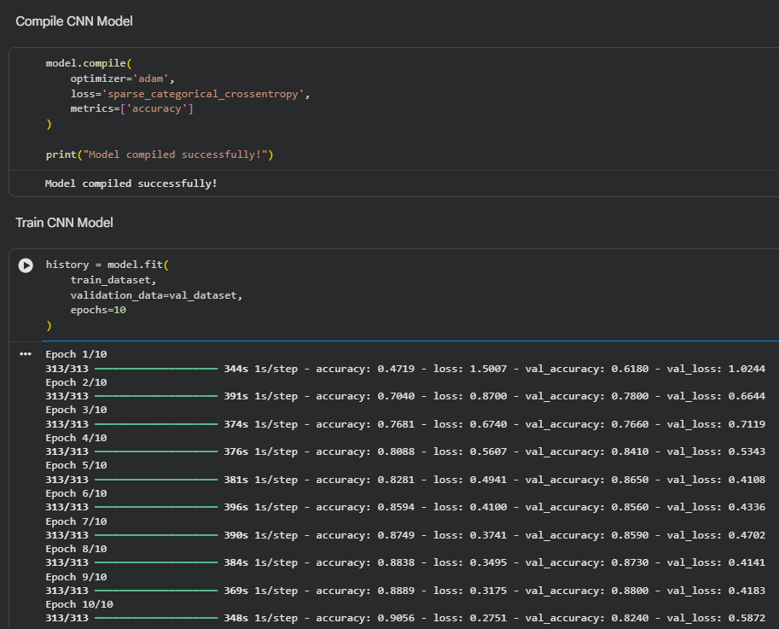

Conclusion :-
The Convolutional Neural Network (CNN) was successfully designed and implemented using TensorFlow/Keras for tomato leaf disease classification. The CNN automatically extracted important features from the images using convolution and pooling layers and classified the tomato leaves into different disease classes. The model performance was evaluated using accuracy, loss, and confusion matrix, and the results showed that CNN can be effectively used for tomato disease image classification.

