BRACT’s
Vishwakarma Institute of Technology, Pune
Practical Implementation Sheet
Department :- CSE-AI Semester :- 5 Academic Year :- 2026-27
Division :- C Batch :- 2 Practical No :- 4
Roll no :- 32 PRN No :- 12413106 Name of Student :- Nikita Katewar
Subject Name :- Deep Learning

Problem Statement :- Develop an LSTM-based model for time-series forecasting using stock price, weather, or sales datasets.

Theory:-

What is Time-Series Forecasting?

Time-series forecasting is the process of predicting future values using previously observed values arranged in a time sequence.

What is LSTM?
LSTM (Long Short-Term Memory) is a type of Recurrent Neural Network (RNN) designed to process sequential data and learn dependencies over time.

Algorithm :-
Step 1: Import the required Python libraries such as NumPy, Pandas, Matplotlib, TensorFlow/Keras and Scikit-learn.
Step 2: Load the stock price dataset.
Step 3: Select the Close price for forecasting.
Step 4: Visualize the stock closing prices.
Step 5: Normalize the data using Min-Max Scaling.
Step 6: Create sequences using the previous 60 days.
Step 7: Split the data into training and testing sets.
Step 8: Reshape the input data according to the required LSTM input format.
Step 9: Create an LSTM model with two LSTM layers and a Dense output layer.
Step 10: Compile the model using the Adam optimizer and an appropriate loss function such as Mean Squared Error.
Step 11: Train the model for 20 epochs.
Step 12: Predict stock prices using the test data.
Step 13: Calculate MAE and RMSE.

Step 14: Plot and compare the actual and predicted values.

窗体顶端
Code :-
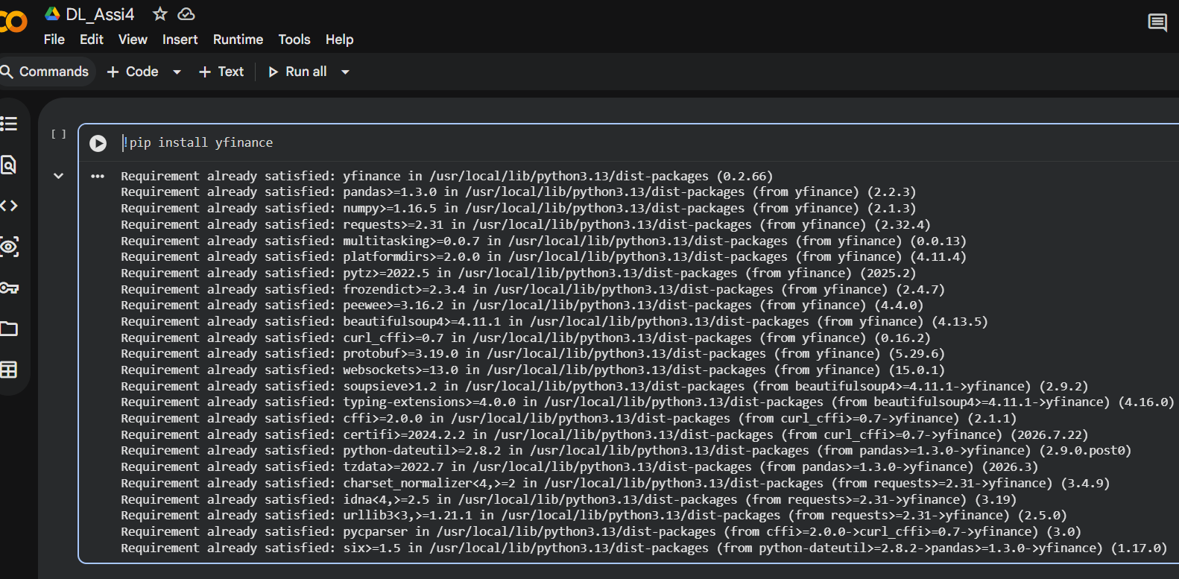
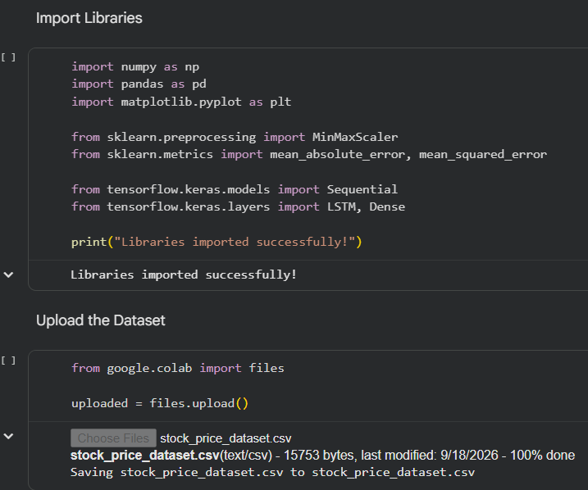
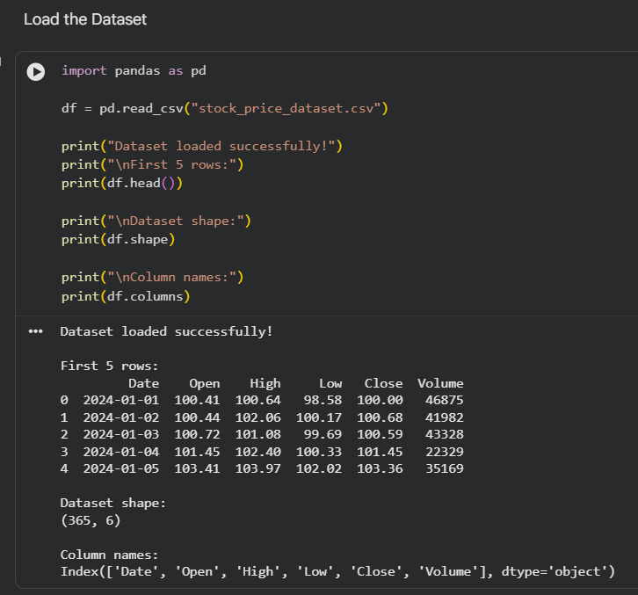
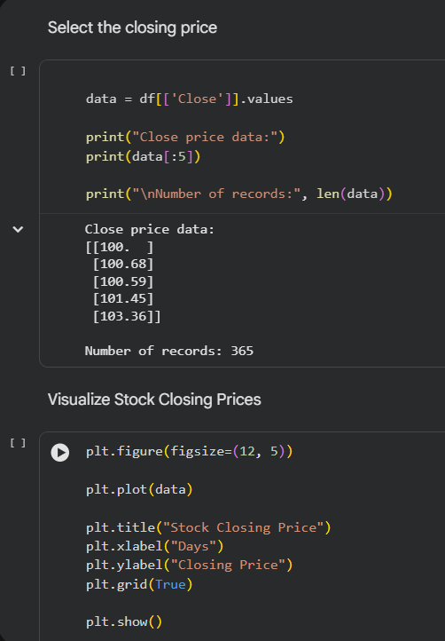
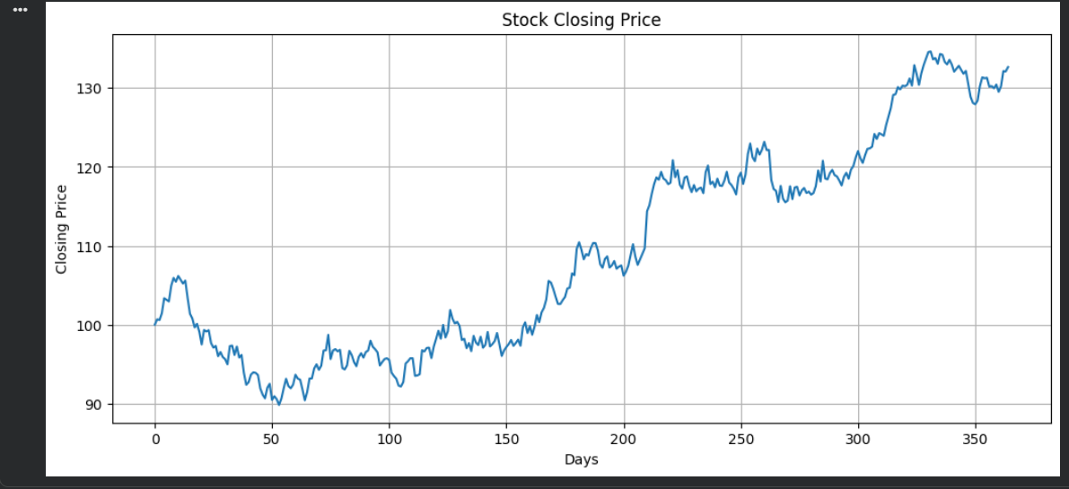
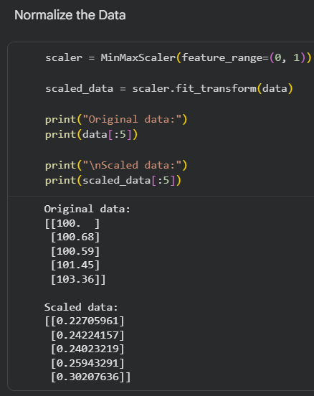
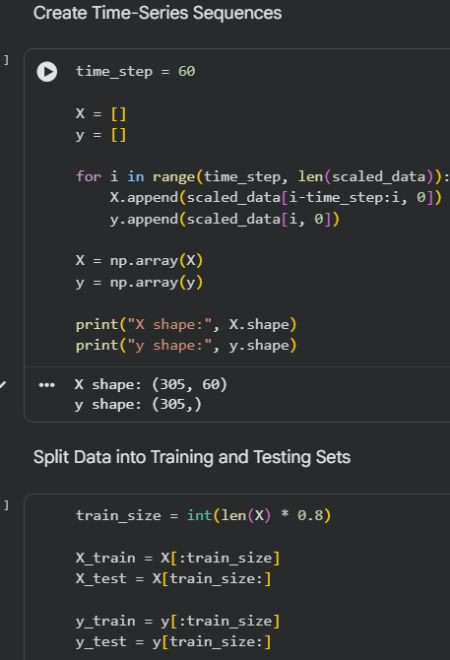
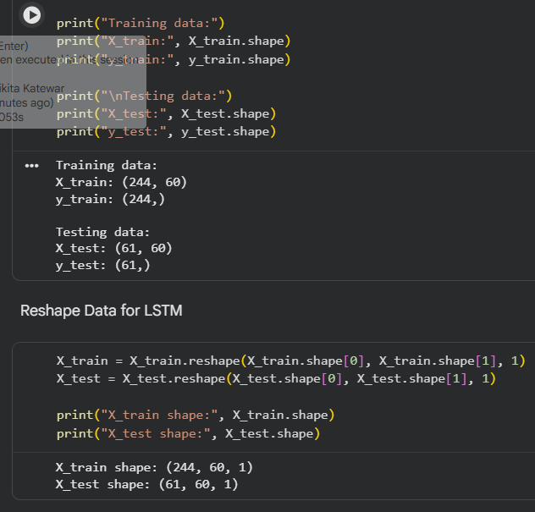
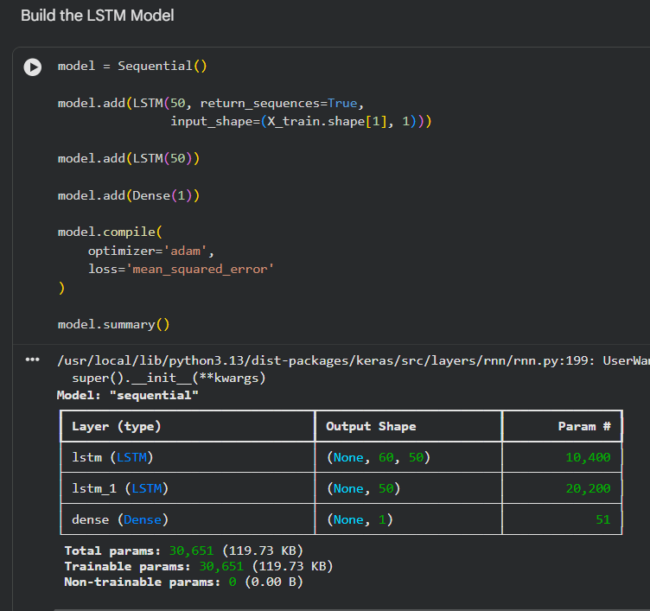
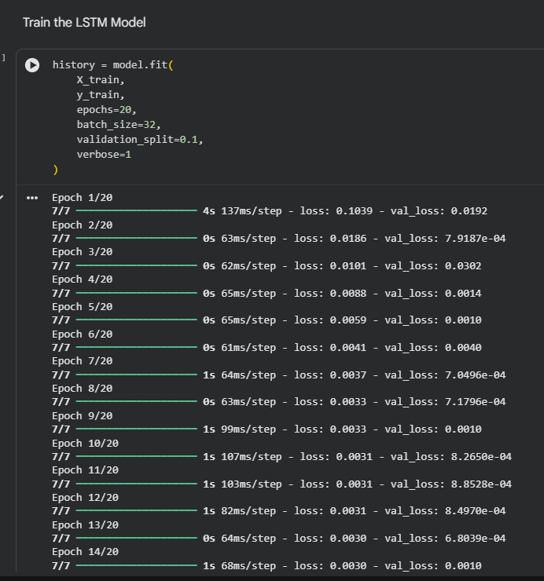
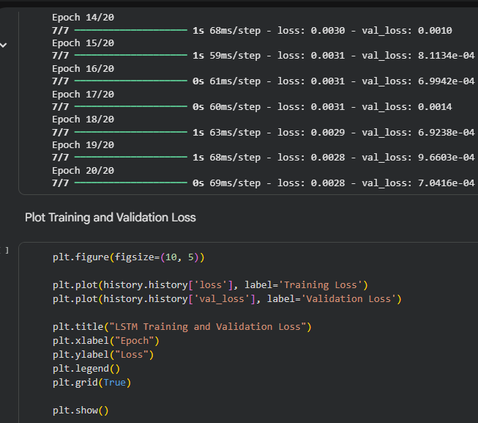
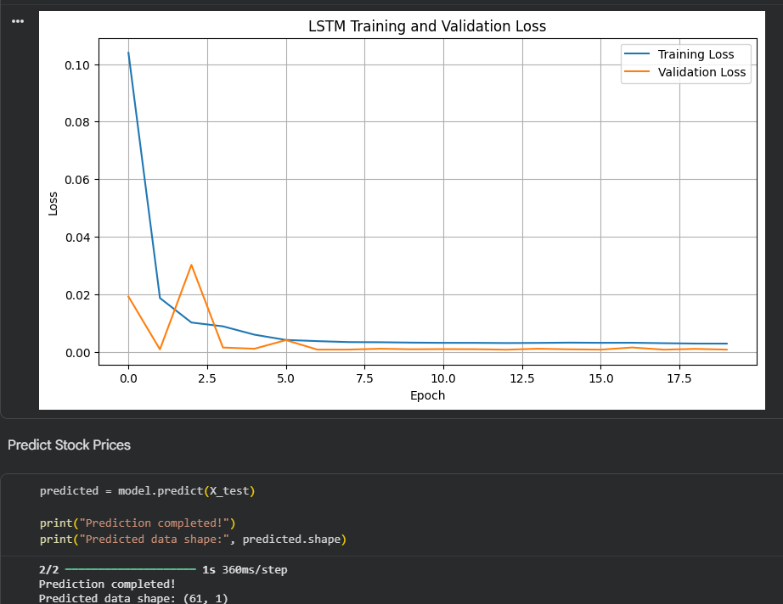
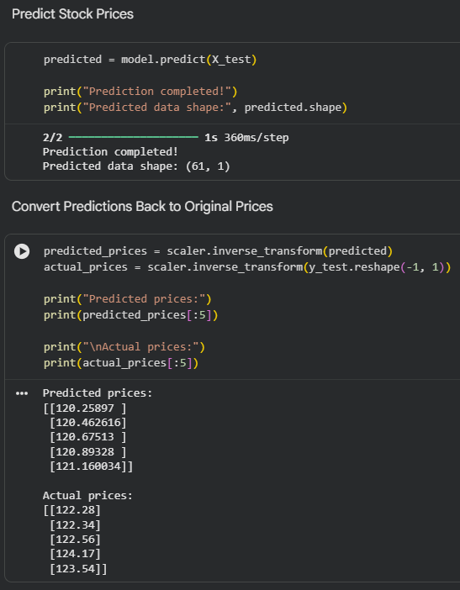
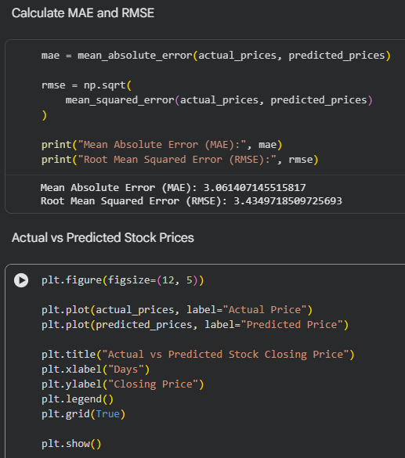
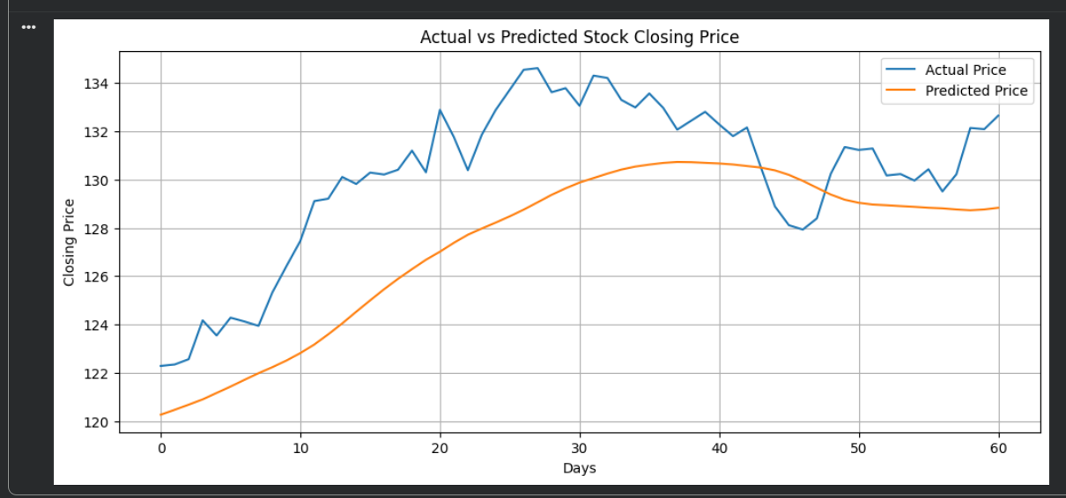

Output :- The LSTM-based model was successfully implemented for stock price time-series forecasting. The model learned temporal patterns from historical stock-price data and generated predictions for the test data. The actual and predicted stock prices were visualized using a graph.

