BRACT’s
Vishwakarma Institute of Technology, Pune
Practical Implementation Sheet
Department :- CSE-AI Semester :- 5 Academic Year :- 2026-27
Division :- C Batch :- 2 Practical No :- 5
Roll no :- 32 PRN No :- 12413106 Name of Student :- Nikita katewar
Subject Name : Deep Learning

Problem Statement :- Implement and compare RNN, LSTM, and GRU models for sequence classification, and analyze their performance using appropriate evaluation metrics.
Theory :-

1. Recurrent Neural Network (RNN)
A Recurrent Neural Network (RNN) is a type of neural network designed to process sequential data, where the order of the input is important.

2. Long Short-Term Memory (LSTM)
LSTM is an improved form of RNN designed to handle long-term dependencies in sequential data.
LSTM is commonly used for:
- Sentiment analysis
- Text classification
- Speech recognition
- Time-series prediction
- Language modeling

3. Gated Recurrent Unit (GRU)
GRU is another improved version of RNN that is designed to capture long-term dependencies.

Algorithm :

Algorithm
Step 1: Start.
Step 2: Load the sequence classification dataset.
Step 3: Preprocess the dataset and convert the sequences into numerical form.
Step 4: Divide the dataset into training and testing data.
Step 5: Create the RNN model with an RNN layer and output layer.
Step 6: Create the LSTM model with an LSTM layer and output layer.
Step 7: Create the GRU model with a GRU layer and output layer.
Step 8: Compile all three models using an optimizer, loss function and evaluation metric.
Step 9: Train the RNN, LSTM and GRU models using the training data.
Step 10: Use the trained models to predict the classes of the test data.
Step 11: Calculate accuracy, precision, recall and F1-score for each model.
Step 12: Generate the confusion matrix for each model.
Step 13: Compare the performance of RNN, LSTM and GRU using the obtained metrics.
Step 14: Display the comparison results in a table.
Step 15: Analyze the performance of the three models.

Code :
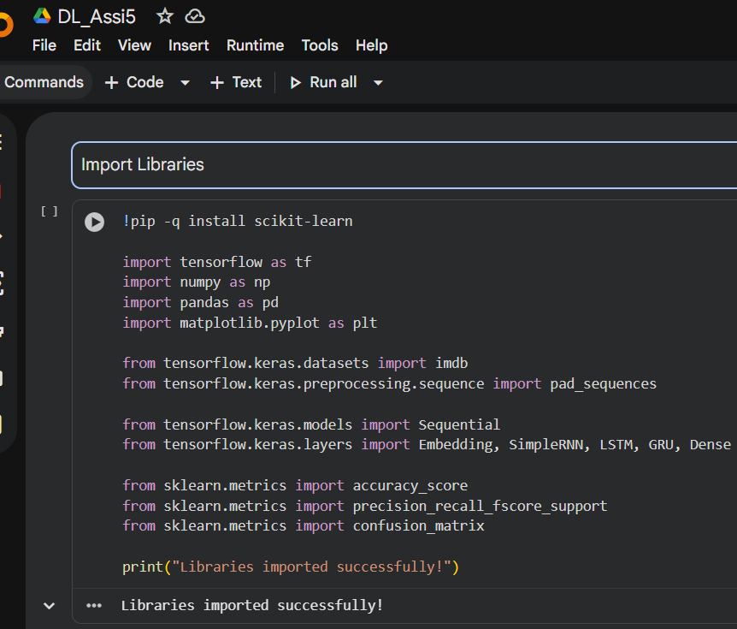
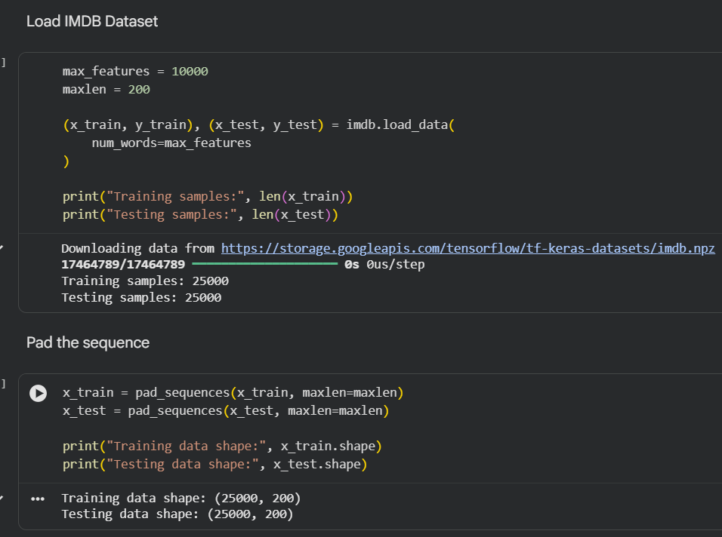
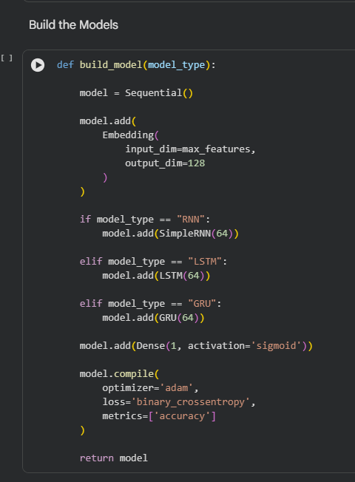
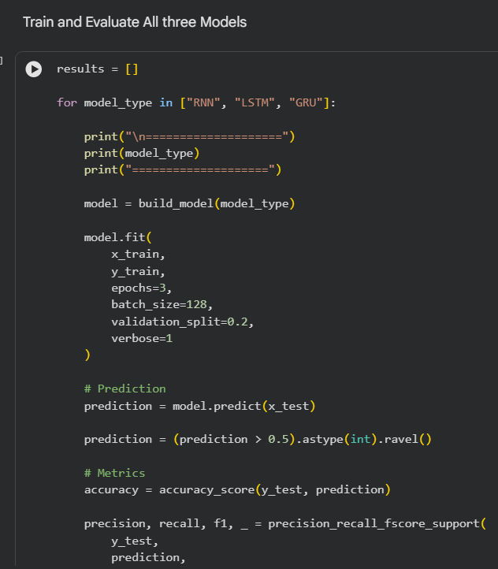
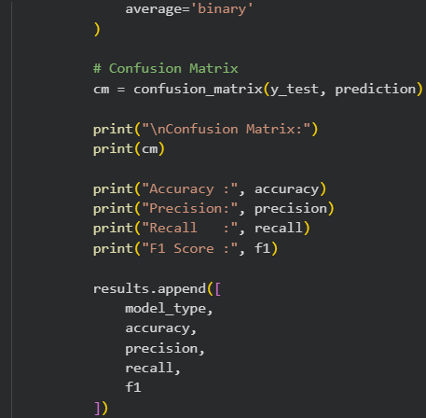
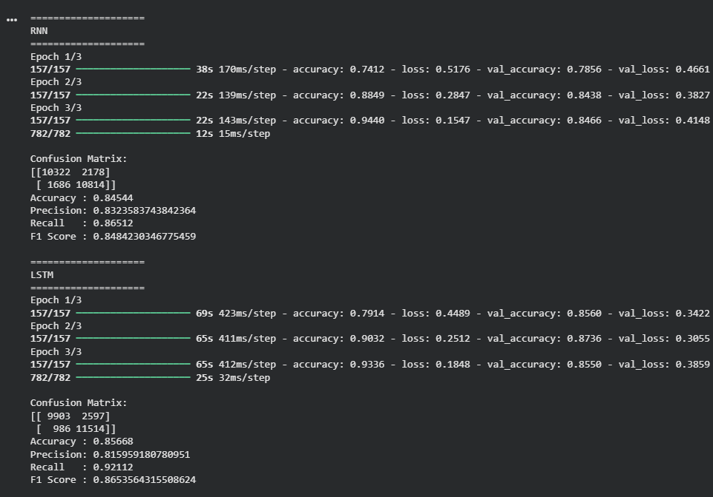
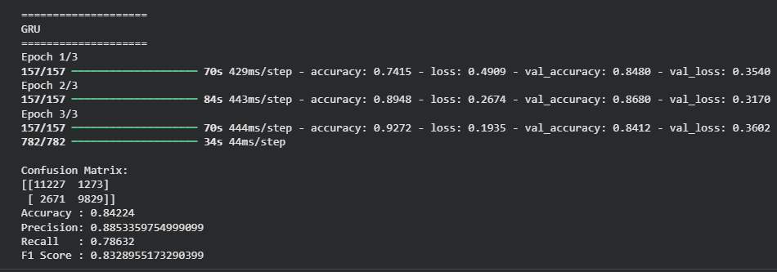
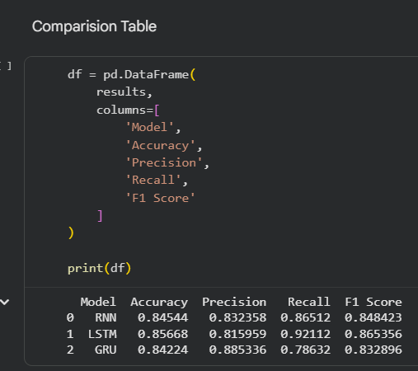
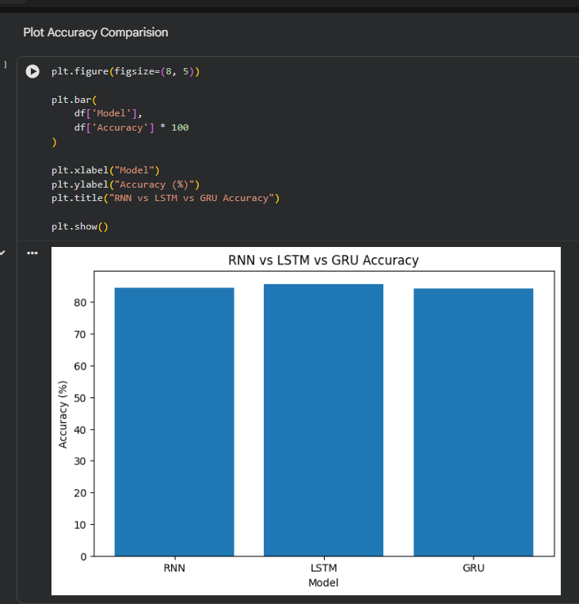
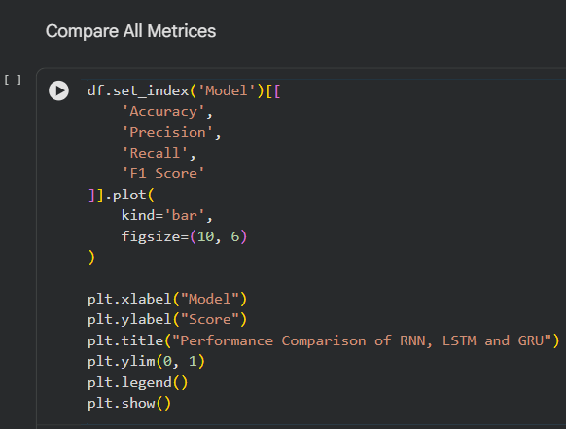
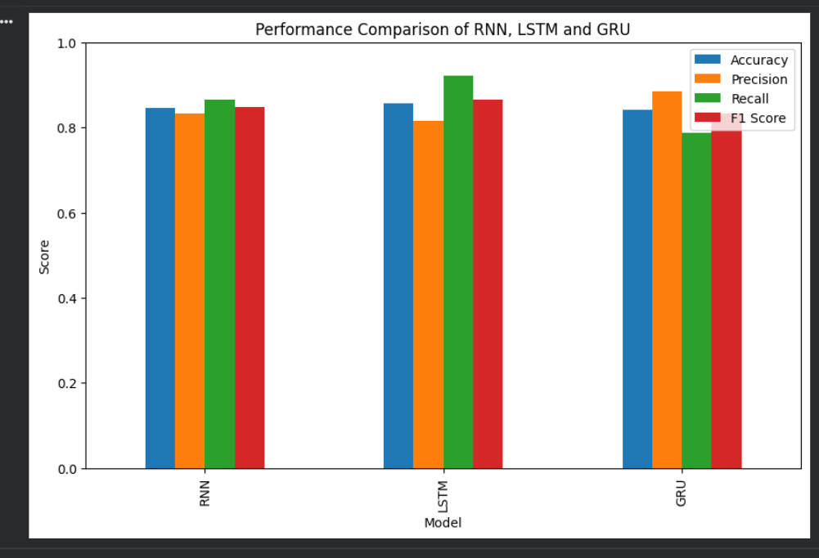
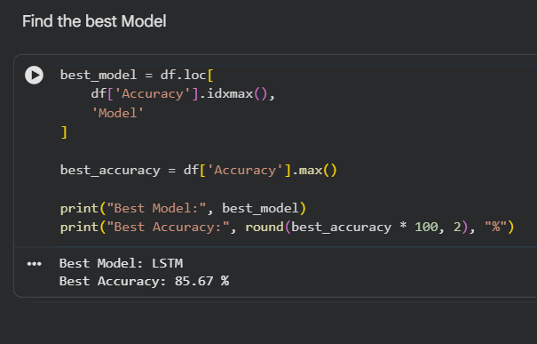

Conclusion :- RNN, LSTM, and GRU models were successfully implemented for sequence classification. The models were evaluated and compared using accuracy, precision, recall, F1-score, and confusion matrix. RNN provides a simple approach for sequence processing, while LSTM and GRU are designed to handle long-term dependencies more effectively. The comparison demonstrates the differences in classification performance and computational complexity among the three recurrent architectures.

