BRACT’s
Vishwakarma Institute of Technology, Pune
Practical Implementation Sheet
Department :- CSE-AI Semester :- 5 Academic Year :- 2026-27
Division :- C Batch :- 2 Practical No :- 8
Roll no :- 32 PRN No :- 12413106 Name of Student :- Nikita Katewar
Subject Name : Deep Learning

Problem Statement :- Implement a pre-trained BERT model for sentiment analysis or text classification on a sample dataset.
Theory :-

BERT
BERT (Bidirectional Encoder Representations from Transformers) is a pre-trained Natural Language Processing (NLP) model developed by Google. It is based on the Transformer architecture and understands the context of words by considering both the left and right sides of a word.
BERT can be used for tasks such as:
- Sentiment analysis
- Text classification
- Question answering
- Named Entity Recognition
- Text similarity
In this practical, a pre-trained bert-base-uncased model is used for binary sentiment classification, where text is classified as:
- 0 → Negative
- 1 → Positive

BERT Tokenizer
The BERT tokenizer converts text into tokens and then into numerical IDs that BERT can understand.

BERT for Sequence Classification
For this practical, BertForSequenceClassification is used. It adds a classification layer on top of BERT to predict whether the given text is positive or negative.

Algorithm :-
Step 1: Install the required libraries such as Transformers and Datasets.
Step 2: Import Python libraries including NumPy, Pandas, PyTorch, Scikit-learn, and Transformers.
Step 3: Create a sample sentiment dataset containing text and corresponding labels.
Step 4: Divide the dataset into training and testing sets using an 80:20 split.
Step 5: Load the pre-trained bert-base-uncased tokenizer.
Step 6: Tokenize the training and testing text using the BERT tokenizer.
Step 7: Create a dataset class containing tokenized inputs and their corresponding labels.
Step 8: Load the pre-trained BERT model for sequence classification with two output classes.
Step 9: Define the training parameters, including:
- Number of epochs = 3
- Training batch size = 4
- Testing batch size = 4
Step 10: Create a BERT Trainer using the training and testing datasets.
Step 11: Train the BERT model for 3 epochs.
Step 12: Evaluate the trained model on the test dataset.
Step 13: Generate predictions for the test samples.
Step 14: Calculate the classification accuracy.
Step 15: Generate the classification report containing precision, recall, and F1-score.
Step 16: Generate the confusion matrix.
Step 17: Test the trained BERT model using a new sentence and display its predicted sentiment.
Code :
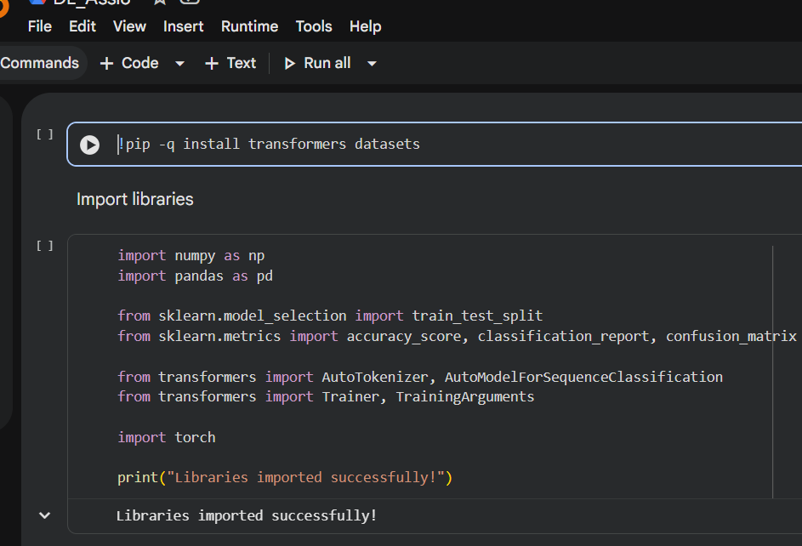
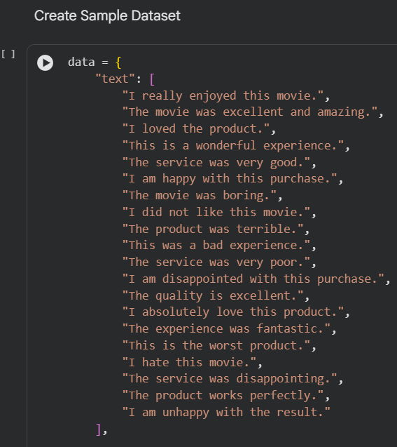
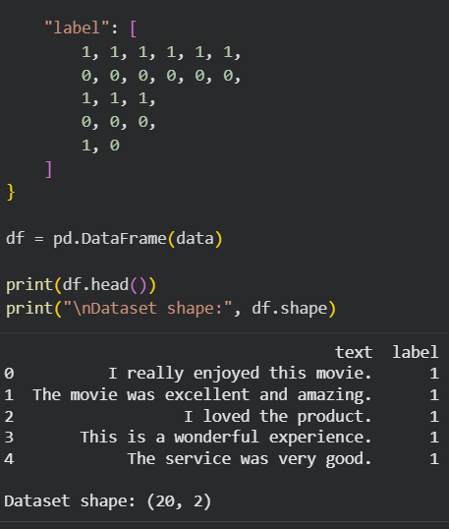
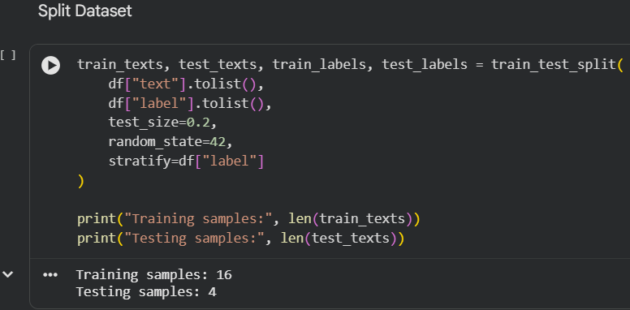
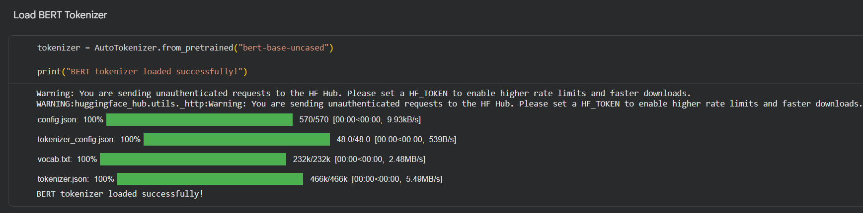
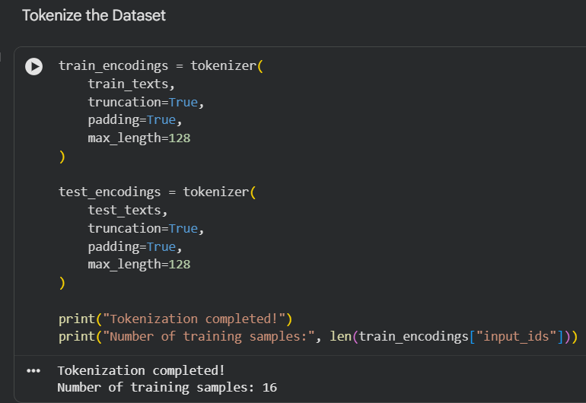
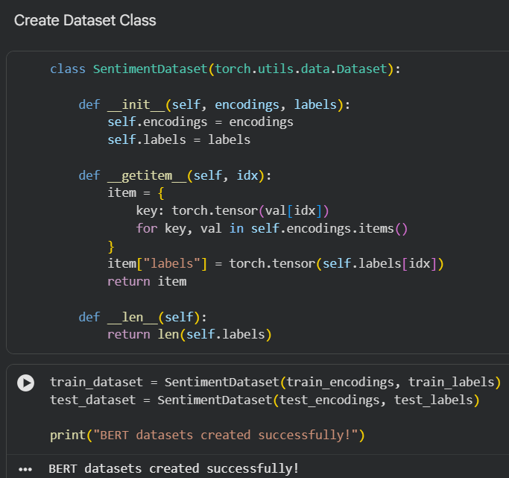
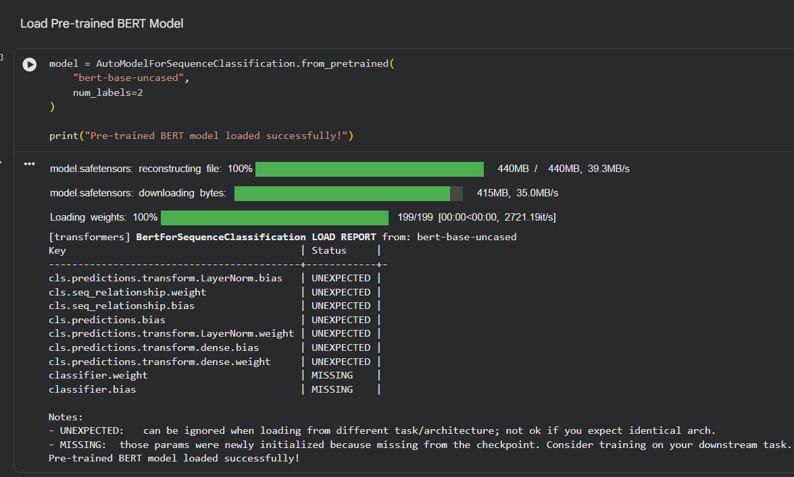
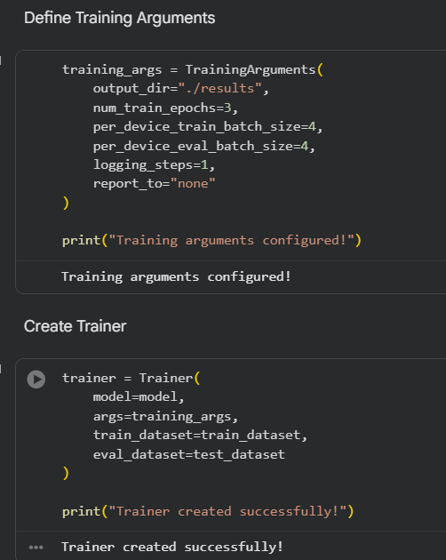
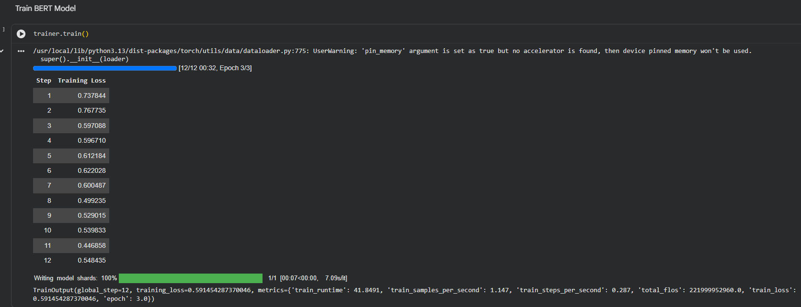
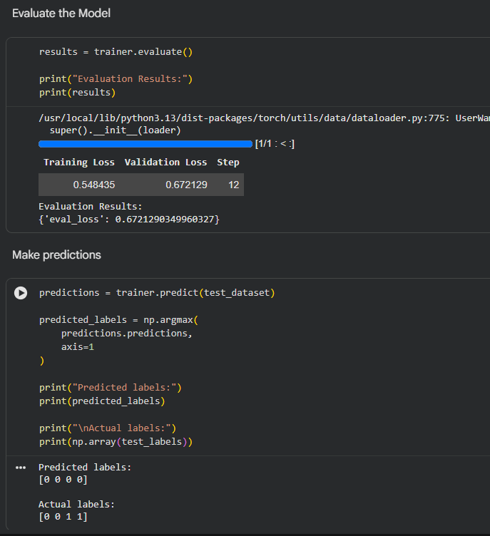
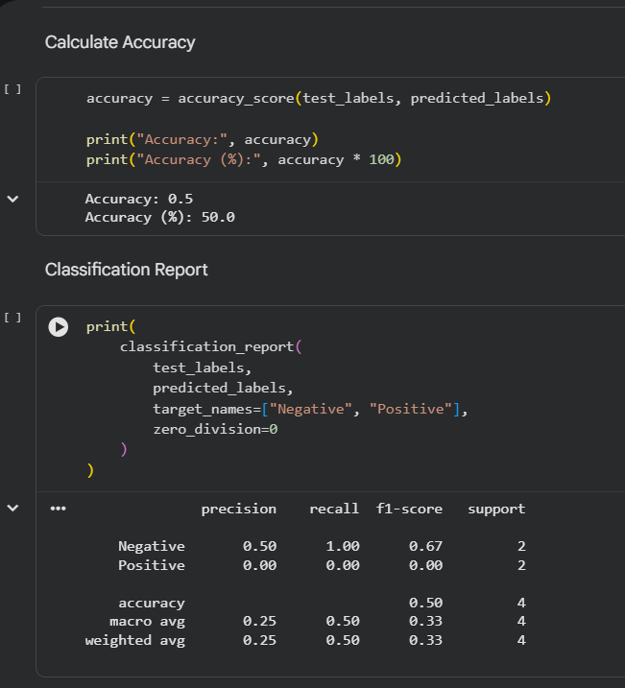
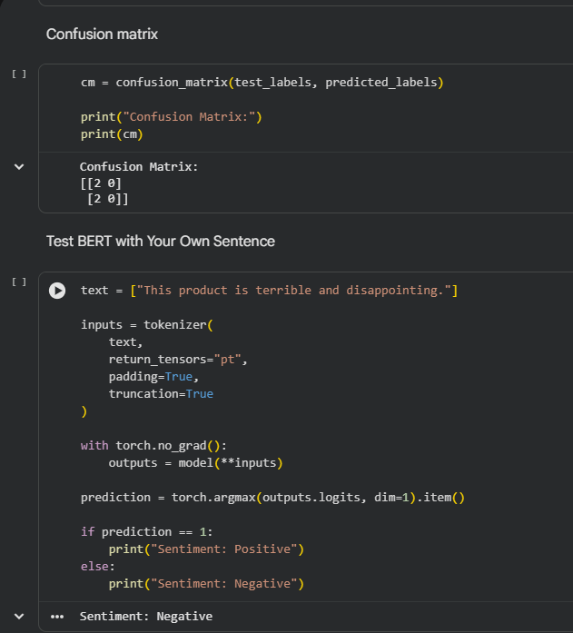

Conclusion :- The pre-trained BERT (bert-base-uncased) model was successfully implemented for sentiment analysis. The text data was tokenized using the BERT tokenizer and classified into positive and negative sentiments. The model achieved 50% accuracy on the small sample test dataset and successfully predicted the sentiment of a new sentence as Negative.

