OPEN-SOURCE INTELLIGENCE CASE REPORT
OSINT Case — Kimura & Co.
Japanese Competitive Landscape of Thin-Section Ball Bearings
超薄型ボールベアリング · 薄肉／超薄肉形玉軸受
Subject Reconstructing the thin-section ball-bearing competitive segment around Kimura & Co. (Kaydon distributor, Japan)
Scope Five Japanese manufacturers with documented thin-section product overlap
Evidence basis Public technical and product sources; no procurement-event evidence
Method Public technical and product sources; terminology-driven identification

All findings, figures, dates and measurements in this report are drawn from the case record as supplied. No external sources were consulted.

1. Research Question

1.1 Research question
Which Japanese manufacturers can be considered real technical competitors to Kimura & Co. in the thin-section ball-bearing segment, and how do their products and manufacturing approaches differ from the Kaydon products distributed by Kimura & Co.?
The objective was not to profile Kimura & Co. as a company, but to reconstruct a narrow competitive segment through the chain:
Company → specific product → Japanese terminology → manufacturers → technical specifications → applications → differentiation
This distinction is important because Kimura & Co. is primarily a specialized engineering trading company, rather than the manufacturer of the bearing examined in this case. Kimura & Co. states that it has historically introduced overseas bearing technologies to Japanese customers and currently distributes Kaydon's thin-section bearings in Japan. Промо Монолит
The relevant product is Kaydon's Reali-Slim® thin-section ball bearing family, together with related Ultra-Slim products.

1.2 The narrowed competitive question
Which Japanese manufacturers produce technically substitutable thin-section bearings rather than merely conventional bearings?
This excludes the very large number of Japanese companies that manufacture ordinary deep-groove or angular-contact bearings but have no demonstrated thin-section product overlap.

2. Target Technology

2.1 What Kimura & Co. actually sells
Kimura & Co.'s Japanese product page identifies Kaydon as its supplier of 超薄型ボールベアリング ("ultra-thin ball bearings"). The company lists Reali-Slim®, Ultra-Slim® and large-diameter turntable bearings. Applications include semiconductor manufacturing equipment, medical equipment, optical equipment, machine tools, wind turbines, aerospace and space equipment, and general industrial machinery. 株式会社木村洋行コーポレートサイト
The technically important feature is not simply that the bearing is "thin".
Kaydon Reali-Slim is based on a constant cross-section architecture: the bearing cross-section remains constant as bore diameter increases, unlike conventional bearing series where the cross-section increases with bore diameter. This allows designers to use a common bearing family across different shaft diameters while maintaining a relatively small radial envelope. Kaydon Bearings
Kaydon offers three principal configurations:
Configuration | Designation | Load envelope as stated in the source
Radial / deep-groove | Type C | Suited to general radial-load applications
Angular contact | Type A | Suited to applications requiring axial-load capability and controlled contact geometry
Four-point contact | Type X | Accommodates radial, axial and moment loads within a single bearing

Table 1. Kaydon product configurations and load envelope as stated in the source
The Type-X architecture is particularly significant because a single bearing can accommodate radial, axial and moment loads that might otherwise require a pair or combination of bearings. 株式会社木村洋行コーポレートサイト
Kaydon's documented range is unusually broad. Reali-Slim products extend from approximately 19 mm to 1,016 mm bore, depending on series, while standard cross-sections range from approximately 4.76 mm to 25.4 mm. Ultra-Slim products go still further in reducing cross-section. Kaydon Bearings
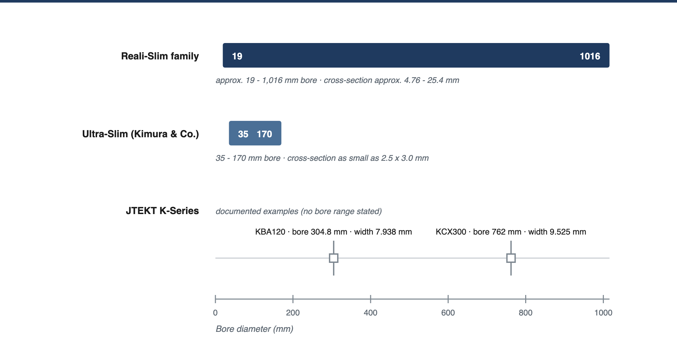
Figure 1. Documented dimensional envelope — bore ranges and the two documented JTEKT examples
Kimura & Co. specifically advertises the Ultra-Slim product as having a cross-section as small as 2.5 × 3.0 mm, with 35–170 mm bore sizes and C/A/X configurations. Промо Монолит

2.2 Core technical value proposition
The product therefore competes on several parameters simultaneously:
- radial space reduction
- weight reduction
- low rotational torque
- running accuracy
- ability to handle combined loads
- large-bore/small-cross-section architecture
- customization for difficult environments
- vacuum, semiconductor and aerospace compatibility
This is a considerably narrower technological segment than the general "ball bearing" market.

3. Japanese Terminology Discovery
One of the most important findings from the Japanese-language search was that the terminology used by Japanese manufacturers is not identical to Kimura & Co.'s commercial terminology.

Kimura & Co. uses:
超薄型ボールベアリング

Japanese manufacturers frequently use:
薄肉ベアリング 薄肉形玉軸受 超薄肉ベアリング 超薄肉形玉軸受
The terms literally describe "thin-wall/thin-section bearings" rather than simply "ultra-thin ball bearings."

3.1 This distinction materially changes search results
For example, JTEKT uses Kシリーズ超薄肉形玉軸受 ("K-Series ultra-thin ball bearings"), while NSK uses Nシリーズ薄肉ベアリング. NTN uses 超薄肉形玉軸受 in its product taxonomy. Koyo
Another important terminology clue is the concept of a constant cross-section.
Kaydon describes the technology in English as:
"single cross section which remains constant as the bore diameter is increased"
Japanese manufacturers tend to communicate the same design principle through terms such as 断面寸法 (cross-sectional dimension) and 寸法系列 (dimensional series), rather than necessarily using "constant-section bearing" as the primary commercial keyword. JTEKT's K-series documentation, for example, explicitly states that bearings within the same series maintain the same cross-sectional dimensions regardless of bore diameter. Koyo
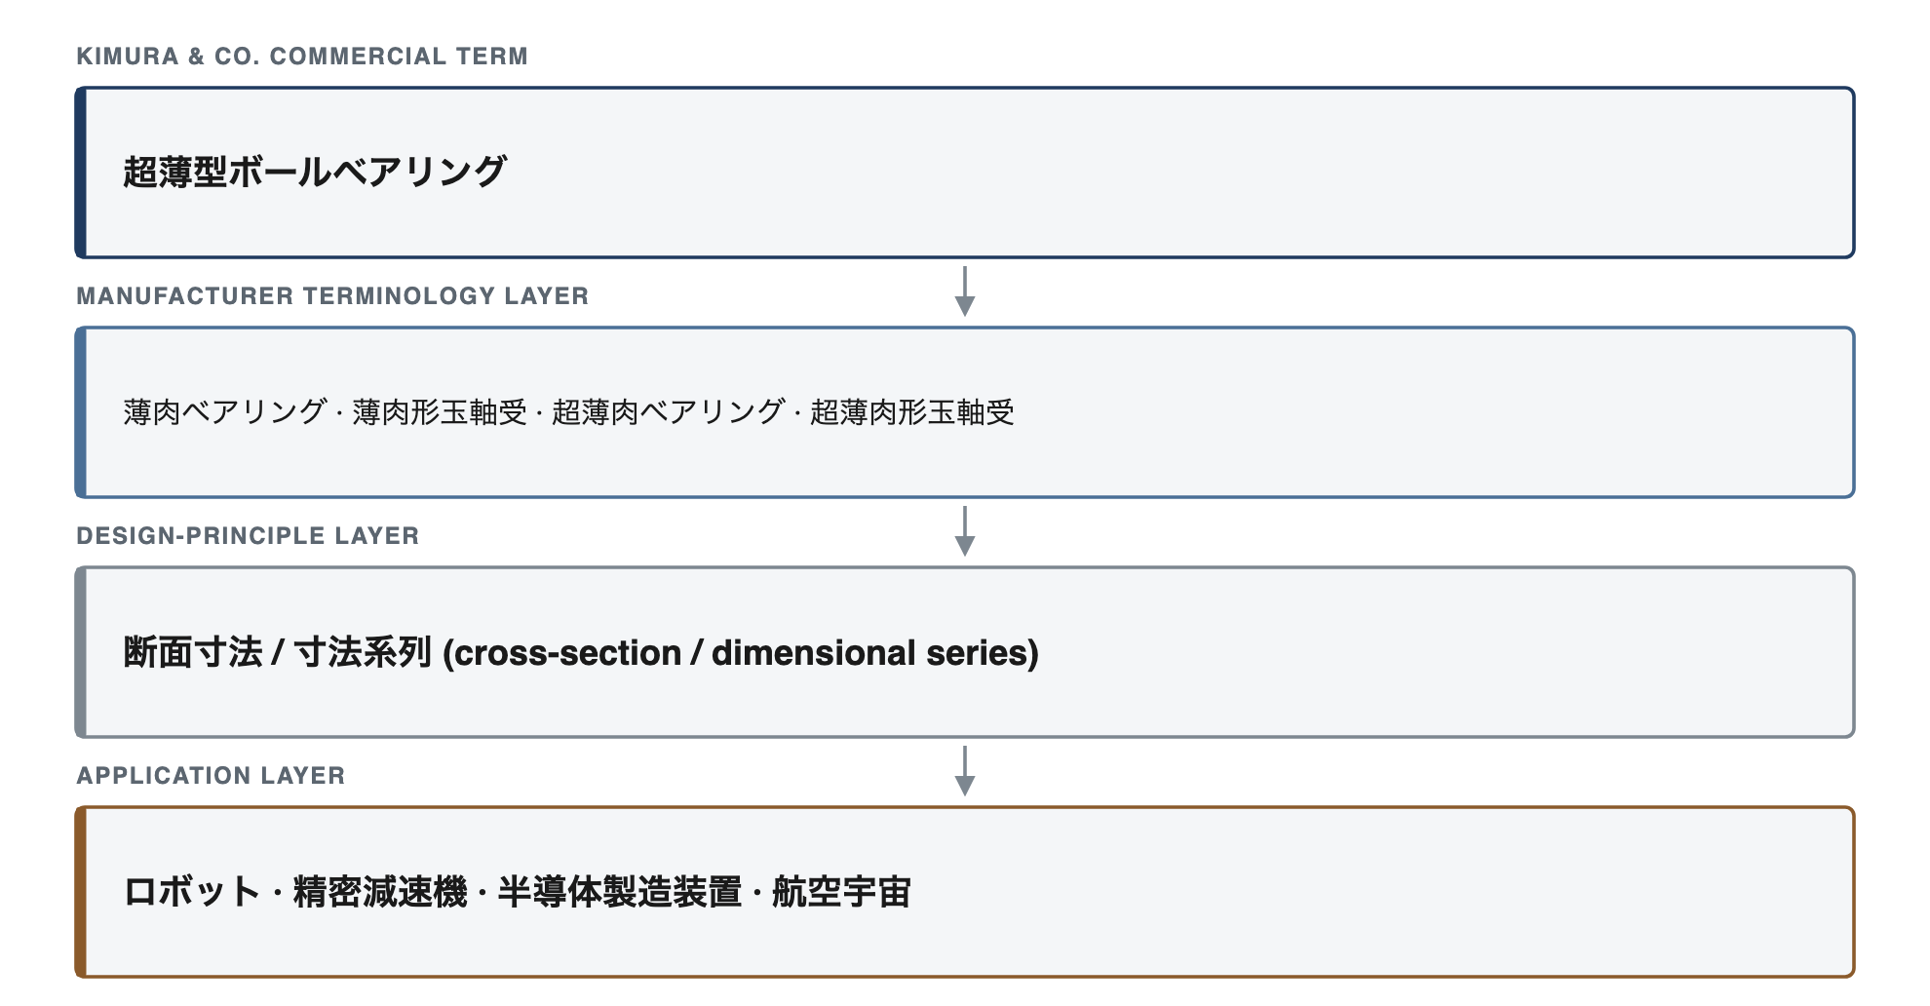
Figure 2. Terminology-derived OSINT search path
This Japanese terminology exposed manufacturers that are not immediately visible through English-language searches.

4. Competitor Identification
The investigation identified five Japanese manufacturers with documented product overlap.
They should not all be interpreted as identical competitors. The strongest competitors are those whose products overlap not only in "thinness" but also in constant-section geometry, contact configuration, diameter range and target applications.
Company | Relevant product | Technical overlap | Main application evidence
JTEKT Precision Bearing | K-Series ultra-thin bearings | Very high | Robotics, semiconductor, vacuum
NTN Corporation | Ultra-thin ball bearings | Very high | Robotics, aerospace, industrial equipment
NACHI Bearing Manufacturing | Ultra-thin bearings | High | Industrial machinery, aerospace-related production
Kitanihon Seiki | EZO ultra-thin bearings | Medium-high | Robotics, medical, optical, semiconductor
Maekawa MFG. | Thin angular-contact bearings | High in large precision applications | Robot precision reducers, industrial machinery

Table 2. Competitor identification — documented product overlap of the five identified Japanese manufacturers
The important finding is that Japanese competition is not a single homogeneous market. Different manufacturers attack different portions of Kaydon's value proposition.

5. Competitor Analysis

5.1 JTEKT Precision Bearing — K-Series
JTEKT Precision Bearing is one of the clearest technical competitors.

Its K-Series is explicitly called:
Kシリーズ超薄肉形玉軸受
The product architecture is particularly revealing because it is extremely close to the Kaydon concept.
JTEKT divides the K-Series into dimensional series in which the cross-section remains constant while bore diameter changes. It offers:
- deep-groove configuration C
- angular-contact configuration A
- four-point-contact configuration X
The documented series include cross-sections from 4.762 mm through 25.4 mm, with bore sizes extending into the very large-diameter range. For example, JTEKT lists KBA120 with a 304.8 mm bore and 7.938 mm width, and KCX300 with a 762 mm bore and 9.525 mm width. Koyo
This is important because it demonstrates that JTEKT is not merely selling conventional 68/69-series bearings with reduced dimensions. It has a true thin-section product architecture overlapping Kaydon's constant-section design philosophy.
JTEKT additionally states that its manufacturing technology for ultra-thin bearings combines control of heat-treatment distortion with high-precision grinding, producing bearings with thickness below 1 mm in another ultra-thin development line. JTEKT Precision
For semiconductor applications, JTEKT offers special K-Series configurations using stainless-steel and ceramic balls for clean/vacuum environments, including wafer-transfer robots and semiconductor manufacturing equipment. Koyo

Competitive position
JTEKT's differentiation is therefore:
constant-section architecture + extremely broad diameter range + three contact geometries + specialized clean/vacuum variants + advanced manufacturing control.
This is probably the closest Japanese technical analogue to Kaydon's standard Reali-Slim concept.

5.2 NTN — Ultra-Thin Ball Bearings
NTN is another direct technical competitor.
The company's Japanese catalogue explicitly identifies:
超薄肉形玉軸受
and describes the product as an "extreme thin-wall design."

The NTN architecture includes:
- radial type
- four-point-contact type
- angular-contact type
- sealed variants
The company provides dedicated dimensional series and cross-sectional specifications rather than simply marketing conventional bearings as "thin." NTN
NTN explicitly lists ultra-thin bearings within its robotics product portfolio, alongside four-point-contact bearings, precision bearings and special-environment bearings. NTN
It also places ultra-thin bearings in its aerospace portfolio. NTN
This matters because the application overlap with Kaydon is substantial:
Kaydon: robotics + aerospace + semiconductor + optical + machine tools
NTN: robotics + aerospace + special environments + precision machinery
The differentiation therefore does not primarily come from the basic concept of thinness. It is more likely to arise from:
- internal bearing geometry,
- load capacity,
- sealing,
- precision class,
- application-specific variants,
- manufacturing economics,
- supply relationships with Japanese OEMs.
The available public sources do not establish a specific performance advantage of NTN over Kaydon across all these parameters, so a portfolio analysis should not claim one.

5.3 NACHI Bearing Manufacturing / NACHI
A less obvious but strategically interesting competitor is NACHI Bearing Manufacturing, part of the NACHI group.
The company began mass production of thin-section bearings in the 1980s. Its corporate history explicitly records the construction of a fourth factory in 1984 for mass production of 薄肉軸受, demonstrating that thin-section bearings are not a recent diversification but a long-established production capability. Nachi Fujikoshi
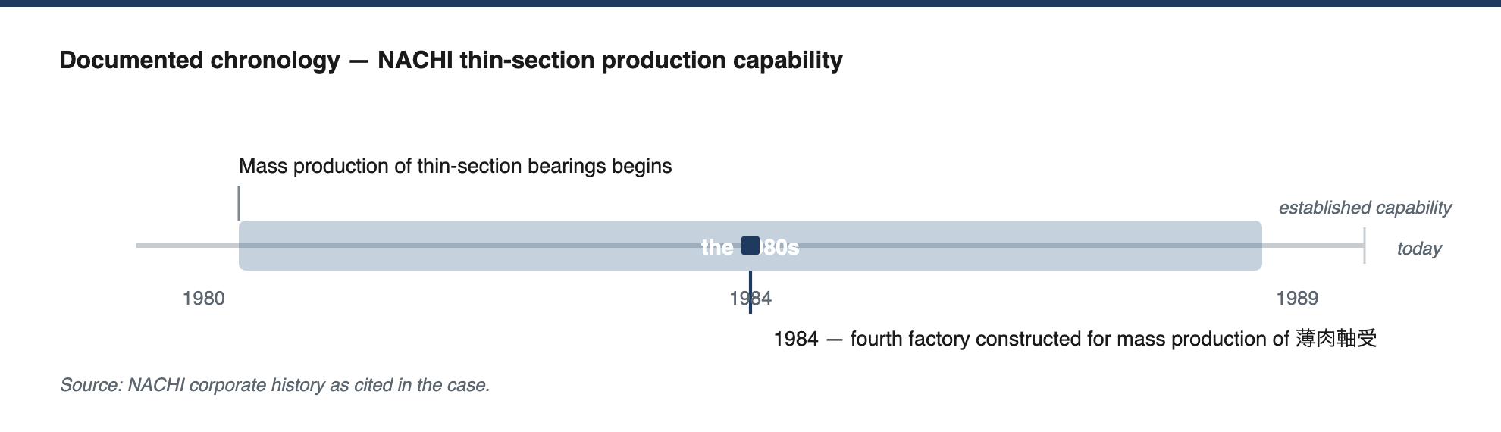
Figure 3. Documented chronology of thin-section production capability
The company currently describes its production scope as including:
- medium and large ball bearings
- angular-contact bearings
- ultra-thin bearings
- precision grinding
- assembly
- inspection
Its manufacturing process is based on micron-level grinding and controlled inspection. Nachi Fujikoshi
NACHI's broader corporate disclosures are also useful. The group identifies thin-section bearings and multi-point-contact ball bearings as products for industrial machinery where equipment miniaturization and weight reduction are important. EDINET DB

Competitive differentiation
NACHI appears less differentiated through the extremely specialized "thin-section bearing as a standalone product identity" that characterizes Kaydon.
Instead, its competitive advantage is more closely connected to:
bearing manufacturing depth + precision grinding + industrial-machine integration + aerospace/industrial applications + established Japanese production infrastructure.
This makes NACHI particularly relevant when the customer is an industrial OEM that wants the bearing integrated into a broader Japanese machinery supply chain.

5.4 Kitanihon Seiki — EZO
Kitanihon Seiki is particularly valuable for this case because it is much less obvious than the major bearing groups.

The company specializes in:
- miniature bearings
- small-diameter bearings
- flange bearings
- ultra-thin bearings
- large stainless-steel bearings

under the EZO brand. 北日本精機株式会社
Its ultra-thin bearing line is technically interesting because it uses many small-diameter balls to achieve low friction torque while retaining rigidity and rotational accuracy. Kitanihon explicitly identifies robot, medical-equipment, office-equipment, optical/imaging and measurement applications. 北日本精機株式会社
The available catalogue data show metric and inch-series products, including 6700/6800/6900-type bearings. 北日本精機株式会社

Its manufacturing differentiation is unusually explicit.
Kitanihon describes its precision-processing capabilities as including:
- high-precision machining,
- ultra-thin bearing manufacturing,
- stainless-steel bearing manufacturing,
- superfinishing of raceways,
- surface roughness processing down to approximately 10 nm scale,
- comprehensive dimensional, accuracy, acoustic, friction, mechanical and fatigue-life testing. 北日本精機株式会社
The company also reports a broad production catalogue exceeding 57,000 bearing variants and exports to more than 30 countries. A regional industry profile identifies ultra-thin bearings as one of its key specialist areas. ほっかいどう受注企業ガイド

Competitive differentiation
Kitanihon therefore occupies a somewhat different niche:

miniaturization + precision + high-volume manufacturing + broad catalogue + small/medium bearing dimensions

rather than Kaydon's strongest differentiator:

large bore + constant cross-section + extreme customization + aerospace/defense-grade thin-section architecture.
This makes EZO a genuine competitor in many Japanese industrial and robotic applications, but not a perfect one-for-one replacement for the entire Kaydon portfolio.

5.5 Maekawa MFG. — MBS
Maekawa MFG. is another unusually relevant specialist.
Its MBS business explicitly manufactures thin angular-contact ball bearings for precision reducers used in:
- industrial robots,
- machine tools,
- precision reduction mechanisms.
The company states that it uses constrained hardening to control heat-treatment distortion in these bearings. MBS

This is an important technical distinction.
A thin-section bearing becomes increasingly difficult to manufacture as ring thickness decreases because heat treatment can distort the raceway and dimensional geometry. Maekawa's explicit focus on controlling this distortion indicates that its differentiation is strongly tied to manufacturing-process engineering rather than simply reducing dimensions.
Maekawa also states that it can manufacture thin angular-contact bearings above 150 mm outside diameter, and its product page gives a maximum production diameter of approximately 300 mm for its angular-contact bearing range. MBS
The company has approximately 50 employees and focuses on high-mix, low-volume, customized bearing production. Its documented customers include industrial machinery companies and SKF, while its own corporate history emphasizes decades of specialized bearing manufacturing. MBS

Competitive differentiation
Maekawa's position is therefore quite different from Kitanihon:

small-lot/custom production + thin angular-contact bearings + precision reducers + manufacturing know-how for heat-treatment distortion.
This makes it particularly relevant to robotics and precision-reducer applications where the customer may need a customized bearing rather than a catalogue-standard product.

6. Competitive Technology Map
The competitor set can therefore be reconstructed as follows:

Dimension | Kaydon / Kimura | JTEKT Precision Bearing | NTN | NACHI | Kitanihon Seiki | Maekawa
Thin-section architecture | Core product | Core product | Core product | Core capability | Core capability | Application-specific
Constant cross-section | Yes | Yes | Strong overlap | Partial / varies | Mainly conventional thin series | Product-dependent
C / radial | Yes | Yes | Yes | Yes / varies | Yes | Yes
A / angular | Yes | Yes | Yes | Yes / varies | Available in portfolio | Strong focus
X / 4-point | Strong | Strong | Yes | Multi-point products | Available | Less central
Very large diameter | Major strength | Major strength | Strong | Strong | More limited | Medium
Miniature / small bearings | Moderate | Moderate | Strong | Strong | Major strength | Moderate
Robotics | Yes | Strong | Strong | Strong | Strong | Strong via reducers
Semiconductor / vacuum | Strong | Strong | Strong | Relevant | Relevant | Less central
Aerospace | Strong | Relevant | Strong | Relevant | Relevant | Limited
Custom engineering | Very strong | Strong | Strong | Strong | Strong | Very strong
Small-lot production | Distributor / custom route | Industrial OEM | Industrial OEM | Industrial OEM | Flexible | Core capability

Table 3. Competitive technology map — source-based capability matrix (not a performance ranking)

The table should not be interpreted as a performance ranking. Public sources provide product claims and specifications, but they do not provide a controlled cross-company test under identical operating conditions.

7. What Is Actually Differentiated in This Niche?
The central finding is that "thin" itself is no longer a sufficient differentiator.
Japanese manufacturers have multiple technically credible thin-section bearing technologies.
The competitive differentiation occurs at several deeper levels.

7.1 Constant-section architecture
This is the most important structural differentiator.
Kaydon's Reali-Slim architecture maintains a constant cross-section as bore diameter changes. JTEKT's K-Series demonstrates an almost directly comparable Japanese architecture. Kaydon Bearings
Therefore:

"Ultra-thin bearing" ≠ necessarily "Kaydon-equivalent bearing."
The more precise comparison is:

constant-section thin-section bearing with equivalent contact geometry, diameter range, load capacity and environmental specification.
That is the actual competitive unit.

7.2 Contact geometry
The three principal architectures create different competitive positions:

Type C / radial
Best suited to general radial-load applications.

Type A / angular contact
Better suited to applications requiring axial-load capability and controlled contact geometry.

Type X / four-point contact
Particularly useful where radial, axial and moment loads need to be accommodated within a single bearing.
Kaydon, JTEKT and NTN all demonstrate overlap in this area. Kaydon Bearings
This means the real engineering decision is not simply:

"Which company's thin bearing?"
but:
"Which contact architecture provides the required load envelope within the available installation envelope?"

7.3 Manufacturing technology
At extreme thinness, manufacturing capability itself becomes part of the product.
JTEKT emphasizes heat-treatment distortion reduction and high-precision grinding. JTEKT Precision
Kitanihon emphasizes precision grinding and nanometer-scale raceway finishing. 北日本精機株式会社
Maekawa specifically emphasizes constrained hardening to control heat-treatment distortion in thin angular-contact bearings. MBS
NACHI emphasizes micron-level grinding and precision inspection. Nachi Fujikoshi
This indicates that thin-section bearing competition is partly a manufacturing-process competition.
Manufacturer | Stated manufacturing emphasis | Source
JTEKT | Heat-treatment distortion reduction combined with high-precision grinding; bearings below 1 mm thickness in a separate ultra-thin development line | JTEKT Precision
Kitanihon Seiki | Precision processing, raceway superfinishing, surface roughness down to approximately 10 nm scale, with dimensional, accuracy, acoustic, friction, mechanical and fatigue-life testing | 北日本精機株式会社
Maekawa MFG. | Constrained hardening to control heat-treatment distortion in thin angular-contact bearings | MBS
NACHI | Micron-level grinding with controlled inspection | Nachi Fujikoshi

Table 4. Manufacturing-process emphasis stated by each manufacturer
The ability to make a ring thinner is only useful if:
- raceway geometry remains controlled;
- heat-treatment distortion remains manageable;
- preload/clearance remains within specification;
- surface finish remains adequate;
- fatigue life remains acceptable;
- vibration/noise remains controlled.

8. Assessment

The investigation supports the following conclusion.

8.1 Finding 1 — Kimura & Co. is positioned around a genuinely specialized technology
Kimura & Co.'s Kaydon offering is not simply another catalogue of standard bearings. The relevant product is a specialized thin-section / ultra-thin bearing architecture with constant-section designs, C/A/X contact configurations, large diameter capability and specialized environmental variants. 株式会社木村洋行コーポレートサイト

8.2 Finding 2 — Japan has genuine technical substitutes
The Japanese market contains multiple manufacturers with documented thin-section capabilities.

The strongest technical overlaps identified are:
- JTEKT Precision Bearing — K-Series
- NTN — 超薄肉形玉軸受
- NACHI — thin/ultra-thin bearing production
- Kitanihon Seiki — EZO ultra-thin bearings
- Maekawa — thin angular-contact bearings for precision reducers
These are not inferred competitors merely because they manufacture bearings. Their products explicitly occupy the same thin-section technology space.

8.3 Finding 3 — JTEKT provides the closest publicly documented Japanese architectural analogue
The K-Series is especially notable because it reproduces the core design principle of constant cross-section across different bore sizes and offers the same fundamental C/A/X configuration family. Its documented size range also overlaps substantially with Kaydon's large-diameter products. Koyo

8.4 Finding 4 — The other competitors differentiate through specialization

The Japanese competitive landscape is segmented:
- Kitanihon Seiki: precision + miniature/small/ultra-thin + high-volume catalogue production
- Maekawa: customized thin angular-contact bearings + precision reducers + small-lot production
- NACHI: industrial/aerospace manufacturing depth + thin-section production
- NTN: broad industrial, robotics and aerospace bearing portfolio
- JTEKT: broad constant-section architecture + robotics + semiconductor/vacuum specialization
Thus, competition is not purely about nominal bearing dimensions.

9. Final OSINT Conclusion
The research demonstrates a useful distinction between product-category competition and technology-level competition.
At the category level, Kimura & Co. competes with a large number of Japanese bearing manufacturers.
At the technology level, the field becomes considerably narrower.

The relevant niche is:
薄肉／超薄肉形玉軸受 — thin-section and ultra-thin ball bearings

and, more specifically:
constant-section precision ball bearings capable of maintaining low radial envelope while supporting radial, axial and/or moment loads.
Within this niche, Japanese manufacturers do not simply copy Kaydon's proposition. They occupy different technical positions.
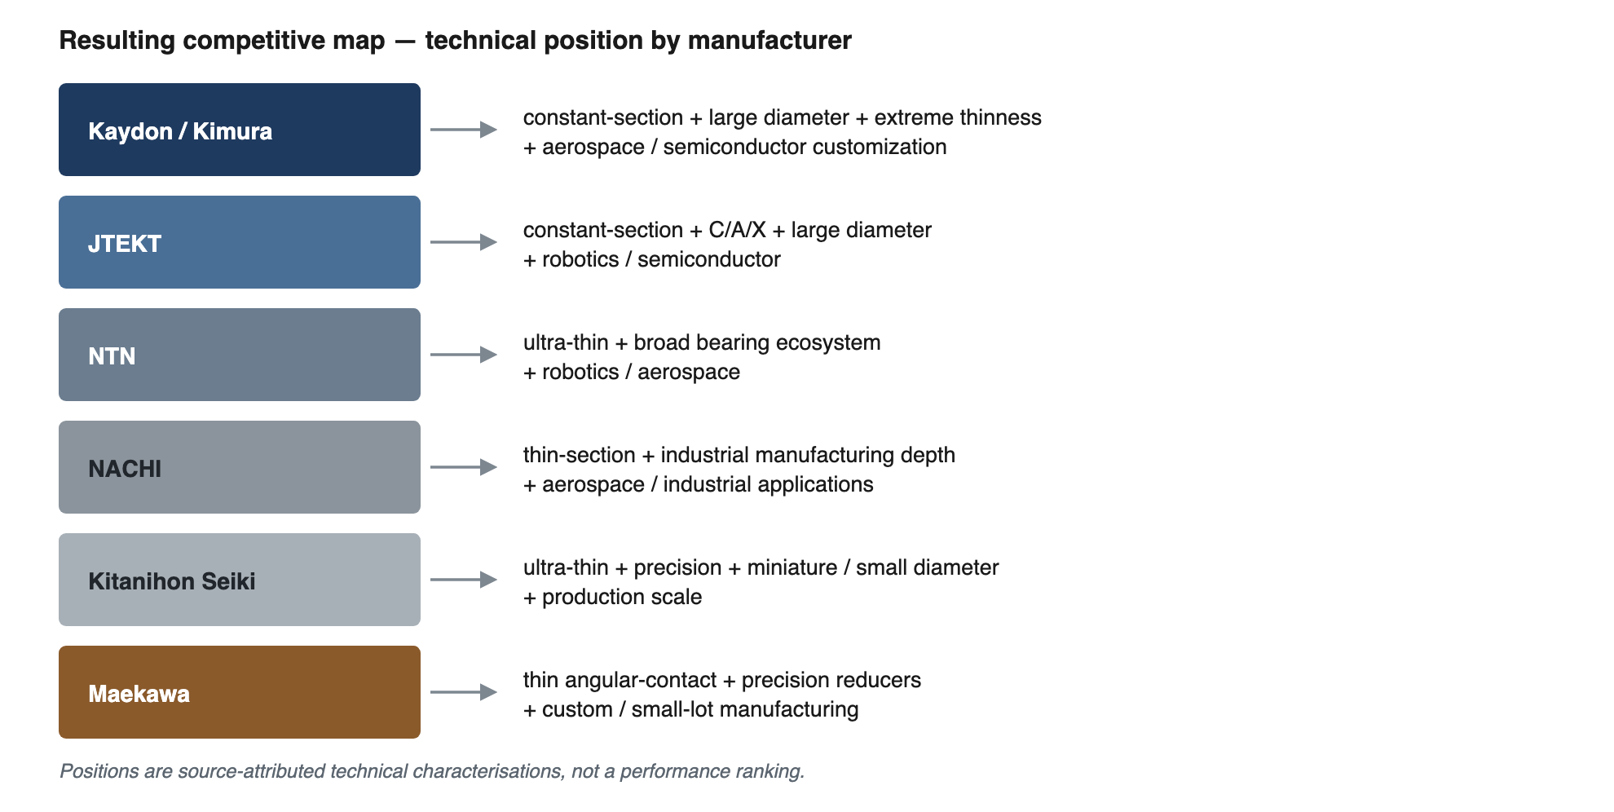
Figure 4. Resulting competitive map — technical position by manufacturer
The key OSINT insight is therefore:
The differentiated technology in this niche is not "making bearings thin." It is maintaining bearing accuracy, load capability, reliability and
manufacturability while reducing the cross-sectional envelope enough to materially change the mechanical architecture of the host machine.
That is why the Japanese terminology and manufacturing-process evidence are more informative than generic searches for "ball bearing manufacturers."

Sources

Kimura & Co. / Kaydon
- Kimura & Co. — 超薄型ボールベアリング
- Kimura & Co. — Kaydon manufacturer profile
- Kaydon — Thin-section bearing CAD/product architecture
- Kaydon — Reali-Slim open bearings
- Kaydon — Aerospace applications

JTEKT
- JTEKT — K-Series ultra-thin bearings
- JTEKT — KBA120 product specification
- JTEKT — KCX300 four-point-contact bearing
- JTEKT Precision Bearing — technology

NTN
- NTN — Robotics product portfolio
- NTN — Aerospace product portfolio
- NTN — Rolling bearing catalogue

NACHI
- NACHI Bearing Manufacturing — company and production information
- NACHI / Fujikoshi — securities report and bearing strategy

Kitanihon Seiki / EZO
- Kitanihon Seiki — ultra-thin bearings
- Kitanihon Seiki — technology strengths
- Kitanihon Seiki — company/product overview

Maekawa / MBS
- Maekawa MFG. — ball bearings
- Maekawa MFG. — product overview
- Maekawa MFG. — company information

Japanese industry terminology / validation
- J-GLOBAL — 2026 Japanese article on ultra-thin ball bearings and robotics
- 日本ベアリング工業会 — bearing industry/application information

Methodological Limitation
Methodological limitation: the public sources establish technical/product overlap, not actual customer-by-customer competitive displacement. In other words, it is justified to call these companies technically substitutable competitors in the niche, but the available public evidence does not establish that every one of them has directly competed against Kaydon in a specific Japanese procurement event. That distinction should be retained in a professional OSINT portfolio.

