 | Министерство науки и высшего образования Российской Федерации  Калужский филиал  федерального государственного автономного  образовательного учреждения высшего образования  «Московский государственный технический университет имени Н.Э. Баумана (национальный исследовательский университет)»  (КФ МГТУ им. Н.Э. Баумана)
ФАКУЛЬТЕТ ИУК «Информатика и управление»
КАФЕДРА ИУК4 «Программное обеспечение ЭВМ, информационные
технологии»

ДОМАШНЯЯ РАБОТА №1

«Взаимодействие СУБД MongoDB и PHP»

ДИСЦИПЛИНА: «Проектирование систем управления базами данных»

Выполнил: студент гр. ИУК4-41М |  | _________________ (Герасимова С.В.)  (Подпись) (Ф.И.О.)
Проверил: |  | _________________ (Глебов Ю.С.)  (Подпись) (Ф.И.О.)
Дата сдачи (защиты):
Результаты сдачи (защиты):
- Балльная оценка:
- Оценка:

Калуга, 2026

Цель: формирование практических навыков работы создание сервера, создающего запросы для базы данных.
Задание
Вариант 2
Библиотека.
Листинг программы
app/migrations/001_initial.sql
-- Пользователи (для админки)
CREATE TABLE IF NOT EXISTS users (
id SERIAL PRIMARY KEY,
username VARCHAR(50) UNIQUE NOT NULL,
email VARCHAR(100) UNIQUE NOT NULL,
password_hash VARCHAR(255) NOT NULL,
role VARCHAR(20) DEFAULT 'user',
created_at TIMESTAMP DEFAULT CURRENT_TIMESTAMP,
updated_at TIMESTAMP DEFAULT CURRENT_TIMESTAMP
);

-- Авторы
CREATE TABLE IF NOT EXISTS authors (
id SERIAL PRIMARY KEY,
first_name VARCHAR(100) NOT NULL,
last_name VARCHAR(100) NOT NULL,
middle_name VARCHAR(100),
birth_date DATE,
death_date DATE,
country VARCHAR(100),
biography TEXT,
created_at TIMESTAMP DEFAULT CURRENT_TIMESTAMP,
updated_at TIMESTAMP DEFAULT CURRENT_TIMESTAMP
);

-- Категории книг
CREATE TABLE IF NOT EXISTS book_categories (
id SERIAL PRIMARY KEY,
name VARCHAR(100) NOT NULL,
slug VARCHAR(100) UNIQUE NOT NULL,
parent_id INTEGER REFERENCES book_categories(id) ON DELETE SET NULL,
created_at TIMESTAMP DEFAULT CURRENT_TIMESTAMP
);

-- Метаданные книг (ссылка на MongoDB)
CREATE TABLE IF NOT EXISTS books_meta (
id SERIAL PRIMARY KEY,
mongo_book_id VARCHAR(24) UNIQUE NOT NULL,
title VARCHAR(255) NOT NULL,
slug VARCHAR(255) UNIQUE NOT NULL,
isbn VARCHAR(20) UNIQUE,
publication_year INTEGER,
pages_count INTEGER,
language VARCHAR(50) DEFAULT 'ru',
publisher VARCHAR(200),
created_at TIMESTAMP DEFAULT CURRENT_TIMESTAMP,
updated_at TIMESTAMP DEFAULT CURRENT_TIMESTAMP
);

-- Связь книг и авторов
CREATE TABLE IF NOT EXISTS book_authors (
book_id INTEGER REFERENCES books_meta(id) ON DELETE CASCADE,
author_id INTEGER REFERENCES authors(id) ON DELETE CASCADE,
role VARCHAR(50) DEFAULT 'author',
PRIMARY KEY (book_id, author_id)
);

-- Связь книг и категорий
CREATE TABLE IF NOT EXISTS book_category_relations (
book_id INTEGER REFERENCES books_meta(id) ON DELETE CASCADE,
category_id INTEGER REFERENCES book_categories(id) ON DELETE CASCADE,
PRIMARY KEY (book_id, category_id)
);

-- Индексы
CREATE INDEX IF NOT EXISTS idx_books_meta_title ON books_meta(title);
CREATE INDEX IF NOT EXISTS idx_books_meta_slug ON books_meta(slug);
CREATE INDEX IF NOT EXISTS idx_books_meta_mongo_id ON books_meta(mongo_book_id);
CREATE INDEX IF NOT EXISTS idx_authors_name ON authors(last_name, first_name);

-- Тестовые данные
INSERT INTO users (username, email, password_hash, role) VALUES
('admin', 'admin@library.com', '$2y$10$92IXUNpkjO0rOQ5byMi.Ye4oKoEa3Ro9llC/.og/at2.uheWG/igi', 'admin');

INSERT INTO authors (first_name, last_name, country) VALUES
('Фёдор', 'Достоевский', 'Россия'),
('Лев', 'Толстой', 'Россия'),
('Джордж', 'Оруэлл', 'Великобритания');

INSERT INTO book_categories (name, slug) VALUES
('Классика', 'classics'),
('Фантастика', 'science-fiction'),
('Романы', 'novels');

app/public/index.php
<?php

declare(strict_types=1);

require_once __DIR__ . '/../vendor/autoload.php';

use Dotenv\Dotenv;
use App\Core\Router;
use App\Config\Database;

$dotenv = Dotenv::createImmutable(__DIR__ . '/..');
$dotenv->load();

Database::init();

$router = new Router();

// Публичные страницы
$router->get('/', [\App\Controllers\HomeController::class, 'index']);
$router->get('/library', [\App\Controllers\LibraryController::class, 'index']);
$router->get('/library/{slug}', [\App\Controllers\LibraryController::class, 'show']);
$router->get('/authors', [\App\Controllers\AuthorController::class, 'index']);
$router->get('/authors/{id}', [\App\Controllers\AuthorController::class, 'show']);

// Админка
$router->get('/admin', [\App\Controllers\AdminController::class, 'dashboard']);
$router->get('/admin/login', [\App\Controllers\AdminController::class, 'login']);
$router->post('/admin/login', [\App\Controllers\AdminController::class, 'authenticate']);
$router->get('/admin/logout', [\App\Controllers\AdminController::class, 'logout']);
$router->get('/admin/books', [\App\Controllers\AdminController::class, 'booksList']);
$router->get('/admin/books/create', [\App\Controllers\AdminController::class, 'createBook']);
$router->post('/admin/books/create', [\App\Controllers\AdminController::class, 'storeBook']);
$router->get('/admin/books/edit/{id}', [\App\Controllers\AdminController::class, 'editBook']);
$router->post('/admin/books/update/{id}', [\App\Controllers\AdminController::class, 'updateBook']);
$router->post('/admin/books/delete/{id}', [\App\Controllers\AdminController::class, 'deleteBook']);
$router->get('/admin/authors', [\App\Controllers\AdminController::class, 'authorsList']);
$router->get('/admin/authors/create', [\App\Controllers\AdminController::class, 'createAuthor']);
$router->post('/admin/authors/create', [\App\Controllers\AdminController::class, 'storeAuthor']);

$router->dispatch();

app/src/Config/Database.php
<?php

namespace App\Config;

use PDO;
use PDOException;
use MongoDB\Client;

class Database
{
private static ?PDO $postgres = null;
private static ?Client $mongo = null;

public static function init(): void
{
self::getPostgres();
self::getMongo();
}

public static function getPostgres(): PDO
{
if (self::$postgres === null) {
$dsn = sprintf(
'pgsql:host=%s;port=%s;dbname=%s',
$_ENV['PG_HOST'],
$_ENV['PG_PORT'],
$_ENV['PG_DATABASE']
);

try {
self::$postgres = new PDO(
$dsn,
$_ENV['PG_USER'],
$_ENV['PG_PASSWORD'],
[
PDO::ATTR_ERRMODE => PDO::ERRMODE_EXCEPTION,
PDO::ATTR_DEFAULT_FETCH_MODE => PDO::FETCH_ASSOC,
PDO::ATTR_EMULATE_PREPARES => false,
]
);
} catch (PDOException $e) {
die("PostgreSQL connection failed: " . $e->getMessage());
}
}

return self::$postgres;
}

public static function getMongo(): Client
{
if (self::$mongo === null) {
$uri = sprintf(
'mongodb://%s:%s',
$_ENV['MONGO_HOST'],
$_ENV['MONGO_PORT']
);

try {
self::$mongo = new Client($uri);
} catch (\Exception $e) {
die("MongoDB connection failed: " . $e->getMessage());
}
}

return self::$mongo;
}

public static function getMongoDatabase(): \MongoDB\Database
{
return self::getMongo()->selectDatabase($_ENV['MONGO_DATABASE']);
}
}

app/src/Controllers/AdminController.php
<?php

namespace App\Controllers;

use App\Core\Response;
use App\Services\LibraryService;
use App\Repositories\Postgres\BookMetaRepository;
use App\Repositories\Postgres\AuthorRepository;
use App\Repositories\Mongo\BookRepository as MongoBookRepository;

class AdminController
{
private Response $response;
private LibraryService $libraryService;
private AuthorRepository $authorRepo;

public function __construct()
{
$this->response = new Response();
$this->libraryService = new LibraryService(
new BookMetaRepository(),
new AuthorRepository(),
new MongoBookRepository()
);
$this->authorRepo = new AuthorRepository();
}

private function requireAuth(): ?array
{
if (session_status() === PHP_SESSION_NONE) {
session_start();
}

if (!isset($_SESSION['user_id'])) {
$this->response->redirect('/admin/login');
return null;
}

return ['id' => $_SESSION['user_id'], 'username' => $_SESSION['username']];
}

public function login(): void
{
$this->response->view('layouts/main.php', [
'title' => 'Вход',
'content' => 'admin/login.php',
'error' => null
]);
}

public function authenticate(): void
{
if (session_status() === PHP_SESSION_NONE) {
session_start();
}

$email = $_POST['email'] ?? '';
$password = $_POST['password'] ?? '';

// Для демо используем хардкод (в продакшене - БД)
if ($email === 'admin@library.com' && $password === 'password') {
$_SESSION['user_id'] = 1;
$_SESSION['username'] = 'admin';
$this->response->redirect('/admin');
} else {
$this->response->view('layouts/main.php', [
'title' => 'Вход',
'content' => 'admin/login.php',
'error' => 'Неверный email или пароль'
]);
}
}

public function logout(): void
{
if (session_status() === PHP_SESSION_NONE) {
session_start();
}
session_destroy();
$this->response->redirect('/admin/login');
}

public function dashboard(): void
{
$user = $this->requireAuth();
if (!$user) return;

$books = $this->libraryService->getBooks(10);

$this->response->view('layouts/main.php', [
'title' => 'Админ-панель',
'content' => 'admin/dashboard.php',
'books' => $books,
'currentUser' => $user
]);
}

public function booksList(): void
{
$user = $this->requireAuth();
if (!$user) return;

$books = $this->libraryService->getBooks(50);

$this->response->view('layouts/main.php', [
'title' => 'Управление книгами',
'content' => 'admin/books-list.php',
'books' => $books,
'currentUser' => $user
]);
}

public function createBook(): void
{
$user = $this->requireAuth();
if (!$user) return;

$authors = $this->libraryService->getAuthors();
$categories = $this->getCategories();

$this->response->view('layouts/main.php', [
'title' => 'Добавить книгу',
'content' => 'admin/book-form.php',
'book' => null,
'authors' => $authors,
'categories' => $categories,
'currentUser' => $user
]);
}

public function storeBook(): void
{
$user = $this->requireAuth();
if (!$user) return;

$bookData = [
'title' => $_POST['title'] ?? '',
'description' => $_POST['description'] ?? '',
'content_html' => $_POST['content_html'] ?? '',
'chapters' => [],
'language' => $_POST['language'] ?? 'ru',
'publication_year' => $_POST['publication_year'] ?? null,
'isbn' => $_POST['isbn'] ?? null
];

$metaData = [
'title' => $bookData['title'],
'isbn' => $bookData['isbn'],
'publication_year' => $bookData['publication_year'],
'pages_count' => $_POST['pages_count'] ?? null,
'language' => $bookData['language'],
'publisher' => $_POST['publisher'] ?? null
];

$authorIds = $_POST['authors'] ?? [];
$categoryIds = $_POST['categories'] ?? [];

try {
$this->libraryService->createBook($bookData, $metaData, $authorIds, $categoryIds);
$this->response->redirect('/admin/books');
} catch (\Exception $e) {
$this->response->view('layouts/main.php', [
'title' => 'Ошибка',
'content' => 'admin/book-form.php',
'error' => $e->getMessage(),
'book' => null,
'authors' => $this->libraryService->getAuthors(),
'categories' => $this->getCategories(),
'currentUser' => $user
]);
}
}

public function editBook(array $params): void
{
$user = $this->requireAuth();
if (!$user) return;

$book = $this->libraryService->getBookById($params['id']);
if (!$book) {
$this->response->redirect('/admin/books');
return;
}

$authors = $this->libraryService->getAuthors();
$categories = $this->getCategories();

$this->response->view('layouts/main.php', [
'title' => 'Редактировать книгу',
'content' => 'admin/book-form.php',
'book' => $book,
'authors' => $authors,
'categories' => $categories,
'currentUser' => $user
]);
}

public function updateBook(array $params): void
{
$user = $this->requireAuth();
if (!$user) return;

$bookData = [
'title' => $_POST['title'] ?? '',
'description' => $_POST['description'] ?? '',
'content_html' => $_POST['content_html'] ?? '',
'chapters' => [],
'language' => $_POST['language'] ?? 'ru',
'publication_year' => $_POST['publication_year'] ?? null,
'isbn' => $_POST['isbn'] ?? null
];

$metaData = [
'title' => $bookData['title'],
'isbn' => $bookData['isbn'],
'publication_year' => $bookData['publication_year'],
'pages_count' => $_POST['pages_count'] ?? null,
'language' => $bookData['language'],
'publisher' => $_POST['publisher'] ?? null
];

$authorIds = $_POST['authors'] ?? [];
$categoryIds = $_POST['categories'] ?? [];

try {
$this->libraryService->updateBook($params['id'], $bookData, $metaData, $authorIds, $categoryIds);
$this->response->redirect('/admin/books');
} catch (\Exception $e) {
$this->response->redirect('/admin/books/edit/' . $params['id']);
}
}

public function deleteBook(array $params): void
{
$user = $this->requireAuth();
if (!$user) return;

try {
$this->libraryService->deleteBook($params['id']);
$this->response->redirect('/admin/books');
} catch (\Exception $e) {
$this->response->redirect('/admin/books');
}
}

public function authorsList(): void
{
$user = $this->requireAuth();
if (!$user) return;

$authors = $this->authorRepo->findAll();

$this->response->view('layouts/main.php', [
'title' => 'Авторы',
'content' => 'admin/authors-list.php',
'authors' => $authors,
'currentUser' => $user
]);
}

public function createAuthor(): void
{
$user = $this->requireAuth();
if (!$user) return;

$this->response->view('layouts/main.php', [
'title' => 'Добавить автора',
'content' => 'admin/author-form.php',
'author' => null,
'currentUser' => $user
]);
}

public function storeAuthor(): void
{
$user = $this->requireAuth();
if (!$user) return;

$data = [
'first_name' => $_POST['first_name'] ?? '',
'last_name' => $_POST['last_name'] ?? '',
'middle_name' => $_POST['middle_name'] ?? null,
'birth_date' => $_POST['birth_date'] ?? null,
'death_date' => $_POST['death_date'] ?? null,
'country' => $_POST['country'] ?? null,
'biography' => $_POST['biography'] ?? null
];

try {
$this->authorRepo->create($data);
$this->response->redirect('/admin/authors');
} catch (\Exception $e) {
$this->response->redirect('/admin/authors/create');
}
}

private function getCategories(): array
{
$sql = "SELECT * FROM book_categories ORDER BY name";
$db = \App\Config\Database::getPostgres();
return $db->query($sql)->fetchAll();
}
}

app/src/Controllers/AuthorController.php
<?php

namespace App\Controllers;

use App\Core\Response;
use App\Repositories\Postgres\AuthorRepository;

class AuthorController
{
private Response $response;
private AuthorRepository $authorRepo;

public function __construct()
{
$this->response = new Response();
$this->authorRepo = new AuthorRepository();
}

public function index(): void
{
$authors = $this->authorRepo->findAll();

$this->response->view('layouts/main.php', [
'title' => 'Авторы',
'content' => 'authors/index.php',
'authors' => $authors
]);
}

public function show(array $params): void
{
$author = $this->authorRepo->findById($params['id']);

if (!$author) {
http_response_code(404);
$this->response->view('layouts/main.php', [
'title' => 'Автор не найден',
'content' => 'errors/404.php'
]);
return;
}

$this->response->view('layouts/main.php', [
'title' => $author['last_name'] . ' ' . $author['first_name'],
'content' => 'authors/show.php',
'author' => $author
]);
}
}

app/src/Controllers/HomeController.php
<?php

namespace App\Controllers;

use App\Core\Response;
use App\Services\LibraryService;
use App\Repositories\Postgres\BookMetaRepository;
use App\Repositories\Postgres\AuthorRepository;
use App\Repositories\Mongo\BookRepository as MongoBookRepository;

class HomeController
{
private Response $response;
private LibraryService $libraryService;

public function __construct()
{
$this->response = new Response();
$this->libraryService = new LibraryService(
new BookMetaRepository(),
new AuthorRepository(),
new MongoBookRepository()
);
}

public function index(): void
{
$books = $this->libraryService->getBooks(6);
$authors = $this->libraryService->getAuthors();

$this->response->view('layouts/main.php', [
'title' => 'Главная',
'content' => 'home/index.php',
'books' => $books,
'authors' => $authors
]);
}
}

app/src/Controllers/LibraryController.php
<?php

namespace App\Controllers;

use App\Core\Response;
use App\Services\LibraryService;
use App\Repositories\Postgres\BookMetaRepository;
use App\Repositories\Postgres\AuthorRepository;
use App\Repositories\Mongo\BookRepository as MongoBookRepository;

class LibraryController
{
private Response $response;
private LibraryService $libraryService;

public function __construct()
{
$this->response = new Response();
$this->libraryService = new LibraryService(
new BookMetaRepository(),
new AuthorRepository(),
new MongoBookRepository()
);
}

public function index(): void
{
$page = max(1, (int)($_GET['page'] ?? 1));
$limit = 20;
$offset = ($page - 1) * $limit;

$books = $this->libraryService->getBooks($limit, $offset);
$total = $this->libraryService->getBooks(1, 0);
$totalPages = ceil(count($total) / $limit);

$this->response->view('layouts/main.php', [
'title' => 'Каталог книг',
'content' => 'library/index.php',
'books' => $books,
'currentPage' => $page,
'totalPages' => $totalPages
]);
}

public function show(array $params): void
{
$book = $this->libraryService->getBookBySlug($params['slug']);

if (!$book) {
http_response_code(404);
$this->response->view('layouts/main.php', [
'title' => 'Книга не найдена',
'content' => 'errors/404.php'
]);
return;
}

$this->response->view('layouts/main.php', [
'title' => $book->title,
'content' => 'library/show.php',
'book' => $book
]);
}
}

app/src/Core/Request.php
<?php

namespace App\Core;

class Request
{
public function getMethod(): string
{
return $_SERVER['REQUEST_METHOD'];
}

public function getUri(): string
{
return $_SERVER['REQUEST_URI'];
}

public function getPost(string $key, $default = null)
{
return $_POST[$key] ?? $default;
}

public function getAllPost(): array
{
return $_POST;
}

public function getQuery(string $key, $default = null)
{
return $_GET[$key] ?? $default;
}
}

app/src/Core/Response.php
<?php

namespace App\Core;

class Response
{
public function redirect(string $url): void
{
header("Location: $url");
exit;
}

public function json(array $data): void
{
header('Content-Type: application/json');
echo json_encode($data);
exit;
}

public function view(string $template, array $data = []): void
{
extract($data);
include __DIR__ . "/../Views/$template";
}
}

app/src/Core/Router.php
<?php

namespace App\Core;

class Router
{
private array $routes = [];
private Request $request;
private Response $response;

public function __construct()
{
$this->request = new Request();
$this->response = new Response();
}

public function get(string $path, array $handler): void
{
$this->routes['GET'][$path] = $handler;
}

public function post(string $path, array $handler): void
{
$this->routes['POST'][$path] = $handler;
}

public function dispatch(): void
{
$method = $this->request->getMethod();
$uri = parse_url($this->request->getUri(), PHP_URL_PATH);

foreach ($this->routes[$method] ?? [] as $route => $handler) {
$pattern = preg_replace('/\{([a-zA-Z_]+)\}/', '(?P<$1>[^/]+)', $route);
$pattern = '#^' . $pattern . '$#';

if (preg_match($pattern, $uri, $matches)) {
$params = array_filter($matches, 'is_string', ARRAY_FILTER_USE_KEY);

[$controller, $action] = $handler;
$instance = new $controller();
$instance->$action($params);
return;
}
}

http_response_code(404);
echo '404 - Not Found';
}
}

app/src/Models/Author.php
<?php

namespace App\Models;

class Author
{
public int $id;
public string $first_name;
public string $last_name;
public ?string $middle_name;
public ?string $birth_date;
public ?string $death_date;
public ?string $country;
public ?string $biography;
public array $books = [];

public function __construct(array $data = [])
{
foreach ($data as $key => $value) {
if (property_exists($this, $key)) {
$this->$key = $value;
}
}
}

public function getFullName(): string
{
$parts = array_filter([
$this->last_name,
$this->first_name,
$this->middle_name
]);
return implode(' ', $parts);
}
}

app/src/Models/Book.php
<?php

namespace App\Models;

class Book
{
public int $id;
public string $mongo_book_id;
public string $title;
public string $slug;
public ?string $isbn;
public ?int $publication_year;
public ?int $pages_count;
public string $language;
public ?string $publisher;
public ?string $created_at;
public ?string $updated_at;

public ?string $content_html;
public ?string $description;
public array $chapters = [];

public array $authors = [];
public array $categories = [];

private array $data = [];

public function __construct(array $data = [])
{
$this->data = $data;
foreach ($data as $key => $value) {
if (property_exists($this, $key)) {
$this->$key = $value;
}
}
}

public function __get(string $name)
{
return $this->data[$name] ?? null;
}

public function __isset(string $name): bool
{
return isset($this->data[$name]);
}
}

app/src/Repositories/Mongo/BookRepository.php
<?php

namespace App\Repositories\Mongo;

use App\Config\Database as AppConfigDatabase;
use MongoDB\Database as MongoDatabase;
use MongoDB\BSON\UTCDateTime;
use MongoDB\BSON\ObjectId;

class BookRepository
{
private MongoDatabase $db;
private \MongoDB\Collection $collection;

public function __construct()
{
$this->db = AppConfigDatabase::getMongoDatabase();
$this->collection = $this->db->selectCollection('books');
}

public function findById(string $mongoId): ?array
{
try {
$result = $this->collection->findOne(['_id' => new ObjectId($mongoId)]);
return $result !== null ? (array) $result : null;
} catch (\Exception $e) {
return null;
}
}

public function create(array $bookData): string
{
$result = $this->collection->insertOne([
'title' => $bookData['title'],
'description' => $bookData['description'] ?? '',
'content_html' => $bookData['content_html'] ?? '',
'chapters' => $bookData['chapters'] ?? [],
'language' => $bookData['language'] ?? 'ru',
'publication_year' => $bookData['publication_year'] ?? null,
'isbn' => $bookData['isbn'] ?? null,
'created_at' => new UTCDateTime(),
'updated_at' => new UTCDateTime()
]);
return (string) $result->getInsertedId();
}

public function update(string $mongoId, array $bookData): bool
{
try {
$updateData = [
'title' => $bookData['title'] ?? null,
'description' => $bookData['description'] ?? null,
'content_html' => $bookData['content_html'] ?? null,
'chapters' => $bookData['chapters'] ?? [],
'updated_at' => new UTCDateTime()
];
$this->collection->updateOne(
['_id' => new ObjectId($mongoId)],
['$set' => $updateData]
);
return true;
} catch (\Exception $e) {
return false;
}
}

public function delete(string $mongoId): bool
{
try {
$this->collection->deleteOne(['_id' => new ObjectId($mongoId)]);
return true;
} catch (\Exception $e) {
return false;
}
}
}

app/src/Repositories/Postgres/AuthorRepository.php
<?php

namespace App\Repositories\Postgres;

use App\Config\Database;
use PDO;

class AuthorRepository
{
private PDO $db;

public function __construct()
{
$this->db = Database::getPostgres();
}

public function findAll(): array
{
$sql = "SELECT * FROM authors ORDER BY last_name, first_name";
return $this->db->query($sql)->fetchAll();
}

public function findById(int $id): ?array
{
$sql = "SELECT * FROM authors WHERE id = :id";
$stmt = $this->db->prepare($sql);
$stmt->execute(['id' => $id]);
$result = $stmt->fetch();
return $result ?: null;
}

public function create(array $data): int
{
$sql = "INSERT INTO authors (first_name, last_name, middle_name, birth_date, death_date, country, biography)
VALUES (:first_name, :last_name, :middle_name, :birth_date, :death_date, :country, :biography)
RETURNING id";
$stmt = $this->db->prepare($sql);
$stmt->execute($data);
return (int) $stmt->fetchColumn();
}

public function update(int $id, array $data): bool
{
$sets = [];
foreach (array_keys($data) as $key) {
$sets[] = "$key = :$key";
}
$sets[] = "updated_at = CURRENT_TIMESTAMP";
$sql = "UPDATE authors SET " . implode(', ', $sets) . " WHERE id = :id";
$data['id'] = $id;
$stmt = $this->db->prepare($sql);
return $stmt->execute($data);
}

public function delete(int $id): bool
{
$sql = "DELETE FROM authors WHERE id = :id";
$stmt = $this->db->prepare($sql);
return $stmt->execute(['id' => $id]);
}
}

app/src/Repositories/Postgres/BookMetaRepository.php
<?php

namespace App\Repositories\Postgres;

use App\Config\Database;
use PDO;

class BookMetaRepository
{
private PDO $db;

public function __construct()
{
$this->db = Database::getPostgres();
}

public function findAll(int $limit = 20, int $offset = 0): array
{
$sql = "SELECT * FROM books_meta ORDER BY title LIMIT :limit OFFSET :offset";
$stmt = $this->db->prepare($sql);
$stmt->bindValue(':limit', $limit, PDO::PARAM_INT);
$stmt->bindValue(':offset', $offset, PDO::PARAM_INT);
$stmt->execute();
return $stmt->fetchAll();
}

public function findBySlug(string $slug): ?array
{
$sql = "SELECT * FROM books_meta WHERE slug = :slug";
$stmt = $this->db->prepare($sql);
$stmt->execute(['slug' => $slug]);
$result = $stmt->fetch();
return $result ?: null;
}

public function findById(int $id): ?array
{
$sql = "SELECT * FROM books_meta WHERE id = :id";
$stmt = $this->db->prepare($sql);
$stmt->execute(['id' => $id]);
$result = $stmt->fetch();
return $result ?: null;
}

public function findByMongoId(string $mongoId): ?array
{
$sql = "SELECT * FROM books_meta WHERE mongo_book_id = :mongo_id";
$stmt = $this->db->prepare($sql);
$stmt->execute(['mongo_id' => $mongoId]);
$result = $stmt->fetch();
return $result ?: null;
}

public function create(array $data): int
{
$sql = "INSERT INTO books_meta (mongo_book_id, title, slug, isbn, publication_year, pages_count, language, publisher)
VALUES (:mongo_book_id, :title, :slug, :isbn, :publication_year, :pages_count, :language, :publisher)
RETURNING id";
$stmt = $this->db->prepare($sql);
$stmt->execute($data);
return (int) $stmt->fetchColumn();
}

public function update(int $id, array $data): bool
{
$sets = [];
foreach (array_keys($data) as $key) {
$sets[] = "$key = :$key";
}
$sets[] = "updated_at = CURRENT_TIMESTAMP";
$sql = "UPDATE books_meta SET " . implode(', ', $sets) . " WHERE id = :id";
$data['id'] = $id;
$stmt = $this->db->prepare($sql);
return $stmt->execute($data);
}

public function delete(int $id): bool
{
$sql = "DELETE FROM books_meta WHERE id = :id";
$stmt = $this->db->prepare($sql);
return $stmt->execute(['id' => $id]);
}

public function count(): int
{
$sql = "SELECT COUNT(*) FROM books_meta";
return (int) $this->db->query($sql)->fetchColumn();
}

public function getBookAuthors(int $bookId): array
{
$sql = "SELECT a.* FROM authors a
JOIN book_authors ba ON a.id = ba.author_id
WHERE ba.book_id = :book_id";
$stmt = $this->db->prepare($sql);
$stmt->execute(['book_id' => $bookId]);
return $stmt->fetchAll();
}

public function getBookCategories(int $bookId): array
{
$sql = "SELECT c.* FROM book_categories c
JOIN book_category_relations bcr ON c.id = bcr.category_id
WHERE bcr.book_id = :book_id";
$stmt = $this->db->prepare($sql);
$stmt->execute(['book_id' => $bookId]);
return $stmt->fetchAll();
}

public function attachAuthors(int $bookId, array $authorIds): void
{
$this->db->beginTransaction();
try {
$this->db->prepare("DELETE FROM book_authors WHERE book_id = :book_id")
->execute(['book_id' => $bookId]);

foreach ($authorIds as $authorId) {
$this->db->prepare("INSERT INTO book_authors (book_id, author_id) VALUES (:book_id, :author_id)")
->execute(['book_id' => $bookId, 'author_id' => $authorId]);
}
$this->db->commit();
} catch (\Exception $e) {
$this->db->rollBack();
throw $e;
}
}

public function attachCategories(int $bookId, array $categoryIds): void
{
$this->db->beginTransaction();
try {
$this->db->prepare("DELETE FROM book_category_relations WHERE book_id = :book_id")
->execute(['book_id' => $bookId]);

foreach ($categoryIds as $categoryId) {
$this->db->prepare("INSERT INTO book_category_relations (book_id, category_id) VALUES (:book_id, :category_id)")
->execute(['book_id' => $bookId, 'category_id' => $categoryId]);
}
$this->db->commit();
} catch (\Exception $e) {
$this->db->rollBack();
throw $e;
}
}
}

app/src/Services/LibraryService.php
<?php

namespace App\Services;

use App\Models\Book;
use App\Repositories\Postgres\BookMetaRepository;
use App\Repositories\Postgres\AuthorRepository;
use App\Repositories\Mongo\BookRepository as MongoBookRepository;

class LibraryService
{
private BookMetaRepository $metaRepo;
private AuthorRepository $authorRepo;
private MongoBookRepository $mongoRepo;

public function __construct(
BookMetaRepository $metaRepo,
AuthorRepository $authorRepo,
MongoBookRepository $mongoRepo
) {
$this->metaRepo = $metaRepo;
$this->authorRepo = $authorRepo;
$this->mongoRepo = $mongoRepo;
}

public function getBooks(int $limit = 20, int $offset = 0): array
{
$books = $this->metaRepo->findAll($limit, $offset);

return array_map(function($book) {
$model = new Book($book);

$mongoBook = $this->mongoRepo->findById($model->mongo_book_id);
if ($mongoBook) {
// ✅ Конвертируем BSON в обычные массивы
$model->content_html = $mongoBook['content_html'] ?? '';
$model->description = $mongoBook['description'] ?? '';
// ✅ Конвертируем BSONArray в PHP array
$model->chapters = isset($mongoBook['chapters'])
? $this->bsonToArray($mongoBook['chapters'])
: [];
}

$model->authors = $this->metaRepo->getBookAuthors($model->id);
$model->categories = $this->metaRepo->getBookCategories($model->id);

return $model;
}, $books);
}

public function getBookBySlug(string $slug): ?Book
{
$meta = $this->metaRepo->findBySlug($slug);
if (!$meta) {
return null;
}

$book = new Book($meta);

$mongoBook = $this->mongoRepo->findById($book->mongo_book_id);
if ($mongoBook) {
// ✅ Конвертируем BSON в обычные массивы
$book->content_html = $mongoBook['content_html'] ?? '';
$book->description = $mongoBook['description'] ?? '';
// ✅ Конвертируем BSONArray в PHP array
$book->chapters = isset($mongoBook['chapters'])
? $this->bsonToArray($mongoBook['chapters'])
: [];
}

$book->authors = $this->metaRepo->getBookAuthors($book->id);
$book->categories = $this->metaRepo->getBookCategories($book->id);

return $book;
}

public function getBookById(int $id): ?Book
{
$meta = $this->metaRepo->findById($id);
if (!$meta) {
return null;
}

$book = new Book($meta);

$mongoBook = $this->mongoRepo->findById($book->mongo_book_id);
if ($mongoBook) {
// ✅ Конвертируем BSON в обычные массивы
$book->content_html = $mongoBook['content_html'] ?? '';
$book->description = $mongoBook['description'] ?? '';
// ✅ Конвертируем BSONArray в PHP array
$book->chapters = isset($mongoBook['chapters'])
? $this->bsonToArray($mongoBook['chapters'])
: [];
}

$book->authors = $this->metaRepo->getBookAuthors($book->id);
$book->categories = $this->metaRepo->getBookCategories($book->id);

return $book;
}

public function getAuthors(): array
{
return $this->authorRepo->findAll();
}

public function createBook(array $bookData, array $metaData, array $authorIds = [], array $categoryIds = []): int
{
$mongoId = $this->mongoRepo->create($bookData);

$metaData['mongo_book_id'] = $mongoId;
$metaData['slug'] = $this->generateSlug($bookData['title']);

$bookId = $this->metaRepo->create($metaData);

if (!empty($authorIds)) {
$this->metaRepo->attachAuthors($bookId, $authorIds);
}

if (!empty($categoryIds)) {
$this->metaRepo->attachCategories($bookId, $categoryIds);
}

return $bookId;
}

public function updateBook(int $id, array $bookData, array $metaData, array $authorIds = [], array $categoryIds = []): bool
{
$meta = $this->metaRepo->findById($id);
if (!$meta) {
return false;
}

$this->mongoRepo->update($meta['mongo_book_id'], $bookData);

unset($metaData['mongo_book_id']);
$this->metaRepo->update($id, $metaData);

$this->metaRepo->attachAuthors($id, $authorIds);
$this->metaRepo->attachCategories($id, $categoryIds);

return true;
}

public function deleteBook(int $id): bool
{
$meta = $this->metaRepo->findById($id);
if ($meta) {
$this->mongoRepo->delete($meta['mongo_book_id']);
}

return $this->metaRepo->delete($id);
}

/**
* ✅ Конвертирует BSONArray/MongoDB документы в обычные PHP массивы
*/
private function bsonToArray($data): array
{
if ($data === null) {
return [];
}

if (is_array($data)) {
return array_map(function($item) {
if ($item instanceof \MongoDB\Model\BSONDocument) {
return (array) $item;
}
if ($item instanceof \MongoDB\Model\BSONArray) {
return $this->bsonToArray($item);
}
return $item;
}, $data);
}

if ($data instanceof \MongoDB\Model\BSONArray) {
return array_map(function($item) {
if ($item instanceof \MongoDB\Model\BSONDocument) {
return (array) $item;
}
if ($item instanceof \MongoDB\Model\BSONArray) {
return $this->bsonToArray($item);
}
return $item;
}, (array) $data);
}

return (array) $data;
}

private function generateSlug(string $title): string
{
$converter = [
'а' => 'a', 'б' => 'b', 'в' => 'v', 'г' => 'g', 'д' => 'd',
'е' => 'e', 'ё' => 'yo', 'ж' => 'zh', 'з' => 'z', 'и' => 'i',
'й' => 'y', 'к' => 'k', 'л' => 'l', 'м' => 'm', 'н' => 'n',
'о' => 'o', 'п' => 'p', 'р' => 'r', 'с' => 's', 'т' => 't',
'у' => 'u', 'ф' => 'f', 'х' => 'h', 'ц' => 'ts', 'ч' => 'ch',
'ш' => 'sh', 'щ' => 'sch', 'ъ' => '', 'ы' => 'y', 'ь' => '',
'э' => 'e', 'ю' => 'yu', 'я' => 'ya',
];

$slug = strtr($title, $converter);
$slug = strtolower($slug);
$slug = preg_replace('/[^a-z0-9_-]/', '-', $slug);
$slug = preg_replace('/-+/', '-', $slug);
$slug = trim($slug, '-');

$baseSlug = $slug;
$counter = 1;

while ($this->metaRepo->findBySlug($slug)) {
$slug = $baseSlug . '-' . $counter;
$counter++;
}

return $slug;
}
}

docker-compose.yml
version: '3.8'

services:
nginx:
image: nginx:alpine
ports:
- "80:80"
volumes:
- ./app/public:/var/www/html
- ./docker/nginx/default.conf:/etc/nginx/conf.d/default.conf
depends_on:
- app

app:
build: ./docker/php
volumes:
- ./app:/var/www
working_dir: /var/www
depends_on:
- postgres
- mongo
environment:
- APP_ENV=development

postgres:
image: postgres:15-alpine
environment:
POSTGRES_DB: news_db
POSTGRES_USER: news_user
POSTGRES_PASSWORD: news_password
ports:
- "5432:5432"
volumes:
- ./docker/postgres/data:/var/lib/postgresql/data
- ./app/migrations:/docker-entrypoint-initdb.d

mongo:
image: mongo:6
command: mongod --bind_ip_all
ports:
- "27017:27017"
volumes:
- ./docker/mongo/data:/data/db
restart: unless-stopped
healthcheck:
test: ["CMD", "mongosh", "--eval", "db.adminCommand('ping')"]
interval: 10s
timeout: 5s
retries: 5

networks:
default:
name: php-project

docker/nginx/default.conf
server {
listen 80;
server_name localhost;
root /var/www/public;
index index.php;

location / {
try_files $uri $uri/ /index.php?$query_string;
}

location ~ \.php$ {
fastcgi_pass app:9000;
fastcgi_index index.php;
fastcgi_param SCRIPT_FILENAME $document_root$fastcgi_script_name;
include fastcgi_params;
}

location ~ /\.ht {
deny all;
}
}

docker/php/Dockerfile
FROM php:8.2-fpm

RUN apt-get update && apt-get install -y \
git \
curl \
libpng-dev \
libjpeg62-turbo-dev \
libfreetype6-dev \
libxml2-dev \
libzip-dev \
zip \
unzip \
libpq-dev \
libonig-dev \
libbz2-dev \
libwebp-dev \
&& rm -rf /var/lib/apt/lists/*

RUN docker-php-ext-configure zip \
&& docker-php-ext-configure bcmath \
&& docker-php-ext-install -j$(nproc) \
pdo \
pdo_pgsql \
pgsql \
mbstring \
exif \
pcntl \
bcmath \
zip \
bz2

RUN pecl install mongodb-1.17.2 \
&& docker-php-ext-enable mongodb

COPY --from=composer:latest /usr/bin/composer /usr/bin/composer

WORKDIR /var/www

# Запуск PHP-FPM
CMD ["php-fpm"]

Результат выполнения работы:
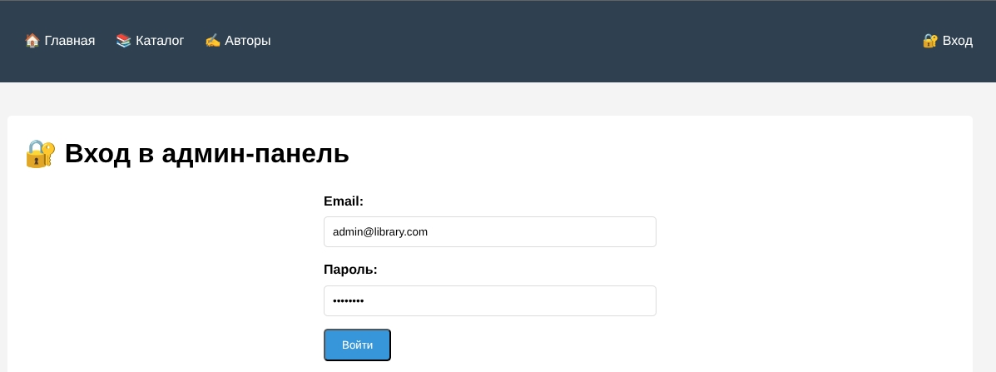
Рисунок 1 – Вход в панель администратора

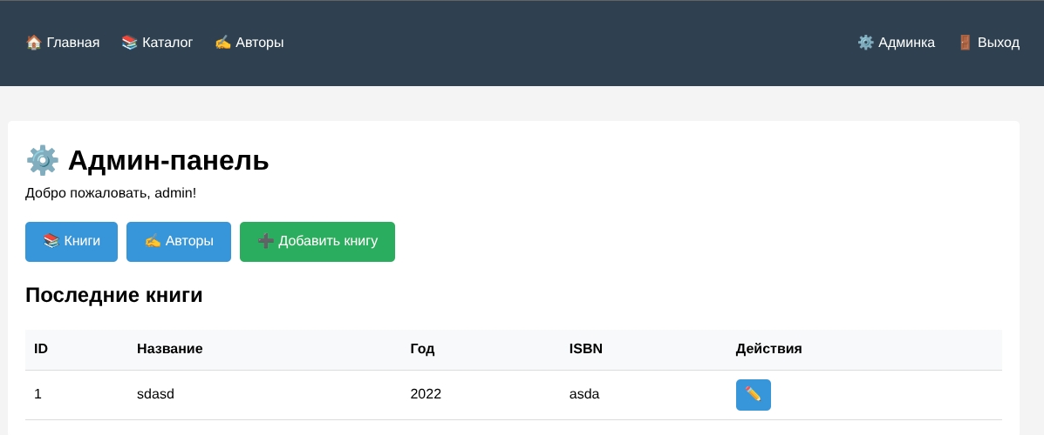
Рисунок 2 – Алмин-панель для работы с книгами и авторами

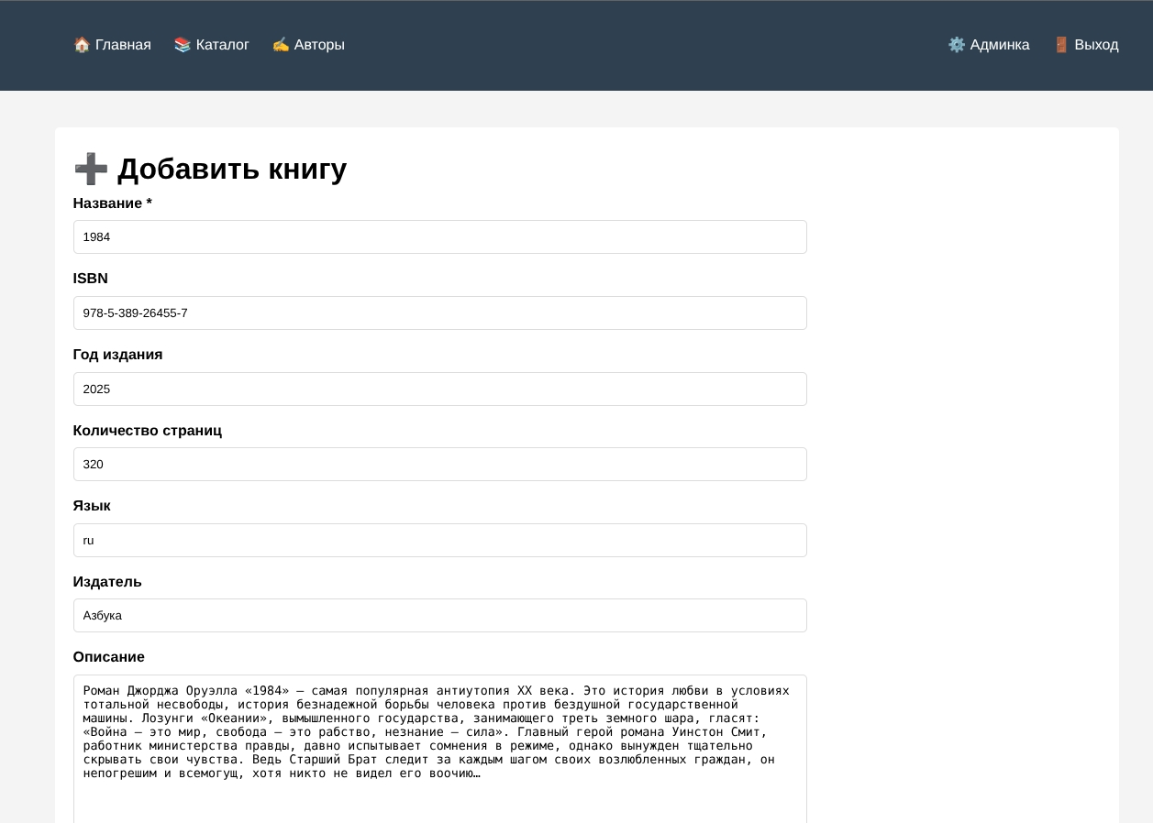
Рисунок 3 – Добавление новой книги

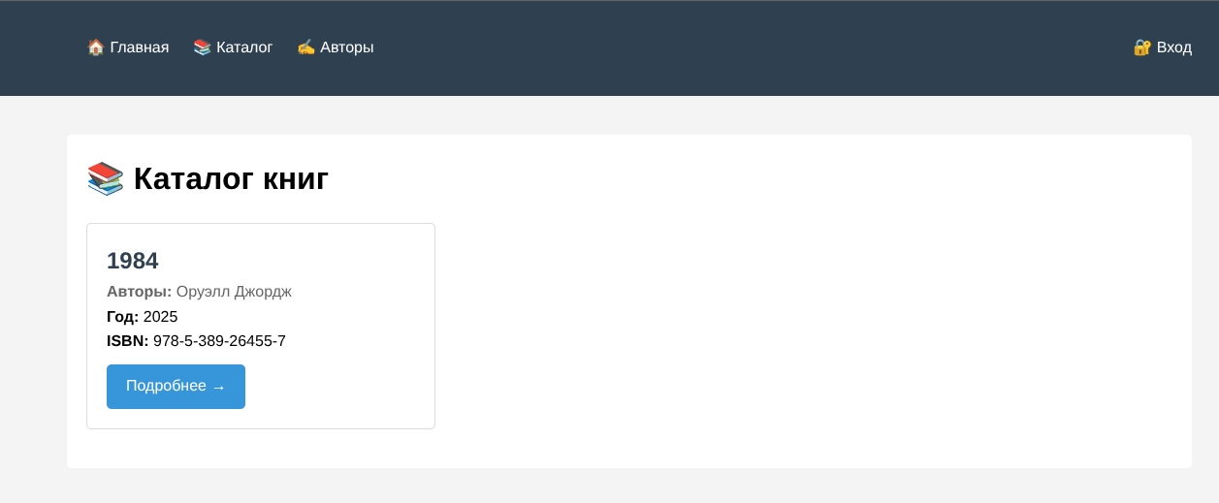
Рисунок 4 – Каталог книг

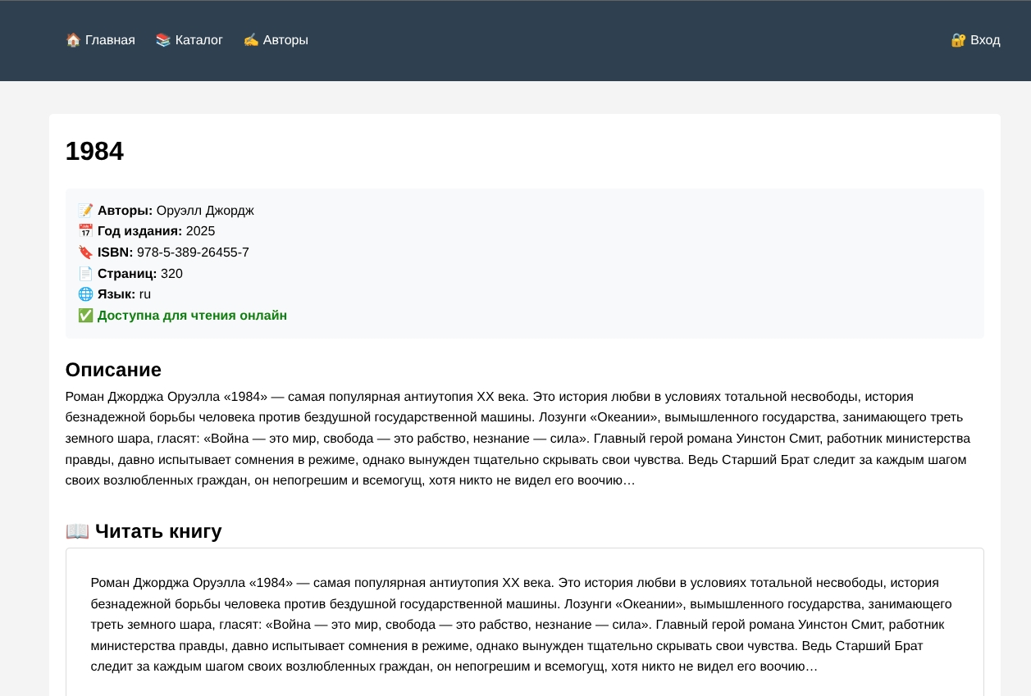
Рисунок 5 – Просмотр книги

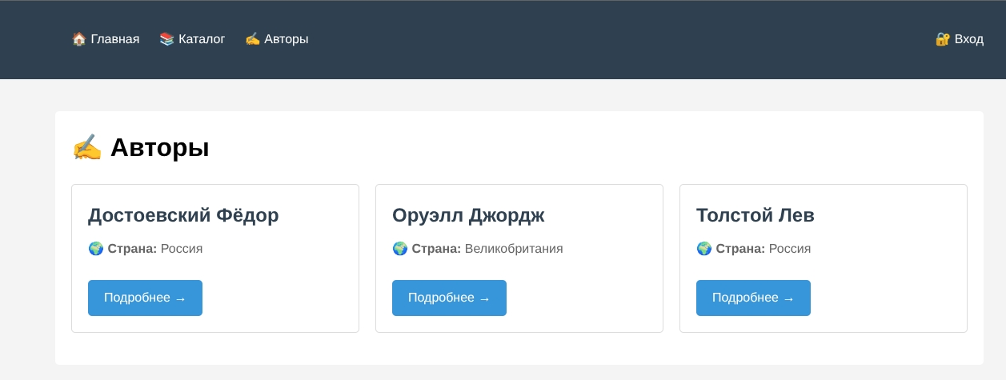
Рисунок 6 – Страница авторов

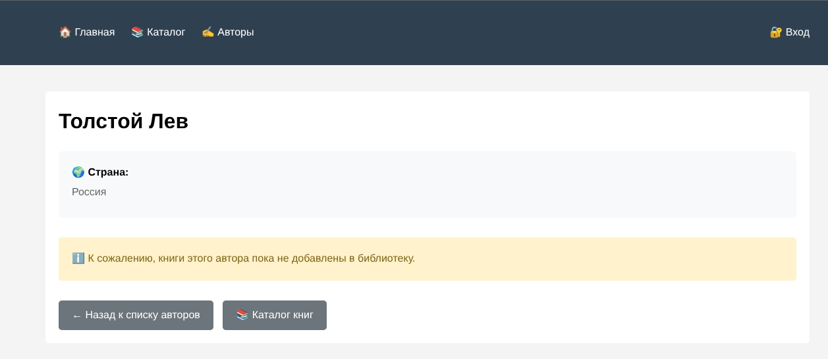
Рисунок 7 – Просмотр страницы автора

Вывод: в ходе выполнения лабораторной работы были сформированы практические навыки работы создание сервера, создающего запросы для базы данных.

