**Implementation Results for Uncertainty in Object position**

**Summary:** Considering Velocity is 0.1(default), acceleration is 0.1(default). Here uncertainty is introduced in the X and Y coordinates of the object position by **Normal** distribution. If the object is grasped then it’s considered as success else failure.

**Case 1: Standard deviation =0.005**

**Sampled X**: [0.48104505, 0.49500613, 0.48290411, 0.48613197, 0.48766223, 0.48071802,

0.4867966, 0.48568909, 0.4925788, 0.48857789, 0.48800684, 0.49491971,

0.49021652, 0.48992253, 0.48866226, 0.49007996, 0.49169649, 0.48162079,

0.49471311, 0.48643898, 0.48699757, 0.4794064, 0.48695449, 0.48584121,

0.48853401, 0.48990025, 0.48912894, 0.48605018, 0.48776877, 0.47899036,

0.49935095, 0.48484099, 0.49212307, 0.48608106, 0.48561608, 0.49296978,

0.48520081, 0.48657169, 0.48789937, 0.48642898, 0.49229357, 0.48770107,

0.48960271, 0.49104514, 0.4931741, 0.48664178, 0.4788064, 0.49727768,

0.49401039, 0.48671501]

**Sampled Y:** [ 0.01350066, 0.00892971, 0.01529761, 0.01189608, 0.00951885, 0.01369649,

0.00920413, 0.00684811, 0.00629782, 0.01440446, 0.00538877, 0.01111595,

-0.00322494, -0.00102746, 0.00643475, 0.00439998, 0.00243189, 0.00473725,

0.01183447, 0.01258955, 0.0009119, 0.00384088, 0.00467828, 0.00756833,

0.01045308, 0.01324922, 0.00892898, 0.0096756, 0.0074446, 0.0114922,

0.00943294, 0.01111746, 0.00170099, 0.00406007, 0.01461333, 0.02636242,

0.01671961, 0.00968786, 0.00632463, 0.01006708, -0.0001044, 0.01469263,

0.00328042, 0.00360712, 0.00404005, 0.00664857, 0.00685884, 0.01230925,

0.01252165, 0.00465789]

|  |  |  |  |
| --- | --- | --- | --- |
| **Experiment No:** | **Gripper Width** | **Success Rate (%)** | **Failure Rate (%)** |
| 1 | 0.03 | 98 | 2 |
| 2 | 0.031 | 94 | 6 |
| 3 | 0.032 | 98 | 2 |
| 4 | 0.033 | 100 | 0 |
| 5 | 0.034 | 50 | 50 |
| 6 | 0.035 | 0 | 100 |

**Graphical representation of this table is shown below:**

Note: I have shown both bar graph and line graph for same data.

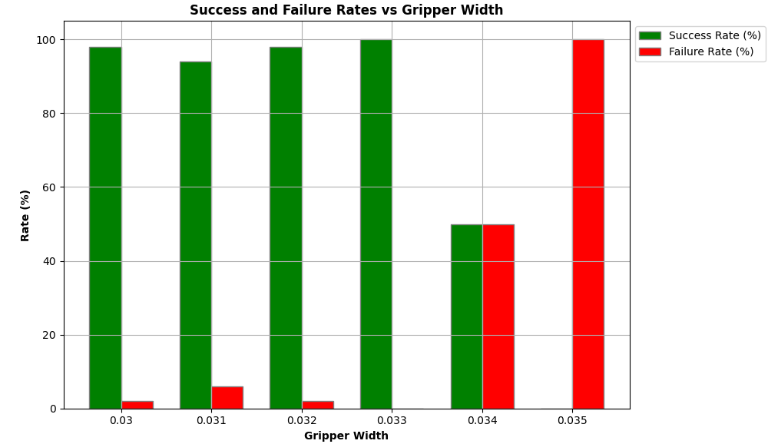

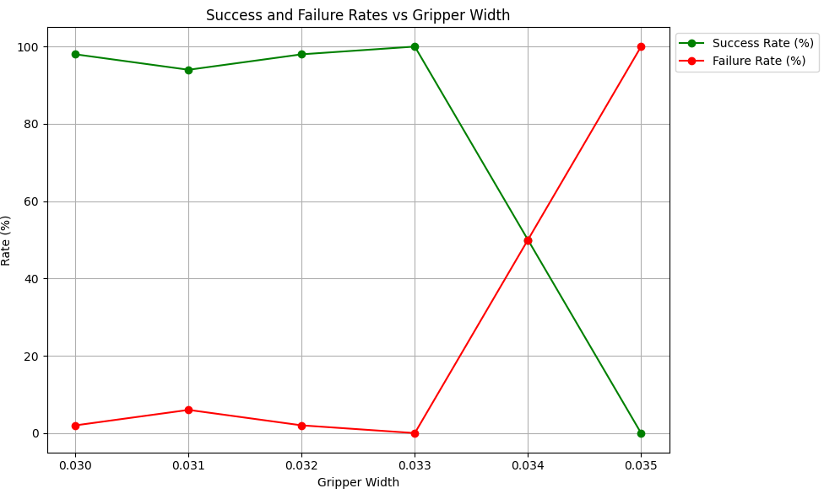

**Case 2: Standard deviation =0.01**

**Sampled X:** [0.50162274, 0.48951069, 0.50341215, 0.49615727, 0.48101159, 0.47225563,

0.501272, 0.48676327, 0.46111212, 0.47396221, 0.48636629, 0.49040326,

0.49434653, 0.48770368, 0.49803126, 0.48269194, 0.4861956, 0.47861138,

0.4871818, 0.47833452, 0.49097439, 0.49541848, 0.49616701, 0.49587376,

0.48589114, 0.48176583, 0.50880319, 0.50292152, 0.49137836, 0.48756908,

0.49160862, 0.49258558, 0.4923422, 0.5045687, 0.48087306, 0.50729335,

0.49387115, 0.48184728, 0.48098471, 0.48100386, 0.47912577, 0.48962986,

0.49796531, 0.49139124, 0.50437722, 0.47272433, 0.46046471, 0.50886724,

0.47090171, 0.48231243]

**Sampled Y**: [ 0.00583692, -0.00183908, 0.01022704, 0.01272923, 0.01383809 -0.00853211

-0.00863691, 0.00434802, 0.0148004, -0.0062895, -0.00249842, 0.01237284,

0.01789194, 0.00260495, 0.00278459, 0.01536117, -0.00491076, 0.00727189,

-0.01302764, -0.00467967, -0.0046506, 0.00556309, -0.00939853, 0.00011278,

0.01854924, 0.00540417, 0.00649814, 0.02043808, -0.00225368, -0.00759682,

0.00524199, 0.01498114, -0.00356128, -0.00178039, 0.01685438, 0.00172228,

-0.00232857, 0.0112997, 0.01051437, -0.00626076, 0.00211887, 0.01688476,

0.00964298, 0.00292617, 0.0043659, -0.00725703, 0.01913036, 0.01320721,

0.00547154, -0.00220461]

|  |  |  |  |
| --- | --- | --- | --- |
| **Experiment No:** | **Gripper Width** | **Success Rate (%)** | **Failure Rate (%)** |
| 7 | 0.03 | 84 | 16 |
| 8 | 0.031 | 78 | 22 |
| 9 | 0.032 | 84 | 16 |
| 10 | 0.033 | 90 | 10 |
| 11 | 0.034 | 68 | 32 |
| 12 | 0.035 | 0 | 100 |

**Graphical representation of this table is shown below:**

Note: I have shown both bar graph and line graph for same data.

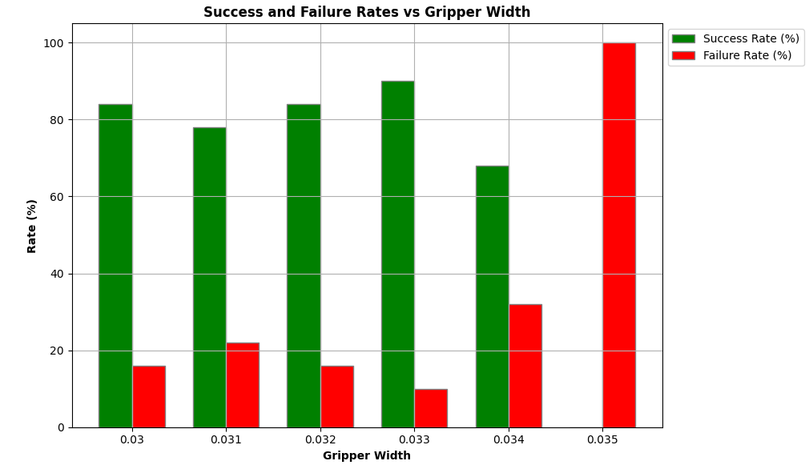

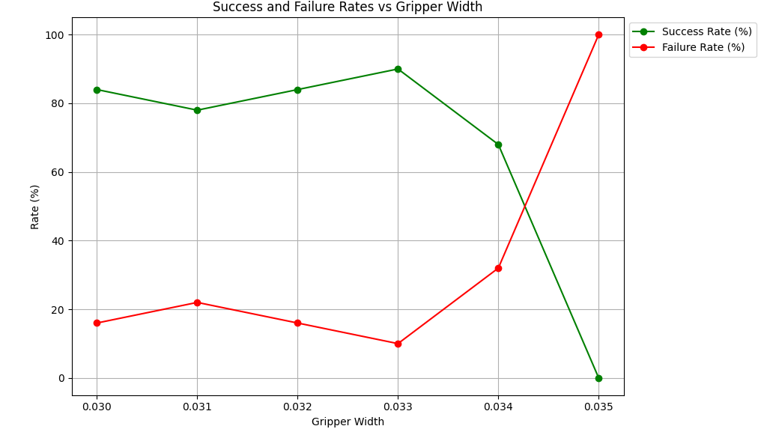

**Case 3: Standard deviation =0.015**

**Sampled position X :** [0.52817004 0.47781538 0.48347333 0.47644912 0.47229299 0.49215782

0.48108983 0.49451688 0.50952371 0.49467763 0.51931935 0.50406943

0.49365829 0.49154672 0.49319184 0.48044947 0.50444674 0.47691984

0.50546039 0.49994809 0.47802174 0.4848325 0.50472937 0.51108524

0.51438223 0.49737883 0.49826391 0.4869972 0.48975308 0.51026992

0.50486362 0.49438791 0.50473331 0.51478674 0.49482924 0.48635056

0.50991401 0.49723334 0.47070941 0.49569434 0.4955236 0.47879982

0.48015623 0.47116252 0.50248834 0.52423314 0.51931238 0.51656111

0.49286415 0.48616485]

**Sampled position Y :** [-0.00943561 -0.02403063 0.00894645 0.00433592 -0.00553837 0.00107396

0.00427964 -0.01813384 -0.01826828 0.00138178 0.01002217 -0.01870127

0.01286875 -0.00971145 -0.01140359 0.00098353 -0.00232736 -0.00583614

-0.00610171 -0.00162321 0.00885178 0.00818393 0.00982798 0.00796513

0.00892783 0.01155855 0.0058058 0.01999556 0.01775738 0.00606241

0.01453677 0.00698136 0.00927569 0.01693907 0.00515997 0.01059407

0.01457932 0.02728572 0.00247928 0.0099418 0.0112108 0.00118753

0.03796486 0.00330199 0.03771238 0.02097836 -0.03442989 0.02069857

0.0120679 -0.00014617]

|  |  |  |  |
| --- | --- | --- | --- |
| **Experiment No:** | **Gripper Width** | **Success Rate (%)** | **Failure Rate (%)** |
| 13 | 0.03 | 70 | 30 |
| 14 | 0.031 | 66 | 34 |
| 15 | 0.032 | 68 | 32 |
| 16 | 0.033 | 66 | 34 |
| 17 | 0.034 | 60 | 40 |
| 18 | 0.035 | 0 | 100 |

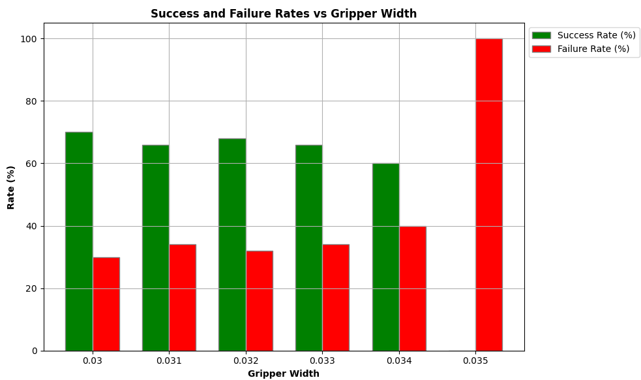

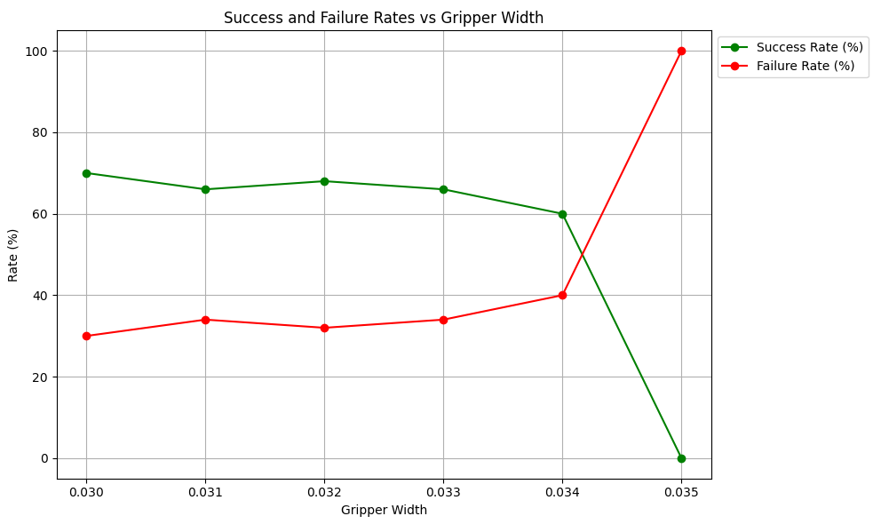

**Case 4: Standard deviation =0.02**

**Sampled position X:** [0.49595519 0.49539206 0.48392382 0.50737977 0.47679858 0.45726685

0.47064831 0.50222171 0.48705423 0.47157001 0.46554328 0.46833145

0.51976731 0.49252534 0.47474103 0.49240316 0.48251021 0.48353603

0.49272743 0.48945895 0.4993079 0.52315294 0.45843905 0.49311931

0.48466342 0.47415746 0.50938196 0.51777378 0.51572448 0.47225704

0.49036271 0.4840957 0.47875408 0.49492706 0.47467887 0.46192672

0.51022041 0.44023917 0.46575549 0.4598838 0.49777198 0.46235493

0.47538211 0.48653783 0.46091943 0.53285508 0.50321611 0.47274003

0.51061581 0.46983421]

**Sampled position X:** [ 2.43223084e-02 4.44620745e-02 9.29145925e-03 1.97122990e-02

-3.86274063e-02 1.28020015e-02 2.82416773e-02 1.06298578e-02

1.81343996e-02 6.68036773e-03 1.87943506e-02 -1.62509629e-02

2.00391470e-02 -1.86082688e-02 -2.69842120e-02 3.50926798e-02

4.28721522e-03 -2.71098796e-02 3.33225654e-02 -8.57646753e-03

-1.43048979e-02 -2.37084094e-03 -1.25327594e-02 -7.78602404e-03

2.00410193e-02 4.19448413e-02 3.81693957e-03 9.79070576e-03

4.54507093e-02 2.37706165e-02 2.16710223e-02 2.24809193e-02

3.64643354e-02 -2.97929343e-03 2.78911145e-02 1.17545278e-02

-9.48046440e-06 4.40884522e-02 -9.90316982e-03 1.10116038e-03

-3.23482610e-02 3.22922365e-02 1.26040358e-02 -8.57664368e-03

9.77686310e-04 1.35856087e-02 -6.27563093e-03 2.90043806e-02

1.48776529e-02 -3.75875632e-04]

|  |  |  |  |
| --- | --- | --- | --- |
| **Experiment No:** | **Gripper Width** | **Success Rate (%)** | **Failure Rate (%)** |
| 19 | 0.03 | 32 | 68 |
| 20 | 0.031 | 42 | 58 |
| 21 | 0.032 | 40 | 60 |
| 22 | 0.033 | 38 | 62 |
| 23 | 0.034 | 30 | 70 |
| 24 | 0.035 | 0 | 100 |

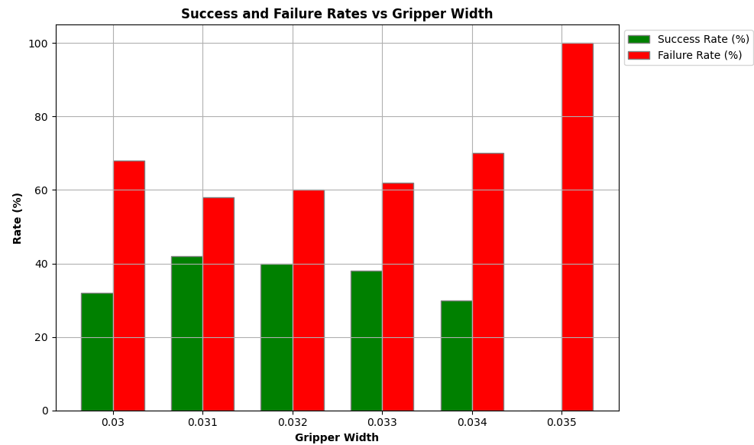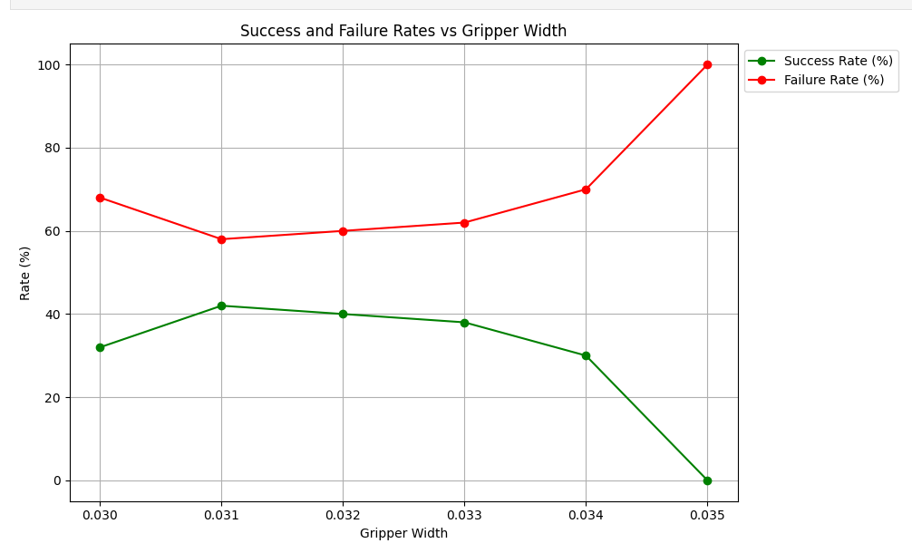

xxxxxxxxxxxxxxxxxxxxxxxxxxxxxxxxxxxxxxxxxxxxxxxxxxxxxxxxxxxxxxxxxxxxx

**Summary:** Considering Velocity is 0.1(default), acceleration is 0.1(default). Here uncertainty is introduced in the X and Y coordinates of the object position by **Uniform** distribution. If the object is grasped then it’s considered as success else failure.

**Case 1: Scale =0.005**

**Sampled Position X:** [0.4935806 0.49002201 0.48766931 0.4938918 0.48646533 0.49207724

0.49005292 0.48846473 0.49132573 0.49484202 0.48912302 0.49380236

0.49552588 0.49258978 0.48955177 0.49061843 0.48634964 0.49365357

0.4893315 0.49123481 0.49268924 0.49140199 0.49180083 0.49475049

0.49293652 0.48993185 0.49071274 0.49544666 0.48802269 0.49523033

0.49511986 0.49259977 0.49437379 0.48909274 0.4897543 0.49118904

0.49119056 0.48821168 0.49066277 0.49554679 0.48787052 0.49059973

0.49365859 0.48618917 0.49340268 0.48807269 0.494415 0.49406533

0.48937076 0.49362769]

**Sampled Position Y:** [0.00849942 0.00857987 0.00807758 0.00751724 0.00789424 0.00795479

0.00880029 0.00813744 0.00906198 0.00730633 0.00899908 0.00812227

0.0076744 0.00914266 0.00768285 0.00781345 0.00771684 0.00861318

0.00868753 0.00816439 0.00825114 0.00920344 0.00885644 0.00909769

0.00898023 0.0078136 0.00830249 0.00765098 0.00769532 0.00787771

0.00917992 0.00850683 0.00755596 0.00757271 0.00771134 0.00864323

0.00906543 0.00806623 0.0089772 0.00787452 0.00820585 0.00901021

0.00741861 0.00830796 0.00800679 0.00817987 0.00739389 0.00801244

0.00906767 0.00765864]

|  |  |  |  |
| --- | --- | --- | --- |
| **Experiment No:** | **Gripper Width** | **Success Rate (%)** | **Failure Rate (%)** |
| 25 | 0.03 | 94 | 6 |
| 26 | 0.031 | 96 | 4 |
| 27 | 0.032 | 100 | 0 |
| 28 | 0.033 | 100 | 0 |
| 29 | 0.034 | 34 | 66 |
| 30 | 0.035 | 0 | 100 |

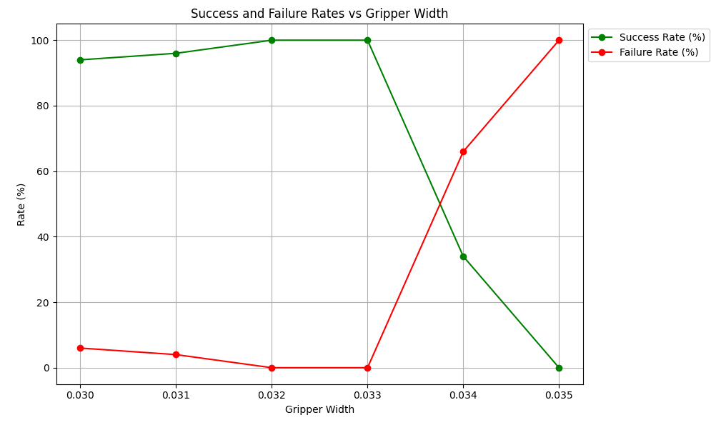

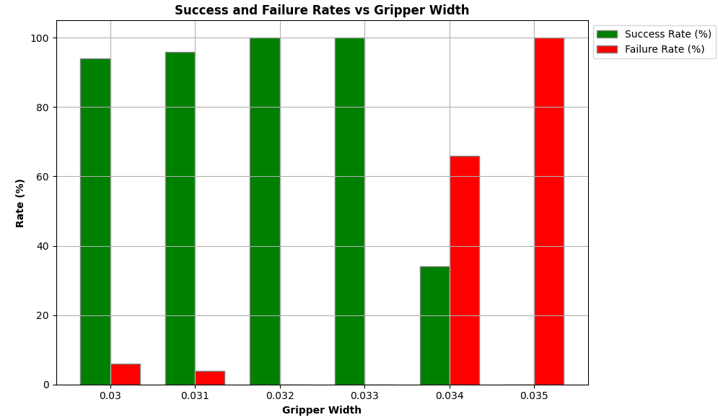

**Case 2: Scale =0.01**

**Sampled position X:** [0.48986224 0.49849899 0.49778287 0.48310396 0.48068828 0.49456048

0.48937307 0.48399434 0.49187228 0.48131579 0.48919911 0.49474629

0.48715421 0.48735412 0.48411129 0.48731301 0.49293188 0.48430535

0.49549563 0.48640572 0.49226516 0.48802866 0.48474123 0.48997884

0.4820212 0.49842736 0.4890064 0.48327664 0.49841448 0.48389909

0.48390943 0.49219055 0.4959142 0.49832987 0.47924817 0.48366851

0.48431584 0.49344031 0.49185738 0.48715049 0.49455533 0.48847915

0.49799268 0.49167805 0.48618079 0.49783367 0.48494072 0.48907386

0.48088485 0.4977336 ]

**Sampled position Y:** [ 0.00591704 -0.00408768 -0.00502385 0.01091512 -0.00264546 -0.00371166

0.00853246 0.01098269 0.00593487 0.00638357 0.00891464 0.00316004

0.01102083 -0.0009722 0.00603625 0.00929173 0.00184509 -0.00399685

0.00850142 0.00390175 -0.00455973 -0.00021015 0.00501242 -0.00078634

-0.00488485 0.00936088 0.00652263 -0.00014801 0.01284807 0.01039371

0.00421111 -0.00382274 0.00699854 0.00742337 0.00251283 -0.00249051

0.00198989 -0.00280405 -0.00356133 0.00018729 -0.00323177 -0.00545456

0.0113685 0.00210742 0.00934102 0.00206273 0.0034866 0.00364521

0.00863474 0.00360679]

|  |  |  |  |
| --- | --- | --- | --- |
| **Experiment No:** | **Gripper Width** | **Success Rate (%)** | **Failure Rate (%)** |
| 31 | 0.03 | 94 | 6 |
| 32 | 0.031 | 92 | 8 |
| 33 | 0.032 | 84 | 16 |
| 34 | 0.033 | 90 | 10 |
| 35 | 0.034 | 72 | 28 |
| 36 | 0.035 | 0 | 100 |

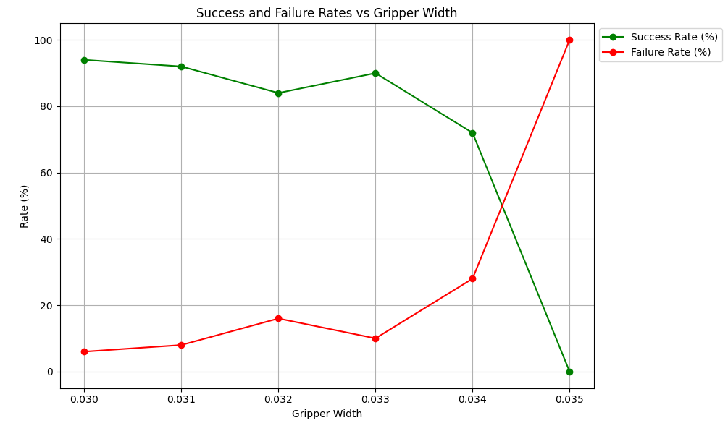

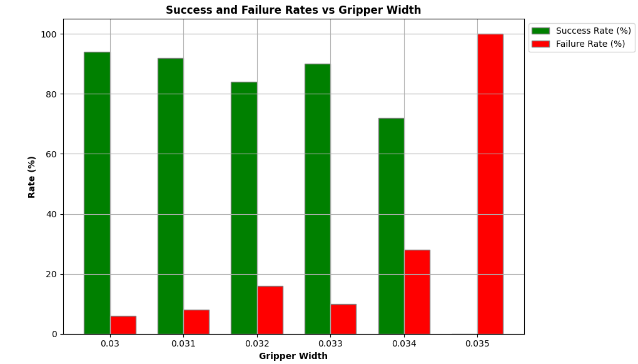

**Case 3: Scale =0.015**

**Sampled position X:** [0.48939613 0.49077018 0.48973831 0.49283143 0.50161268 0.47634057

0.48942749 0.50087776 0.49621683 0.50180384 0.49610676 0.48885339

0.48609109 0.48579321 0.50444484 0.50027673 0.4868005 0.4915861

0.50397457 0.48470029 0.48272394 0.48698248 0.48014044 0.50311498

0.47530471 0.49124017 0.49404903 0.49303261 0.49345101 0.48988165

0.49553922 0.47567796 0.48140014 0.479682 0.47987438 0.48268084

0.49662951 0.49608315 0.5031264 0.48706709 0.48881139 0.48952831

0.50155226 0.49752681 0.48658458 0.49165245 0.47733061 0.48693354

0.4806583 0.4825417 ]

**Sampled position Y:** [ 0.01863245 -0.00527137 0.02146295 0.00232262 -0.00232966 0.01921742

0.01764583 0.01706353 0.00101758 0.00280894 -0.00454052 -0.00476592

0.02061263 0.01676417 0.0017193 0.01849194 0.0212133 0.00639641

0.01040398 0.01690422 0.01590506 -0.00068389 0.01953884 -0.00059241

0.00515226 0.02266521 0.01495946 -0.00526044 0.00805057 -0.00608711

0.00530042 0.00028008 0.02045739 0.01814811 -0.00236258 0.00902515

0.01926565 -0.00096212 0.0199311 0.00260788 0.01657832 -0.00303754

0.01655385 -0.00654511 0.00871424 0.01897553 0.00052 0.00344807

0.01593543 -0.00065189]

|  |  |  |  |
| --- | --- | --- | --- |
| **Experiment No:** | **Gripper Width** | **Success Rate (%)** | **Failure Rate (%)** |
| 37 | 0.03 | 80 | 20 |
| 38 | 0.031 | 92 | 8 |
| 39 | 0.032 | 88 | 12 |
| 40 | 0.033 | 90 | 10 |
| 41 | 0.034 | 50 | 50 |
| 42 | 0.035 | 0 | 100 |

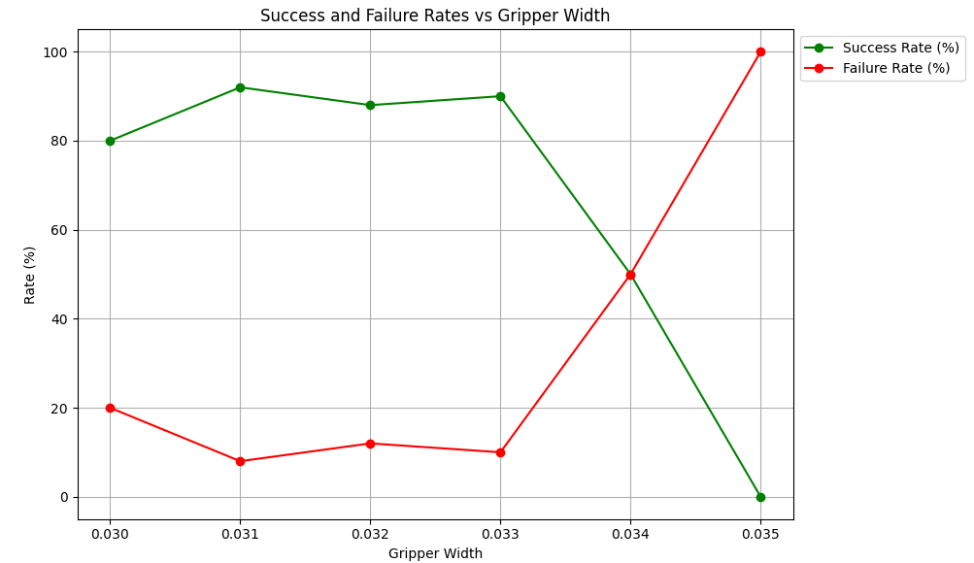

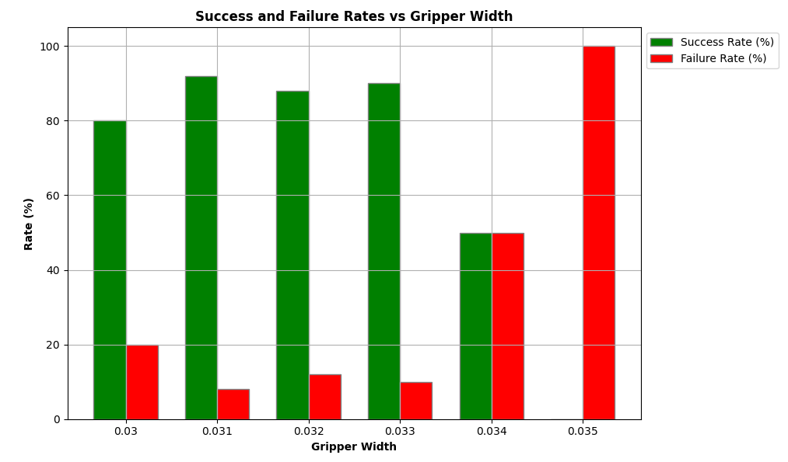

**Case 4: Scale =0.02**

**Sampled position X:** [0.48555117 0.47670729 0.50601379 0.48025193 0.49241815 0.51087208

0.48758345 0.47972214 0.49100881 0.50246381 0.49001166 0.510129

0.48088111 0.4817089 0.48177141 0.50998832 0.48058501 0.49660133

0.50473693 0.4993915 0.5105544 0.49098094 0.48511919 0.50822063

0.48842108 0.48255574 0.47922552 0.48463938 0.51512187 0.49656756

0.50391779 0.48678201 0.48533544 0.50141921 0.50103433 0.49805101

0.47996094 0.49691696 0.49168265 0.50303303 0.51450631 0.50803052

0.4838819 0.49102342 0.4895732 0.48106731 0.50603059 0.4924823

0.50504652 0.47665043]

**Sampled position Y:** [-0.01273905 0.00500519 0.00350171 0.01805933 0.0113926 -0.00864066

0.00787333 0.01708065 0.01691917 0.02366908 0.02147704 0.01862736

-0.00018133 0.00197057 0.01053857 0.02523747 0.0039918 0.00082397

0.01191046 0.00272241 0.00875555 0.01925381 0.00076027 0.00200981

-0.01189823 0.02496256 0.00411953 -0.00606639 0.01576231 0.02516817

0.01197517 0.01728728 0.00288621 -0.00269427 -0.00100441 0.0115168

0.00822135 0.01535334 -0.00739405 0.01757615 -0.00643796 0.02534187

-0.01426708 0.00800934 0.0176593 -0.00022322 0.00118828 0.00154019

0.01565445 0.00514922]

|  |  |  |  |
| --- | --- | --- | --- |
| **Experiment No:** | **Gripper Width** | **Success Rate (%)** | **Failure Rate (%)** |
| 43 | 0.03 | 72 | 28 |
| 44 | 0.031 | 72 | 28 |
| 45 | 0.032 | 74 | 26 |
| 46 | 0.033 | 70 | 30 |
| 47 | 0.034 | 32 | 68 |
| 48 | 0.035 | 0 | 100 |

