**Implementation Results for Uncertainty in Gripper Width**

**Summary:** Considering Velocity is 0.1(default), acceleration is 0.1(default) and constant object position. Here uncertainty is introduced in the gripper width centered around optimal width (0.03). If the object is grasped then it’s considered as success else failure.

**Case 1: Normal distribution**

|  |  |  |  |
| --- | --- | --- | --- |
| **Experiment No:** | **Standard Deviation** | **Success Rate (%)** | **Failure Rate (%)** |
| 1 | 0.0025 | 94 | 6 |
| 2 | 0.005 | 74 | 26 |
| 3 | 0.0075 | 64 | 36 |
| 4 | 0.01 | 70 | 30 |

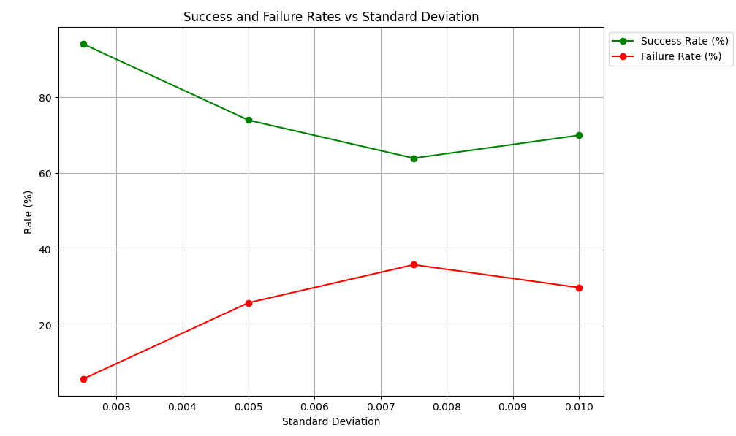

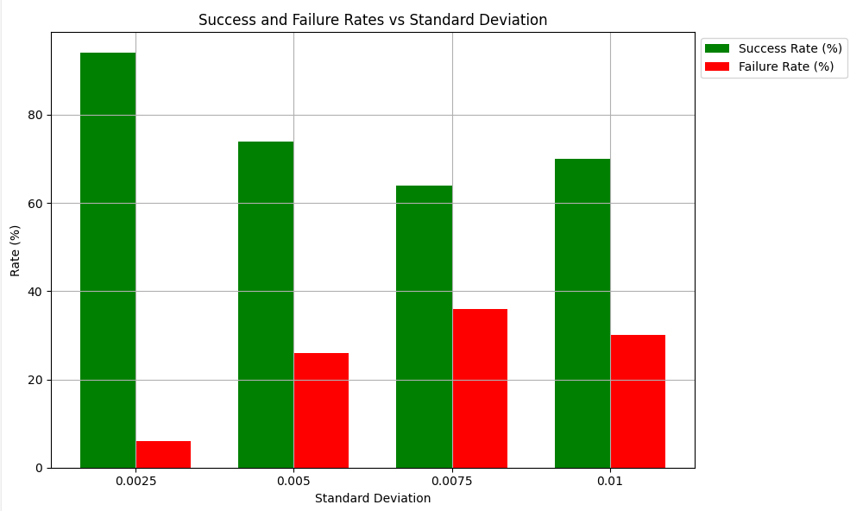

**Case 2: Uniform distribution**

|  |  |  |  |
| --- | --- | --- | --- |
| **Experiment No:** | **Scale** | **Success Rate (%)** | **Failure Rate (%)** |
| 5 | 0.005 | 92 | 8 |
| 6 | 0.01 | 70 | 30 |
| 7 | 0.02 | 64 | 36 |
| 8 | 0.03 | 64 | 36 |

