**Implementation Results for Uncertainty in Motion Parameters**

**Scenario 1: Uncertainty in Velocity**

In this scenario, uncertainty was introduced only in the velocity while keeping acceleration constant at 0.1. The velocity arrays were generated using a normal distribution with a standard deviation of 0.3 around a mean velocity of 0.5 m/s. Both the object position and gripper width were kept constant at their optimal values. The success rate in this scenario was 100%, as shown by the green bar in the graph, indicating that the uncertainty in velocity had minimal impact on the robot's performance in this case.

**velocities** = [0.42703107, 0.65054628, 0.92381211, 0.88242321, 0.06409533, 0.51991044,  
 0.43203649, 0.27483223, 0.83336267, 0.02550827, 0.75090269, 0.02264429,  
 0.65405846, 0.66280533, 0.56989851, 0.68723757, 0.86994983, 0.36043064,  
 0.34402646, 0.65436021, 0.6591422, 0.78463515, 0.88210962, 0.72336961,  
 0.25443845, 0.76279022, 0.46886211, 0.36765262, 0.59939354, 0.30912722,  
 0.66781543, 0.30594075, 0.06743806, 1.00547776, 0.391729, 0.3916542,  
 0.37883287, 0.7622545, 0.46375612, 0.5830149, 0.69778815, 0.35644257,  
 0.13074546, 0.04309196, 0.35561919, 0.0730527, 0.12520682, 0.14678731,  
 0.3663727, 0.76891574]

**Scenario 2: Uncertainty in Acceleration**

Here, uncertainty was modeled in the acceleration parameter using a uniform distribution with a scale of 0.5, while velocity was kept constant at 0.5 m/s. Similar to the first scenario, the object position and gripper width were fixed. The robot's success rate was 99%, showing that even with variability in acceleration, the pick-and-place task was nearly unaffected, though there was a slight increase in the failure rate compared to Scenario 1.

**accelerations** = [0.0467997, 0.35615545, 0.17009115, 0.24398892, 0.4896305, 0.01974982,  
 0.94418495, 0.43542593, 0.96057379, 0.08151943, 0.23918518, 0.97230289,  
 0.94863992, 0.92756688, 0.03830152, 0.24073922, 0.74912436, 0.48310211,  
 0.46059096, 0.39073863, 0.51503254, 0.30436251, 0.3912778, 0.46240073,  
 0.53232177, 0.28667387, 0.08246239, 0.96527791, 0.83631219, 0.31838201,  
 0.25881522, 0.25272922, 0.48158767, 0.93534967, 0.39018217, 0.37232855,  
 0.54877344, 0.21277038, 0.8446034, 0.3901857, 0.8445308, 0.60013632,  
 0.19664784, 0.19792021, 0.66873008, 0.40150629, 0.82411241, 0.2059014,  
 0.66412756, 0.33099307]

**Scenario 3: Combined Uncertainty in Velocity and Acceleration**

In this case, uncertainties in both velocity and acceleration were introduced simultaneously, using the same arrays as in Scenarios 1 and 2. The object position and gripper width remained constant. The results show a success rate of 100%, demonstrating that the robot could handle combined uncertainties without any significant degradation in performance.

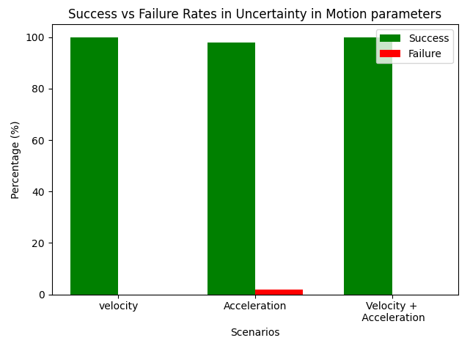

|  |  |  |
| --- | --- | --- |
| **Scenario** | **Success (%)** | **Failure (%)** |
| Velocity | 100 | 0 |
| Acceleration | 98 | 2 |
| Acceleration +Velocity | 100 | 0 |