NMO_109005 GRP EXCITATORY INTERNEURON
Complete morphology-constrained eTrC-like model report
Cell: 26-11-14-A-A6
NeuroMorpho: NMO_109005
Project condition: 35°C
Decision: ENGINEERING READY / BIOLOGICALLY PROVISIONAL
Network integration: NO

1. Biological identity
NMO_109005 is a reconstructed mouse GRP-positive excitatory interneuron from lamina II of the mid-lumbar spinal dorsal horn. The reconstruction is used here as a GRP-positive lamina-II excitatory interneuron used as a biologically informed transient-central/eTrC-like model.

2. Why this morphology is suitable for eTrC-like modelling
Dickie et al. showed that GRP cells are excitatory interneurons, many have central-like somatodendritic morphology, and most recorded GRP cells fired transiently or with a single spike. That evidence supports an eTrC-like computational interpretation at the population level. The NMO_109005 record provides soma, dendrites, and a native partial/moderate axon without requiring invented dendritic geometry.

3. Critical identity warning
GRP does not uniquely imply eTrC, and NMO_109005 itself has not been experimentally assigned to a molecular class called “eTrC.” Its exact electrophysiological recording is not publicly linked to the morphology. All Dickie quantitative constraints below are GRP population values rather than same-cell targets.

4. Morphology QA
The existing SWC was retained byte-for-byte (SHA-256 3f74c3796e9992b63dabb4f9c8430695658f35bd03f824bb47a58ce1c625726e). It contains 10,314 valid records in one connected component: 9 soma, 7,056 dendrite, and 3,249 axon nodes. Soma, dendrites, and axon are present; there are no orphan parents, non-positive radii, zero-length edges, or invalid rows. Approximate cable length is 3,291.95 µm, with 83 branch points and 87 endpoints. The native axon is treated as partial/moderate, consistent with the NeuroMorpho physical-integrity record.
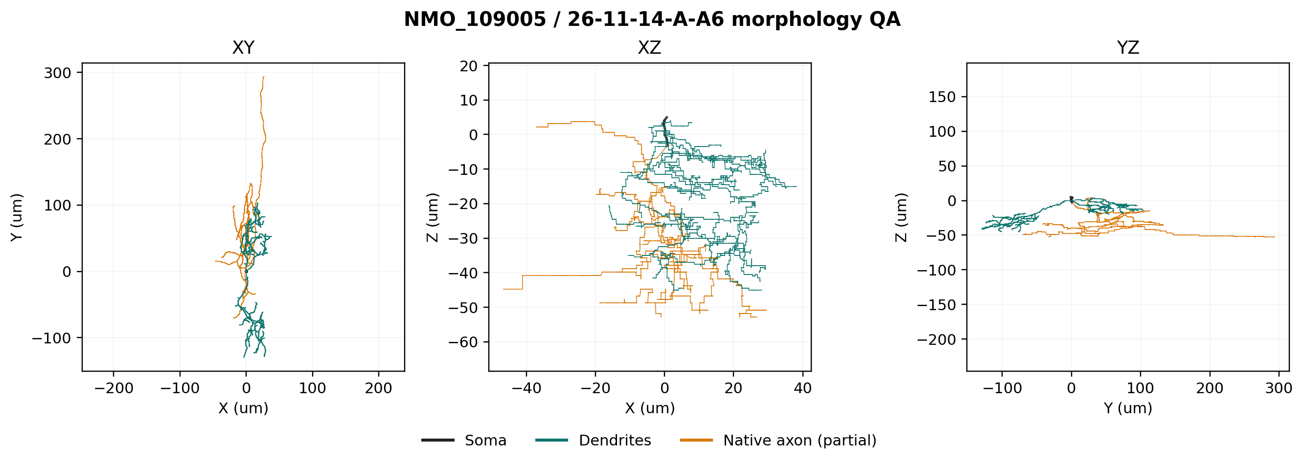
Morphology QA

5. Dickie experimental evidence
Dickie et al. reported data as mean ± SEM unless otherwise stated. Key GRP values are RMP −52.89 ± 0.78 mV (n=230), Rin 1,588 ± 85 MΩ (n=232), whole-cell capacitance 5.12 ± 0.11 pF (n=232), rheobase 18.30 ± 1.07 pA (n=155), and first-spike latency at rheobase 137.1 ± 6.2 ms (n=155). Firing classes were transient 49.5%, single 32.9%, tonic 8.3%, reluctant 6.5%, and delayed 2.8% (n=216).
The paper also reported IAr in 40.9%, Ih in 37.3%, IAs in 25.8%, and ICaT in 33.3% of tested GRP cells. Prevalence in a population does not prove that any one current is present in NMO_109005.

6. Passive targets and acceptance rule
RMP and Rin were fitted using the paper's −60 mV voltage-clamp logic: 100 ms steps from −70 to −50 mV in 2.5 mV increments. A model value within the population mean ±2 SEM was counted as a comparison pass. This is a transparent engineering criterion, not a same-cell biological interval.

7. Passive parameters and result
Parameter | Final value | Basis
Ra | 100 Ω·cm | bounded fit
cm | 0.7 µF/cm² | plausible bounded fit
g_pas | 1.0×10⁻⁵ S/cm² | bounded fit
e_pas | −52.89 mV | population constraint
d-lambda | 0.1 at 100 Hz | numerical policy

The passive model produced RMP −52.940 mV and Rin 1,574.08 MΩ: both pass the declared ±2 SEM comparison. Morphology-derived capacitance was 48.68 pF and fails the 5.12 pF population value. This mismatch was preserved because forcing it would require an implausibly small specific membrane capacitance.
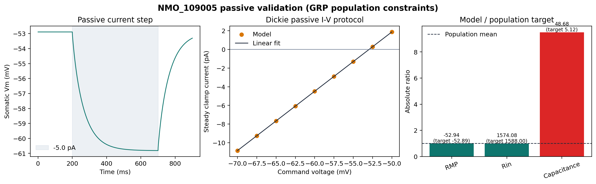
Passive validation

8. Active firing distribution target
The primary target was transient firing and the declared secondary acceptable phenotype was single-spike firing. Automatic classes were based on spike times, late-step voltage, recovery voltage, and response to a later test pulse. A brief response followed by sustained depolarization or failed recovery was classified as depolarization block rather than transient firing.

9. Rheobase and first-spike latency
At 35°C, a −5.3 pA holding current maintained the soma near −60 mV. On the declared current grid, 17 pA was silent and 18 pA produced one spike, giving a rheobase of 18 pA (pass versus 18.30 ± 1.07 pA). First-spike latency was 25.25 ms (fail versus 137.1 ± 6.2 ms). The latency mismatch was not hidden by adding unsupported conductances.

10. Channel evidence
Fast Na and delayed-rectifier K currents are mechanistically necessary for AP initiation and repolarization. Their densities are fitted model parameters, not measurements from NMO_109005. Rapid A-current had direct population-level prevalence evidence, while KCa was only a Medlock-supported comparator. HCN, T-type Ca, and a distinct slow A-current were not tested because appropriate audited mechanisms or a validated observable requiring them were absent.

11. Channels tested
- Model A: pas + B_Na + B_DR.
- Model B: Model A plus B_A at restrained somatodendritic densities.
- HH2 basic-spiking comparator.
- Paired iCaL + CaIntraCellDyn + iKCa comparator.
- HCN, T-type Ca, and a distinct slow A-current: not tested, with reasons recorded in active_validation.json.

12. Channels retained
The final complement is pas, B_Na, and B_DR. It is the largest channel set justified by both evidence and necessity in this task; additional tested channels did not improve the constrained phenotype.

13. Channels rejected
B_A shifted rest negative and raised rheobase at restrained densities, while larger values silenced the model; it did not recover the long latency. HH2 produced tonic firing at useful densities, and high-K apparent single-spike regimes were depolarization block. The Ca/KCa comparator reduced firing but did not produce a necessary stable transient, so its complexity was rejected. iCaL is L-type and was never treated as evidence for ICaT.

14. Reason for every final channel
- pas: defines the fitted subthreshold membrane response.
- B_Na: required for an overshooting action potential.
- B_DR: required for repolarization, stable late-step voltage, and recovery.

15. Final conductance table
Mechanism | Soma | Model-defined proximal native axon | Elsewhere | Reversal
B_Na gnabar | 0.2 S/cm² | 0.4 S/cm² at path distance ≤20 µm | 0 | ENa = +53 mV
B_DR gkbar | 0.6 S/cm² | 1.2 S/cm² at path distance ≤20 µm | 0 | EK = −84 mV

The active domain is explicitly MODEL-DEFINED. It changes channel distribution only; no synthetic AIS or other geometry was added to the native partial axon.

16. Representative traces
The 17 pA trace is subthreshold. Rheobase, 2× rheobase, and the 50 pA strong condition each produce one onset spike. Every panel includes the later 36 pA recovery pulse.
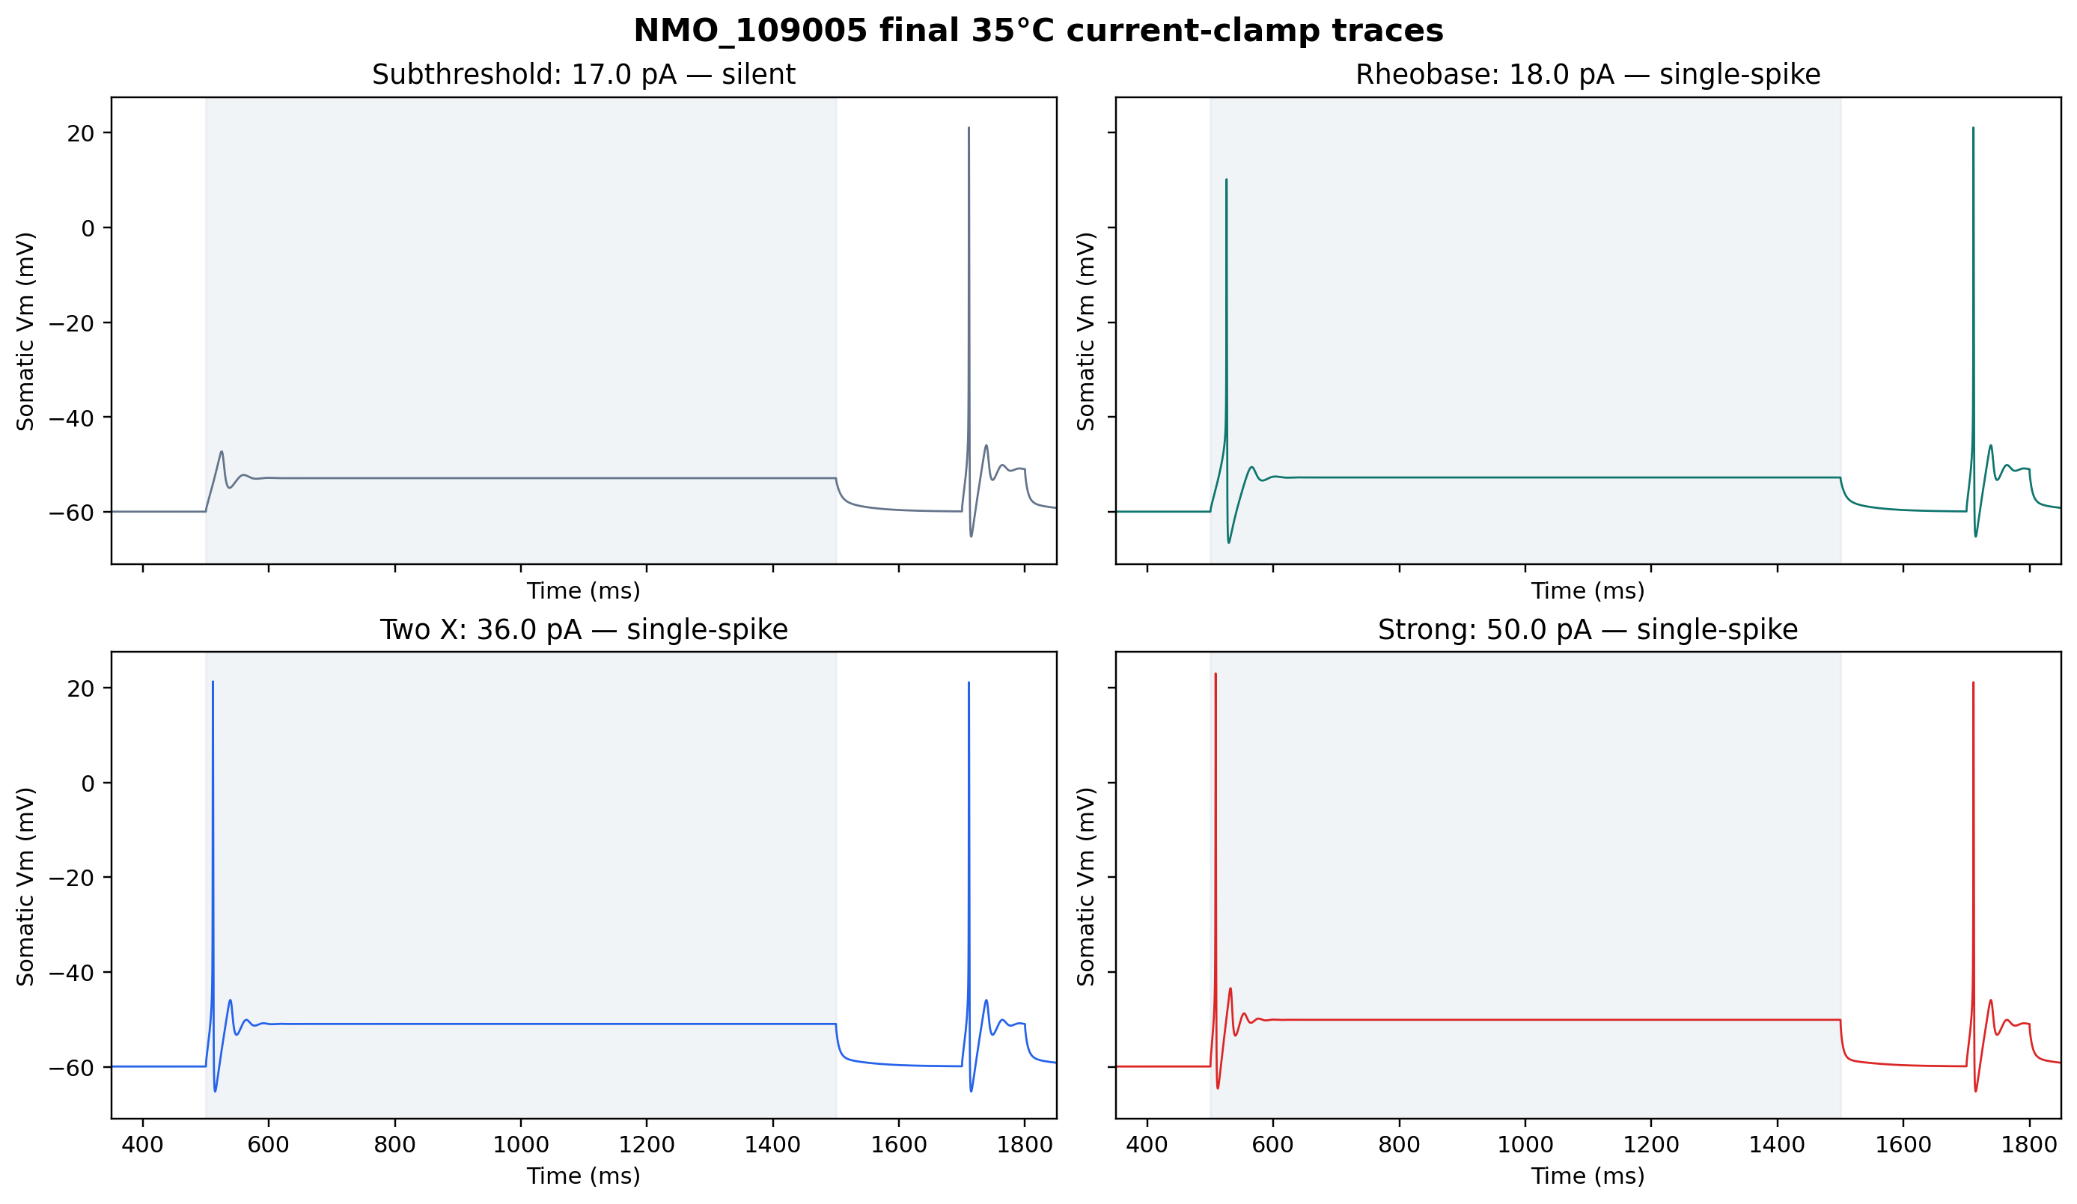
Active traces

17. Evidence against depolarization block
At rheobase, the late-step Vm was −52.73 mV, the AP peak was +10.18 mV, voltage returned within 3 mV of the pre-step value, and the later test pulse elicited another spike. No current in the 0–50 pA final series met the automatic depolarization-block rule. The single-spike phenotype is therefore a stable cessation of firing, not failed recovery at a strongly depolarized voltage.
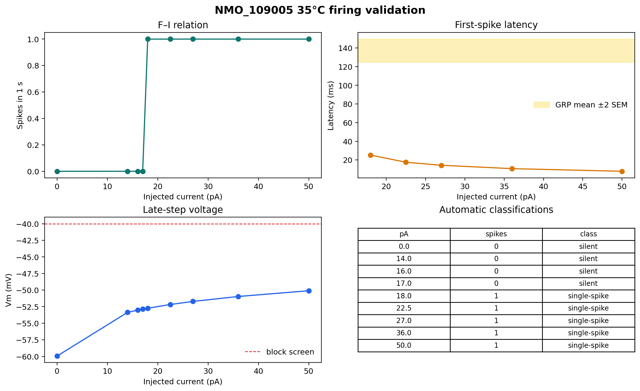
Firing validation

18. Translation to 35°C
h.celsius is set to 35 before initialization. Source audit found that B_Na computes a Q10=3 tadj relative to 23°C but uses tau_factor, not tadj, in gate tau; B_DR computes tadj and never applies it. With tables disabled, 23°C and 35°C traces are numerically identical. The accurate statement is therefore: 35°C project-condition model constrained by room-temperature GRP population data, with retained channel kinetics effectively temperature-independent. This is a material limitation, not evidence of a validated physiological temperature translation.
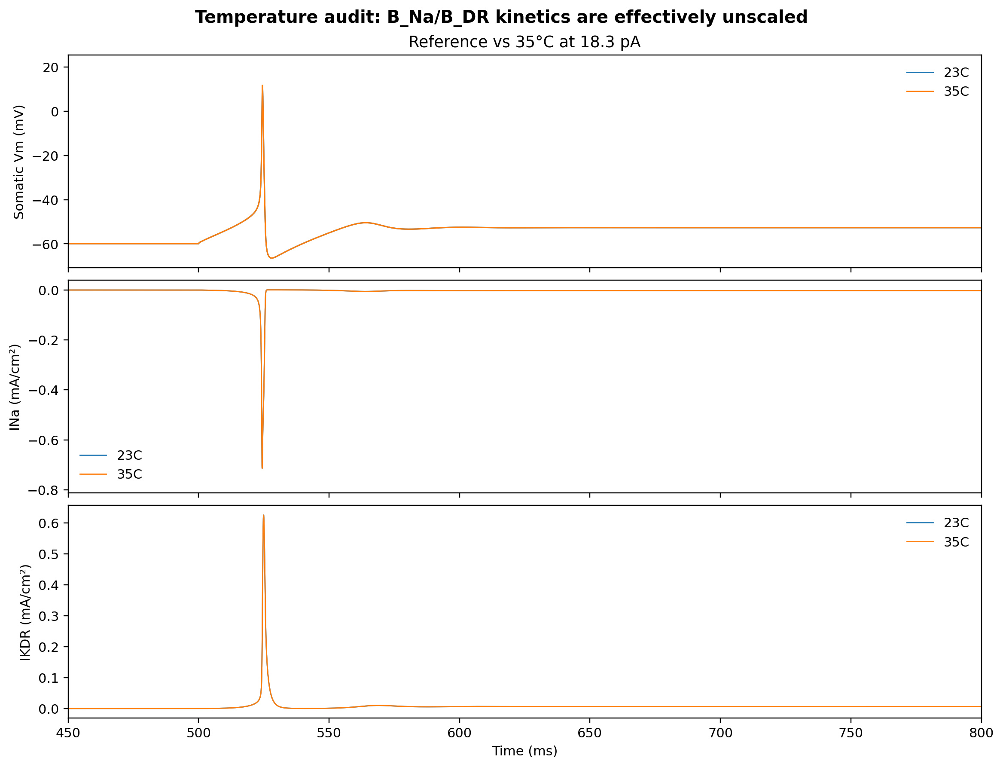
Temperature audit

19. Numerical robustness
Halving dt from 0.025 to 0.0125 ms and tightening d-lambda from 0.1 to 0.05 left rheobase at 18 pA, the single-spike phenotype intact, and metrics nearly unchanged. Independent ±10% channel tests preserved a non-blocking single-spike/transient-compatible rheobase response and recovery. Rheobase ranged from 16 to 22 pA; Na −10% moved it 4 pA above baseline, so robustness is PARTIAL, not PASS.

20. Known limitations
- No same-cell physiology is linked to NMO_109005.
- GRP identity does not uniquely establish eTrC membership.
- Whole-cell capacitance is incompatible with the full reconstructed area under plausible cm.
- The final active model has natural RMP −55.67 mV and Rin 464.24 MΩ; active Rin fails the GRP population target and active RMP falls outside mean ±2 SEM.
- First-spike latency is much too short.
- The 20 µm active domain is model-defined rather than reconstructed AIS anatomy.
- Retained B_Na/B_DR kinetics are effectively temperature-independent.
- Synapses and network behavior were not tested; the mandated build order stops at failed single-cell gates.

21. Final readiness decision
ENGINEERING READY / BIOLOGICALLY PROVISIONAL. The package is reproducible, self-contained, numerically stable, morphology-constrained, and honest about failures. It is not ready for network integration because active-model Rin and latency remain failed single-cell gates. Synapse unit tests and scaled-population tests should wait until those biological gaps are resolved with better-supported mechanisms or same-cell/closer-class data.

22. Exact reproduction command
From either target repository root in a Linux NEURON environment:
python cells/eTrc/scripts/run_eTrC_final.py
For the full staged audit and robustness set:
python cells/eTrc/scripts/fit_active.py

References
1. Dickie AC et al. Morphological and functional properties distinguish the substance P and gastrin-releasing peptide subsets of excitatory interneuron in the spinal cord dorsal horn. *PAIN*. 2019;160:442–462. DOI 10.1097/j.pain.0000000000001406; PMCID PMC6330098. 2. NeuroMorpho.Org. 26-11-14-A-A6 / NMO_109005. 3. ModelDB 267056. Medlock dorsal-horn model mechanism source.
The machine-readable evidence matrix is ../evidence/evidence_matrix.csv; detailed protocol metrics are in ../results/.

