COMPUTATIONAL NEUROSCIENCE MODEL REPORT
23-04-18C-04-cell-1
NMO_170087 mouse PV+/Pax2+ inhibitory interneuron
Region | Lumbar spinal dorsal horn, lamina II-III
Medlock mapping | iPV
NEURON | 9.0.1
Report date | 2026-08-13
Final status | ENGINEERING READY / BIOLOGICALLY PROVISIONAL
Network integration | NO - unresolved active and robustness failures
A traceable, uncertainty-explicit single-cell package for supervisor review and future refinement

1. Executive summary
NMO_170087 is a reconstructed mouse lumbar dorsal-horn interneuron with same-cell PV reporter and Pax2 labeling. It was selected as the strongest available real-morphology analogue for the Medlock iPV population. The geometry and marker identity are cell-specific; every electrophysiological target is from the genetically defined PV population and no trace is linked to this reconstruction.
Morphology QA passes structural checks, but NeuroMorpho grades dendrites moderate and the axon incomplete and flags No Diameter. The source SWC is preserved byte-for-byte. The NEURON model imports a separately checksummed copy that removes blank lines only.
The passive model reproduces adult PV input resistance (225.000 versus 225 +/- 22 MOhm) but does not reproduce the 10.9 +/- 0.6 pF whole-cell capacitance estimate within a restrained cm range. The active model uses the smallest tested channel set: leak, fast Na, and delayed-rectifier K. It reproduces a population-supported tonic phenotype and AP threshold but fails rheobase, AP amplitude, AP half-width, and AHP gates. Strong-current block, spatial sensitivity, sodium-density sensitivity, dependence on a model-defined proximal-axon region, and an unvalidated 35 C translation prevent network integration.

2. Biological identity
Field | Evidence-backed statement | Classification
Cell | 23-04-18C-04-cell-1 / NMO_170087 | SC
Species | Mouse | SC archive metadata
Strain/reporter | Pvcre; Cre-dependent Brainbow labeling | SC/cohort context
Region | Lumbar spinal dorsal horn | SC
Lamina | II-III | SC
Marker | PV reporter positive | SC
Inhibitory marker | Pax2 positive | SC
Cell class | Inhibitory interneuron | SC inference strongly supported by Pax2
Medlock mapping | iPV | M mapping, not biological identity
Exact-cell firing class | Unknown | Not measured/linked

The phrase “PV+/Pax2+ inhibitory interneuron” is justified. The phrase “the exact cell is tonic” is not justified. Tonic firing is a population-level modeling target.

3. Morphology provenance
The standardized SWC was downloaded from NeuroMorpho on 2026-08-13 from the exact NMO_170087 record. Its SHA256 is e2ecaffc1ebcf9c88b72224fa4172aa93dfb013edb3ad40ee2bfadebe06ec915. The source paper is Gradwell et al., Pain 2022 (DOI 10.1097/j.pain.0000000000002422; PMID 34326298; PMCID PMC8832545).
The source used PVCre Brainbow labeling, sagittal 60-um sections, a 40x oil objective, and Neurolucida reconstruction. NeuroMorpho records all three domains, but dendrites are “Moderate” and axon “Incomplete.” The archive No Diameter flag creates additional uncertainty for cable properties.
The model copy checksum is 0e05613af9b747d3ca856d1b643c7c776d8207df2397637d302144834ea8c9f2. Its sole transformation is removal of 15 blank lines. There are zero coordinate, topology, type, parent, or radius changes.

4. Morphology QA
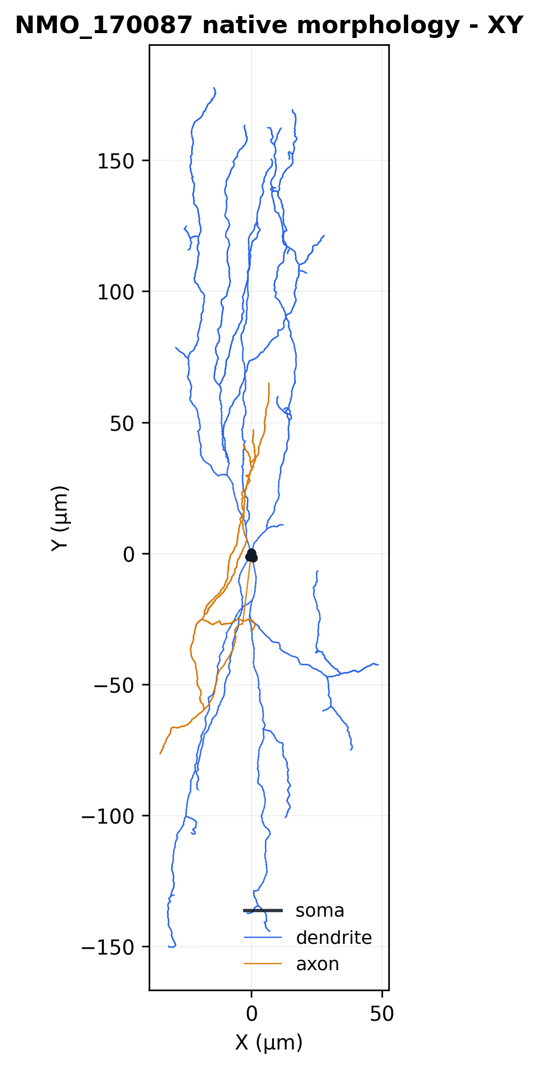
Figure 1. Native deposited morphology in XY; axon shown separately from soma/dendrites.
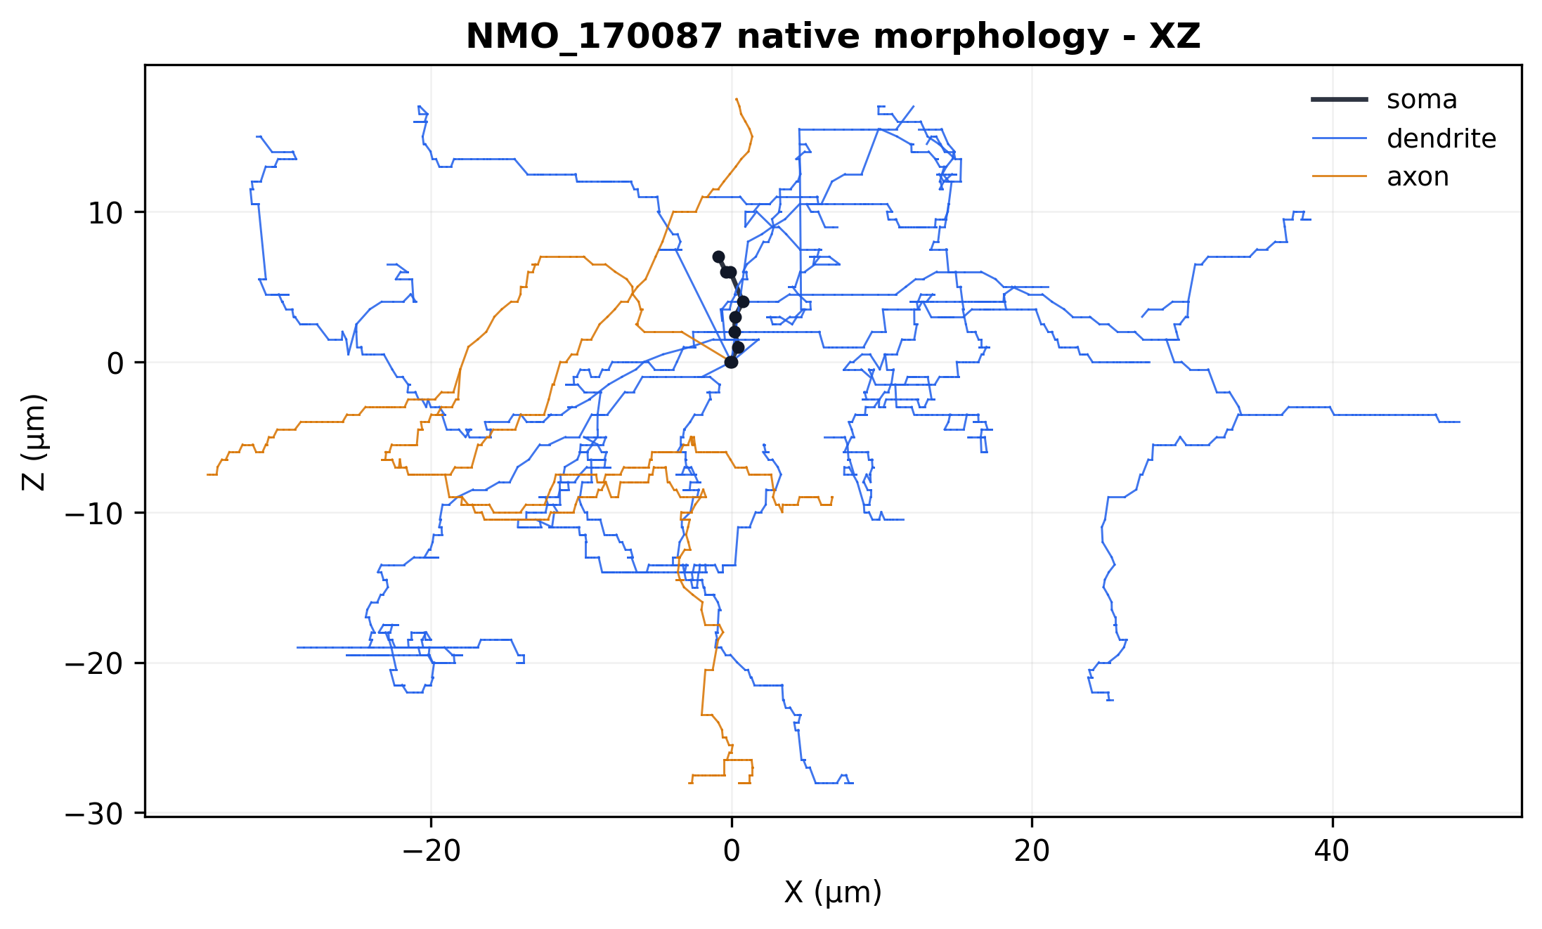
Figure 2. Native morphology in XZ, showing the limited sagittal-section depth.
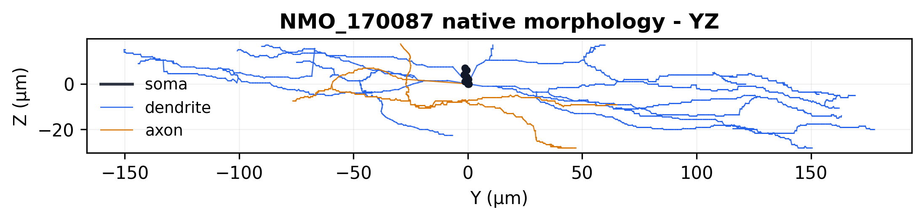
Figure 3. Native morphology in YZ.
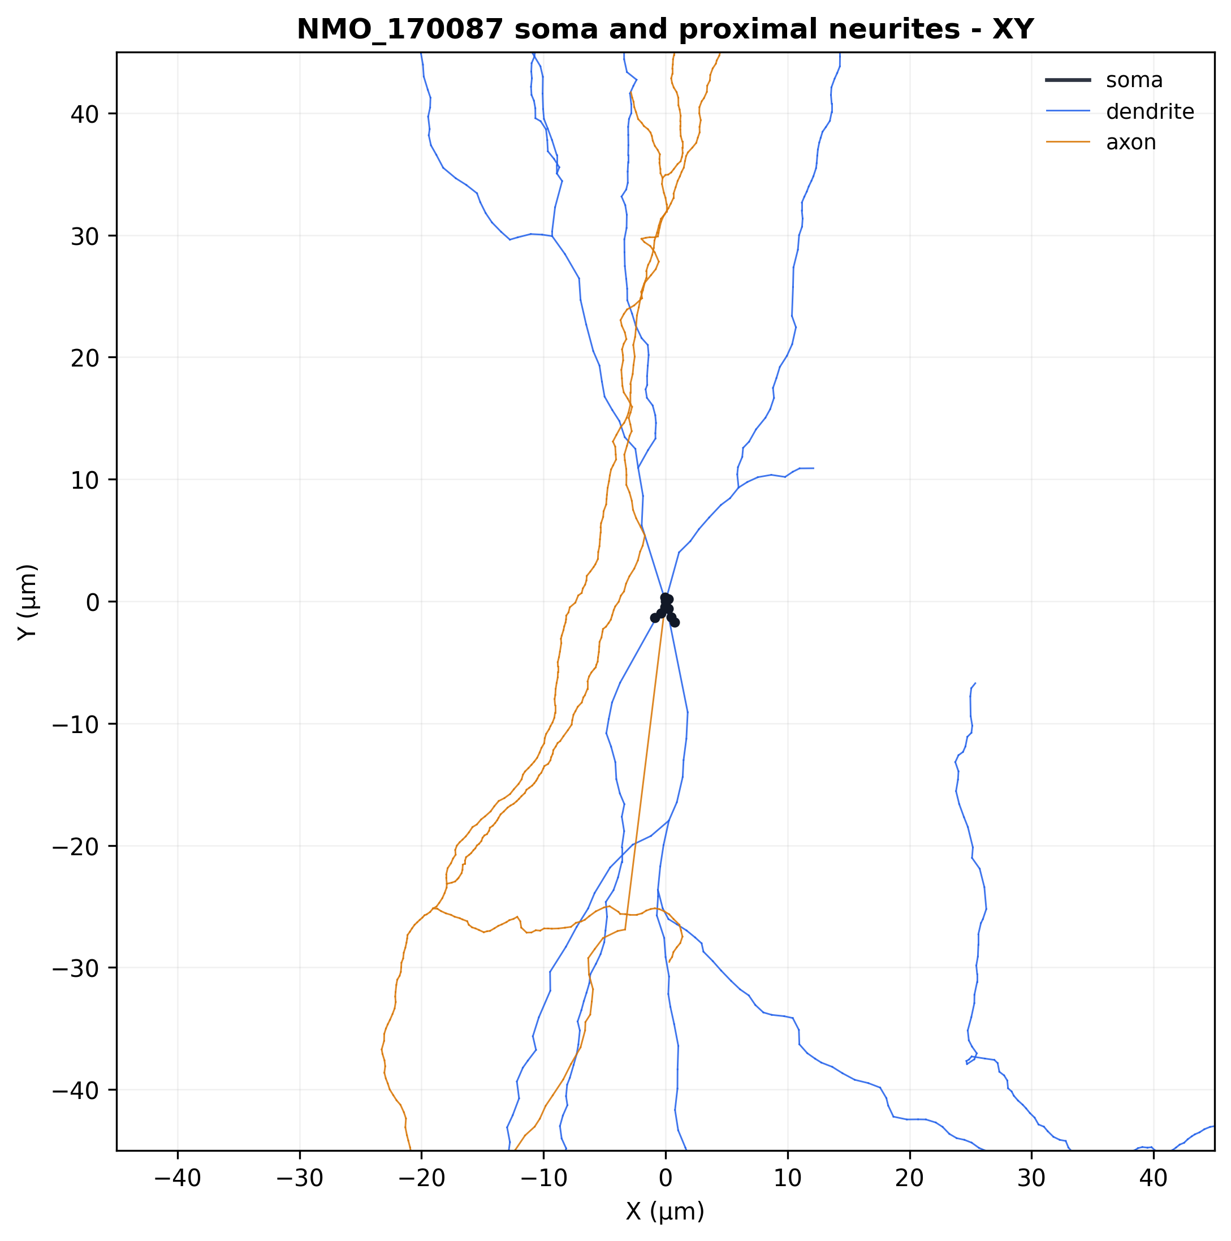
Figure 4. Soma and proximal-neurite zoom; no synthetic process is present.
Metric | Result
Nodes | 2,897
Soma / dendrite / axon nodes | 9 / 2,240 / 648
Roots / components | 1 / 1
Orphans | 0
Duplicate coordinates or records | 0
Zero-length segments | 0
Non-positive radii | 0
Branch points / endpoints | 30 / 34
Dendritic cable | 1,727.654 um
Axonal cable | 390.994 um
Total cable | 2,129.952 um
Maximum root path | 215.263 um
Imported surface | 7,596.193 um2
NeuroMorpho soma surface | 396.349 um2
Imported soma surface | 427.408 um2
Structural QA | PASS
Anatomical completeness | LIMITED: moderate dendrites, incomplete axon

The XY, XZ, YZ, and soma/proximal zoom figures show a clean connected arbor without plotting artifacts. Structural integrity does not imply completeness.

5. Evidence hierarchy
Level | Meaning | Cell 1 use
SC | Same reconstructed cell | Geometry, PV, Pax2, location
SP | Same identified population | Mouse dorsal-horn PV physiology
PL | Population level | All passive/active quantitative targets
AN | Anatomical analogue | Not needed for primary baseline
M | Medlock-derived | iPV mapping; kinetic lineage only
F | Fitted | Leak and active conductance densities
A | Assumed | Ra, cm range, reversals, regional distribution
P | Prediction | Exact-morphology outputs and 35 C translation

The evidence matrix was written before fitting. It does not merge cohort values as though they were same-cell measurements.

6. Passive electrophysiology
The strongest adult PV passive source is Gradwell et al. 2022 (Front Neural Circuits; DOI 10.3389/fncir.2022.834173). At 21-24 C, adult PV neurons had Rin 225 +/- 22 MOhm and whole-cell capacitance 10.9 +/- 0.6 pF. Rin and capacitance were derived from a 5-mV, 10-ms voltage-clamp step from -70 mV.
The source did not report membrane time constant or unforced RMP. Current-clamp experiments held cells at -60 mV using bias current; -60 mV is therefore not labeled RMP. The model uses a standardized -20 pA, 800-ms pulse to obtain a stable voltage response and to remain compatible with the published 800-ms active protocol.

7. Passive model parameters
Parameter | Value | Units | Source/reason | Confidence
Ra | 150 | ohm cm | restrained grid; model assumption | Low
cm | 0.5 | uF/cm2 | lower pre-registered boundary minimizes capacitance mismatch | Low
g_pas | 6.076828312e-5 | S/cm2 | fitted to Rin | Moderate
e_pas | -60 | mV | experimental holding condition, not RMP | Low
d_lambda | 0.1 at 100 Hz | dimensionless | numerical baseline | Engineering
dt | 0.025 | ms | converged fixed step | Engineering

8. Passive validation
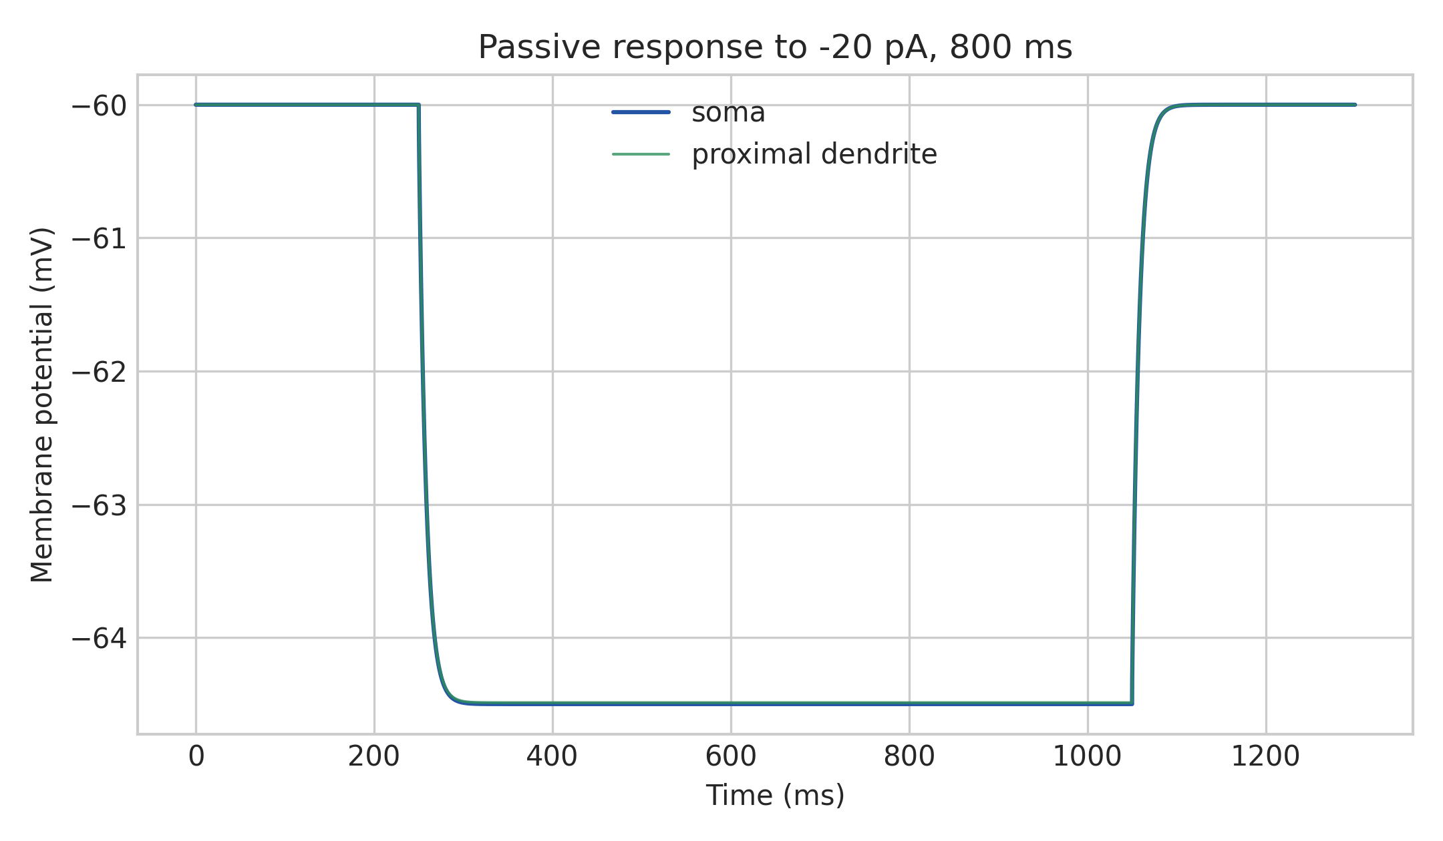
Figure 5. Passive response to the standardized -20 pA, 800-ms current step.
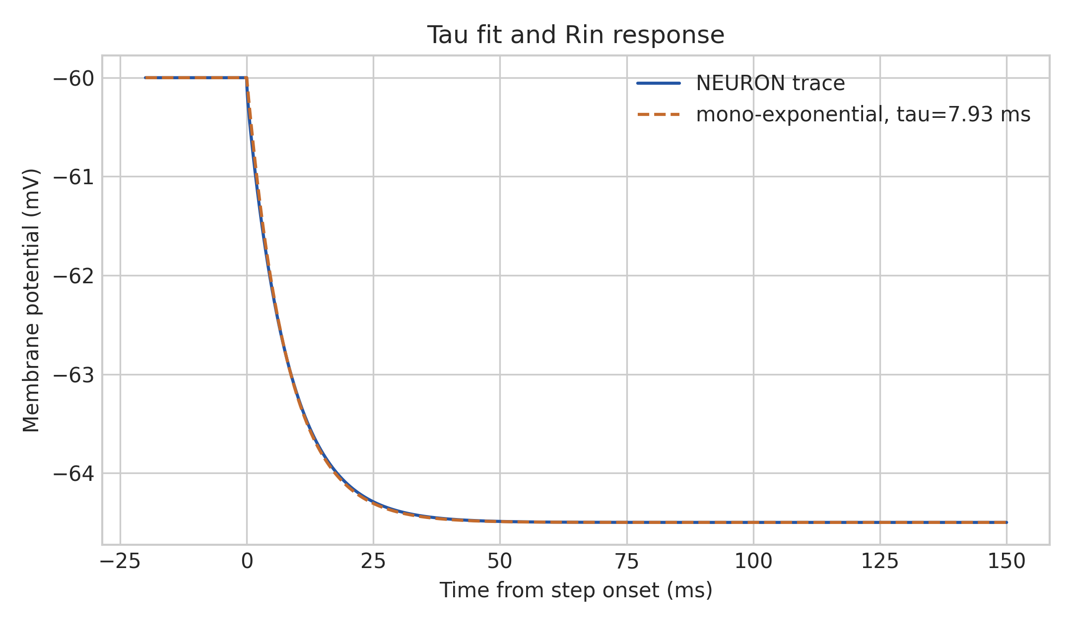
Figure 6. Somatic charging response, mono-exponential tau fit, and Rin probe.
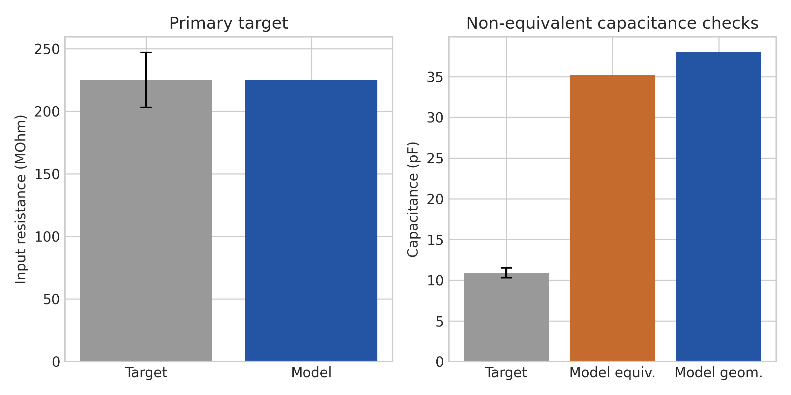
Figure 7. Primary Rin target and non-equivalent capacitance comparisons.
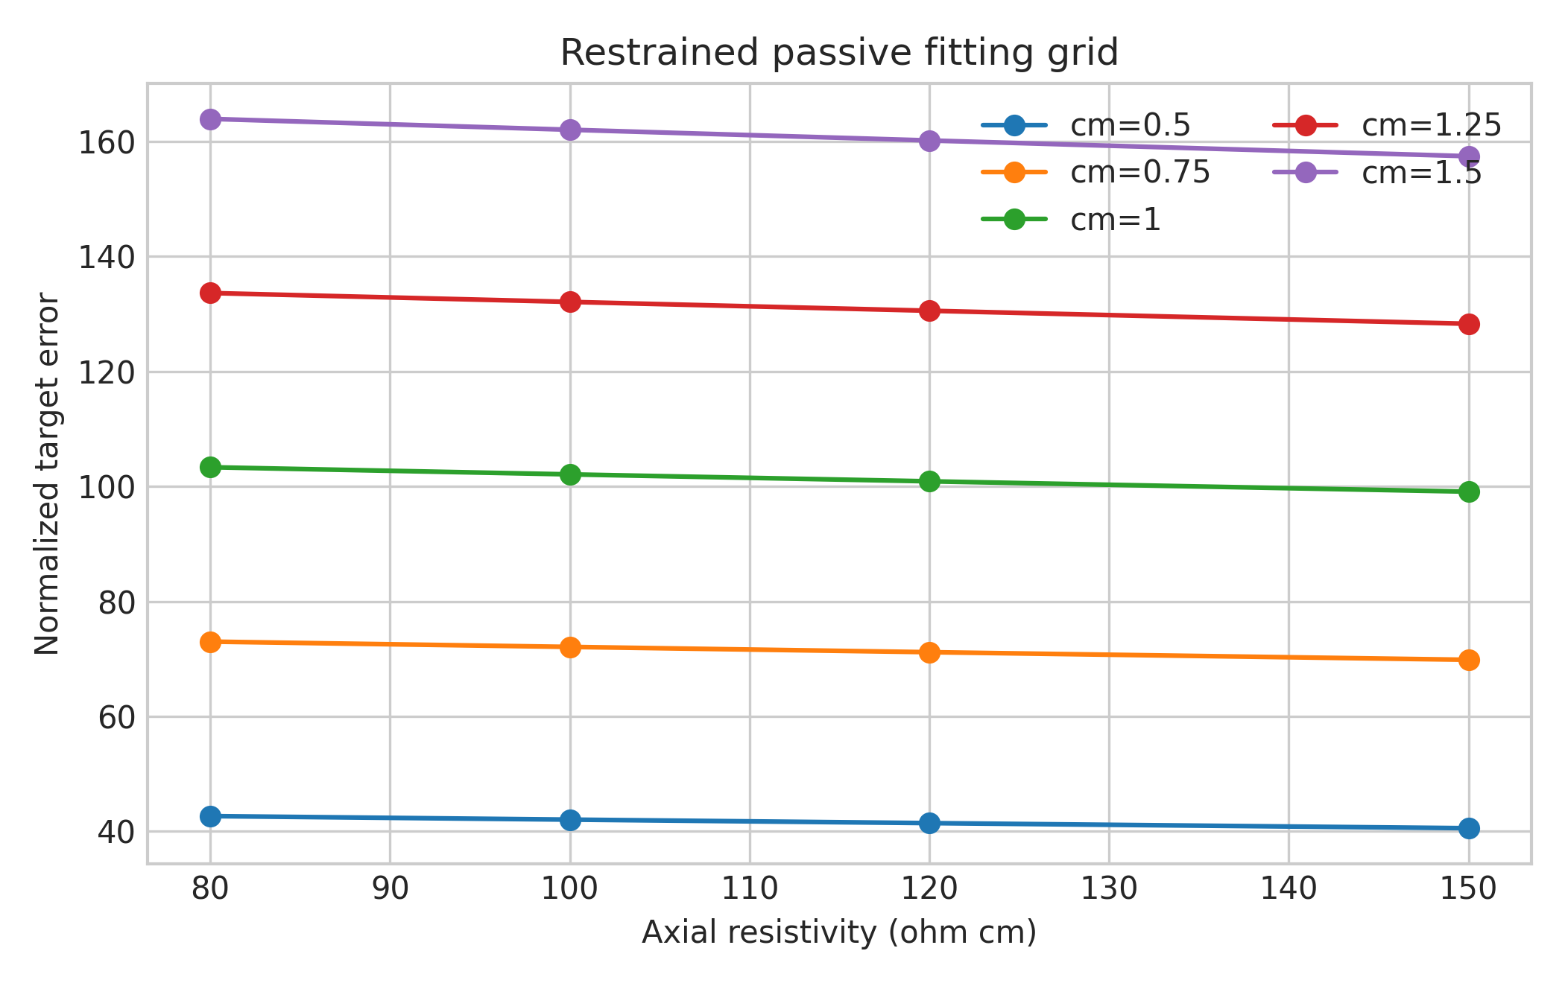
Figure 8. Retained restrained passive-parameter grid.
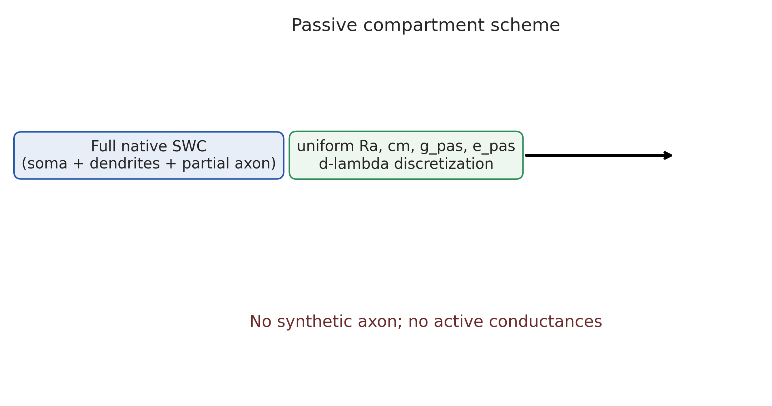
Figure 9. Full native-morphology passive compartment scheme.
Metric | Experimental target | Model | Error | Gate
Rin | 225 +/- 22 MOhm | 225.000 MOhm | approximately 0% | PASS
Equivalent C from tau/Rin | 10.9 +/- 0.6 pF | 35.230 pF | 223.2% | FAIL
Geometric capacitance | no equivalent target | 37.981 pF | n/a | REPORTED
Mono-exponential tau | not reported | 7.927 ms | n/a | NO TARGET

The capacitance failure is not concealed. Achieving 10.9 pF would require cm below the restrained 0.5-1.5 uF/cm2 range. Whole-cell electrode capacitance and total reconstructed membrane capacitance are not identical observables, so the failed comparison was not treated as a reason to distort cm further.

9. Active electrophysiology
Gradwell et al. report tonic firing in 64.2% of a broader PV cohort and in 55% of the adult cohort; the remainder was predominantly initial bursting. Adult population values at rheobase were 77 +/- 7 pA, threshold -34.9 +/- 1.3 mV, amplitude 44.8 +/- 1.6 mV, half-width 1.4 +/- 0.1 ms, AHP relative to threshold -17.6 +/- 1.6 mV, and AHP half-width 28.9 +/- 6.9 ms. Measurements were at 21-24 C, from -60 mV, with 800-ms steps in 20-pA increments. Voltages were reported without correction for a 14.7-mV liquid junction potential.
No exact-cell F-I curve or firing trace exists for NMO_170087. Model comparisons use the source’s uncorrected voltage convention and are labeled SP/PL.

10. Ion channels
Mechanism | Ion/role | Location | Evidence | Decision
pas | leak/subthreshold | all sections | passive response requires it | Include
l571_na | Na; AP initiation/upstroke | soma, native axon; absent dendrites | spiking requires fast Na; exact isoform unknown | Include
l571_kdr | K; repolarization/repetitive firing | soma, dendrites, native axon | repetitive narrow spikes require outward current; exact isoform unknown | Include
SK | K(Ca); slow AHP/adaptation | none | same-population modulation exists | Exclude baseline: adds Ca/buffering parameters and would likely deepen already excessive AHP
VGCC | Ca entry | none | no quantitative Cell 1 target | Exclude
HCN/Ih | sag/rebound | none | no quantitative selected sag target | Exclude
A-type K | delay/transient firing | none | target is tonic, not delayed | Exclude

The Na and KDR equations are reused from audited project mechanisms to avoid MOD duplication. The kinetic lineage is Medlock ModelDB 267056, but all Cell 1 densities are newly fitted. Q10 and Tref are explicit.

11. Active parameters
Region | Na (S/cm2) | KDR (S/cm2) | Status
Soma | 0.006 | 0.003 | MODEL-FITTED
Dendrites | 0 | 0.002 | MODEL-FITTED/ASSUMED
Proximal 30 um native axon | 0.4 | 0.03 | MODEL-FITTED; MODEL-DEFINED AIS proxy
Distal native axon | 0.02 | 0.01 | MODEL-FITTED/ASSUMED

The source’s moderate/incomplete morphology and archive diameter warning make exact density interpretation uncertain. The proximal region is not histologically confirmed as an AIS.

12. Active validation
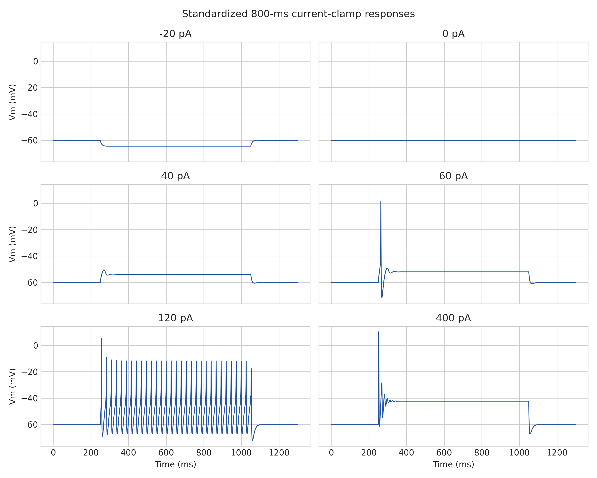
Figure 10. Representative current-clamp traces, including strong-current block.
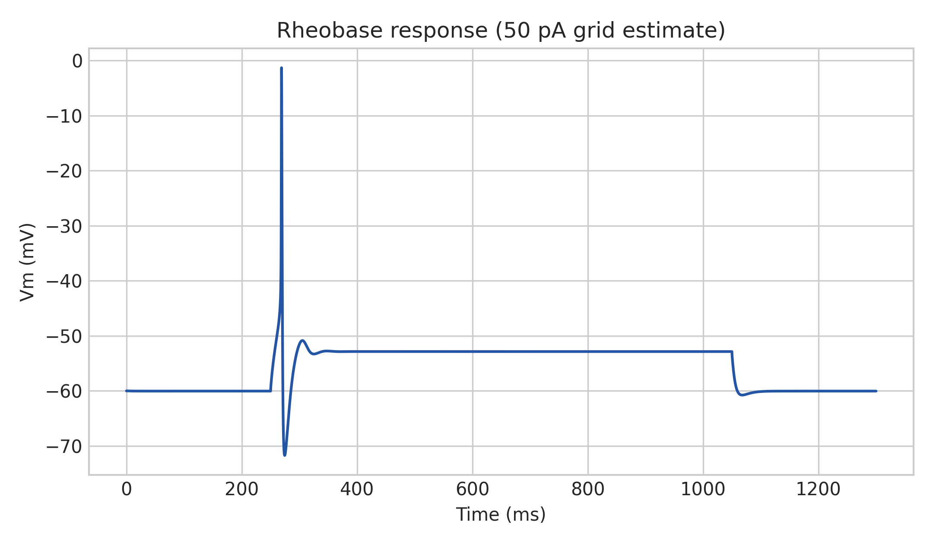
Figure 11. Model rheobase response on the final 10-pA validation grid.
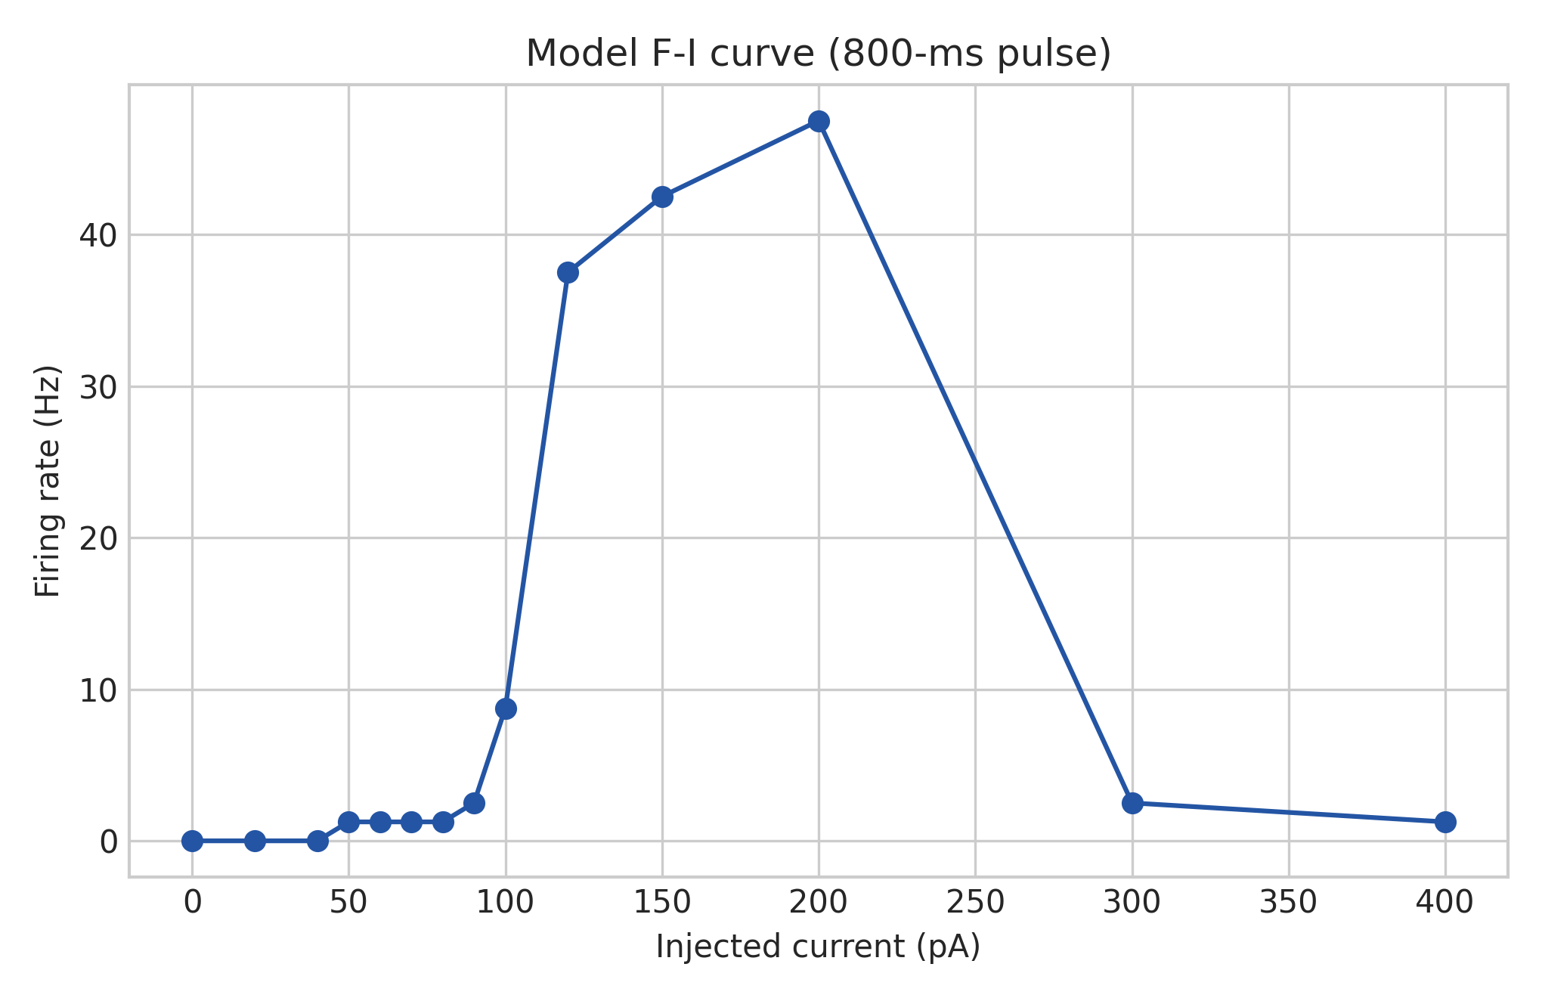
Figure 12. F-I curve over the standardized 800-ms protocol.
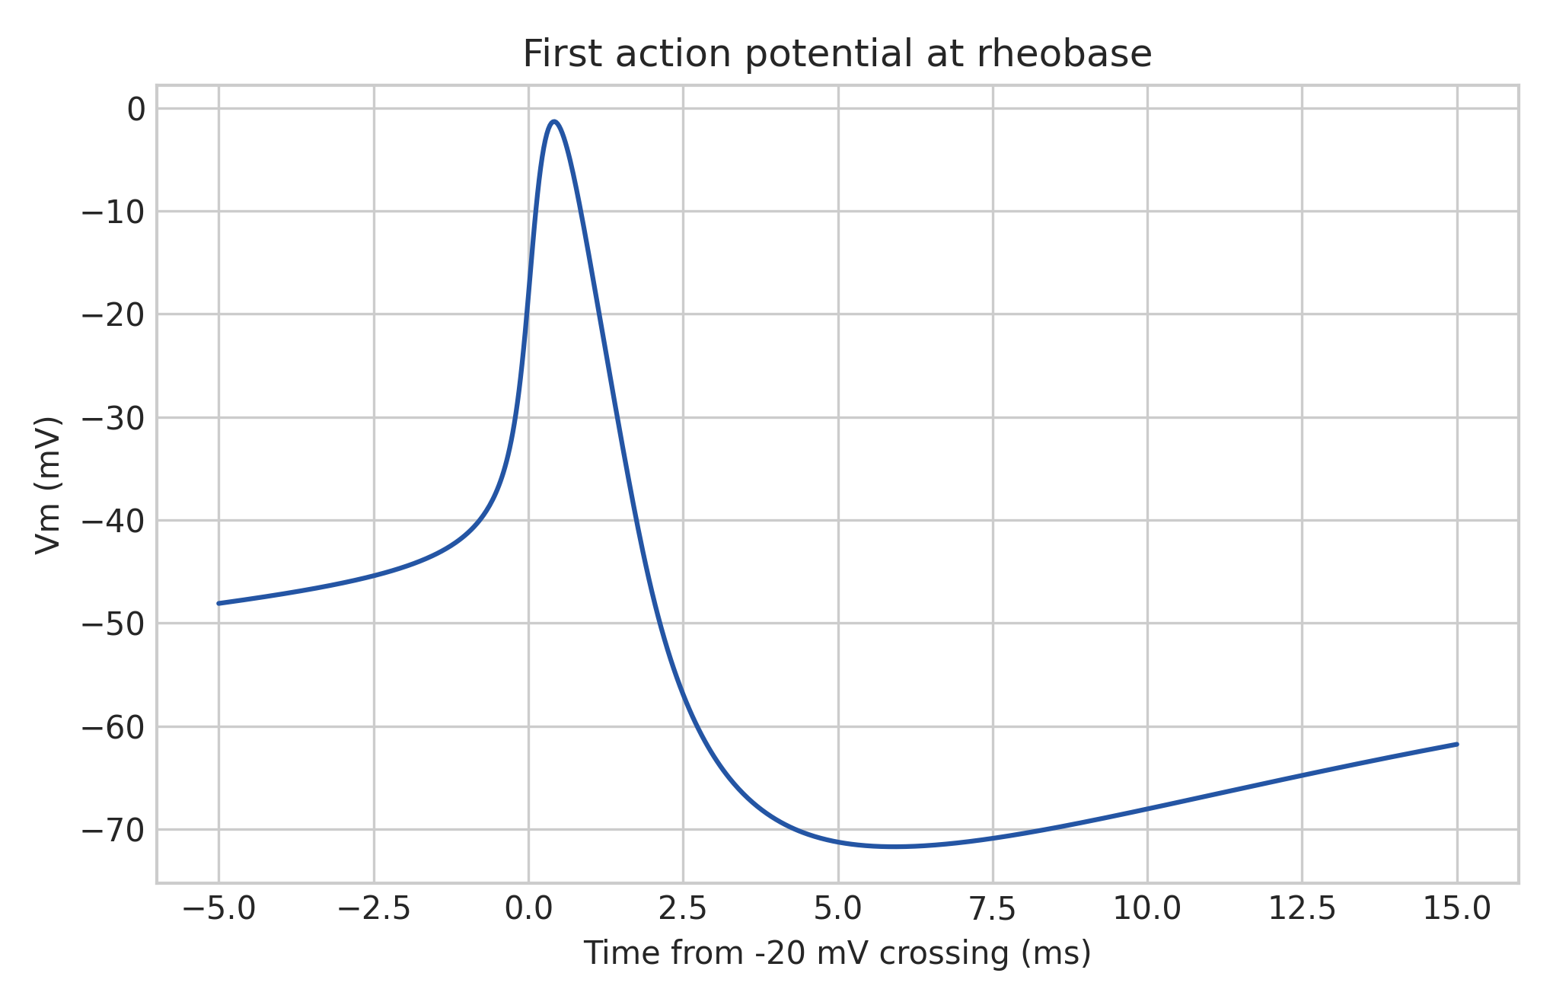
Figure 13. First action potential at model rheobase.
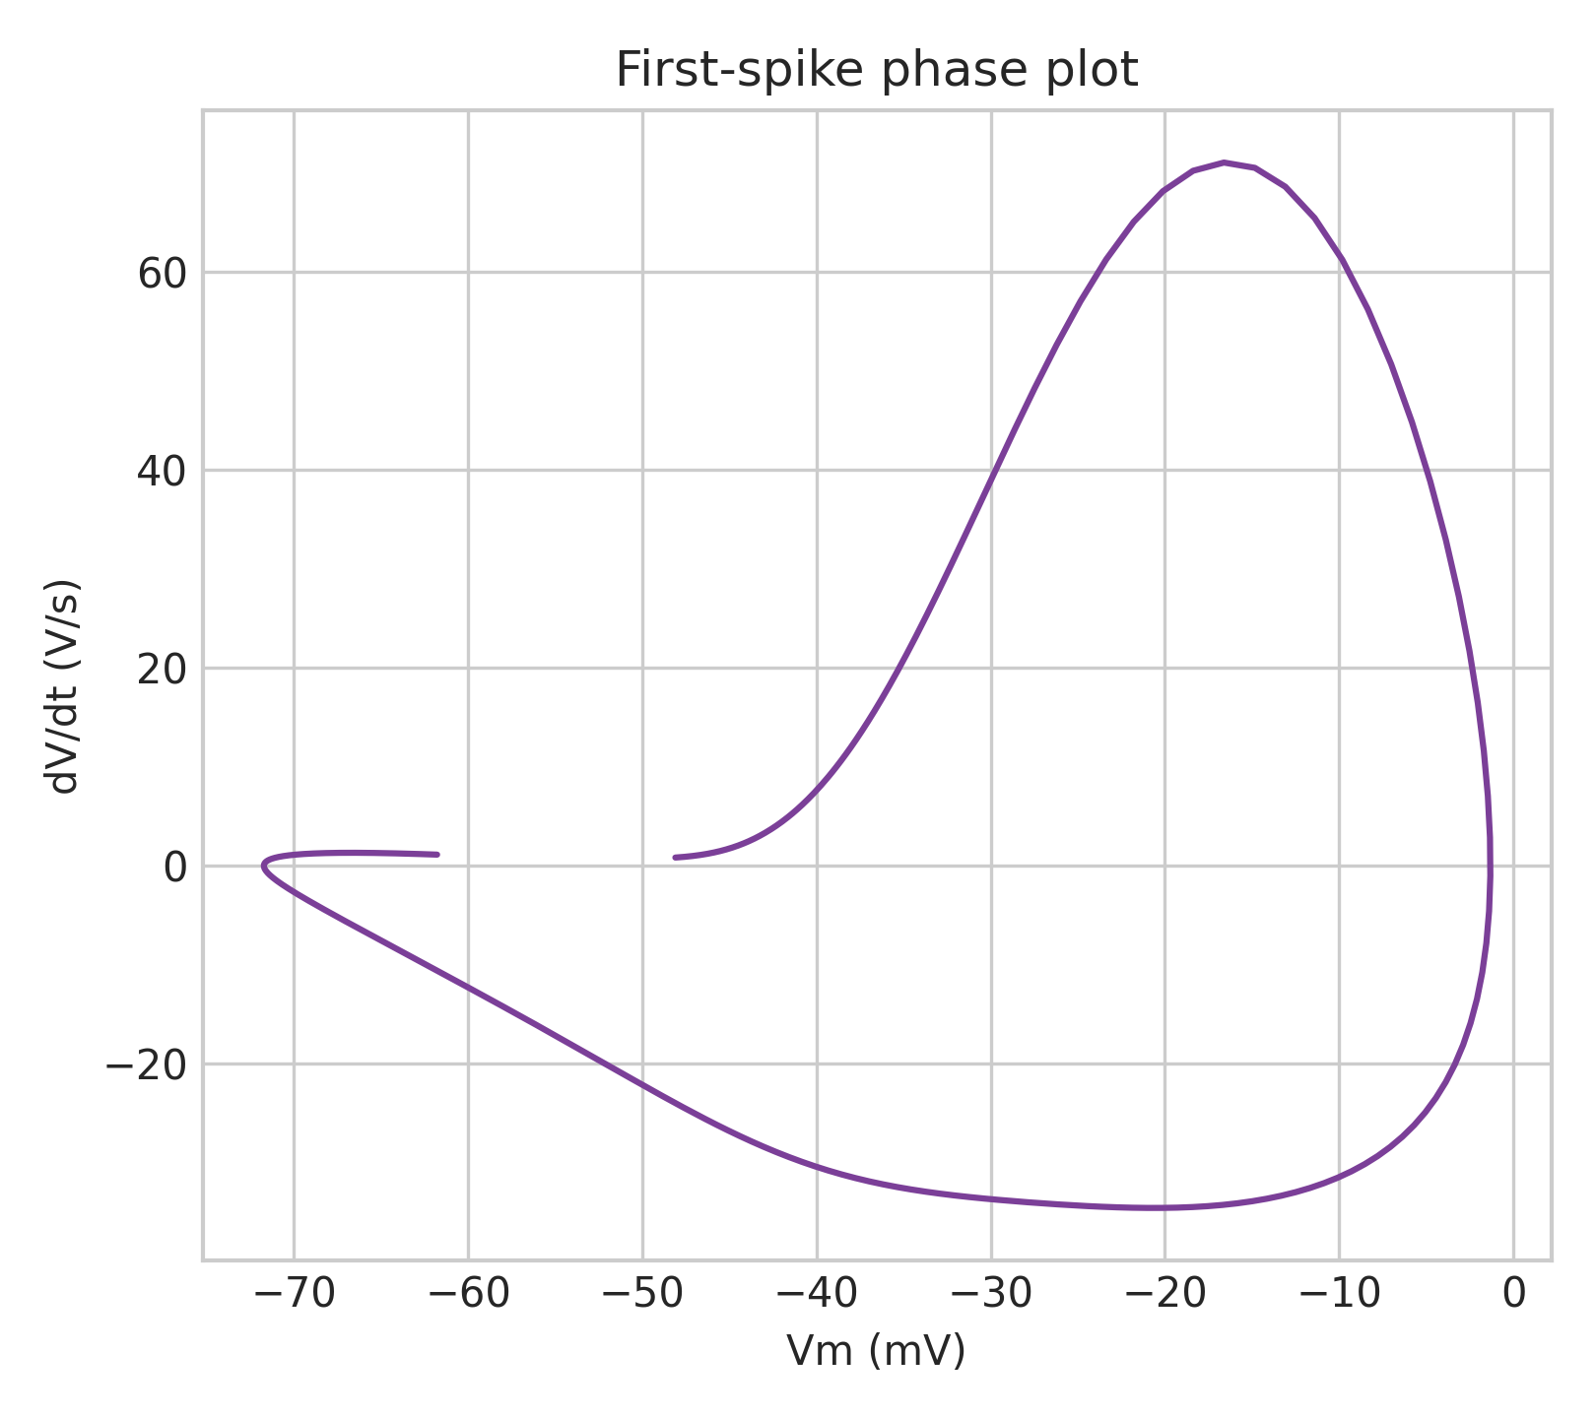
Figure 14. First-spike phase plot.
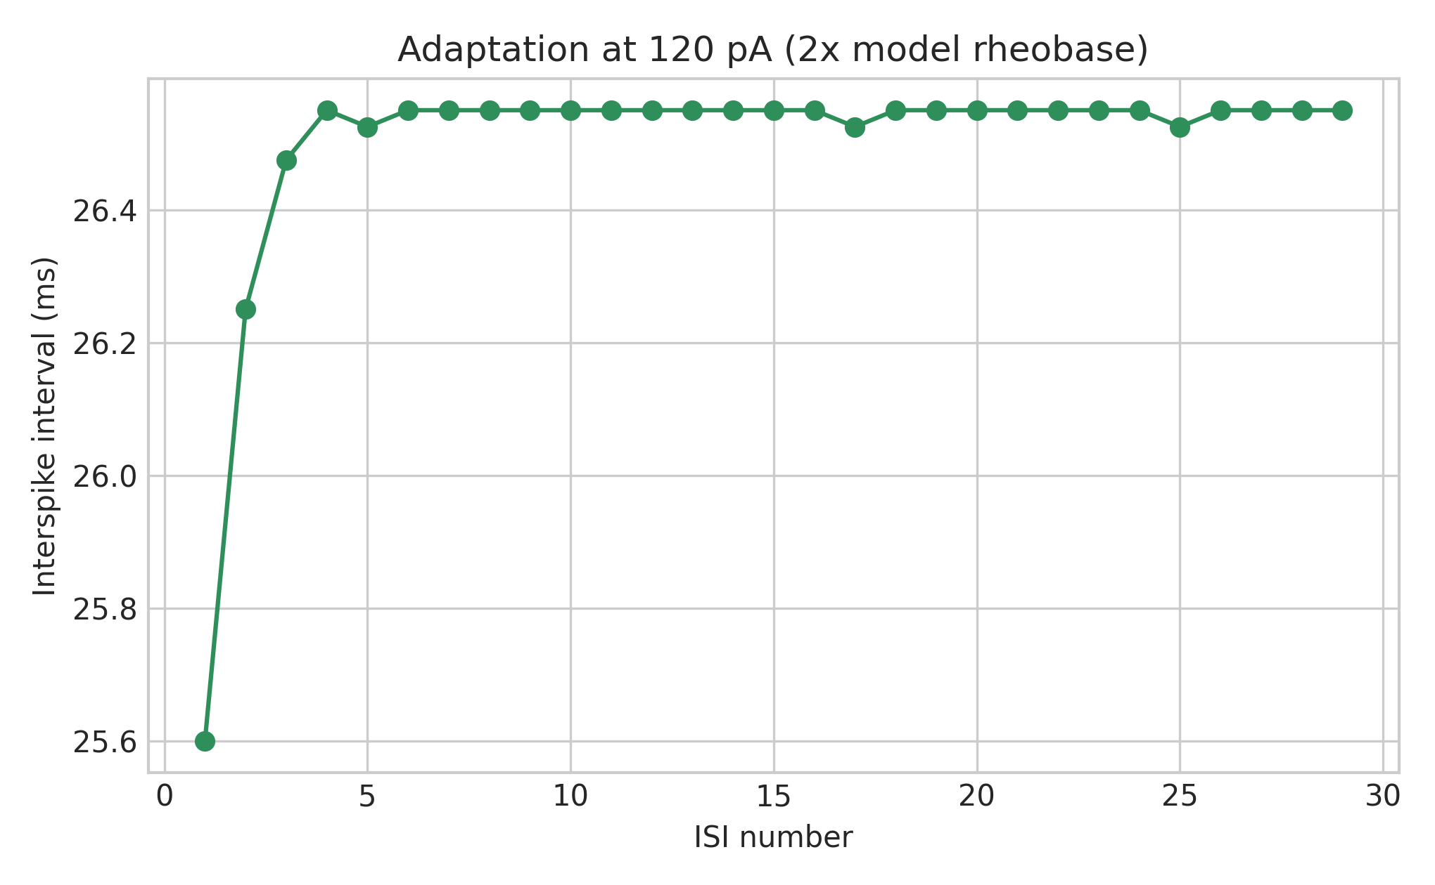
Figure 15. Interspike intervals at 120 pA.
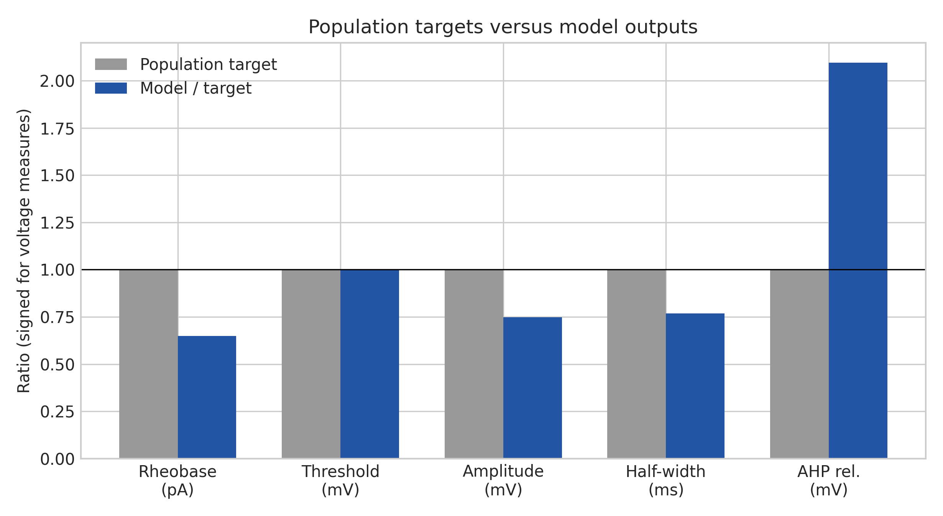
Figure 16. Signed target ratios exposing active-model mismatches.
Metric | Population target | Model | Acceptance | Status
Active-model Rin probe | 225 +/- 22 MOhm passive target | 219.738 MOhm | 203-247 MOhm | PASS
Rheobase | 77 +/- 7 pA | 50 pA | 63-91 pA | FAIL
AP threshold | -34.9 +/- 1.3 mV | -34.839 mV | -37.5 to -32.3 | PASS
AP amplitude | 44.8 +/- 1.6 mV | 33.514 mV | 41.6-48.0 | FAIL
AP half-width | 1.4 +/- 0.1 ms | 1.075 ms | 1.2-1.6 | FAIL
AHP relative threshold | -17.6 +/- 1.6 mV | -36.877 mV | -20.8 to -14.4 | FAIL
Tonic persistence | tonic common | 30 spikes at 120 pA; final spike at 96.84% | >=3 spikes and >=80% | PASS
Recovery | engineering target | returns near baseline | within 5 mV | PASS

At 120 pA the model fires 30 spikes (37.5 Hz), with an adaptation ratio of 1.037. The F-I curve rises through 200 pA (38 spikes, 47.5 Hz) and then collapses at 300-400 pA, a model-predicted depolarization-block transition without a matching experimental threshold.

13. Temperature
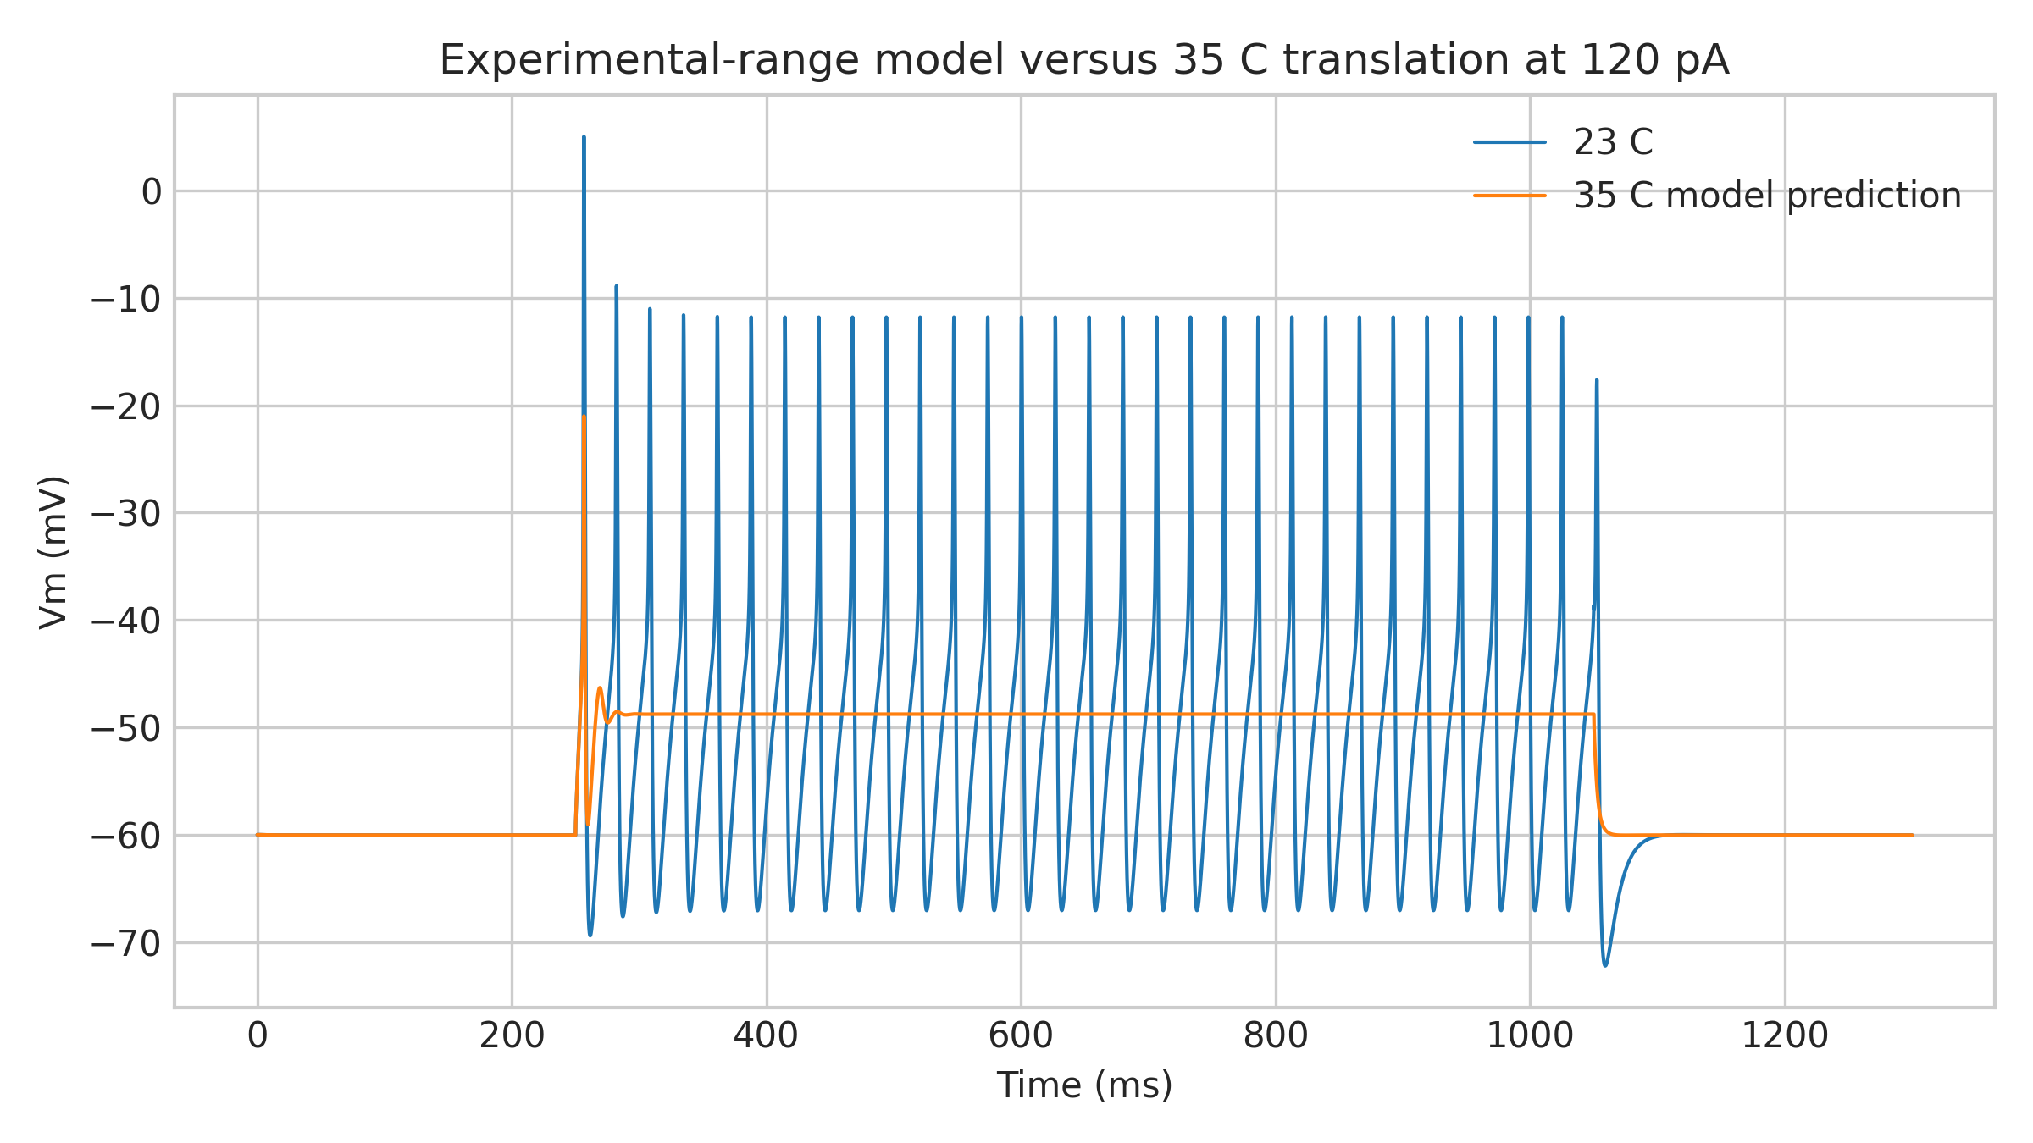
Figure 17. Primary 23 C model and explicitly predictive 35 C translation at 120 pA.
Experimental recordings were at 21-24 C. The 23 C model is primary. Q10 = 3 and Tref = 23 C scale Na and KDR time constants through Q10^((T-Tref)/10); conductance maxima and passive properties do not scale.
Temperature | Classification | Rheobase | Spikes at 120 pA | Interpretation
21 C | experimental-range model | 50 pA | 27 | comparison
23 C | primary model | 50 pA | 30 | primary
24 C | experimental-range model | 50 pA | 32 | comparison
35 C | MODEL PREDICTION | 150 pA | 0 | not experimentally validated

The 35 C translation is not ready for physiological network simulation.

14. AIS and axon
The native reconstructed axon is incomplete. No synthetic axon is created. The model applies enriched Na/KDR density to the first 30 um of native axonal path distance and labels this region MODEL-DEFINED AIS proxy.
At 120 pA, shortening enrichment to 15 um or making the reconstructed axon passive abolishes spiking; lengthening it to 45 um produces 36 rather than 30 spikes. The native axon’s incomplete state and the model’s dependence on this distribution are major limitations.

15. Numerical robustness
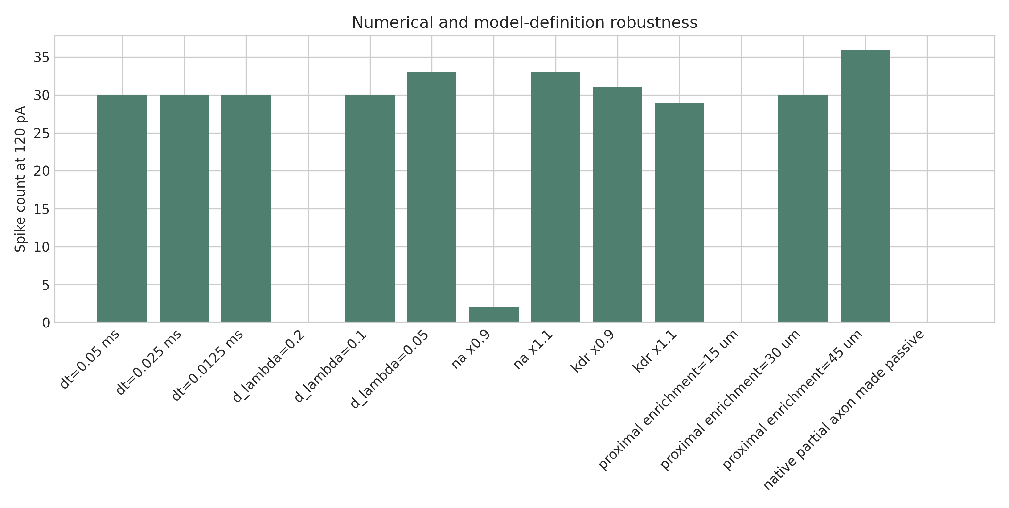
Figure 18. Spike-count sensitivity to numerical and model-definition changes.
Test family | Conditions | Outcome
dt | 0.05 / 0.025 / 0.0125 ms | 30 spikes at every dt; first-AP peak differs by 0.13 mV
d_lambda | 0.2 / 0.1 / 0.05 | 0 / 30 / 33 spikes; incomplete spatial convergence
Initial voltage | -70 / -60 / -50 mV | 30 spikes each
Global Na | -10% / baseline / +10% | 2 / 30 / 33 spikes; high sensitivity
Global KDR | -10% / baseline / +10% | 31 / 30 / 29 spikes
g_pas +/-5% | 32 / 28 spikes | moderate sensitivity
cm +/-10% | 32 / 29 spikes | moderate sensitivity
Ra +/-10% | 30 / 31 spikes | small sensitivity
Temperature | 22 / 24 C | 29 / 32 spikes
Proximal enrichment | 15 / 30 / 45 um | 0 / 30 / 36 spikes

The model passes timestep and initialization checks but fails a strict robustness interpretation for spatial discretization, sodium density, and proximal-axon definition.

16. Comparison with Medlock
Feature | Real reconstructed cell/population | Cell 1 model | Medlock iPV | Interpretation
Identity | Mouse PV+/Pax2+, lamina II-III | same morphology/identity | abstract iPV population | mapping only
Morphology | real 3D; moderate dendrites; incomplete axon | native import | reduced rule-based morphology | Cell 1 is anatomically richer but incomplete
Rin | 225 +/- 22 MOhm population | 225.000 passive; 219.738 active probe | model-defined | real-population target prioritized
Capacitance | 10.9 +/- 0.6 pF population | 35.230 pF equivalent; fail | model-defined | mismatch exposed
Active mechanisms | molecular densities unknown | Na + KDR + leak | broader rule set/model mechanisms | minimal set used
Firing | tonic common; initial burst also present | tonic at 120-200 pA | iPV phenotype | population match only
Temperature | 21-24 C experiments | 23 C primary | project/model convention | 35 C only a prediction

Medlock conductances were not copied. Its mechanism equations are a documented kinetic lineage/control, subordinate to real-cell and same-population evidence.

17. Limitations
- No exact-cell electrophysiology is linked to NMO_170087.
- NeuroMorpho grades dendrites moderate, axon incomplete, and diameters unconfirmed.
- Passive capacitance comparison fails at the lowest restrained cm.
- Ra, cm, reversals, channel identities, densities, and distributions are assumed/fitted.
- The active model fails four population gates.
- AHP half-width is not modeled accurately by the minimal channel set.
- Strong-current depolarization block has no matching quantitative target.
- Spatial convergence is incomplete at the phenotype level.
- The response is highly sensitive to Na density and proximal-axon enrichment.
- The 35 C translation is unvalidated and qualitatively different from 23 C.

18. What is directly supported
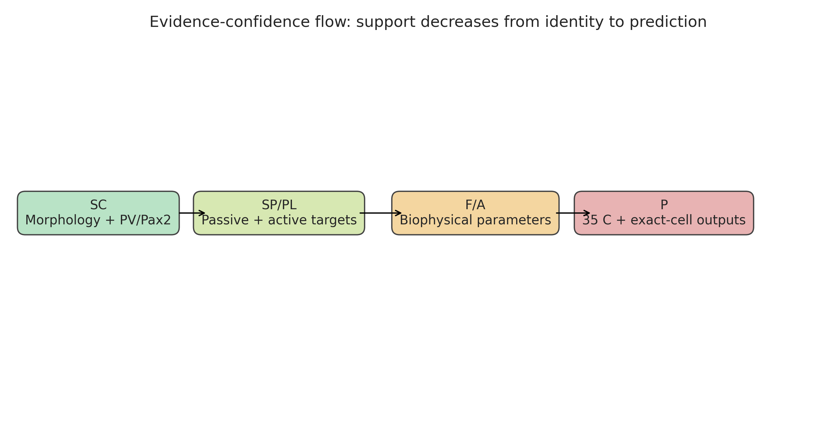
Figure 19. Evidence confidence decreases from same-cell identity to model prediction.
Claim | Support | Confidence
PV reporter positive | exact reconstructed cell | High
Pax2 positive/inhibitory identity | exact reconstructed cell | High
Lumbar dorsal horn lamina II-III | exact reconstructed cell | High
Native morphology topology | exact deposited reconstruction | High for deposited data; completeness limited
Adult PV Rin and waveform target values | same identified population | Moderate-high, population only
Tonic firing common in PV cohorts | same identified population | Moderate-high, population distribution

19. What is model-derived
Item | Classification | Confidence
Ra, cm, e_pas | MODEL-ASSUMED/FITTED | Low
g_pas | MODEL-FITTED to Rin | Moderate
Na/KDR kinetic choice | MEDLOCK-DERIVED/project-reused | Low-moderate
All channel densities | MODEL-FITTED | Low
Proximal 30-um enrichment | MODEL-ASSUMED/FITTED | Low
Exact-cell F-I and waveform | MODEL-PREDICTED | Low
35 C response | MODEL-PREDICTED | Low

20. Final model status
Single-cell implementation: ENGINEERING READY / BIOLOGICALLY PROVISIONAL. Network integration: NO.
The package is reproducible, auditable, and suitable for targeted single-cell refinement. It is not a defensible production network component because the active phenotype depends on a sensitive model-defined axonal region, four quantitative active gates fail, spatial convergence is incomplete, and the 35 C translation lacks physiological support.

21. Reproducibility
Environment: Linux/WSL, Python 3.10.20, NEURON 9.0.1, NumPy 2.2.6. Commands are run from repository root on branch repo-reorganization-2026-08.
(cd cells/L571_inhibitory_interneuron/mechanisms && nrnivmodl)
python cells/23-04-18C-04-cell-1_inhibitory_interneuron/scripts/morphology_qa.py
python cells/23-04-18C-04-cell-1_inhibitory_interneuron/scripts/prepare_model_swc.py
python cells/23-04-18C-04-cell-1_inhibitory_interneuron/scripts/fit_passive.py
python cells/23-04-18C-04-cell-1_inhibitory_interneuron/scripts/fit_active.py
python cells/23-04-18C-04-cell-1_inhibitory_interneuron/scripts/refine_active.py
python cells/23-04-18C-04-cell-1_inhibitory_interneuron/scripts/targeted_active_search.py
python cells/23-04-18C-04-cell-1_inhibitory_interneuron/scripts/validate_cell.py
python -m unittest discover -s tests
Deterministic identifier/seed 170087 is stored even though current protocols contain no stochastic process. Full sweeps, selected JSON, traces, metrics, and figures are retained. Build products are excluded.

22. File manifest
- morphology/primary/: immutable downloaded SWC.
- morphology/model/: blank-line-only parser copy.
- morphology/metadata/: raw and consolidated NeuroMorpho metadata.
- morphology/provenance/: narrative and machine-readable transformation ledger.
- parameters/passive/, active/, final/: search inputs and frozen final configuration.
- mechanisms/MANIFEST.md: dependency declaration; no duplicated MOD files.
- scripts/: QA, conversion, fitting, validation, and report builders.
- results/morphology_qa/, passive/, active/, temperature/, robustness/, validation/: machine-readable outputs.
- figures/morphology/, passive/, active/, final/: publication-scale figures.
- docs/evidence/: evidence matrix, passive evidence, and channel audit.
- docs/methodology/: pre-fit, mechanism, and temperature decisions.
- reports/: focused validation reports and complete Markdown/DOCX report.

23. References
- Gradwell MA et al. Diversity of inhibitory and excitatory parvalbumin interneuron circuits in the dorsal horn. Pain. 2022;163:e432-e452. DOI 10.1097/j.pain.0000000000002422. PMID 34326298. PMCID PMC8832545.
- Gradwell MA et al. Altered Intrinsic Properties and Inhibitory Connectivity in Aged Parvalbumin-Expressing Dorsal Horn Neurons. Front Neural Circuits. 2022;16:834173. DOI 10.3389/fncir.2022.834173. PMID 35874431. PMCID PMC9305305.
- Ma et al. Modulation of SK Channels via Calcium Buffering Tunes Intrinsic Excitability and Firing Properties of Spinal Dorsal Horn Neurons. J Neurosci. 2023;43:5608-5623. DOI 10.1523/JNEUROSCI.0426-23.2023. PMID 37451982. PMCID PMC10401647.
- Gradwell MA et al. Heteromeric alpha/beta glycine receptors regulate excitability in parvalbumin-expressing dorsal horn neurons. J Physiol. 2017. DOI 10.1113/JP274926. PMID 28905384. PMCID PMC5709328.
- Medlock L et al. Computational model and mechanisms deposited as ModelDB accession 267056 (2022); used only as documented kinetic lineage/control.

Appendices
The Word report embeds the final parameter set, passive/active validation tables, F-I data, morphology QA, evidence matrix, channel justification, and robustness summary. The source CSV/JSON files remain authoritative for machine-readable precision.

Appendices
These appendices embed the complete selected configuration and machine-readable validation records. Repository CSV/JSON files remain authoritative for numerical precision.

Appendix A. Full final parameter JSON
{
"schema_version": "1.0",
"model_id": "NMO_170087",
"cell_name": "23-04-18C-04-cell-1",
"status": "engineering_ready_biologically_provisional",
"random_seed": 170087,
"temperature_c": 23.0,
"morphology": {
"file": "morphology/model/23-04-18C-04-cell-1.model.swc",
"source_file": "morphology/primary/23-04-18C-04-cell-1.CNG.swc",
"source_sha256": "e2ecaffc1ebcf9c88b72224fa4172aa93dfb013edb3ad40ee2bfadebe06ec915",
"model_sha256": "0e05613af9b747d3ca856d1b643c7c776d8207df2397637d302144834ea8c9f2",
"transformation": "blank lines removed only",
"synthetic_axon": false,
"axon_status": "native reconstructed axon retained; NeuroMorpho marks it incomplete"
},
"discretization": {
"method": "d_lambda",
"frequency_hz": 100.0,
"d_lambda": 0.1
},
"passive": {
"ra_ohm_cm": 150.0,
"cm_uf_cm2": 0.5,
"g_pas_s_cm2": 0.00006076828312277793,
"e_pas_mv": -60.0,
"classification": {
"ra_ohm_cm": "MODEL-ASSUMED",
"cm_uf_cm2": "MODEL-ASSUMED at lower restrained boundary",
"g_pas_s_cm2": "MODEL-FITTED to adult PV population input resistance",
"e_pas_mv": "MODEL-ASSUMED/FITTED to experimental holding condition; not RMP"
}
},
"ions": {
"ena_mv": 60.0,
"ek_mv": -84.0
},
"active": {
"enabled": true,
"minimal_channel_set": ["l571_na", "l571_kdr", "pas"],
"mechanism_dependency": "cells/L571_inhibitory_interneuron/mechanisms",
"kinetic_source": "Medlock et al. ModelDB 267056 equations as transparently adapted in existing project l571_na/l571_kdr mechanisms",
"density_source": "Cell 1 coarse/refined deterministic search; not inherited L571 densities",
"temperature_scaling": true,
"q10_na": 3.0,
"q10_kdr": 3.0,
"reference_temperature_c": 23.0,
"temperature_equation": "rate_multiplier = Q10^((celsius - Tref)/10); maximal conductance is unchanged",
"ais_proxy_max_distance_um": 30.0,
"ais_label": "MODEL-DEFINED proximal-axon spike-initiation proxy; not an anatomically confirmed AIS",
"conductance_s_cm2": {
"soma": {"na": 0.006, "kdr": 0.003},
"dendrite": {"na": 0.0, "kdr": 0.002},
"ais_proxy": {"na": 0.4, "kdr": 0.03},
"distal_axon": {"na": 0.02, "kdr": 0.01}
}
},
"simulation": {
"dt_ms": 0.025,
"v_init_mv": -60.0,
"stim_delay_ms": 250.0,
"stim_duration_ms": 800.0,
"post_stim_ms": 250.0,
"spike_crossing_mv": -20.0
},
"protocols": {
"passive_current_na": -0.02,
"fi_currents_na": [-0.02, 0.0, 0.02, 0.04, 0.05, 0.06, 0.07, 0.08, 0.09, 0.1, 0.12, 0.15, 0.2, 0.3, 0.4],
"representative_current_na": 0.12,
"strong_current_na": 0.4
},
"evidence_scope": {
"morphology_and_markers": "same reconstructed cell",
"passive_and_active_targets": "same genetically identified population; population level",
"conductance_values": "model fitted",
"35c_behavior": "model predicted"
}
}

Appendix B. Full active validation table
Metric | Target | Model | Acceptance | Status | Evidence
rheobase | 77 +/- 7 pA | 50.0 | 63-91 pA (mean +/- 2 SEM) | FAIL | SP/PL
AP threshold | -34.9 +/- 1.3 mV | -34.839411579748024 | -37.5 to -32.3 mV (mean +/- 2 SEM) | PASS | SP/PL
AP amplitude | 44.8 +/- 1.6 mV | 33.51370805983069 | 41.6-48.0 mV (mean +/- 2 SEM) | FAIL | SP/PL
AP half-width | 1.4 +/- 0.1 ms | 1.0749999999990223 | 1.2-1.6 ms (mean +/- 2 SEM) | FAIL | SP/PL
AHP relative to threshold | -17.6 +/- 1.6 mV | -36.8773076809614 | -20.8 to -14.4 mV (mean +/- 2 SEM) | FAIL | SP/PL
tonic persistence | tonic in 55% adult and 64.2% broader PV cohorts | 0.9684062500019206 | >=3 spikes and last spike after 80% of 800-ms pulse at 2x rheobase | PASS | SP/PL
strong-current recovery | no quantitative target | 1 | spikes present and post-stimulus voltage returns within 5 mV of baseline | PASS | engineering

Appendix C. Full F-I numerical data
I (nA) | Spikes | Hz | Latency | Last spike | Mean ISI | Adapt. | Persistence
-0.02 | 0 | 0.0 |  |  |  |  | 0.0
0.0 | 0 | 0.0 |  |  |  |  | 0.0
0.02 | 0 | 0.0 |  |  |  |  | 0.0
0.04 | 0 | 0.0 |  |  |  |  | 0.0
0.05 | 1 | 1.25 | 18.499999999892736 | 18.499999999892736 |  |  | 0.02312499999986592
0.06 | 1 | 1.25 | 13.324999999897443 | 13.324999999897443 |  |  | 0.016656249999871805
0.07 | 1 | 1.25 | 10.899999999899649 | 10.899999999899649 |  |  | 0.01362499999987456
0.08 | 1 | 1.25 | 9.349999999901058 | 9.349999999901058 |  |  | 0.011687499999876323
0.09 | 2 | 2.5 | 8.224999999902082 | 40.09999999987309 | 31.87499999997101 |  | 0.050124999999841366
0.1 | 7 | 8.75 | 7.374999999902855 | 194.69999999973248 | 31.220833333304938 | 1.1601731601731602 | 0.2433749999996656
0.12 | 30 | 37.5 | 6.174999999903946 | 774.7250000015365 | 26.501724137987328 | 1.0371093750047162 | 0.9684062500019206
0.15 | 34 | 42.5 | 4.999999999905015 | 779.1750000015527 | 23.459848484898416 | 1.0329670329717304 | 0.9739687500019408
0.2 | 38 | 47.5 | 3.874999999906038 | 781.8500000015624 | 21.026351351396116 | 1.0498753117254724 | 0.977312500001953
0.3 | 2 | 2.5 | 2.7249999999070837 | 20.499999999890917 | 17.774999999983834 |  | 0.025624999999863646
0.4 | 1 | 1.25 | 2.1249999999076294 | 2.1249999999076294 |  |  | 0.002656249999884537

Appendix D. Full morphology QA JSON
{
"schema_version": "1.0",
"source_file": "morphology/primary/23-04-18C-04-cell-1.CNG.swc",
"sha256": "e2ecaffc1ebcf9c88b72224fa4172aa93dfb013edb3ad40ee2bfadebe06ec915",
"thresholds": {
"zero_length_um": 1e-12,
"suspicious_neurite_diameter_um": 10.0
},
"node_count": 2897,
"node_counts_by_type": {
"soma": 9,
"axon": 648,
"dendrite": 2240
},
"root_count": 1,
"root_node_ids": [
1
],
"orphan_count": 0,
"orphan_node_ids": [],
"connected_component_count": 1,
"connected_component_sizes": [
2897
],
"duplicate_node_id_count": 0,
"duplicate_node_ids": [],
"duplicate_coordinate_group_count": 0,
"duplicate_coordinate_groups": [],
"duplicate_exact_record_group_count": 0,
"duplicate_exact_record_groups": [],
"zero_length_segment_count": 0,
"zero_length_segment_node_ids": [],
"nonpositive_radius_count": 0,
"nonpositive_radius_node_ids": [],
"suspicious_neurite_diameter_count": 0,
"suspicious_neurite_diameter_node_ids": [],
"branch_point_count": 30,
"branch_point_node_ids": [
1,
15,
91,
149,
193,
228,
352,
422,
439,
481,
681,
694,
698,
845,
854,
905,
956,
998,
1083,
1490,
1586,
1593,
1938,
2000,
2006,
2219,
2288,
2430,
2499,
2651
],
"endpoint_count": 34,
"endpoint_node_ids": [
107,
152,
190,
282,
359,
375,
444,
471,
546,
585,
678,
850,
893,
910,
967,
1008,
1052,
1229,
1425,
1500,
1605,
1611,
1742,
1931,
1945,
2014,
2030,
2233,
2249,
2351,
2493,
2670,
2702,
2897
],
"total_cable_length_um": 2129.9518857567496,
"cable_length_by_child_type_um": {
"axon": 390.99416094270435,
"dendrite": 1727.6542186659387,
"soma": 11.303506148108355
},
"maximum_root_path_distance_um": 215.26333273261483,
"cycle_detected": false,
"radius_um": {
"minimum": 0.145,
"median": 0.46,
"maximum": 6.53665
},
"neurite_diameter_um": {
"minimum": 0.29,
"median": 0.92,
"maximum": 3.21
},
"coordinate_extents_um": {
"x": {
"minimum_um": -34.88,
"maximum_um": 48.43,
"span_um": 83.31
},
"y": {
"minimum_um": -150.3,
"maximum_um": 177.68,
"span_um": 327.98
},
"z": {
"minimum_um": -28.0,
"maximum_um": 17.5,
"span_um": 45.5
}
},
"reported_neuromorpho_soma_surface_um2": 396.349,
"reported_neuromorpho_total_surface_um2": 7083.34,
"integrity_from_neuromorpho": {
"dendrites": "Moderate",
"axon": "Incomplete"
},
"structural_qa_pass": true,
"scientific_limitations": [
"NeuroMorpho marks the dendrites as moderate integrity and the axon as incomplete.",
"The deposited record is tagged 'No Diameter'; diameter-dependent cable results require sensitivity testing.",
"A structural pass does not establish anatomical completeness or biophysical validity."
]
}

Appendix E. Full evidence matrix

Appendix E.1 Morphology
Parameter: Morphology
Value: NMO_170087
Units:
Species: mouse
Region: lumbar spinal dorsal horn
Lamina: II-III
Cell identity: PV+/Pax2+ inhibitory interneuron
Exact reconstructed cell?: Yes
Same genetic population?: Yes
Population-level?: No
Different cell class?: No
Source paper: NeuroMorpho record linked to Gradwell et al. 2022
DOI/PMID: 10.1097/j.pain.0000000000002422 / PMID 34326298
Recording temperature: Not applicable
Experimental protocol: Brainbow reconstruction in 60-um sagittal sections
Confidence: SC; high
Used in model?: Yes
Reason: Cell-specific geometry
Notes: Dendrites moderate; axon incomplete; archive says No Diameter

Appendix E.2 PV reporter identity
Parameter: PV reporter identity
Value: positive
Units:
Species: mouse
Region: lumbar spinal dorsal horn
Lamina: II-III
Cell identity: PV+/Pax2+ inhibitory interneuron
Exact reconstructed cell?: Yes
Same genetic population?: Yes
Population-level?: No
Different cell class?: No
Source paper: Gradwell et al. 2022
DOI/PMID: 10.1097/j.pain.0000000000002422 / PMID 34326298
Recording temperature: Not applicable
Experimental protocol: PVCre Brainbow labeling
Confidence: SC; high
Used in model?: Yes
Reason: Defines population mapping
Notes: Reporter identity is not a conductance measurement

Appendix E.3 Pax2 identity
Parameter: Pax2 identity
Value: positive
Units:
Species: mouse
Region: lumbar spinal dorsal horn
Lamina: II-III
Cell identity: PV+/Pax2+ inhibitory interneuron
Exact reconstructed cell?: Yes
Same genetic population?: Yes
Population-level?: No
Different cell class?: No
Source paper: Gradwell et al. 2022
DOI/PMID: 10.1097/j.pain.0000000000002422 / PMID 34326298
Recording temperature: Not applicable
Experimental protocol: Post hoc Pax2 immunolabeling
Confidence: SC; high
Used in model?: Yes
Reason: Supports inhibitory identity
Notes: Exact reconstructed morphology is deposited with Pax2-positive label

Appendix E.4 Resting membrane potential
Parameter: Resting membrane potential
Value: -52.79 +/- 1.26
Units: mV
Species: mouse
Region: lumbar spinal dorsal horn
Lamina: IIi-III
Cell identity: PV-lineage inhibitory interneurons
Exact reconstructed cell?: No
Same genetic population?: Yes
Population-level?: Yes
Different cell class?: No
Source paper: Ma et al. 2023
DOI/PMID: 10.1523/JNEUROSCI.0426-23.2023 / PMID 37451982
Recording temperature: 23 C
Experimental protocol: Whole-cell current clamp; naive cohort
Confidence: SP/PL; moderate
Used in model?: No
Reason: Secondary cohort reference only
Notes: Gradwell cohorts did not report RMP; model baseline holding potential is not called RMP

Appendix E.5 Input resistance
Parameter: Input resistance
Value: 225 +/- 22
Units: MOhm
Species: mouse
Region: lumbar spinal dorsal horn
Lamina: IIi-III
Cell identity: PV inhibitory interneurons
Exact reconstructed cell?: No
Same genetic population?: Yes
Population-level?: Yes
Different cell class?: No
Source paper: Gradwell et al. 2022 (aging study)
DOI/PMID: 10.3389/fncir.2022.834173 / PMID 35874431
Recording temperature: 21-24 C
Experimental protocol: 5-mV 10-ms voltage-clamp step from -70 mV; adult cohort
Confidence: SP/PL; high
Used in model?: Yes
Reason: Strongest directly reported adult PV population passive constraint
Notes: Whole-cell population mean; not linked to reconstructed cell

Appendix E.6 Whole-cell capacitance
Parameter: Whole-cell capacitance
Value: 10.9 +/- 0.6
Units: pF
Species: mouse
Region: lumbar spinal dorsal horn
Lamina: IIi-III
Cell identity: PV inhibitory interneurons
Exact reconstructed cell?: No
Same genetic population?: Yes
Population-level?: Yes
Different cell class?: No
Source paper: Gradwell et al. 2022 (aging study)
DOI/PMID: 10.3389/fncir.2022.834173 / PMID 35874431
Recording temperature: 21-24 C
Experimental protocol: 5-mV 10-ms voltage-clamp step from -70 mV; adult cohort
Confidence: SP/PL; high
Used in model?: Comparison only
Reason: Electrode-derived whole-cell capacitance is not identical to geometric total membrane capacitance
Notes: Exact-morphology surface with conventional cm predicts a much larger total capacitance

Appendix E.7 Membrane time constant
Parameter: Membrane time constant
Value: Not reported
Units: ms
Species: mouse
Region: lumbar spinal dorsal horn
Lamina: IIi-III
Cell identity: PV inhibitory interneurons
Exact reconstructed cell?: No
Same genetic population?: Yes
Population-level?: Yes
Different cell class?: No
Source paper: Gradwell et al. 2022 (aging study)
DOI/PMID: 10.3389/fncir.2022.834173 / PMID 35874431
Recording temperature: 21-24 C
Experimental protocol: Not reported
Confidence: SP/PL; unavailable
Used in model?: No
Reason: Missing datum is not invented
Notes: Model tau is reported as a prediction

Appendix E.8 Current-clamp holding potential
Parameter: Current-clamp holding potential
Value: -60
Units: mV
Species: mouse
Region: lumbar spinal dorsal horn
Lamina: II-III
Cell identity: PV inhibitory interneurons
Exact reconstructed cell?: No
Same genetic population?: Yes
Population-level?: Yes
Different cell class?: No
Source paper: Gradwell et al. 2022
DOI/PMID: 10.1097/j.pain.0000000000002422 / PMID 34326298
Recording temperature: 21-24 C
Experimental protocol: Current clamp with less than 20-pA bias current
Confidence: SP/PL; high
Used in model?: Yes
Reason: Reproduces experimental baseline
Notes: This is not an RMP measurement

Appendix E.9 Adult firing phenotype
Parameter: Adult firing phenotype
Value: 55% tonic; 45% initial bursting
Units: percent
Species: mouse
Region: lumbar spinal dorsal horn
Lamina: IIi-III
Cell identity: PV inhibitory interneurons
Exact reconstructed cell?: No
Same genetic population?: Yes
Population-level?: Yes
Different cell class?: No
Source paper: Gradwell et al. 2022 (aging study)
DOI/PMID: 10.3389/fncir.2022.834173 / PMID 35874431
Recording temperature: 21-24 C
Experimental protocol: 800-ms current steps in 20-pA increments every 8 s from -60 mV
Confidence: SP/PL; high
Used in model?: Yes
Reason: Primary active phenotype target
Notes: Target is population distribution not an exact-cell label

Appendix E.10 Rheobase
Parameter: Rheobase
Value: 77 +/- 7
Units: pA
Species: mouse
Region: lumbar spinal dorsal horn
Lamina: IIi-III
Cell identity: PV inhibitory interneurons
Exact reconstructed cell?: No
Same genetic population?: Yes
Population-level?: Yes
Different cell class?: No
Source paper: Gradwell et al. 2022 (aging study)
DOI/PMID: 10.3389/fncir.2022.834173 / PMID 35874431
Recording temperature: 21-24 C
Experimental protocol: 800-ms current steps in 20-pA increments from -60 mV
Confidence: SP/PL; high
Used in model?: Yes
Reason: Constrains excitability
Notes: Population mean

Appendix E.11 AP threshold
Parameter: AP threshold
Value: -34.9 +/- 1.3
Units: mV
Species: mouse
Region: lumbar spinal dorsal horn
Lamina: IIi-III
Cell identity: PV inhibitory interneurons
Exact reconstructed cell?: No
Same genetic population?: Yes
Population-level?: Yes
Different cell class?: No
Source paper: Gradwell et al. 2022 (aging study)
DOI/PMID: 10.3389/fncir.2022.834173 / PMID 35874431
Recording temperature: 21-24 C
Experimental protocol: First AP at rheobase; no 14.7-mV junction-potential correction
Confidence: SP/PL; high
Used in model?: Yes
Reason: Constrains spike initiation
Notes: Comparison uses reported uncorrected voltage convention

Appendix E.12 AP amplitude
Parameter: AP amplitude
Value: 44.8 +/- 1.6
Units: mV
Species: mouse
Region: lumbar spinal dorsal horn
Lamina: IIi-III
Cell identity: PV inhibitory interneurons
Exact reconstructed cell?: No
Same genetic population?: Yes
Population-level?: Yes
Different cell class?: No
Source paper: Gradwell et al. 2022 (aging study)
DOI/PMID: 10.3389/fncir.2022.834173 / PMID 35874431
Recording temperature: 21-24 C
Experimental protocol: Peak minus threshold for first AP at rheobase
Confidence: SP/PL; high
Used in model?: Yes
Reason: Constrains sodium/potassium balance
Notes: Not peak relative to 0 mV

Appendix E.13 AP half-width
Parameter: AP half-width
Value: 1.4 +/- 0.1
Units: ms
Species: mouse
Region: lumbar spinal dorsal horn
Lamina: IIi-III
Cell identity: PV inhibitory interneurons
Exact reconstructed cell?: No
Same genetic population?: Yes
Population-level?: Yes
Different cell class?: No
Source paper: Gradwell et al. 2022 (aging study)
DOI/PMID: 10.3389/fncir.2022.834173 / PMID 35874431
Recording temperature: 21-24 C
Experimental protocol: First AP at rheobase measured at half amplitude
Confidence: SP/PL; high
Used in model?: Yes
Reason: Constrains spike kinetics
Notes: Population mean

Appendix E.14 AHP amplitude
Parameter: AHP amplitude
Value: -17.6 +/- 1.6
Units: mV
Species: mouse
Region: lumbar spinal dorsal horn
Lamina: IIi-III
Cell identity: PV inhibitory interneurons
Exact reconstructed cell?: No
Same genetic population?: Yes
Population-level?: Yes
Different cell class?: No
Source paper: Gradwell et al. 2022 (aging study)
DOI/PMID: 10.3389/fncir.2022.834173 / PMID 35874431
Recording temperature: 21-24 C
Experimental protocol: AHP relative to AP threshold
Confidence: SP/PL; high
Used in model?: Yes
Reason: Diagnostic active observable
Notes: Sign follows source convention

Appendix E.15 AHP half-width
Parameter: AHP half-width
Value: 28.9 +/- 6.9
Units: ms
Species: mouse
Region: lumbar spinal dorsal horn
Lamina: IIi-III
Cell identity: PV inhibitory interneurons
Exact reconstructed cell?: No
Same genetic population?: Yes
Population-level?: Yes
Different cell class?: No
Source paper: Gradwell et al. 2022 (aging study)
DOI/PMID: 10.3389/fncir.2022.834173 / PMID 35874431
Recording temperature: 21-24 C
Experimental protocol: First AP at rheobase
Confidence: SP/PL; high
Used in model?: Comparison only
Reason: Minimal Na/KDR model may not reproduce slow AHP
Notes: Failure can justify a later additional mechanism

Appendix E.16 Axial resistivity
Parameter: Axial resistivity
Value: 150
Units: ohm cm
Species: mouse
Region: lumbar spinal dorsal horn
Lamina: II-III
Cell identity: model parameter
Exact reconstructed cell?: No
Same genetic population?: No
Population-level?: No
Different cell class?: No
Source paper: None
DOI/PMID: A
Recording temperature: Not applicable
Experimental protocol: Restrained passive sweep
Confidence: A; low
Used in model?: Yes
Reason: Numerical/cable parameter; selected by constrained grid
Notes: Not experimentally measured in the source cell

Appendix E.17 Specific capacitance
Parameter: Specific capacitance
Value: 0.5
Units: uF/cm2
Species: mouse
Region: lumbar spinal dorsal horn
Lamina: II-III
Cell identity: model parameter
Exact reconstructed cell?: No
Same genetic population?: No
Population-level?: No
Different cell class?: No
Source paper: None
DOI/PMID: A/F
Recording temperature: Not applicable
Experimental protocol: Restrained passive sweep
Confidence: A/F; low
Used in model?: Yes
Reason: Lower boundary of restrained range minimized capacitance mismatch
Notes: Equivalent capacitance remains 35.23 pF and fails the 10.9 +/- 0.6 pF comparison

Appendix E.18 Leak reversal
Parameter: Leak reversal
Value: -60
Units: mV
Species: mouse
Region: lumbar spinal dorsal horn
Lamina: II-III
Cell identity: model parameter
Exact reconstructed cell?: No
Same genetic population?: No
Population-level?: No
Different cell class?: No
Source paper: None
DOI/PMID: A/F
Recording temperature: Not applicable
Experimental protocol: Passive fit
Confidence: A/F; low
Used in model?: Yes
Reason: Stabilizes experimental holding condition
Notes: Experimental -60 mV was a holding potential and is not claimed as measured RMP

Appendix E.19 Leak conductance
Parameter: Leak conductance
Value: 0.0000607682831
Units: S/cm2
Species: mouse
Region: lumbar spinal dorsal horn
Lamina: II-III
Cell identity: model parameter
Exact reconstructed cell?: No
Same genetic population?: No
Population-level?: No
Different cell class?: No
Source paper: None
DOI/PMID: F
Recording temperature: Not applicable
Experimental protocol: Fit to input resistance
Confidence: F; moderate
Used in model?: Yes
Reason: Controls input resistance with native morphology
Notes: Passive Rin 225.000 MOhm; active-model probe 219.738 MOhm

Appendix E.20 Somatic fast-Na conductance
Parameter: Somatic fast-Na conductance
Value: 0.006
Units: S/cm2
Species: mouse
Region: lumbar spinal dorsal horn
Lamina: II-III
Cell identity: model parameter
Exact reconstructed cell?: No
Same genetic population?: No
Population-level?: No
Different cell class?: No
Source paper: Medlock ModelDB kinetics via existing project mechanism
DOI/PMID: F/M
Recording temperature: 23 C
Experimental protocol: Deterministic conductance sweep
Confidence: F/M; low
Used in model?: Yes
Reason: Required for AP generation
Notes: Density is fitted; channel isoform is not identified

Appendix E.21 Somatic delayed-rectifier-K conductance
Parameter: Somatic delayed-rectifier-K conductance
Value: 0.003
Units: S/cm2
Species: mouse
Region: lumbar spinal dorsal horn
Lamina: II-III
Cell identity: model parameter
Exact reconstructed cell?: No
Same genetic population?: No
Population-level?: No
Different cell class?: No
Source paper: Medlock ModelDB kinetics via existing project mechanism
DOI/PMID: F/M
Recording temperature: 23 C
Experimental protocol: Deterministic conductance sweep
Confidence: F/M; low
Used in model?: Yes
Reason: Required for repolarization
Notes: Density is fitted; molecular identity is not established

Appendix E.22 Proximal-axon Na conductance
Parameter: Proximal-axon Na conductance
Value: 0.4
Units: S/cm2
Species: mouse
Region: lumbar spinal dorsal horn
Lamina: II-III
Cell identity: MODEL-DEFINED AIS proxy
Exact reconstructed cell?: No
Same genetic population?: No
Population-level?: No
Different cell class?: No
Source paper: Medlock ModelDB kinetics via existing project mechanism
DOI/PMID: F/M/A
Recording temperature: 23 C
Experimental protocol: 30-um proximal native axon region
Confidence: F/M/A; low
Used in model?: Yes
Reason: Enables persistent firing
Notes: Highly sensitive to -10% Na and proxy length; not an anatomically confirmed AIS

Appendix E.23 35-C active response
Parameter: 35-C active response
Value: Model prediction
Units:
Species: mouse
Region: lumbar spinal dorsal horn
Lamina: II-III
Cell identity: model parameter
Exact reconstructed cell?: No
Same genetic population?: No
Population-level?: No
Different cell class?: No
Source paper: None
DOI/PMID: P
Recording temperature: 35 C
Experimental protocol: Same standardized current-clamp protocol
Confidence: P; low
Used in model?: Yes
Reason: Network-temperature translation
Notes: No direct 35-C PV population target used

Appendix F. Full channel justification

Appendix F.1 Leak
Channel/current: Leak
Biological role: Passive resting and subthreshold current
Evidence in exact cell: None directly
Evidence in same population: Input resistance and capacitance quantified
Evidence in mouse SDH: Universal membrane component
Medlock uses it?: Yes
Required phenotype: Passive response
Mechanism source: NEURON pas
Reason to include: Required by passive model
Reason not to include: None
Final decision: Include
Confidence: High

Appendix F.2 Fast voltage-gated Na
Channel/current: Fast voltage-gated Na
Biological role: AP initiation and upstroke
Evidence in exact cell: None directly
Evidence in same population: PV cells fire action potentials and can follow high-frequency drive
Evidence in mouse SDH: Required for spiking dorsal-horn neurons
Medlock uses it?: Yes
Required phenotype: Tonic/high-frequency-capable spiking
Mechanism source: Existing project l571_na kinetics with cell-specific density
Reason to include: Minimal mechanism required for spikes
Reason not to include: Exact isoform/density not measured
Final decision: Include in minimal active model
Confidence: Moderate

Appendix F.3 Delayed-rectifier K
Channel/current: Delayed-rectifier K
Biological role: Repolarization and repetitive firing
Evidence in exact cell: None directly
Evidence in same population: PV cells show narrow repetitive spikes
Evidence in mouse SDH: Common in spiking dorsal-horn neurons
Medlock uses it?: Yes
Required phenotype: Repolarization and sustained firing
Mechanism source: Existing project l571_kdr kinetics with cell-specific density
Reason to include: Minimal mechanism required for stable repetitive firing
Reason not to include: Exact molecular identity/density not measured
Final decision: Include in minimal active model
Confidence: Moderate

Appendix F.4 SK calcium-activated K
Channel/current: SK calcium-activated K
Biological role: Slow AHP and adaptation
Evidence in exact cell: None directly
Evidence in same population: Ma et al. shows SK modulation in PV neurons and pain-state plasticity
Evidence in mouse SDH: Experimentally present in mouse SDH PV population
Medlock uses it?: Model-dependent
Required phenotype: AHP/adaptation
Mechanism source: Not selected for baseline
Reason to include: Could improve slow AHP if minimal model fails
Reason not to include: Would require calcium source/buffering and adds poorly constrained parameters
Final decision: Exclude from baseline; retain as documented future escalation
Confidence: Moderate

Appendix F.5 Voltage-gated Ca
Channel/current: Voltage-gated Ca
Biological role: Calcium entry for Ca-dependent currents
Evidence in exact cell: None directly
Evidence in same population: Used in Ma et al. computational model but not established for this reconstruction
Evidence in mouse SDH: Multiple Ca currents exist in SDH neurons
Medlock uses it?: Model-dependent
Required phenotype: None required for minimal tonic spiking
Mechanism source: Not selected
Reason to include: Could support SK/AHP
Reason not to include: No direct quantitative target and unnecessary for baseline
Final decision: Exclude from baseline
Confidence: Low

Appendix F.6 HCN/Ih
Channel/current: HCN/Ih
Biological role: Sag and rebound
Evidence in exact cell: None directly
Evidence in same population: Supporting PV literature discusses Ih but no quantitative target for this reconstructed cell
Evidence in mouse SDH: Present in subsets of dorsal-horn neurons
Medlock uses it?: Model-dependent
Required phenotype: No quantitative sag target
Mechanism source: Not selected
Reason to include: Could reproduce sag if a supported target emerges
Reason not to include: No observation in current evidence set requires it
Final decision: Exclude from baseline
Confidence: Low to moderate

Appendix F.7 A-type K
Channel/current: A-type K
Biological role: Delayed/transient firing
Evidence in exact cell: None directly
Evidence in same population: No selected PV source requires a delayed phenotype
Evidence in mouse SDH: Common in dorsal-horn interneurons
Medlock uses it?: Model-dependent
Required phenotype: Tonic phenotype does not require delay
Mechanism source: Not selected
Reason to include: None for baseline
Reason not to include: Could oppose target tonic firing and adds unconstrained kinetics
Final decision: Exclude
Confidence: Low

Appendix F.8 Persistent Na
Channel/current: Persistent Na
Biological role: Subthreshold amplification and repetitive firing
Evidence in exact cell: None directly
Evidence in same population: No quantitative PV evidence selected
Evidence in mouse SDH: Reported in some CNS neurons
Medlock uses it?: Model-dependent
Required phenotype: Not required initially
Mechanism source: Not selected
Reason to include: Could lower rheobase
Reason not to include: No direct need before minimal model is tested
Final decision: Exclude initially
Confidence: Low

Appendix G. Full robustness data
Family | Condition | nseg | Spikes | Hz | Persist. | Threshold | Peak | Width
dt convergence | dt=0.05 ms | 118 | 30 | 37.5 | 0.9706874999991897 | -35.501240126924344 | 5.1319454390839265 | 1.0999999999989996
dt convergence | dt=0.025 ms | 118 | 30 | 37.5 | 0.9684062500019206 | -36.0834564021723 | 5.051127098208009 | 1.1249999999989768
dt convergence | dt=0.0125 ms | 118 | 30 | 37.5 | 0.9673125000032863 | -36.37342874641791 | 4.999535945232052 | 1.1375000000041382
spatial convergence | d_lambda=0.2 | 88 | 0 | 0.0 | 0.0
spatial convergence | d_lambda=0.1 | 118 | 30 | 37.5 | 0.9684062500019206 | -36.0834564021723 | 5.051127098208009 | 1.1249999999989768
spatial convergence | d_lambda=0.05 | 180 | 33 | 41.25 | 0.9838437500019768 | -36.97480878578597 | 8.139499683231763 | 1.0999999999989996
initial voltage | v_init=-70 mV | 118 | 30 | 37.5 | 0.9684062500019206 | -36.08286607686577 | 5.051199993152717 | 1.1249999999989768
initial voltage | v_init=-60 mV | 118 | 30 | 37.5 | 0.9684062500019206 | -36.0834564021723 | 5.051127098208009 | 1.1249999999989768
initial voltage | v_init=-50 mV | 118 | 30 | 37.5 | 0.9684062500019206 | -36.08277900308166 | 5.051467957867132 | 1.1249999999989768
conductance perturbation | na x0.9 | 118 | 2 | 2.5 | 0.04290624999984793 | -35.642872420359446 | 3.4593634569450904 | 1.149999999998954
conductance perturbation | na x1.1 | 118 | 33 | 41.25 | 0.9993437500020331 | -36.623235276700974 | 6.444854850674783 | 1.1249999999989768
conductance perturbation | kdr x0.9 | 118 | 31 | 38.75 | 0.9801875000019635 | -36.018790823209045 | 5.336456040331115 | 1.149999999998954
conductance perturbation | kdr x1.1 | 118 | 29 | 36.25 | 0.9714062500019316 | -36.13686919985348 | 4.779525105592796 | 1.0999999999989996
passive perturbation | g_pas_s_cm2 x0.95 | 118 | 32 | 40.0 | 0.9987187500020309 | -36.100529557286116 | 5.206069386241209 | 1.1249999999989768
passive perturbation | g_pas_s_cm2 x1.05 | 118 | 28 | 35.0 | 0.9675312500019174 | -36.11941010882097 | 4.89813820675183 | 1.1249999999989768
passive perturbation | cm_uf_cm2 x0.9 | 114 | 32 | 40.0 | 0.9856875000019835 | -36.42148081608836 | 6.9734073113079456 | 1.0999999999989996
passive perturbation | cm_uf_cm2 x1.1 | 118 | 29 | 36.25 | 0.9857500000019838 | -35.79868965444977 | 3.3121035121802915 | 1.1749999999989313
passive perturbation | ra_ohm_cm x0.9 | 114 | 30 | 37.5 | 0.9763750000019497 | -35.87282901914265 | 5.60205171113338 | 1.1249999999989768
passive perturbation | ra_ohm_cm x1.1 | 118 | 31 | 38.75 | 0.9940000000020137 | -36.309478262663866 | 4.525071166158945 | 1.1249999999989768
temperature perturbation | temperature=22 C | 118 | 29 | 36.25 | 0.992156250002007 | -35.59667232506964 | 7.044458277524469 | 1.1749999999989313
temperature perturbation | temperature=24 C | 118 | 32 | 40.0 | 0.9865000000019865 | -36.226507389251914 | 3.0461442256217737 | 1.0749999999990223
partial-axon/AIS-proxy sensitivity | proximal enrichment=15 um | 118 | 0 | 0.0 | 0.0
partial-axon/AIS-proxy sensitivity | proximal enrichment=30 um | 118 | 30 | 37.5 | 0.9684062500019206 | -36.0834564021723 | 5.051127098208009 | 1.1249999999989768
partial-axon/AIS-proxy sensitivity | proximal enrichment=45 um | 118 | 36 | 45.0 | 0.9790937500019595 | -39.2243653380148 | 7.086336825943472 | 1.1249999999989768
partial-axon/AIS-proxy sensitivity | native partial axon made passive | 118 | 0 | 0.0 | 0.0

