1. Executive Summary
This Power BI report enables FurniturePro & Co. to make strategic decisions by tracking sales, customer behavior, and operational KPIs. The dashboard combines multiple views, filters, and insights:
- Track KPIs like Net Sales, Profit, Predicted Profit (What-If), and Margin.
- Monitor segment- and region-wise sales distribution.
- Evaluate sales vs targets at state level.
- Apply RFM segmentation to identify high-value and at-risk customers.
- Analyze top customer contributions using Pareto principle.
- Track new customer acquisition and top-performing salespeople.

2. Dashboard Overview
This Power BI dashboard is divided into six key tabs:
1. Sales Overview
2. Target Achievement Analysis
3. What-If Discount-Profit Analysis
4. Pareto Analysis
5. Customer Analysis - RFM
6. New Customer & Top Salesperson Analysis

3. Sales Performance Analysis
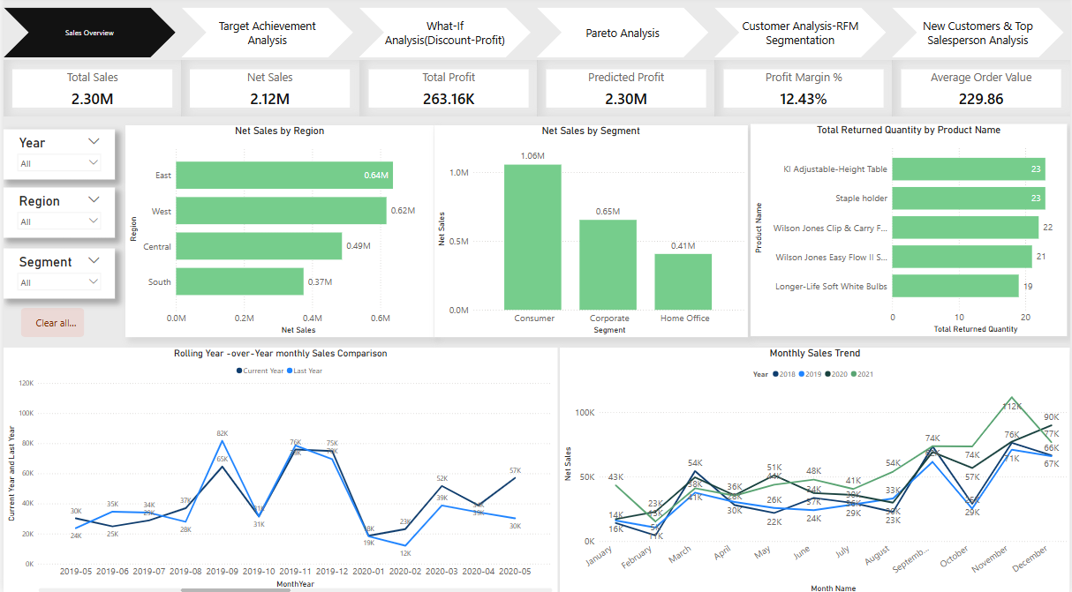
Sales Overview:
- Total Sales: ₹2.30M | Net Sales: ₹2.12M | Total Profit: ₹263.16K | Profit Margin: 12.43%
- The highest net sales come from the Consumer Segment (₹1.06M).
- East and West regions outperform others; South has the lowest sales.
- Returned products are mainly Office Supplies.
- Sales peaked in Nov-Dec across years, visible in both year-wise and comparative trends.

4. Target Achievement Analysis
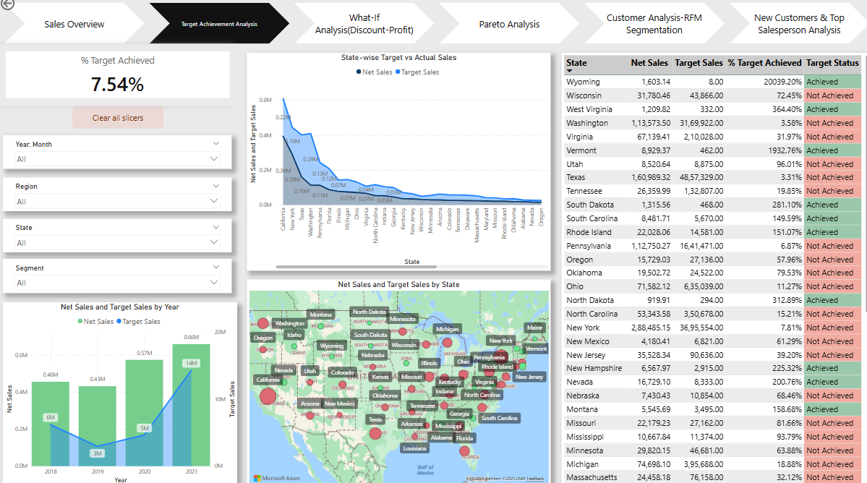
Target vs Actual Sales:
- Overall % Target Achieved: 7.54%, indicating underperformance across many states.
- States like Wyoming, Vermont, and West Virginia exceed targets by large margins.
- California and Texas have high net sales but failed to meet their targets.
- Geographic map and matrix allow filtering and regional comparisons (including tooltip as well)

5. Pareto Analysis
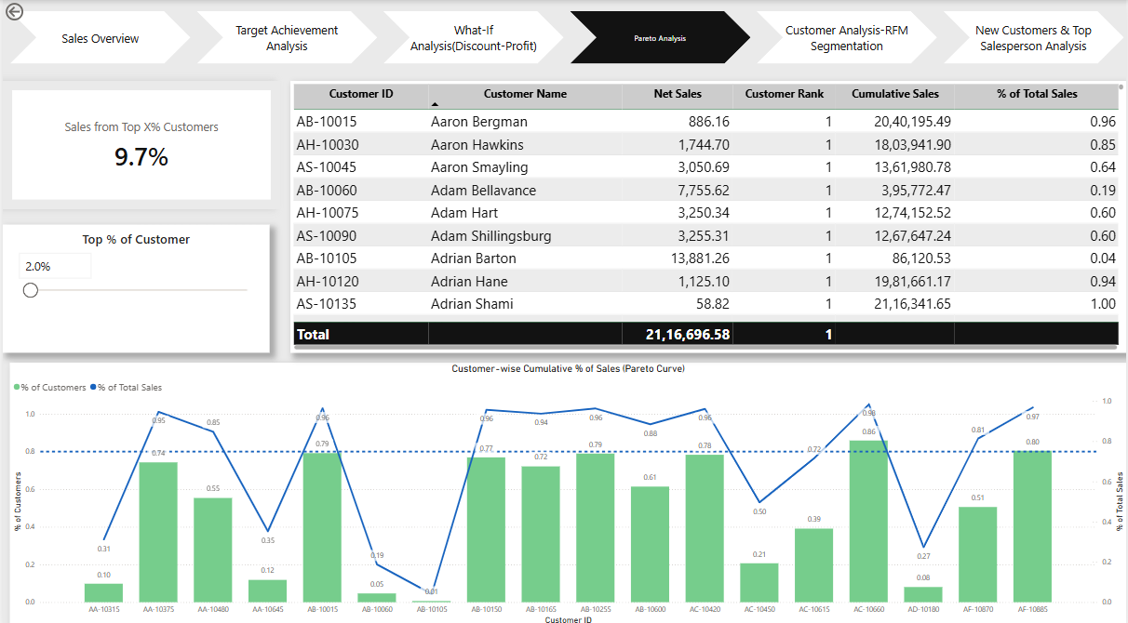
Pareto Insight:
- 2% of customers contributes 9.7% of total sales.
- Allows slider to test different % top customers and see their contribution.
- Identifies loyal customers for retention campaigns.

6. Customer Analysis (RFM)
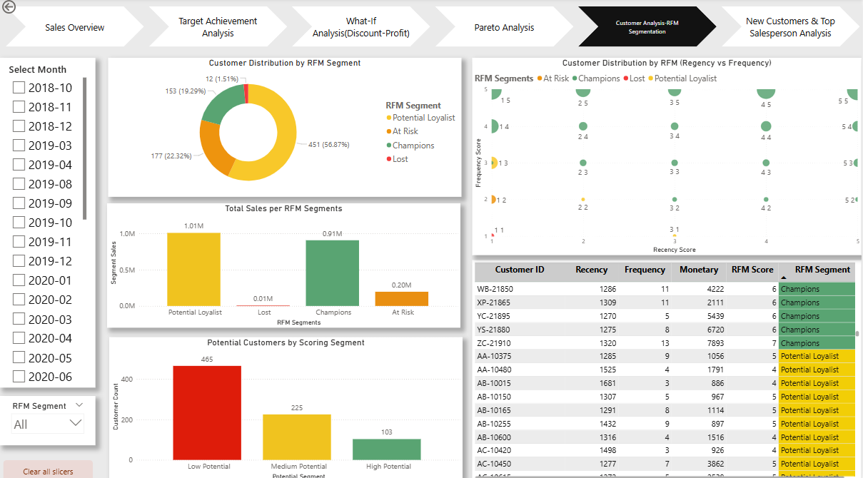
RFM Segmentation:
- Largest segment: 'Potential Loyalist' (56.87%), followed by 'At Risk' and 'Champions'.
- Champions have the highest sales: ₹0.91M.
- Scoring identifies 465 Low Potential and 103 High Potential future customers.
- Recency vs Frequency plot maps customer engagement clearly.

7. Bonus Insights – New Customers & Salesperson Performance
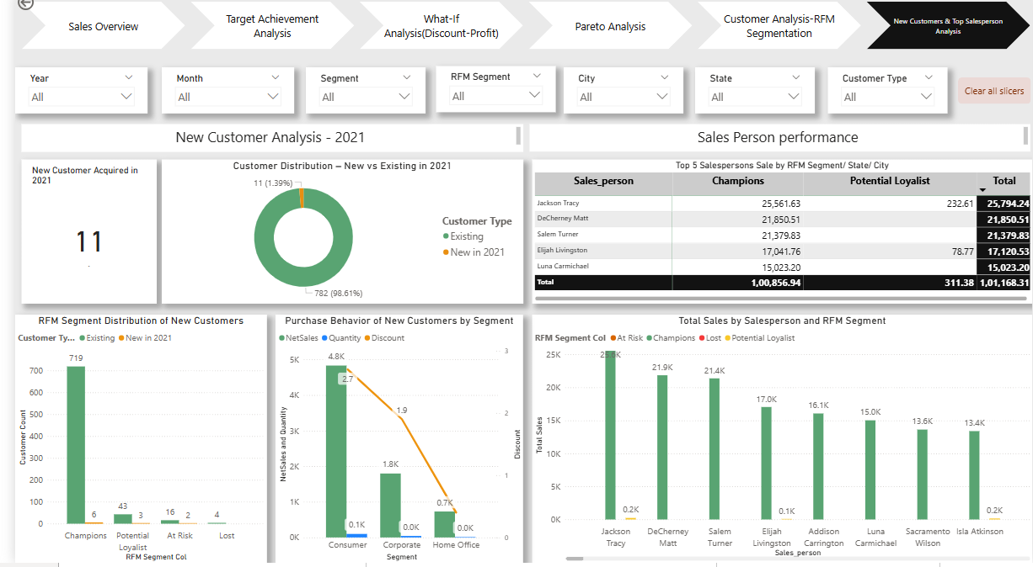
New Customer Behavior:
- Only 11 new customers in 2021, accounting for a small share of revenue.
- Consumer segment dominates new customer purchases.
- Most new customers fall into 'Champions' and 'Potential Loyalist'.
Salesperson Performance:
- Jackson Tracy leads sales across segments, followed by DeCherney Matt.
- Visuals offer breakdown by salesperson, segment, and city.

8. Conclusion
This Power BI solution empowers FurniturePro & Co. to:
- Monitor and improve performance vs targets at region/state level.
- Focus on retaining Champion and Potential Loyalist customers.
- Target discounts carefully using What-If analysis.
- Promote top salespeople strategies across segments.
It sets the stage for continuous improvement, performance monitoring, and smarter strategic planning.

