Motors and movement

In these activities we are going to write programs using the LEGO word blocks.

Let’s start by using the motors. There are two types of movement block, the pink blocks move both wheels at the same time.
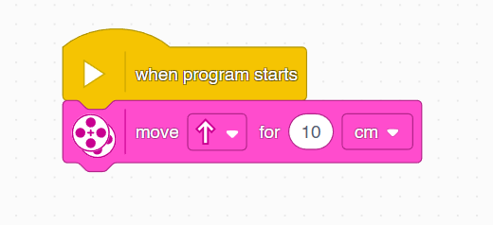

The blue blocks only move one motor.
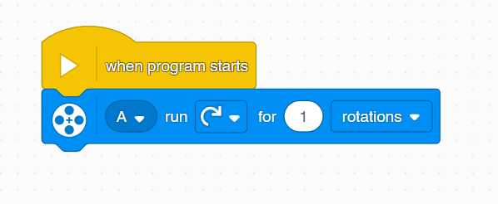

Challenge: can you make your robot spin in a circle?

The speakers

The robot can be used to create music. If you find the ‘play beep’ block a little piano will pop up when you click it. We can then program the robot to play each note in a sequence.
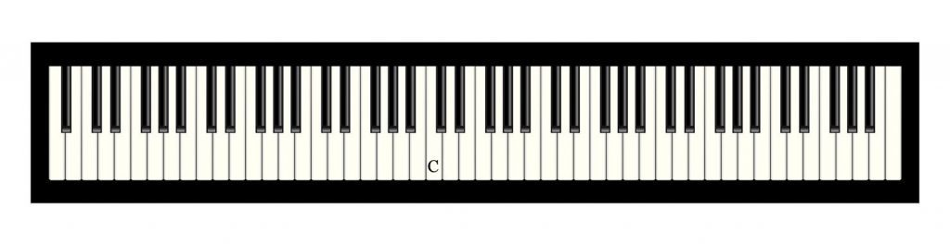
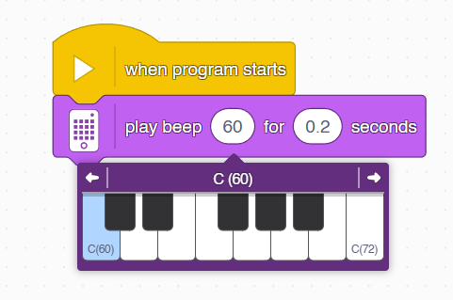

Let’s now create a program to play a song:
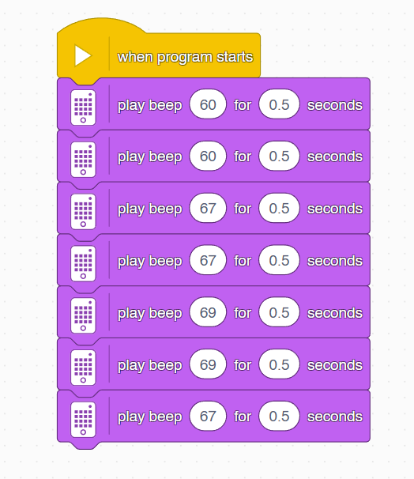

Do you recognise the tune?

Challenge: create your own piece of music!

The speakers (part 2)

The robot has inbuilt sounds you can play, for example, you could make it produce a cat meow.
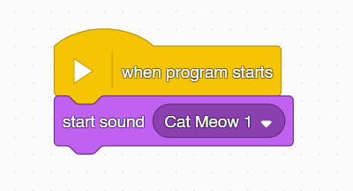
You can use ‘add sound’ to explore other sounds on the robot or ‘record sound’ to create your own.
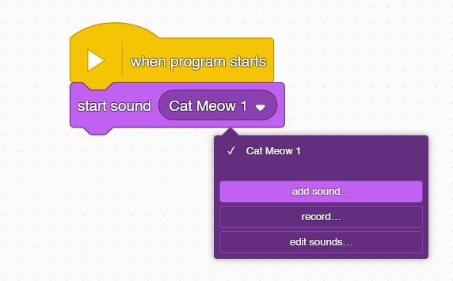

You can even make the sounds higher or lower pitch – try the blocks below and see what happens!
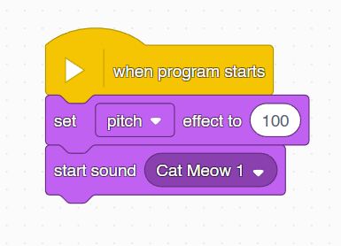

The lights

The robot has multiple types of light including it’s ‘eyes’ at the front, the display on the top and the centre light button.
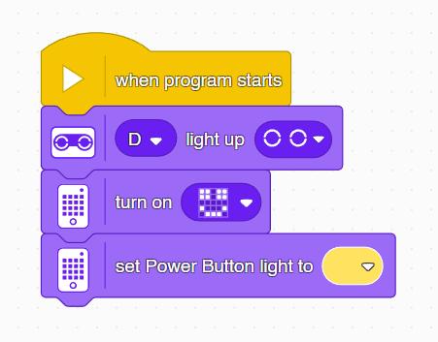

Challenge: Change the colour of the centre light button.

Lights and sounds

You can have multiple ‘when program starts’ blocks. These are found under the ‘events’ section. These blocks of code will activate at the same time. Here we use a ‘forever’ block to make our program keep looping through our lights and sounds at the same time.

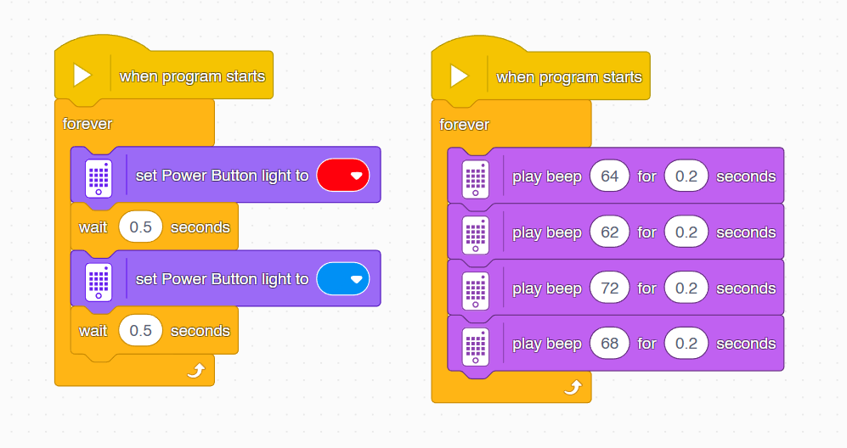

Challenge: make the robot spin side to side whilst the other two programs play.

The distance sensor

The robot has a distance sensor at the front. This allows the robot to respond to it’s ‘eyes’ being covered. Try the below code and see what happens!

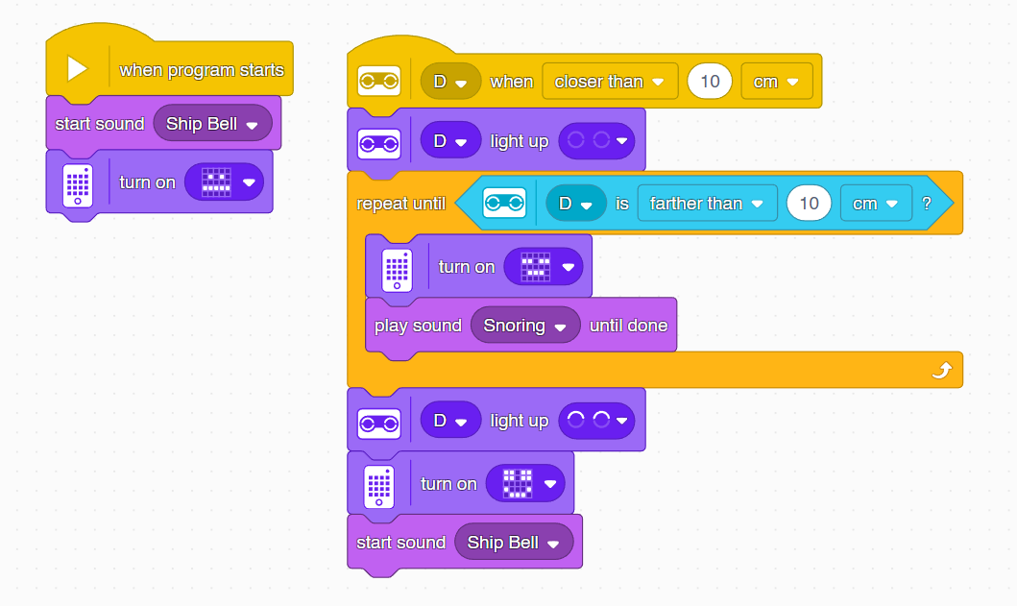

The distance sensor uses ultrasonic sound to detect when objects are close. This is like a bat or a whale or a submarine using echolocation.

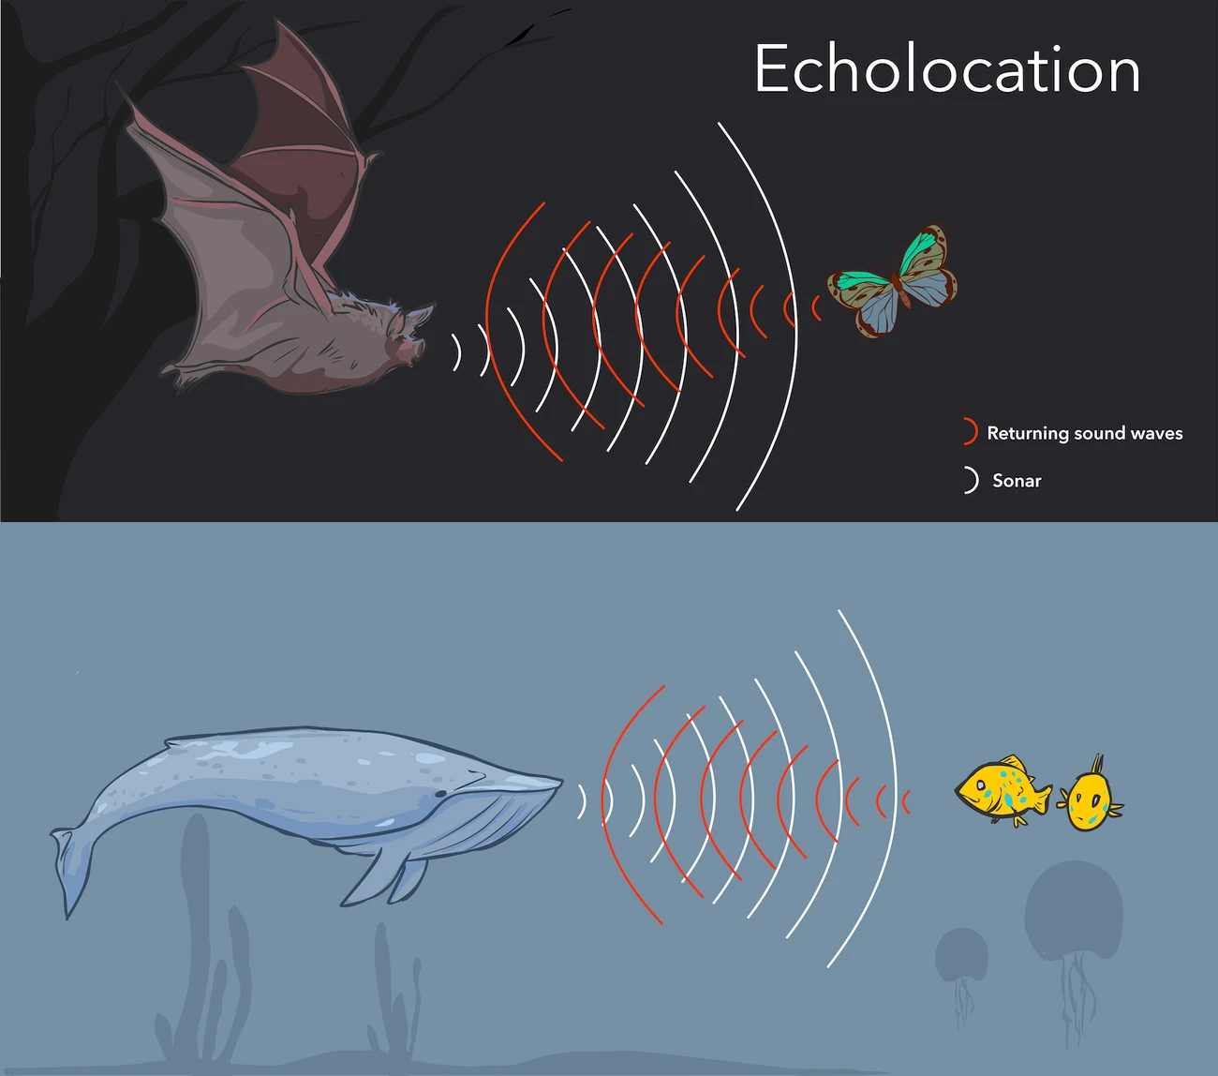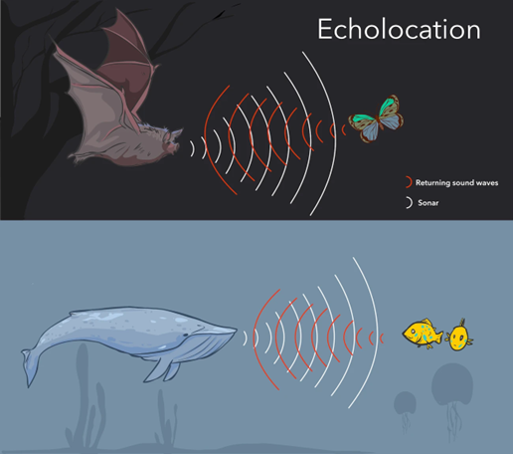

The colour sensor

The robot also has a colour sensor near the front. We can program the robot so it can detect a certain colour.
This program will detect the colour red. It will set the centre light button red and show a tick if the sensor is directed at something red. Otherwise it will set the centre light button to white and show a cross.

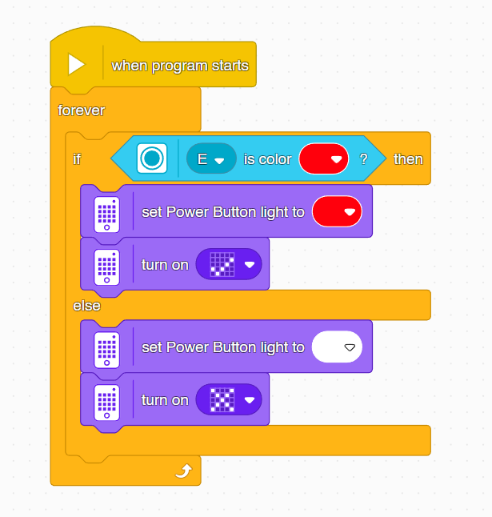

Challenge: modify the program so it detects a different colour instead!

Colour sensor (part 2)

We can make our program better and simpler by changing the blocks we use. Programmers simplify long programs into something shorter that works better all the time.

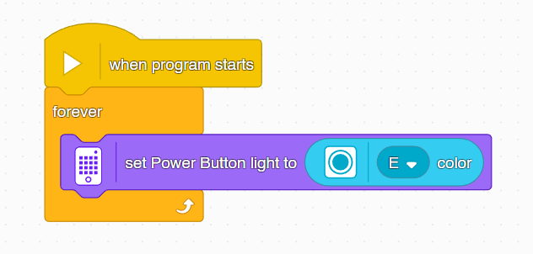

Waiting for sensors

We’re going to use the colour sensor again to show how the robot can wait for a certain ‘trigger’. This time the robot will keep moving until it detects a red line on the ground, after that it will stop and make a sound.

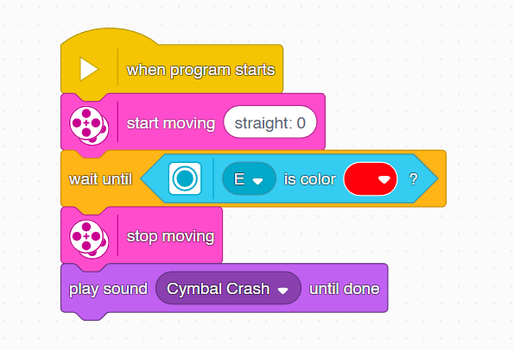

Challenge: make the robot respond in a different way after it passes the red line. You could make it turn around, or spin in a circle, or play a different sound, or pull a face.

The motion sensor

The ‘hub’ that controls the robot is sensitive to movement. The program below makes the robot appear dizzy or unhappy whenever you turn it over.
The yellow blocks mean that whenever the trigger happens the robot carries out the blocks underneath.
So, when the program starts it smiles. When the bottom of the hub is up (i.e. it’s flipped over), the robot makes a dizzy sound and frowns. When the top of the hub is up it waits, then makes a noise and neutral face.

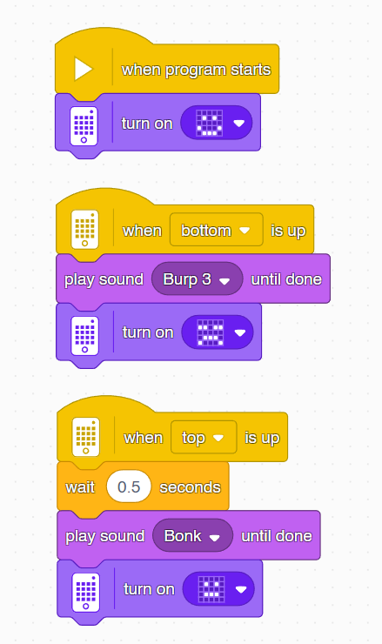

Challenge: write a program that makes the robot happy/excited whenever you shake it! Make a face that looks happy to you, find a sound that sounds excited.

