Activity 1 – hello micro:bit:

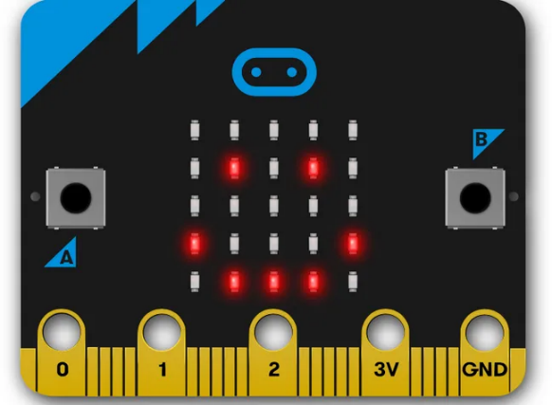

We are going to write our first program and then send it to the micro:bit.
The following website should already be open: https://makecode.microbit.org/ . When it comes to programming, the first script we’ll usually write is what’s known as a ‘hello world!’ script. So first, we’ll get the micro:bit to say ‘hello world!’

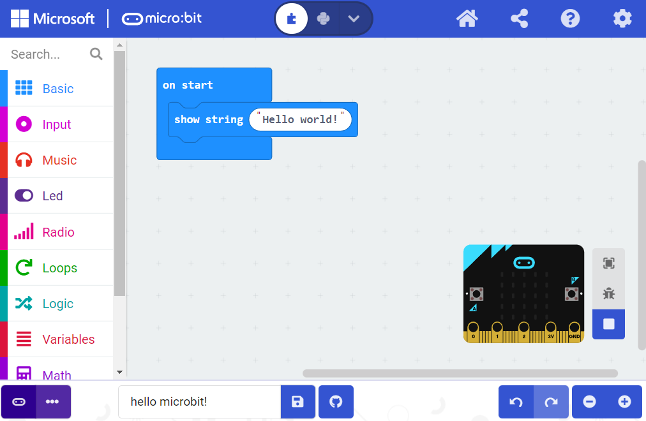

Challenges:

- Can you make the micro:bit display something different? Such as your name or the name of your school?

Activity 2 – beating heart animation:

- The program creates a beating heart animation on the display using two built-in icons: a large heart and a small heart.
- Different images shown in a sequence create the illusion of movement.
- After showing each image, the program pauses for half a second (500 milliseconds) before showing the next image.

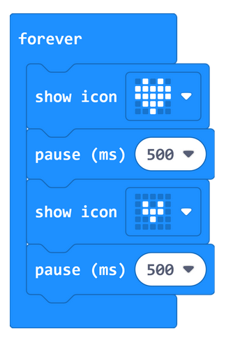

Challenges:

- Can you make the heart beat faster or slower?
- Try and animate a diamond that gets larger and smaller
- Can you make different animations appear depending on if the A or B button is pressed? Hint: look under the purple ‘input’ section.

Activity 3 – dice roller:

We are going to create a program that turns our micro:bit into a simple dice roller. The program is below. You may need to unplug the micro:bit and connect the battery pack to shake it properly.

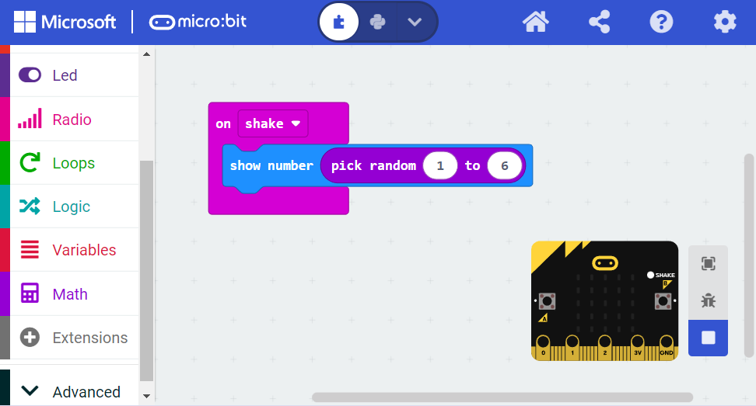

How can we improve it?
Most six-sided dice show pips instead of numbers, like the image below.

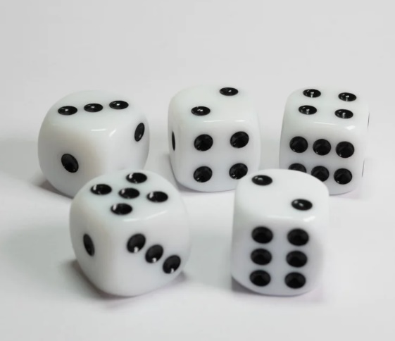
On the next page we’re going to modify our program to show dice pips instead.
To begin, we need to create a custom block known as a ‘variable’ for ‘number’. We do so by clicking on ‘variables’, then ‘make a variable’. After this we can create our program (next page).

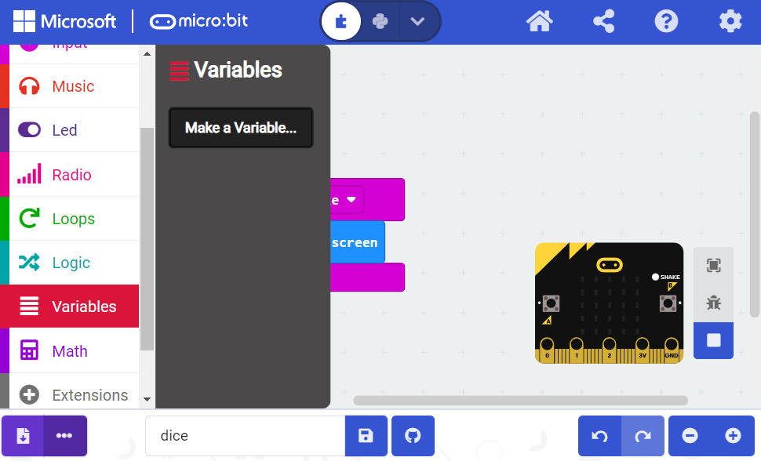
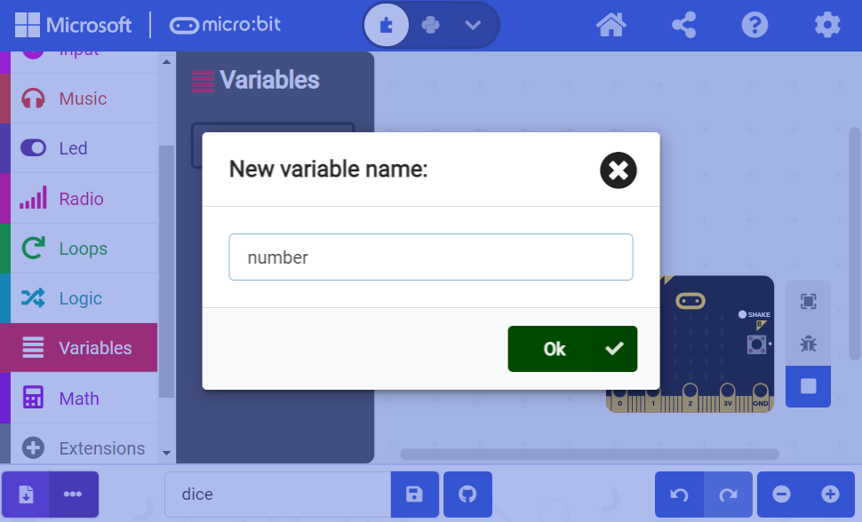
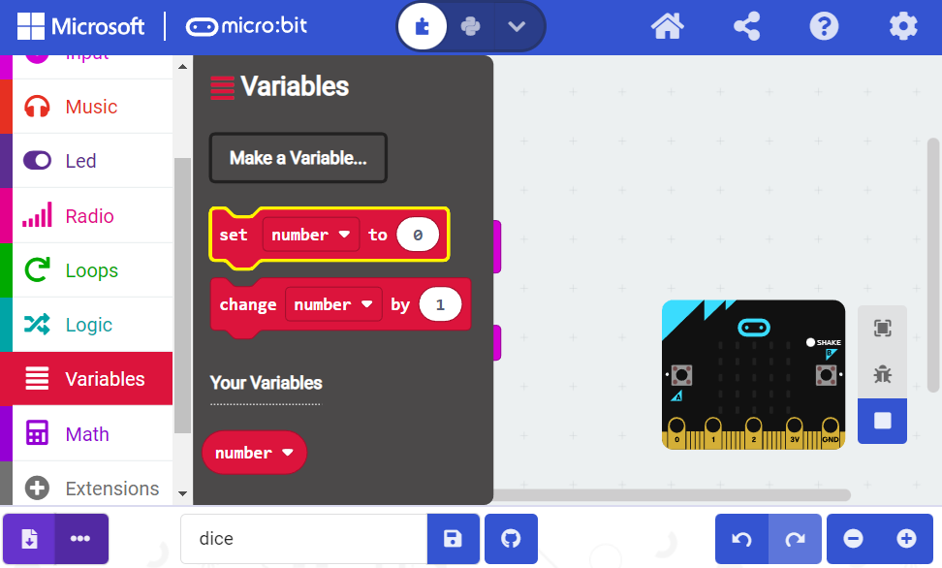

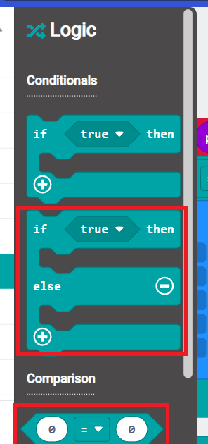
We are now going to build up our program. The program uses the same idea that we shake the micro:bit and get a random number between 1 & 6.
However, instead of displaying that number on the screen it saves the number inside the variable ‘number’.
We then pass our number to a logic block. The logic block is basically our program asking a series of questions:
Is the number 1? If yes show 1 pip otherwise… is the number 2? If yes show 2 pips, otherwise… and so on.
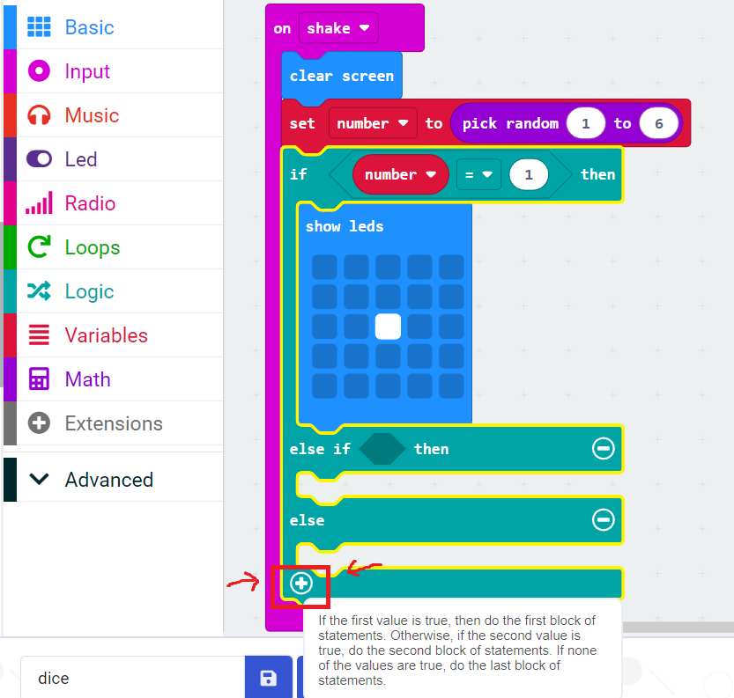

Challenge: can you complete the rest of the program?

Extra activities:

If you have finished all the available activities and still have time you can browse the micro:bit website for more challenges.
The projects page (https://microbit.org/projects/make-it-code-it/) has all sorts of additional ideas.

