Guidance:
Workshops will generally be 1.5 hrs. The schedule of the workshop is inside the presentation – generally we run the shorter one.
It begins with a brief opening. Then the micro:bit activities, then some history, then the LEGO activities, then programming careers and then finally the LEGO robot programming competition.
Equipment is stored in CBF office inside the cupboard closest to the rear exit (not the one opposite the break room). Robots and micro:bits are in labelled boxes.

Micro:bits
These should be plugged into a USB drive on the laptops.
Microsoft MakeCode for micro:bit
They then can be programmed using the above link (https://makecode.microbit.org/). Before the session open a blank canvas for the blocks by going to My projects > new project. This will bring up an interface that looks like this:
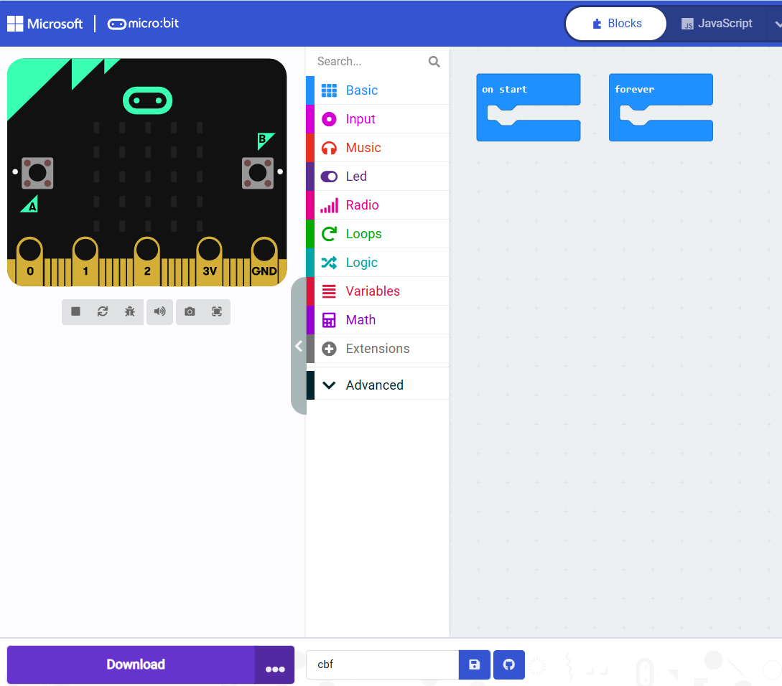

Before running the session devices should be connected too:
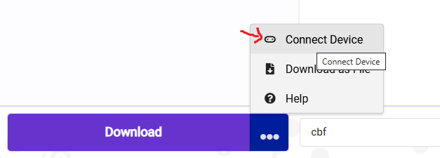
After the device is connected the block-based code can be sent to it by clicking download.
**IMPORTANT: THIS ONLY WORKS WITH MICROSOFT EDGE BROWSER, NOT CHROME OR FIREFOX**

LEGO robots
Each robot pairs with a laptop, indicated by the stickers. These will sync via Bluetooth. They can be programmed using the following link.
https://spike.legoeducation.com/prime/lobby/
If prompted, select ‘word blocks’ to create a new project.

