Exp4- Version Control-Software Configuration Management in Linux

Installing Git
admin1@ubuntu:~$ sudo apt-get install git
[sudo] password for admin1:
Reading package lists... Done
Building dependency tree
Reading state information... Done
The following extra packages will be installed:
git-man liberror-perl patch
Suggested packages:
git-daemon-run git-daemon-sysvinit git-doc git-el git-arch git-cvs git-svn
git-email git-gui gitk gitweb diffutils-doc
The following NEW packages will be installed:
git git-man liberror-perl patch
0 upgraded, 4 newly installed, 0 to remove and 573 not upgraded.
Need to get 6,703 kB of archives.
After this operation, 15.5 MB of additional disk space will be used.
Do you want to continue [Y/n]? y
Get:1 http://us.archive.ubuntu.com/ubuntu/ precise/main liberror-perl all 0.17-1 [23.8 kB]
Get:2 http://us.archive.ubuntu.com/ubuntu/ precise/main git-man all 1:1.7.9.5-1 [630 kB]
Get:3 http://us.archive.ubuntu.com/ubuntu/ precise/main git i386 1:1.7.9.5-1 [5,963 kB]
Get:4 http://us.archive.ubuntu.com/ubuntu/ precise/main patch i386 2.6.1-3 [86.0 kB]
Fetched 6,703 kB in 1min 10s (95.5 kB/s)
Selecting previously unselected package liberror-perl.
(Reading database ... 151075 files and directories currently installed.)
Unpacking liberror-perl (from .../liberror-perl_0.17-1_all.deb) ...
Selecting previously unselected package git-man.
Unpacking git-man (from .../git-man_1%3a1.7.9.5-1_all.deb) ...
Selecting previously unselected package git.
Unpacking git (from .../git_1%3a1.7.9.5-1_i386.deb) ...
Selecting previously unselected package patch.
Unpacking patch (from .../patch_2.6.1-3_i386.deb) ...
Processing triggers for man-db ...
Setting up liberror-perl (0.17-1) ...
Setting up git-man (1:1.7.9.5-1) ...
Setting up git (1:1.7.9.5-1) ...
Setting up patch (2.6.1-3) ...

Commands in Git
admin1@ubuntu:~$ git
usage: git [--version] [--exec-path[=<path>]] [--html-path] [--man-path] [--info-path]
[-p|--paginate|--no-pager] [--no-replace-objects] [--bare]
[--git-dir=<path>] [--work-tree=<path>] [--namespace=<name>]
[-c name=value] [--help]
<command> [<args>]

The most commonly used git commands are:
add Add file contents to the index
bisect Find by binary search the change that introduced a bug
branch List, create, or delete branches
checkout Checkout a branch or paths to the working tree
clone Clone a repository into a new directory
commit Record changes to the repository
diff Show changes between commits, commit and working tree, etc
fetch Download objects and refs from another repository
grep Print lines matching a pattern
init Create an empty git repository or reinitialize an existing one
log Show commit logs
merge Join two or more development histories together
mv Move or rename a file, a directory, or a symlink
pull Fetch from and merge with another repository or a local branch
push Update remote refs along with associated objects
rebase Forward-port local commits to the updated upstream head
reset Reset current HEAD to the specified state
rm Remove files from the working tree and from the index
show Show various types of objects
status Show the working tree status
tag Create, list, delete or verify a tag object signed with GPG
See 'git help <command>' for more information on a specific command.

Making a new directory
admin1@ubuntu:~$ dir
Desktop Downloads Music Public Videos
Documents examples.desktop Pictures Templates wire_statistics
admin1@ubuntu:~$ cd Documents/
admin1@ubuntu:~/Documents$ mkdir Nikita
admin1@ubuntu:~/Documents$ ls
git.odt Nikita
admin1@ubuntu:~/Documents$ cd Nikita

Initialize Git
admin1@ubuntu:~/Documents/Nikita$ git init
Initialized empty Git repository in /home/admin1/Documents/Nikita/.git/
admin1@ubuntu:~/Documents/Nikita$ touch README.md

Adding a new file to repository
admin1@ubuntu:~/Documents/Nikita$ git add README.md
admin1@ubuntu:~/Documents/Nikita$ gedit README.md

Commiting changes
admin1@ubuntu:~/Documents/Nikita$ git commit
[master (root-commit) e143cc3] Initial Commit - New git
Committer: admin <admin1@ubuntu.ubuntu-domain>
Your name and email address were configured automatically based
on your username and hostname. Please check that they are accurate.
You can suppress this message by setting them explicitly:

git config --global user.name "Your Name"
git config --global user.email you@example.com
After doing this, you may fix the identity used for this commit with:
git commit --amend --reset-author
0 files changed
create mode 100644 README.md
admin1@ubuntu:~/Documents/Nikita$ gedit README.md

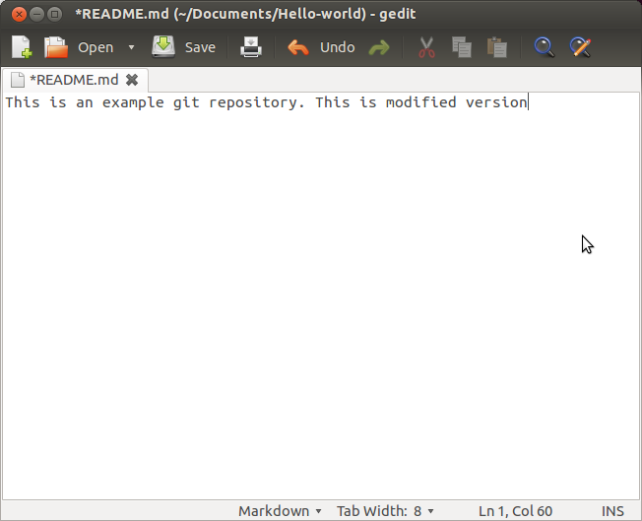
admin1@ubuntu:~/Documents/Nikita$ git add README.md
admin1@ubuntu:~/Documents/Nikita$ git commit
[master e5a48f3] Second commit
Committer: admin <admin1@ubuntu.ubuntu-domain>
Your name and email address were configured automatically based
on your username and hostname. Please check that they are accurate.
You can suppress this message by setting them explicitly:
git config --global user.name "Your Name"
git config --global user.email you@example.com
After doing this, you may fix the identity used for this commit with:
git commit --amend --reset-author
1 file changed, 1 insertion(+)

After this step you need to sign up in Github

1. Create a free account on github.com, and login.
2. Initiate process to create new repository by clicking first option next to username on the top right
corner of web page.

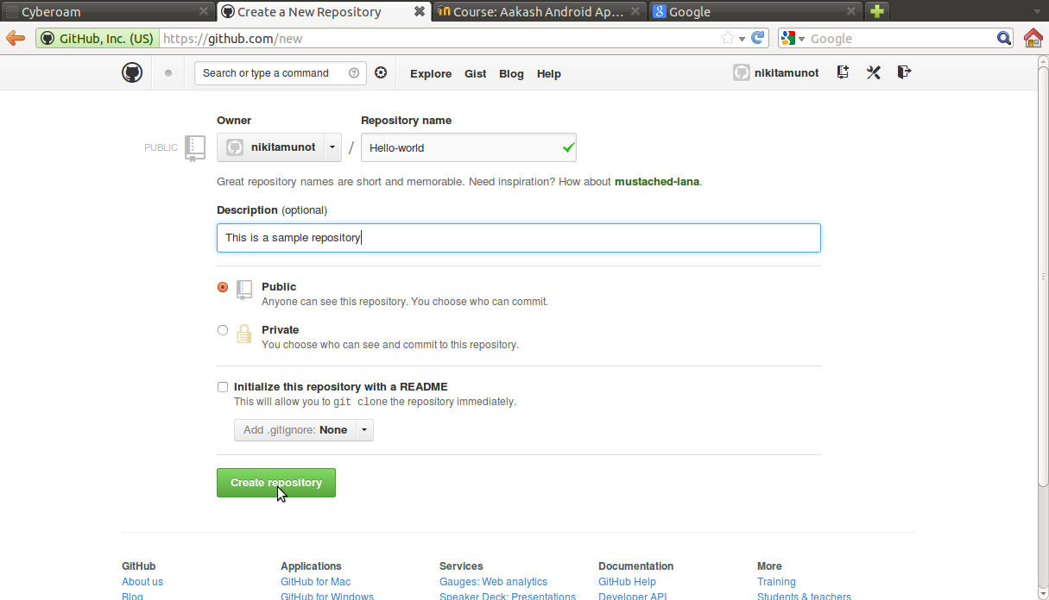

Pushing an existing repository

admin1@ubuntu:~/Documents/Nikita$ git remote add origin https://github.com/nikitamunot/Test.git
admin1@ubuntu:~/Documents/Nikita$ git push -u origin master
Username for 'https://github.com': nikita.0149@gmail.com
Password for 'https://nikita.0149@gmail.com@github.com':
To https://github.com/nikitamunot/Test.git
* [new branch] master -> master
Branch master set up to track remote branch master from origin.
admin1@ubuntu:~/Documents/Nikita$ git commit
# On branch master
# Untracked files:
# (use "git add <file>..." to include in what will be committed)
#
# README.md~
# git.odt
nothing added to commit but untracked files present (use "git add" to track)
admin1@ubuntu:~/Documents/Nikita$ git add git.odt
admin1@ubuntu:~/Documents/Nikita$ git commit
[master 0d520f6] Added new file
Committer: admin <admin1@ubuntu.ubuntu-domain>
Your name and email address were configured automatically based
on your username and hostname. Please check that they are accurate.
You can suppress this message by setting them explicitly:
git config --global user.name "Your Name"
git config --global user.email you@example.com
After doing this, you may fix the identity used for this commit with:
git commit --amend --reset-author
1 file changed, 0 insertions(+), 0 deletions(-)
create mode 100644 git.odt
admin1@ubuntu:~/Documents/Nikita$ git push -u origin master
Username for 'https://github.com': nikita.0149@gmail.com
Password for 'https://nikita.0149@gmail.com@github.com':
To https://github.com/nikitamunot/Test.git
e5a48f3..0d520f6 master -> master
Branch master set up to track remote branch master from origin.
admin1@ubuntu:~/Documents/Nikita$ cd Test/
bash: cd: Test/: No such file or directory

Pull changes into local repository

admin1@ubuntu:~/Documents/Nikita$ git pull
remote: Counting objects: 10, done.
remote: Compressing objects: 100% (7/7), done.
remote: Total 9 (delta 2), reused 8 (delta 1)
Unpacking objects: 100% (9/9), done.
From https://github.com/nikitamunot/Test
0d520f6..2ae578f master -> origin/master
Updating 0d520f6..2ae578f
Fast-forward
chkrootkit.odt | Bin 0 -> 19459 bytes
hello.md | 1 +
2 files changed, 1 insertion(+)
create mode 100644 chkrootkit.odt
create mode 100644 hello.md

Adding a new user name and e mail for local machine
admin1@ubuntu:~/Documents/Nikita$ git config --global user.name "Nikita"
admin1@ubuntu:~/Documents/Nikita$ git config --global user.email nikita.0149@gmail.com
admin1@ubuntu:~/Documents/Nikita$

Clone an existing repository

admin1@ubuntu:~/Documents$ git clone https://github.com/amathew121/CSL201
Cloning into 'CSL201'...
remote: Counting objects: 54, done.
remote: Compressing objects: 100% (46/46), done.
remote: Total 54 (delta 12), reused 42 (delta 5)
Unpacking objects: 100% (54/54), done.

admin1@ubuntu:~/Documents/CSL201$ git add Exp4\ -\ Version\ Control/Exp4-Version\ control.odt
admin1@ubuntu:~/Documents/CSL201$ git commit
[master e85aaee] Added git document for print out
1 file changed, 0 insertions(+), 0 deletions(-)
create mode 100644 Exp4 - Version Control/Exp4-Version control.odt
admin1@ubuntu:~/Documents/CSL201$ git push -u origin master
Username for 'https://github.com': nikita.0149@gmail.com
Password for 'https://nikita.0149@gmail.com@github.com':
To https://github.com/amathew121/CSL201
054964e..e85aaee master -> master
Branch master set up to track remote branch master from origin.
admin1@ubuntu:~/Documents/CSL201$
administrator@ubuntu:~/Documents/CSL201/CSL201$ git fetch origin
administrator@ubuntu:~/Documents/CSL201/CSL201$ git pull
Already up-to-date.
administrator@ubuntu:~/Documents/CSL201/CSL201$ git pull
remote: Counting objects: 13, done.
remote: Compressing objects: 100% (7/7), done.
remote: Total 10 (delta 3), reused 10 (delta 3)
Unpacking objects: 100% (10/10), done.
From https://github.com/amathew121/CSL201
6a3f578..83b4994 master -> origin/master
Updating 6a3f578..83b4994
Fast-forward
Exp1 - Wireshark/tool acl_roshani.docx | Bin 0 -> 1405229 bytes
Exp2 - Nessus/ExpNo_2_Nessus_Open_Source.odt | Bin 0 -> 1896064 bytes
Exp2 - Nessus/nikita_4f9bc9.html | 485 +++++++++++++++
Exp2 - Nessus/nikita_cz7x7v.html | 828 ++++++++++++++++++++++++++
4 files changed, 1313 insertions(+)
create mode 100644 Exp1 - Wireshark/tool acl_roshani.docx
create mode 100644 Exp2 - Nessus/ExpNo_2_Nessus_Open_Source.odt
create mode 100644 Exp2 - Nessus/nikita_4f9bc9.html
create mode 100644 Exp2 - Nessus/nikita_cz7x7v.html

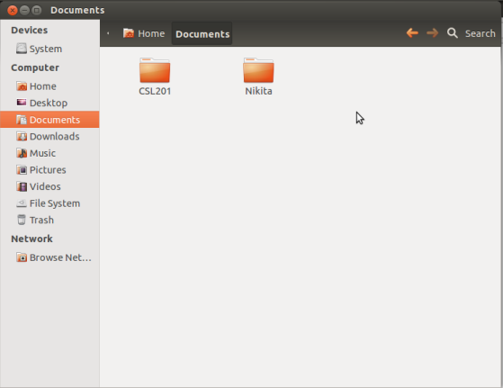

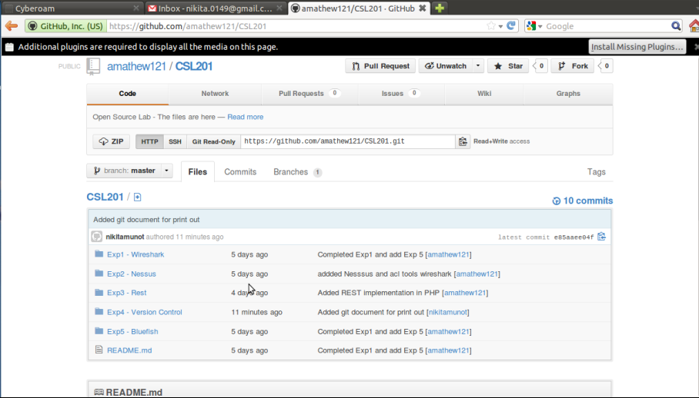

To view log
administrator@ubuntu:~/Documents/CSL201/CSL201$ git log
commit 83b499447711adb6a94ba070ece88280269bd115
Merge: 38d30e9 6a3f578
Author: Ashish Mathew <amathew121@gmail.com>
Date: Thu Mar 28 14:13:06 2013 +0530
Merge branch 'master' of https://github.com/amathew121/CSL201
commit 38d30e91f4696b4a962f74c42b2a3c689e7c72bd
Author: Ashish Mathew <amathew121@gmail.com>
Date: Thu Mar 28 14:11:52 2013 +0530
addded Nesssus and acl tools wireshark
commit 6a3f578c269b32a7f883c04c7b27f0c076470c0c
Author: Administrator <administrator@ubuntu.ubuntu-domain>
Date: Thu Mar 28 13:55:02 2013 +0530
Git version control pdf added
commit 9bd26f6ac131373c07ec9714482e2ed2310f234d
Author: Ashish Mathew <amathew121@gmail.com>
Date: Thu Mar 28 00:19:25 2013 +0530
updated Readme and moved files to a folder
commit dd4cc706156de199d97bd02810f83a8b7ef77f92
Author: Ashish Mathew <amathew121@gmail.com>
Date: Wed Mar 27 23:49:58 2013 +0530
initial commit
commit e1bb1acf59b933fae45f9eb0fe73326ac5efe433
Author: Ashish Mathew <amathew121@gmail.com>
Date: Wed Mar 27 11:08:38 2013 -0700

Initial commit
administrator@ubuntu:~/Documents/CSL201/CSL201$

