Step 1:

Create two networks N1 and N2

Step 2:

Create containers.

C2,C4 in N1,C5,C6 in N2

Step 3:

To connect C5 with C2, add C5 to N1 using command

docker network connect N1 c5

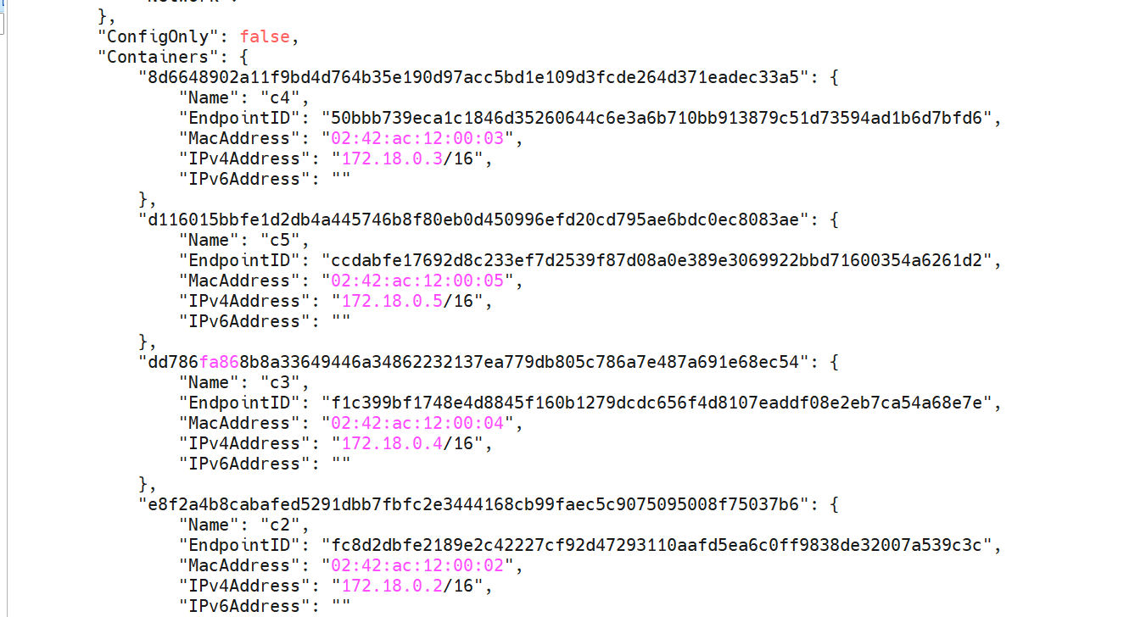

Step 4:

From c2 ping c5

But can not ping c6

