Created new image 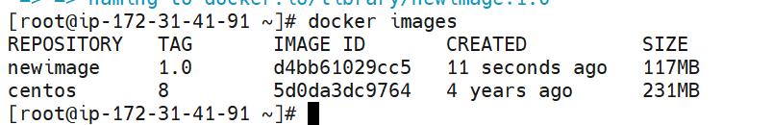



Dockerfile:

FROM ubuntu AS build

RUN apt-get update

RUN apt-get install vim -y

RUN echo "Hello" > /mnt/mytext

WORKDIR /mnt

CMD ping localhost -c 20

FROM httpd

COPY --from=build /mnt/mytext /usr/local/apache2/htdocs/index.html

WORKDIR /mnt

CMD CMD ping localhost -c 21