Three jobs:

Git repo used : https://github.com/nikitap485/httpd-repo.git

Build job1-main:

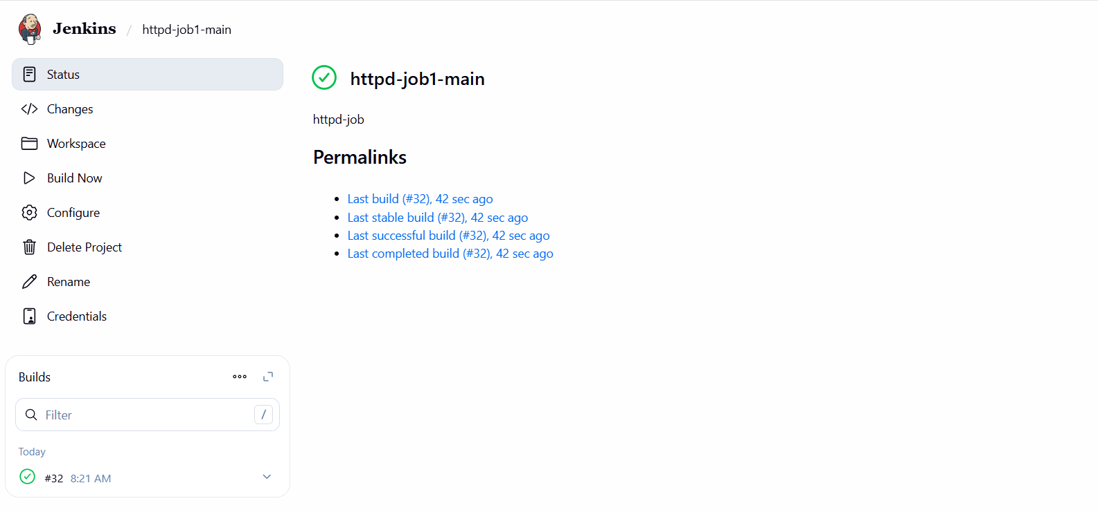

Index.html:



Build job1-dev:

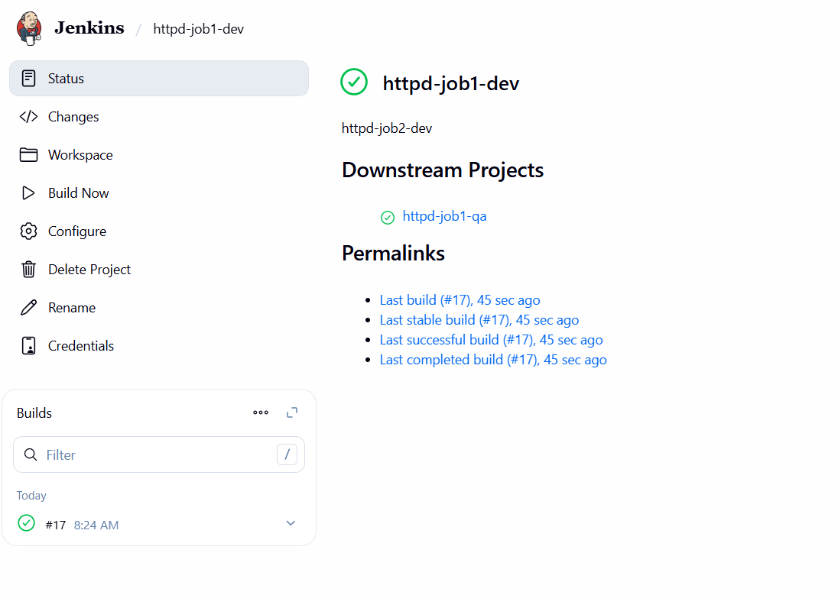

Index.html:

Build job1-qa:

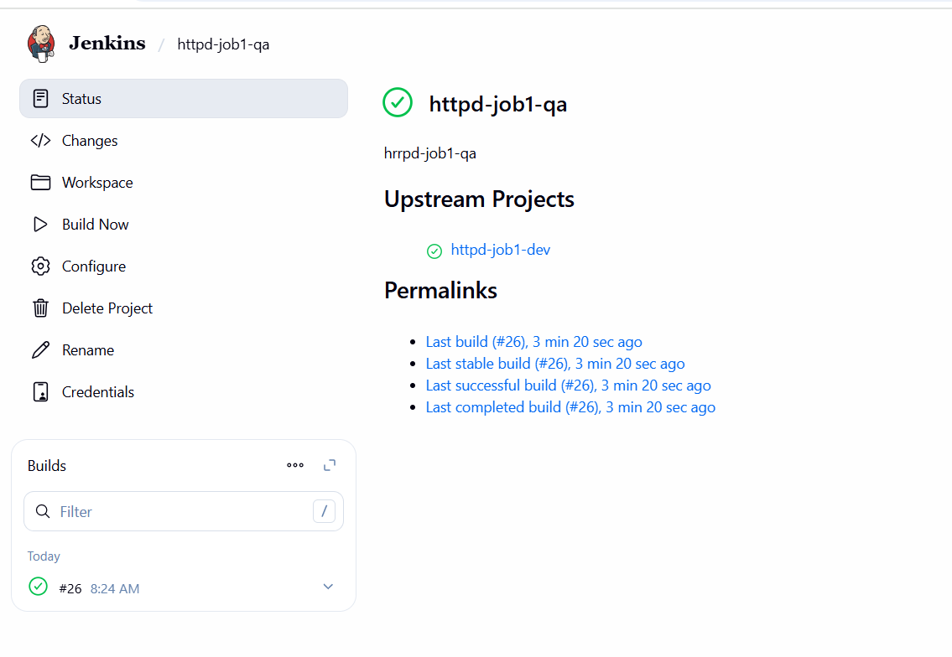

Index.html:

