Launched jenkins master:

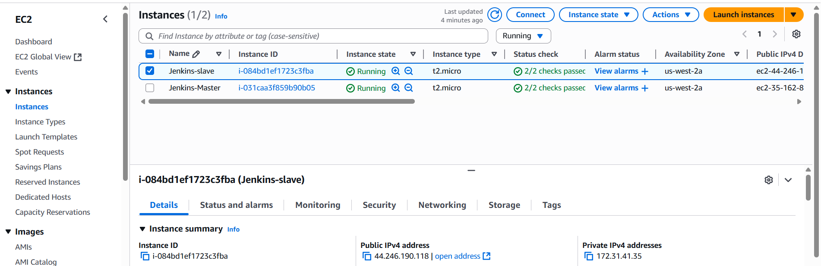

Git repo: <https://github.com/nikitap485/httpd-repo.git>

Three jobs on Jenkins-master:

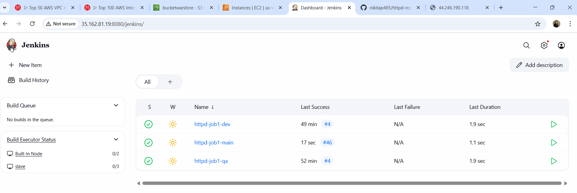

Ip of slave(44.246.190.118):

index.html (master):

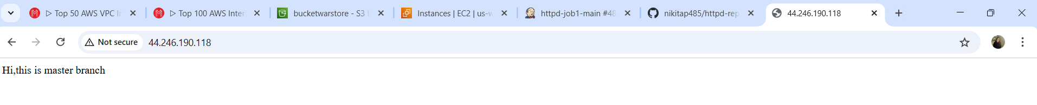index.html(dev):



index.html(qa):

