Launched two machines:

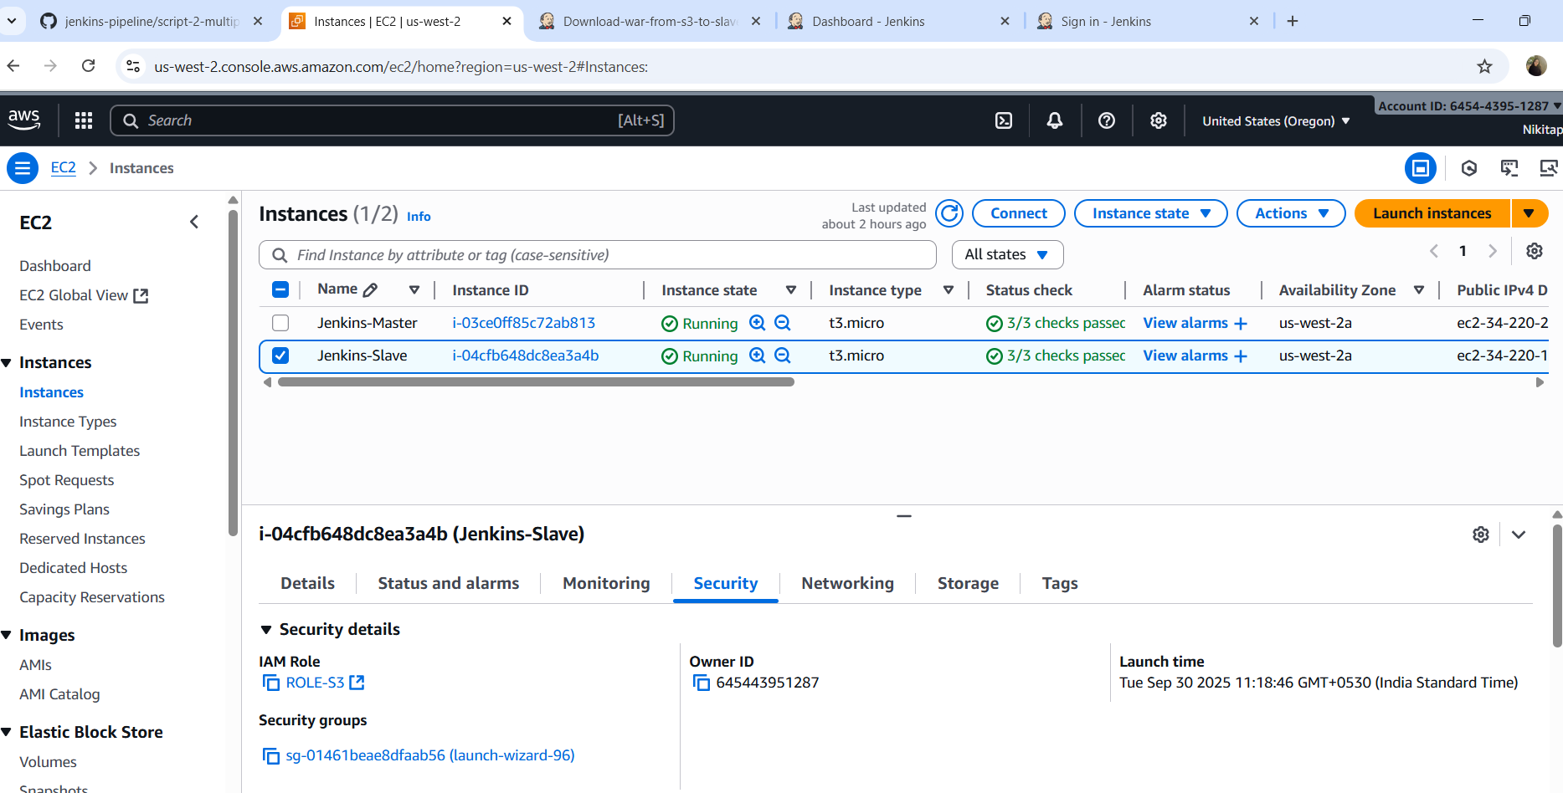

Added IAM Role:

Created two jobs:

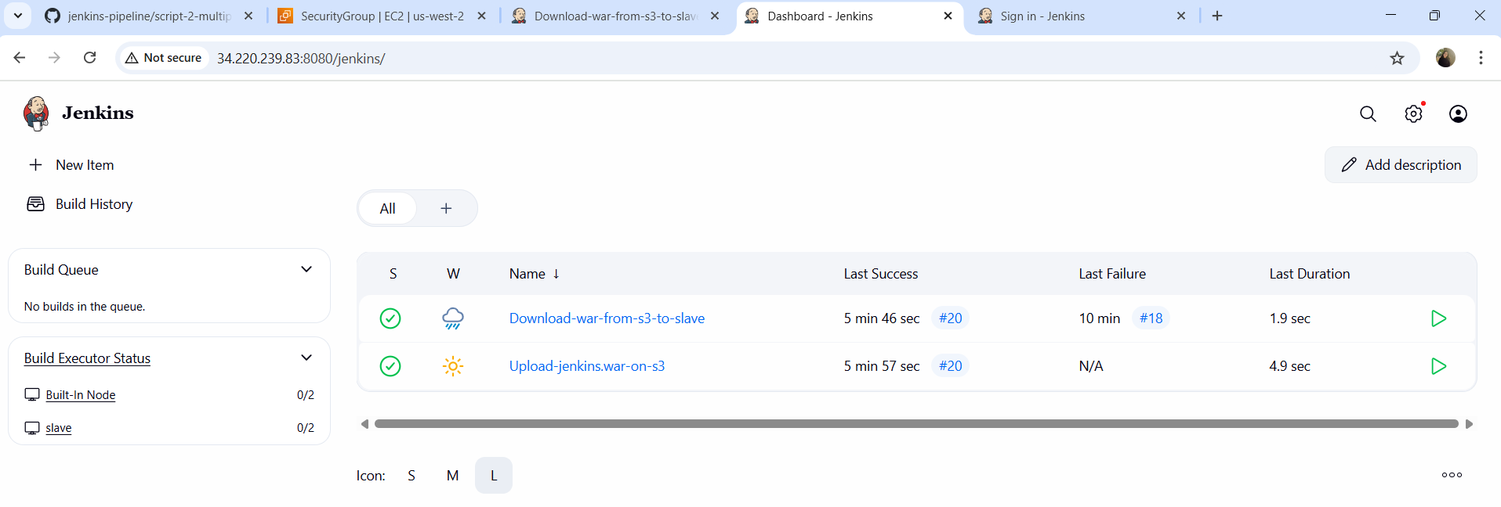

Steps:

There are two jobs

1.Upload job----Uploads Jenkins.war to S3

Execute this on master

Post build actions:

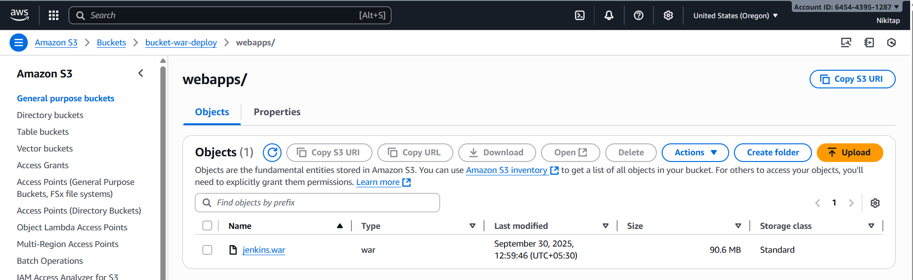

2.Download from S3 bucket to slave’s webapps:



