Launched 2 instances:

Master:

Master slave:

Established slave connection:

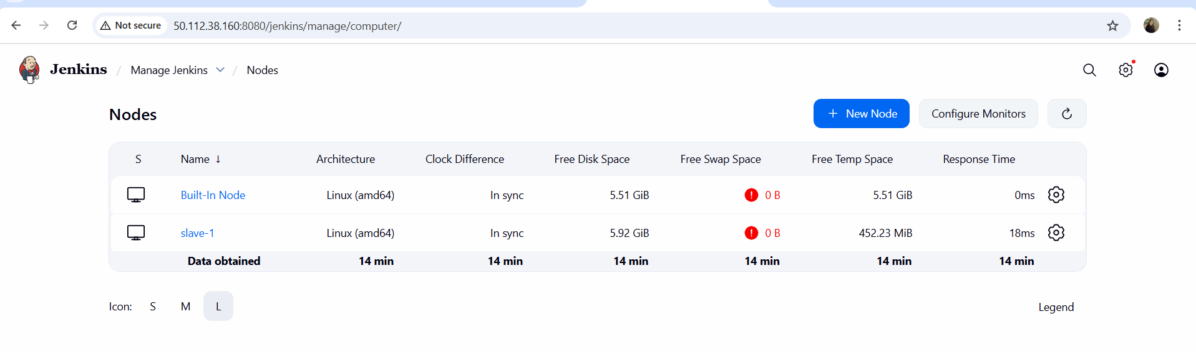

Executed job on Master machine:

On slave machine:

