Build with parameters:

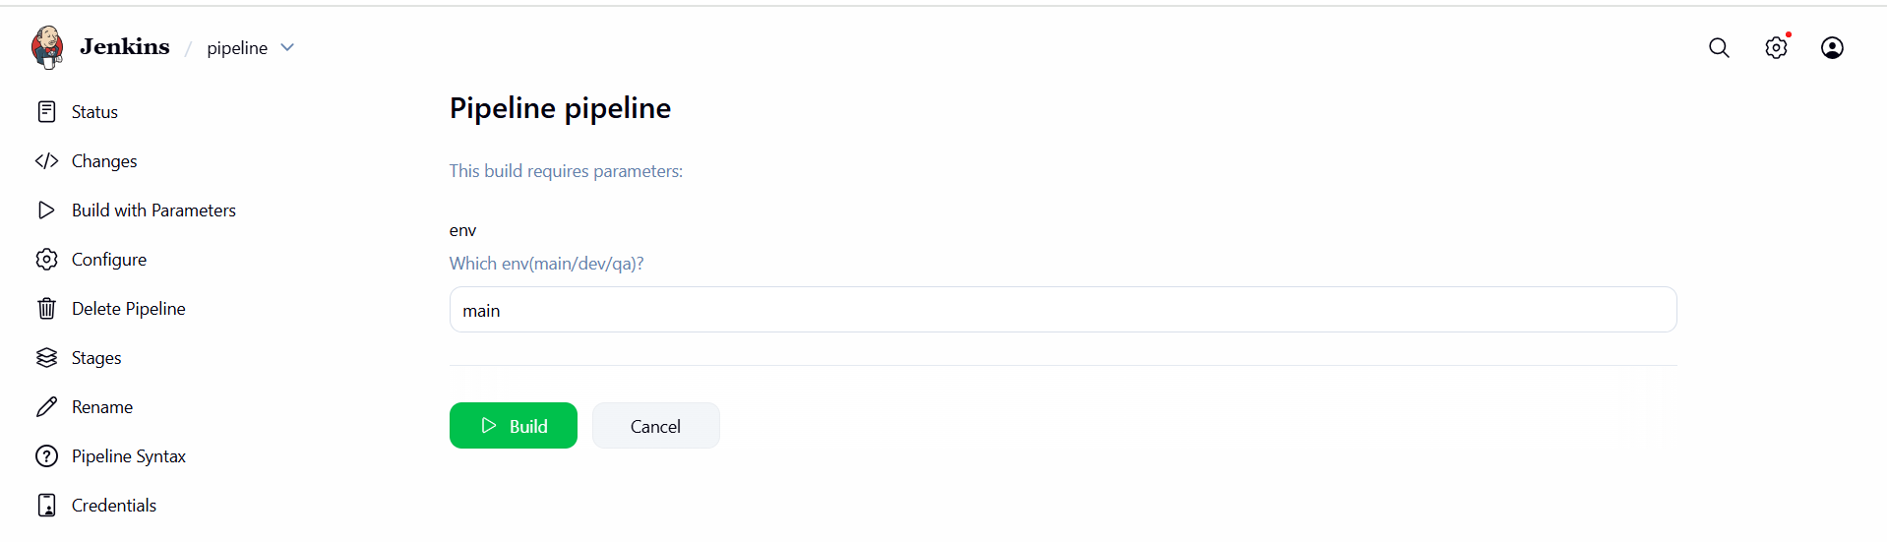

Main:

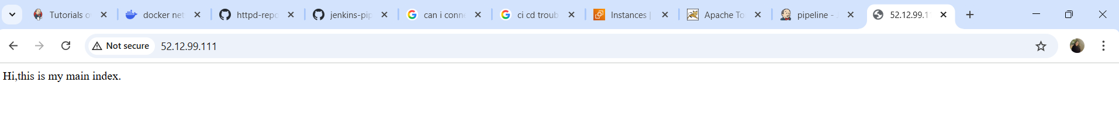

Dev:



Qa:

