OUTPUT

• **Time Period**

* The dataset covers transactions from **January 1, 2024, onwards**.
* Dates appear in a daily transaction format — one or more transactions per day.

• **Product Categories**

* The major product categories include:
  + **Electronics**
  + **Home Appliances**
  + **Clothing**
  + **Books**
  + **Beauty Products**
  + **Sports**
* These categories indicate a **multi-sector retail dataset**.

• **Transaction Details**

* Each transaction has a unique **Transaction ID** (e.g., 10001, 10002, etc.).
* The **Units Sold** vary between 1 and 6 in the visible data.
* **Unit Price** ranges widely from **$15.99 (Books)** to **$2499.99 (Electronics)**.
* **Total Revenue** = Units Sold × Unit Price (consistent across entries).

• **Regional Distribution**

* Transactions are spread across regions such as:
  + **North America**
  + **Europe**
  + **Asia**
* This suggests the company operates **internationally**.

• **Payment Methods**

* The main payment methods are **Credit Card**, **PayPal**, and **Debit Card**.
* **Credit Card** seems to be the most frequent method among North American customers.

• **Product Insights**

* High-value electronics such as **iPhone 14 Pro** and **MacBook Pro 16-inch** generate substantial revenue.
* Books and beauty products contribute smaller but consistent transactions.
* Sports products like **Wilson Basketball** and **Nike Air Force 1** also appear popular.

• **Revenue Range**

* Highest observed revenue: **$2,499.99** (MacBook Pro 16-inch).
* Lowest observed revenue: **$63.96** (Books — “The Da Vinci Code”).

• **Potential Uses of Data**

* Can be used for **sales analysis**, **regional performance tracking**, **payment preference study**, and **product profitability**.

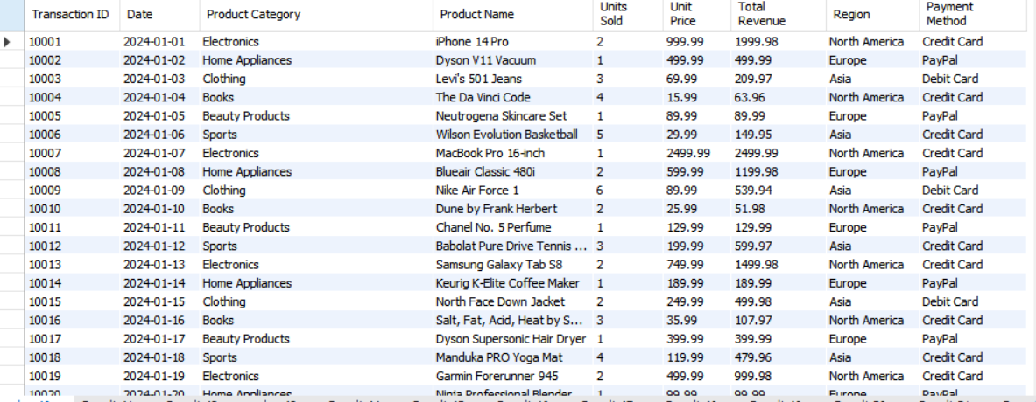the total number of rows and columns are :

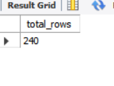

The dataset 10 rows :

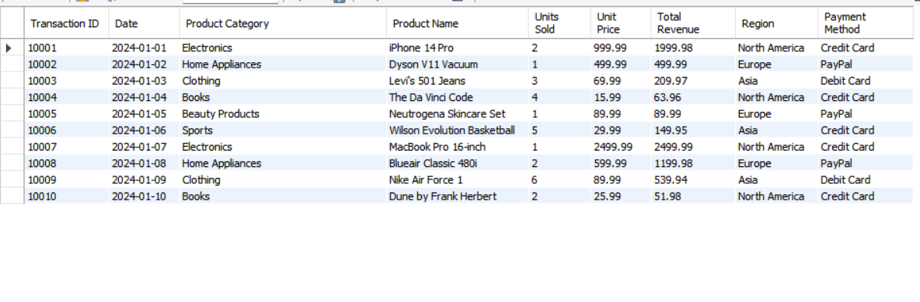

Unique Values

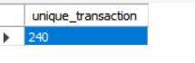



* 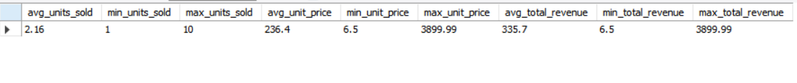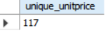The average of sold units is 2.16
* The min quantity is 1
* The max quantity is 10
* The min unit price is 6.5
* The max unit price is 3899.99
* The average of total revenue is 335.7

The total null values in the dataset

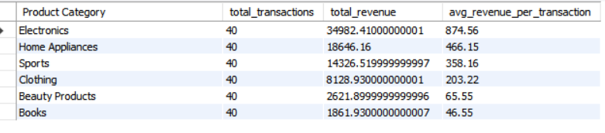

Sales by product category

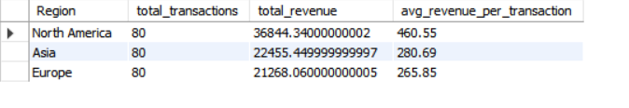sales by region

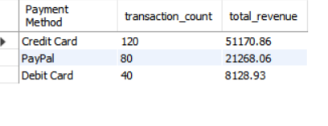payment method wise sales

day wise revenue

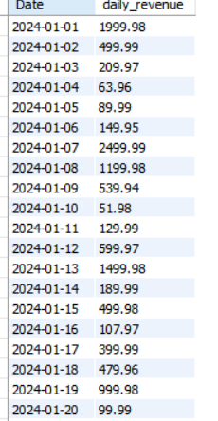

Month wise sales

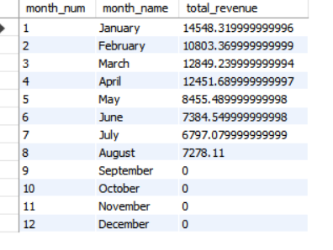

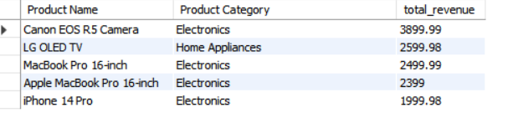product name and category wise sales

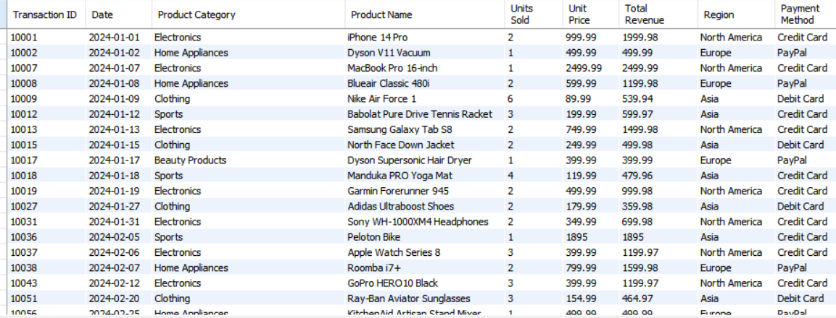Outliers