1 September 2023

To Whom It May Concern

**Ref: Reference letter for Nikita Poyrekar**

I have known Nikita for over a year and a half since early 2022 as her manager/technical lead during her tenure as a Frontend engineer on a major Automotive client engagement delivering products across the EU market.

Nikita has been a key member of our software delivery. She has been delivering to a high standard throughout and has been a great team member. She is very proactive and loves sharing learnings and good practices with the team. She's been leading multiple features and managing delivery all the way to production. She is an attentive listener as well as a good team player capable of learning things quickly.

To the best of my knowledge, she is a self-starter and possesses a good moral character. I believe, all these attributes along with the standard of her work and inspiration would help her do well in her career.

Should you have any further queries please feel free to contact me.

Best Regards

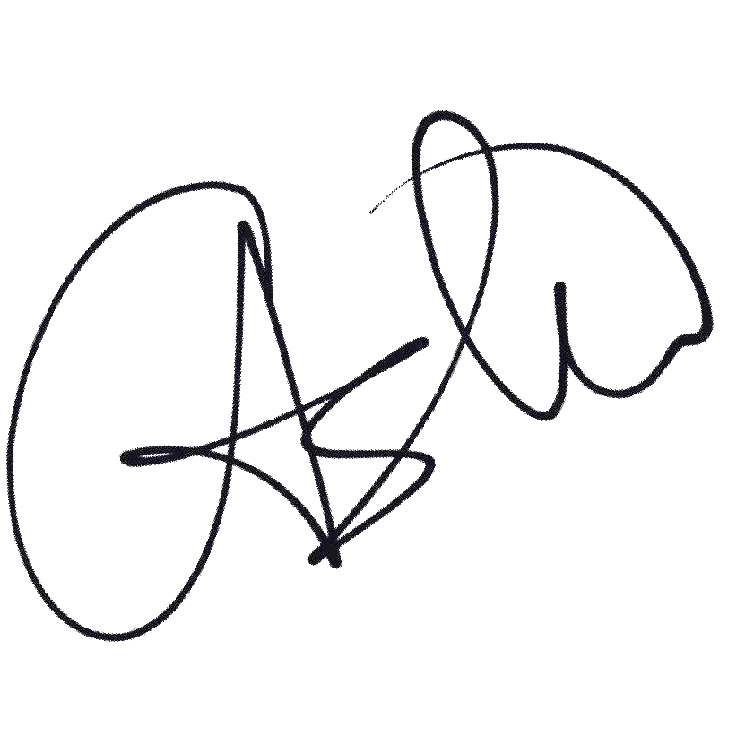

Ashraful Alam

Principal Engineer

London, UK

https://www.linkedin.com/in/ashecret/