1. Search for a mail with this subject: ‘Here are your Google Cloud learning resources’

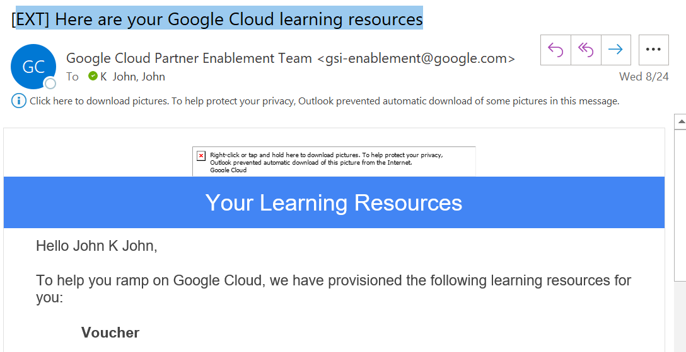

1. Copy the Voucher Code and click on Redeem Voucher
2. Click on the link >>

<https://www.webassessor.com/wa.do?page=certInfo&branding=GOOGLECLOUD&tabs=13>

1. Click on ‘Create New Account’ option (top-right corner)
2. Enter the details. Use your Deloitte email id for registering.

Example:

* 1. User ID: anlahoty
  2. Password: as per the policy
  3. Email: [anlahoty@deloitte.com](mailto:anlahoty@deloitte.com)
  4. Legal First Name: First Name appearing in your government ID proof
  5. Legal Last Name: Last Name appearing in your government ID proof
  6. Address: As per your government ID proof
  7. Select Country and then select State
  8. Enter PIN code
  9. Date of Birth (Click and hold on to the left-side double arrow to select the year)
  10. Confirm 18 years or older: Yes
  11. Organization: Deloitte Touche Tohmatsu India LLP
  12. Primary relationship: Partner
  13. Recovery email id: Enter your personal email id
  14. Marketing opt-in: Yes/No
  15. Name on your certificate
  16. How did you first hear about us: Training Event

1. On successful account creation, login to webaccesor
2. Select Google Cloud Certified Cloud Digital Leader
3. Select onsite-proctored to take exam at a center or remote-proctored to take it from your home (personal laptop required)

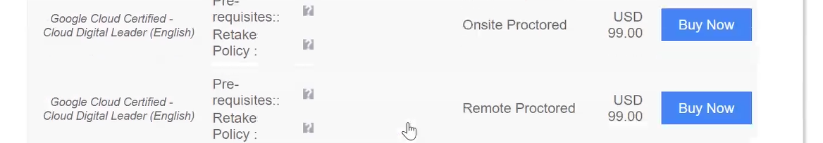

1. Select Centre, date and time slot if Onsite Proctored is selected OR Select Date and time slot if Remote Proctored is selected
2. Click on Proceed
3. Enter your Voucher Code and click on Apply. The amount should reflect as zero (0) now
4. Click on Checkout
5. Fill this form to inform us of your exam registration date: <https://forms.office.com/r/svBgxCvvE9>
6. Post your exam, inform Bakshi, Aalo - Ext [abakshi.ext@deloitte.com](mailto:abakshi.ext@deloitte.com) and K John, John [jkjohn@deloitte.com](mailto:jkjohn@deloitte.com) of the exam result. If you pass the exam, share the certification id with them