Glossary:
MVP: minimal viable product
ARTA: shorthand for the risk mitigation strategies
PSI: potentially shippable increment
Feature: same as backlog item
Product backlog item: a planned feature
Sprint backlog item: a feature being worked on in a past or current sprint
DoD: definition of done: a measure of implementation quality has all the features previously agreed upon been implemented + tested + are they working without errors.
Skateboard: Proof of concept version demonstrating viability of a complete project.
Wheel: Proof of concept of a (small) part of the project, parts of which are thus unimplemented. This must be individually testable and runnable.
CR: code review
RA: risk assesment
RMP: Risk mitigation plan
Capstone Assignment 1
Submit this form as a MS Word docx file to Amathuba.
Also check it in to your Gitlab repo as a MS word docx file, so that team members, tutors, and clients have access to it.
Initial project plan [10% of total mark]
Do not edit this document after submission to Amathuba
Project name: | AI CV Evaluator (CV-EVAL)
Team nickname | TL;DR
Team names (first/last) | Nikita |  | Keegan |  | Akram
Team names (first/last) | Wu |  | Joubert |  | Harris
Student numbers | WXXNIK001 |  | JBRKEE001 |  | HRRAKR001
Project description  1 or 2 lines | CV-EVAL is an AI powered CV evaluation and rewriting assistant, using multiple AI agents to evaluate a CV with respect to a job description. The system will identify weaknesses, rank candidates, and rewrite CV content to improve its suitability for a specific position without fabricating information.
Planned programming language(s) | Python
Git url | https://gitlab.cs.uct.ac.za/wxxnik001/ai-cv-eval
Sprint length | 1 or 2 weeks
non-backlog/non-coding work
Work item 1 | Find relevant AI models to use
Person responsible | Nikita
Work item 2 | Design AI Council variations & dynamics
Person responsible | Nikita
Work item 3 | Design Rewriter Approaches
Person responsible | Akram
Work item 4 | Design Prompt Strategies
Person responsible | Akram
Work item 5 | UML Diagrams
Person responsible | Keegan
Work item 6 | User manual
Person responsible | Keegan
Risk analysis
Describe Risk 1 | Team member is unavailable due to illness, etc. do not remove or alter this risk.
Likelihood | Unlikely | Impact |  | Expensive
ARTA strategy | Transfer
Mitigations | User version control and regular commits to ensure work is accessible to entire team.  Ensure documentation for each major component, and that at least one other team member understands its purpose and interfaces.  Divide tasks so that no critical section depends entirely on undocumented work by one person.
Describe Risk 2 | Free resources limit progress of sprint.
Likelihood | Likely | Impact |  | Cheap
ARTA strategy | Reduce
Mitigations | Investigate and test multiple free models/APIs in early stages of project.  Design system so that underlying model can be replaced without rewriting entire application.  Use smaller/locally available models for development, reserve more capable models for comparison and final evaluation.
Describe Risk 3 | Models capture personal information in response, and this is stored in database.
Likelihood | Likely | Impact |  | Expensive
ARTA strategy | Avoid
Mitigations | Ensure database security.  Minimise storage of personal information, avoid unnecessary storage of CVs or model responses.  Sensitive information should not be included in logs.  Restrict access to stored data, and remove stored data when no longer required.
Describe Risk 4 | Information loss during rewriting, resulting in important information from the original CV being omitted.
Likelihood | Likely | Impact |  | Expensive
ARTA strategy | Avoid
Mitigations | Compare original and rewritten CVs to identify missing information.  Require rewriter to preserve important information (factual claims, qualifications, experience, skills etc.) unless explicitly instructed otherwise.  Test rewriter using CVs containing different types of information, perform manual inspection on outputs during development.
Describe Risk 5 | Fabrication on rewrite (e.g. appending non-existent qualifications)
Likelihood | Likely | Impact |  | Expensive
ARTA strategy | Avoid
Mitigations | Explicitly instruct rewriter not to introduce information that is not present in the original CV.  Implement validation to compare factual claims in rewritten CV against original CV.  Test system with incomplete CVs and prompts that might encourage rewriter model to invent information. Flag / reject rewrites that contain unsupported claims.
Project backlog items
Add as many backlog items as needed
Backlog item 1
Name | AI Council – Independent evaluators
Description | Implement an AI Council in which multiple AI agents independently evaluate a CV against a job listing.  The multiple scores and reasoning produced will then be aggregated using a ‘judge’ model to produce an overall evaluation and candidate ranking.
Priority | High
Main developer | Nikita
Estimated time | 1,5 weeks
Acceptance criteria (DoD):
Functionality | - Multiple AI agents independently evaluate the same CV.  - Each agent receives the relevant CV and job description.  - Each agent produces structured evaluation criteria and scores.  - Number and identity of participating models can be configured.
Test cases | - Test with multiple CVs against the same job description.  - Test that all configured council members receive the required input.  - Test that council result is produced when all models respond successfully.  - Test behaviour when one model fails/returns invalid response.
Client remarks
Approved by client | signature
Backlog item 2
Name | AI Council – Judge / Aggregator
Description | Find and configure an AI model to act as a judge. This AI’s role would be to aggregate the different agents ranking and reasoning into one final score.
Priority | High
Main developer | Akram
Estimated time | 1 week
Acceptance criteria (DoD):
Functionality | - Judge model receives the full set of council members' scores, reasoning, and (where applicable) aspect-specific reports for a given candidate.  - Judge model produces a single final score/ranking per candidate.  - Judge model produces written justification for its final decision, referencing where council members agreed or disagreed.  - Judge explicitly flags cases of high disagreement between council members (e.g. large score spread) rather than silently averaging them away.  - Judge model is swappable independently of which models make up the council.
Test cases | - Test judge output when all council members agree closely. Confirm final score reflects consensus.  - Test judge output when council members disagree sharply. Confirm disagreement is shown in the judges output.  - Test judge behaviour when one or more council member responses are missing/errored.  - Test that judge justification text references specific council input rather than generic reasoning.  - Test with multiple candidates ranked against the same job, confirming consistent relative ordering.  - Verify judge output is deterministic given identical council input
Client remarks
Approved by client | signature
Backlog item 3
Name | CV Rewriter
Description | Given a candidate's CV and a target job listing, the system generates a revised version of the CV optimized to improve the candidate's ranking against that job. The rewriter uses the evaluation reasoning (strengths/weaknesses) produced by the AI Council to guide targeted improvements by rephrasing weak sections, making relevant experience more apparent and aligning terminology with the job description without fabricating qualifications the candidate doesn't have
Priority | High
Main developer | Akram
Estimated time | 1 week
Acceptance criteria (DoD):
Functionality | - System accepts a candidate's original CV and a target job description as input.  - System accepts (or generates) evaluation feedback identifying weaknesses/gaps relevant to that job.  - System produces a rewritten CV that addresses identified weaknesses where legitimately possible (e.g. rewording, reprioritizing, reformatting existing content).  - Rewriter does not fabricate experience, qualifications, or credentials not present in the original CV.  - Output preserves factual claims (dates, job titles, education) from the original CV unchanged.
Test cases | - Test that factual details (employment dates, institutions, certifications) are unchanged between original and rewritten CV.  - Test that no new skills/qualifications appear in the rewritten CV that weren't present in the original.  - Test rewritten CV against the same job description through the AI Council and confirm score improves or does not regress.  - Test behaviour when the original CV has little/no relevant content to improve (i.e. rewriter should not invent relevance).  - Test with multiple job descriptions against the same base CV, confirming the rewrite is tailored differently per job.
Client remarks
Approved by client | signature
Backlog item 4
Name | PDF parsing
Description | Extract clean, usable text from CV and job description PDFs so they can be passed to AI models for evaluation. Must reliably handle real-world CVs of varying layout, length, and formatting complexity.
Priority | Low
Main developer | Nikita
Estimated time | 0,5 week
Acceptance criteria (DoD):
Functionality | - System extracts text content from text-based PDF CVs and job descriptions.  - System detects and flags PDFs where extraction fails or produces suspiciously little/no text  - Extracted text is sanitized of invalid/control characters before being sent to any downstream model or API.  - System enforces or truncates text length sensibly when a CV exceeds a model's context window, rather than sending an oversized request that gets rejected outright.  - Parsing failures for one file do not halt processing of the remaining batch.
Test cases | - Test with a standard single-column text-based CV PDF.  - Test with a multi-column or table-heavy CV layout.  - Test with a scanned/image-based PDF (should be flagged, not silently produce empty text).  - Test with an unusually long CV (multiple pages) to confirm truncation/context handling works as intended.  - Test with a corrupted or unreadable PDF file, confirming the batch continues processing other files.
Client remarks
Approved by client | signature
Backlog item 5
Name | MVP Application Interface
Description | Develop an interface through which a user can provide a CV and job description, and receive an evaluation and rewritten CV.
Priority | Middle
Main developer | Keegan
Estimated time | 1 week
Acceptance criteria (DoD):
Functionality | - User can provide a CV.  - User can provide job description.  - System can start an evaluation.  - Resulting evaluation presented clearly  - Rewritten CV can be viewed/saved  - User may be a candidate / recruiter  - Interface provides useful error messages
Test cases | - Test valid CV and job input  - Test missing CV input  - Test missing job input  - Test invalid file input  - Test successful end-to-end evaluation and rewrite
Client remarks
Approved by client | signature
Backlog item 6
Name | CV Rewriter – PDF Export
Description | Take the CV Rewriter's rewritten text output and generate a polished, professional PDF document the candidate can actually use to apply for jobs. Output should follow standard CV formatting conventions (clear section headings, consistent typography, sensible layout) rather than a plain text dump, so the result is presentation-ready without manual reformatting.
Priority | Middle
Main developer | Keegan
Estimated time | 1 week
Acceptance criteria (DoD):
Functionality | - System converts the rewriter's structured text output into a formatted PDF document.  - Output includes standard CV sections (e.g. contact details, experience, education, skills) as distinct, clearly labelled sections.  - Formatting such as fonts, spacing, and heading styles are consistent throughout the document.  - Generated PDF is downloadable/saved in a location accessible to the user.  - System handles CVs of varying length (e.g. one-page vs multi-page) without breaking layout.
Test cases | - Test with a short, rewritten CV. Confirm clean single-page layout.  - Test with a long, rewritten CV. confirm page breaks fall in sensible places (not mid-section).  - Test that all section headings and content from the rewriter output appear correctly in the PDF, with nothing dropped or duplicated.  - Test that special characters (accents, bullet points, symbols) render correctly in the output PDF.  - Test generated PDF opens correctly in standard PDF viewer.
Client remarks
Approved by client | signature
GenAI declaration
Did you use GenAI | Yes
Describe use | - Understanding the capabilities and limitations of available hardware to assess what could realistically be implemented by the team in the first sprint.  - Recommendations for models and approaches that could be run locally on available hardware as a starting point for development.  - Understanding how Python programs can be connected to AI models, including how to run models locally and how to interact with models through OpenRouter APIs.  - Generation of preliminary diagram for visualisation (below).  These uses were primarily for research, exploration and understanding.  Specific models used: Anthropic Claude Sonnet 5, OpenAI ChatGPT (GPT-5.6 Luna)
Diagram showing multiple independent evaluator agents providing evaluations to a judge model.
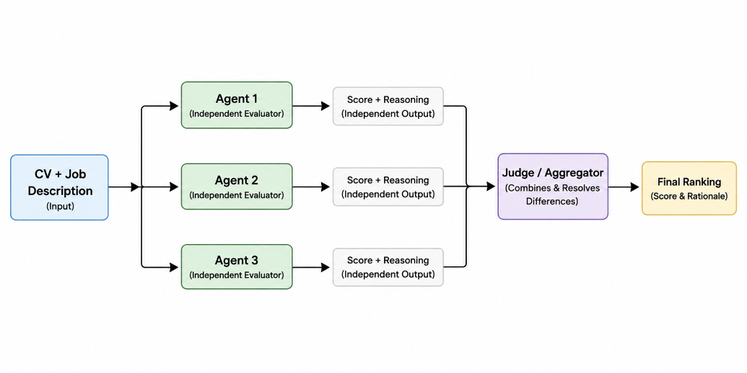
Illustrated with GenAI ChatGPT: GPT-5.6 Luna. Reviewed and adapted by the team to reflect proposed project design.

