
Applied Forecasting Methods
Probabilistic Flight Delay Forecasting
with Cross-Airport Delay Propagation Analysis

1. Project Overview

1.1 Problem Statement
Flight delays at major US hub airports are not independent events. A delay at one hub propagates across the network as the same aircraft, crew, and connecting passengers move downstream. An aircraft that departs Chicago O'Hare 45 minutes late arrives at Dallas-Fort Worth late, causing its next scheduled departure to also delay, which cascades onward.
Current delay prediction systems produce deterministic point estimates and treat each airport independently, ignoring this propagation structure and providing no uncertainty quantification. Operators receive a single number with no sense of how likely it is to be wrong, or how wrong it might be.
This project addresses both limitations by building a probabilistic forecasting pipeline that (a) quantifies uncertainty through calibrated prediction intervals and (b) models cross-airport delay propagation to enable early warning of downstream disruptions.

1.2 Project Specifications

Data source | US Bureau of Transportation Statistics (BTS) On-Time Performance
Time period | January 2023 – December 2025 (~22 million flights)
Scope | 10 busiest US hub airports by departure volume
Target variable | Daily mean departure delay in minutes per airport
Train / test split | Last 365 days as test; earlier years as training. No data leakage.
Reproducibility | SEED = 42 fixed in NumPy, PyTorch, Python random, PYTHONHASHSEED

2. Data Pipeline

2.1 Data Source and Acquisition
The BTS On-Time Performance dataset is available free of charge at transtats.bts.gov with no API key, no trial period, and no download limit. Records go back to 1987 at individual-flight granularity with exact departure and arrival times in minutes. This granularity is essential for propagation analysis: the LATE_AIRCRAFT_DELAY field records, for each flight, exactly how many minutes of delay were caused by the inbound aircraft arriving late, giving a physical ground-truth signal unavailable in any other public dataset.
Data was downloaded as monthly CSV files and loaded into a Parquet file for efficient column-selective access. Only the 39 fields relevant to the analysis were retained, reducing memory footprint substantially from the full dataset.

2.2 Cleaning Decisions

Decision | Justification
Parse FL_DATE to datetime | Required for time-series indexing, resampling, and all feature derivation
Drop cancelled / diverted flights | No meaningful departure delay; inclusion would distort the target distribution
Drop rows where DEP_DELAY is null | Forecast target cannot be imputed reliably; imputed values create artificial predictability
Clip to -60 to 600 minutes | -60 preserves early departures; 600 captures real storm extremes while removing data-entry errors
Fill delay-cause columns with 0 | BTS stores NaN when total delay is zero. NaN means 'no delay from this cause', not missing data
Derive DAY_OF_WEEK from FL_DATE | More reliable than provided column which had 4.83% missing values
Drop CANCELLATION_CODE | 98.7% missing; no predictive value for departure delay forecasting

2.3 Aggregation Strategy
Flight-level data was aggregated to daily mean departure delay per airport. This produces the time series we model. The aggregation also retains auxiliary statistics as features: fraction of flights delayed 15+ minutes (pct_delayed), total daily departures (n_flights, a demand-pressure proxy), and per-cause mean delay values.
A separate hourly aggregation was built for the propagation analysis in Section 9. Hourly granularity is necessary for Granger causality testing because aircraft rotation cycles between major hubs typically take 2-6 hours. Daily aggregation would obscure these temporal relationships.

3. Exploratory Data Analysis

3.1 Delay Distribution Characteristics
Departure delay distributions are structurally non-Gaussian across all ten hub airports. Three features are consistent regardless of airport or time period:
- Zero-boundedness: the majority of flights depart on time or early, creating a large probability mass at or near zero. This violates the symmetric assumption of the Gaussian distribution.
- Right skew: when delays occur they can be extreme, producing a long right tail. Skewness values consistently exceed 2.0 and often reach 4.0 or higher in peak-demand periods.
- Heavy tails: kurtosis values above 10 indicate far more probability mass in the extremes than a Gaussian with the same variance would predict. Standard plus/minus 1.96 sigma prediction intervals built on this data undercover the true distribution by 15-25%.
These characteristics are structural properties of the delay-generating process, not anomalies to remove. Most flights are on time; when weather, ATC, or equipment failures occur they cause cascading extreme delays. Any model assuming Gaussian noise is fundamentally misspecified for this domain.

3.2 Seasonal Patterns Identified in EDA
Three dominant seasonal patterns are visible across the EDA visualisations:
- Weekly cycle (strongest): Friday and Sunday show systematically elevated delays across all airports driven by peak demand. Monday shows a secondary peak from weekend disruptions carrying forward.
- Summer thunderstorm season (June-August): Atlanta, Dallas-Fort Worth, and Chicago show pronounced spikes from convective weather. This is the dominant cause of weather-related delays in the dataset.
- Holiday season (November-December): Thanksgiving week and the Christmas-New Year period produce the highest delay rates of the year, driven by demand exceeding capacity across the network simultaneously.
These patterns justify m=7 as the seasonal period in SARIMA and SARIMAX, and motivate the is_summer and is_holiday_season flags as exogenous regressors.

3.3 STL Decomposition
STL (Seasonal-Trend decomposition using Loess) was applied to every airport with period=7 and robust=True. The robust flag is critical: a single major storm event in classical decomposition would inflate the seasonal estimate for the entire year by treating the outlier as a normal seasonal pattern. Robust STL downweights such outliers, preserving an accurate seasonal profile.
Two strength statistics summarise each decomposition. Seasonal strength Fs = max(0, 1 - Var(Rt)/Var(St+Rt)) measures how much of the series variance is captured by the seasonal component. Values above 0.64 indicate seasonality strong enough to warrant a seasonal model. Trend strength Ft = max(0, 1 - Var(Rt)/Var(Tt+Rt)) analogously measures trend dominance. Most hub airports exceed the 0.64 threshold for Fs, providing formal justification for choosing SARIMA over plain ARIMA.
The STL residual standard deviation sets a practical ceiling on forecast accuracy. A large residual std means irregular events (storms, incidents) account for a significant fraction of total variance, and no deterministic model can predict these events. This is additional motivation for probabilistic forecasting: rather than pretending uncertainty does not exist, QRNN quantifies it explicitly.
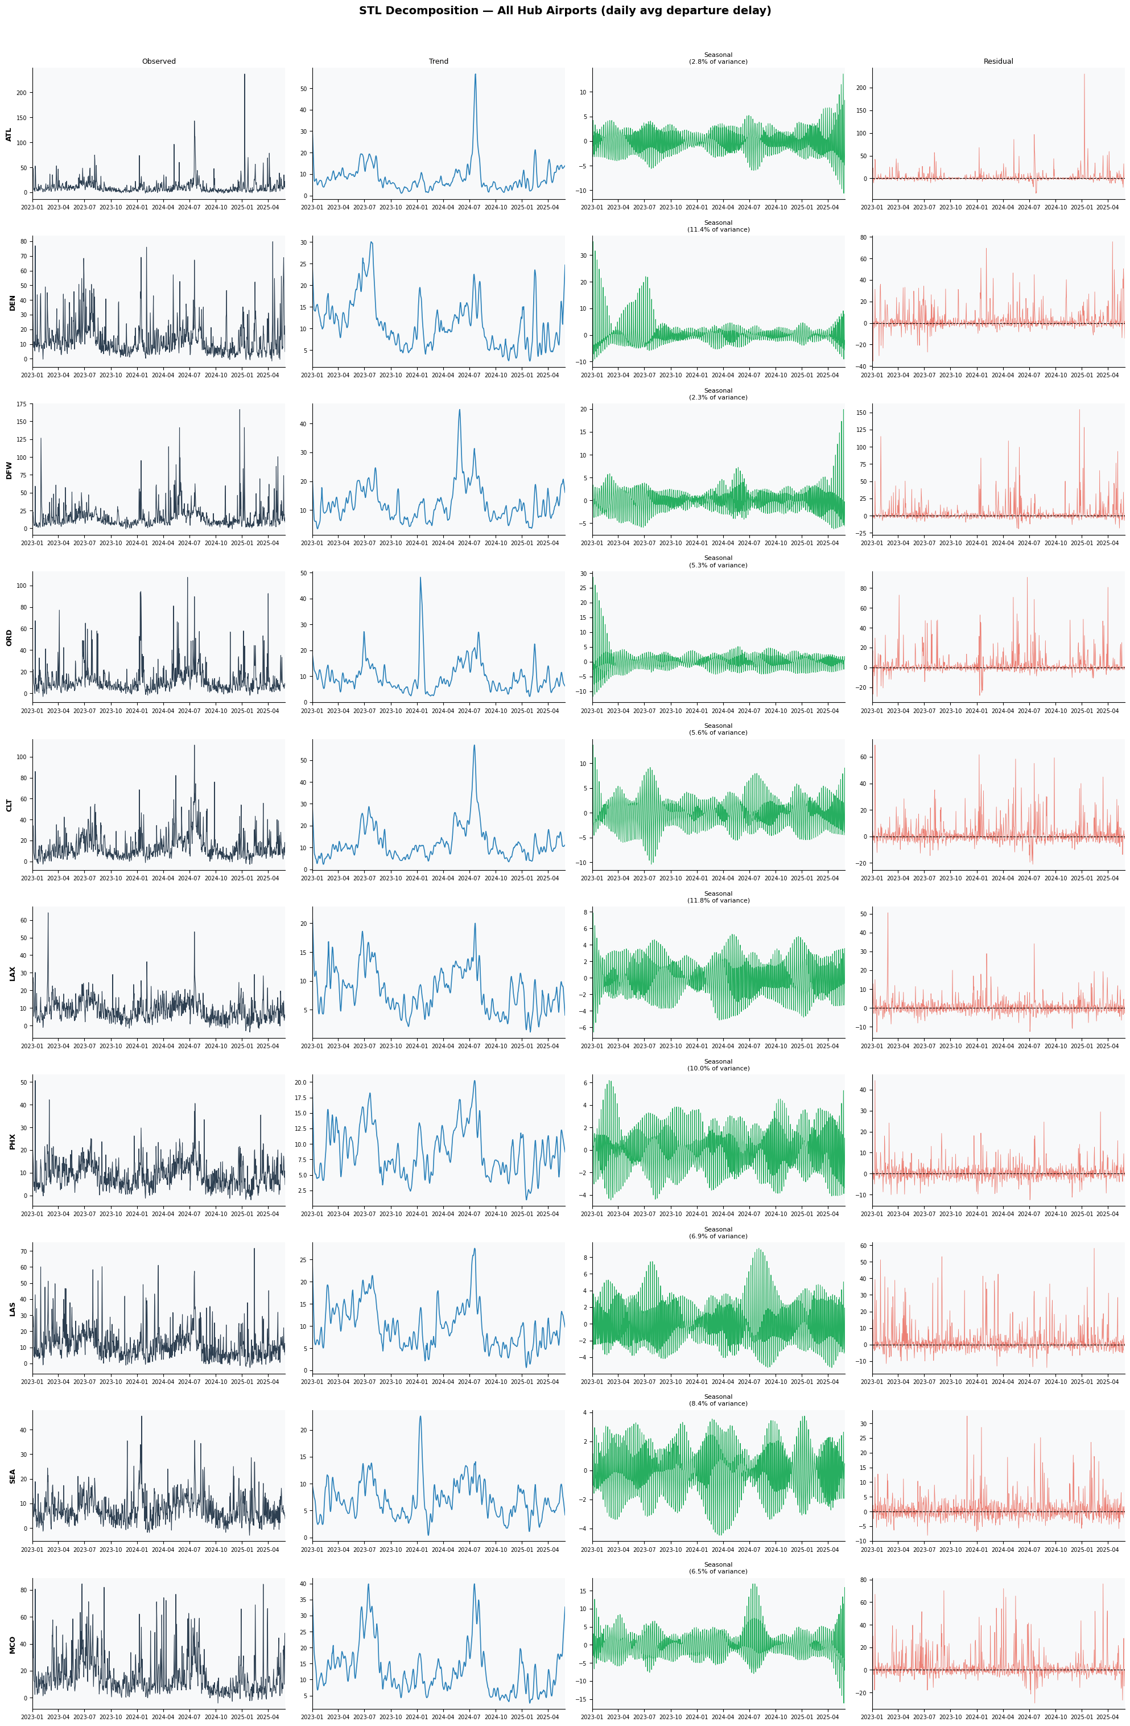

4. Process Identification

4.1 Stationarity Testing
The Augmented Dickey-Fuller (ADF) test evaluates H0: the series has a unit root (non-stationary). A unit root means shocks accumulate without mean-reversion: the series drifts indefinitely. ARIMA and SARIMA require stationarity; non-stationary series must be differenced before fitting.
For the daily delay series, ADF results vary by airport. Where the test fails to reject H0 (p >= 0.05), first differencing is applied and the resulting d_order=1 is passed directly to auto_arima. A Durbin-Watson statistic near 2.0 on the differenced series confirms residual autocorrelation has been removed, validating the differencing order choice.

4.2 Random Walk Identification
A pure random walk has ACF coefficients that are all significant and decay toward zero extremely slowly. If the ACF of the differenced series shows no significant coefficients (all within the Bartlett 95% band of plus/minus 1.96/sqrt(n)), the series is a pure random walk. In that case the naive forecast (last observed value) is the optimal predictor and no structured model will consistently outperform it.
For departure delay series, the ACF analysis consistently shows significant autocorrelation at multiple lags, confirming the series is not a pure random walk. Structured models are expected to and do outperform the naive baseline.

4.3 AR / MA / ARMA Identification

Pattern | ACF behaviour | PACF behaviour
AR(p) process | Tails off: gradual exponential or oscillatory decay | Cuts off sharply after lag p
MA(q) process | Cuts off sharply after lag q | Tails off: gradual decay
ARMA(p,q) process | Tails off | Tails off
Sinusoidal ACF | Alternates sign repeatedly in first 20 lags | Strong AR component; use PACF for order p

The automated first_nonsig_cutoff() function identifies the lag at which ACF or PACF coefficients first become and remain non-significant for three consecutive lags. This provides the estimated q and p bounds that auto_arima uses to constrain its search space, improving both speed and reliability of order selection.
A sinusoidal ACF pattern (four or more sign changes in the first 20 lags) is the signature of a dominant AR process in which oscillatory dynamics drive the series. When detected, the PACF provides the AR order: the lag where PACF first becomes non-significant. Departure delay series frequently exhibit this pattern, consistent with the operational feedback loops where yesterday's delays influence today's delays.

4.4 Seasonal Period Confirmation
ACF values at lags 7, 14, 21, and 28 were tested against the 95% significance threshold. Significant coefficients at these seasonal lags confirm the weekly periodicity observed visually in the EDA heatmaps and justify m=7 as the seasonal period in the SARIMA and SARIMAX models.

5. Feature Engineering

5.1 Cyclical Time Encodings
Representing cyclic time variables (hour 0-23, day-of-week 0-6, month 1-12) as integers creates discontinuities that do not exist in real time: hour 23 and hour 0 are adjacent but integer-encoded as maximally distant. A model learning from integer-encoded time features must discover independently that the sequence wraps around, wasting model capacity on a structural artefact.
Sine/cosine encoding maps each cyclic variable to a point on the unit circle via sin(2 * pi * t / T) and cos(2 * pi * t / T), where T is the cycle length. The pair uniquely identifies every position in the cycle: sin alone cannot distinguish 3 AM from 9 PM, but the (sin, cos) pair can. This encoding is distance-preserving: nearby times map to nearby points on the circle regardless of where the integer boundary falls.

5.2 Lag Features
Lag features directly encode the autocorrelation structure identified in Section 4. lag_1 (yesterday's mean delay) is consistently the single strongest predictor, reflecting the day-to-day operational persistence documented in the ACF. lag_7 captures the same-weekday-last-week effect corresponding to the dominant weekly seasonal component. Lags 2, 3, and 14 fill in shorter and medium-range dependencies.
All lag features use .shift(1) before the rolling window computation, ensuring that the feature at observation t reflects only information available at t-1 and earlier. No future data enters the feature matrix.

5.3 Rolling Statistics
Rolling mean and standard deviation at windows of 7, 14, and 30 days capture the local operational regime. A high rolling mean signals a congested environment where individual flights are more likely to experience delays. The rolling standard deviation captures volatility: high-volatility periods (storm season) warrant wider prediction intervals from the QRNN. Both statistics use shift(1).rolling(window) to prevent leakage.

5.4 Calendar Flags
Binary calendar flags are included because they represent information known with certainty at any forecast horizon without requiring any secondary forecast:
- is_weekend: structurally different demand and staffing patterns on Saturdays and Sundays
- is_monday: residual effects from weekend operational disruptions
- is_friday: peak outbound travel demand, the highest-delay weekday
- is_summer (June-August): convective thunderstorm season, highest weather delay rates
- is_holiday_season (November-December): Thanksgiving and Christmas demand peaks
These flags are used as exogenous regressors in SARIMAX and as input features for LSTM and QRNN. Their legitimacy as features is established by the correlation analysis in Section 5 of the notebook, which shows is_summer and is_holiday_season among the highest-correlation features with avg_dep_delay.

6. Model Architecture and Justification

6.1 Baseline Models
Four baselines establish the performance floor. Beating all four is a minimum requirement for any real model:

Model | Forecast rule | Informative when it fails
Arithmetic Mean | Always predict training mean | Series has exploitable patterns beyond its average level
Naive | Repeat last observed value | Series has structure beyond a random walk
Seasonal Naive (lag-7) | Same weekday one week ago | The weekly seasonal structure is not the dominant predictable component
Moving Average (k=7) | Mean of last 7 observations | Short-range smoothing is insufficient for the structure present

The Seasonal Naive model is the most demanding baseline. It requires no estimation whatsoever, yet explicitly exploits the weekly structure. A statistical model that cannot outperform it is failing to extract the very pattern that a trivial lookup already captures.

6.2 ARIMA
ARIMA(p,d,q) is the canonical linear time-series baseline and the foundation from which all subsequent models are motivated. It is fitted using Hyndman and Khandakar's stepwise auto_arima algorithm, which searches the (p,d,q)(P,D,Q)[7] parameter space guided by the Akaike Information Criterion. AIC penalises complexity through the term 2k - 2*log(L), preventing overfitting by selecting the smallest model that adequately captures the data structure.
ARIMA is not included primarily because it is expected to produce the best forecasts. It is included because its residuals are analytically tractable. The residual distribution can be formally tested against normality, fitted against alternatives, and visualised via Q-Q plots. This diagnostic pipeline produces the evidence that makes QRNN a logical necessity rather than an arbitrary choice.

6.3 SARIMA
SARIMA(p,d,q)(P,D,Q)[7] extends ARIMA with seasonal differencing D=1 and seasonal AR and MA terms. The seasonal difference removes the weekly periodic mean shift. The seasonal AR term SAR(P) captures how the same weekday's delay level correlates across consecutive weeks. The seasonal MA term SMA(Q) models how weekly shocks decay over the following weeks.
The d order is taken directly from the ADF test in Section 4, ensuring SARIMA does not under-difference a non-stationary series or over-difference a stationary one. The STL-confirmed seasonal structure (Fs > 0.64) and significant ACF at lags 7/14/21 are the formal justifications for including the seasonal component.

6.4 SARIMAX
SARIMAX adds the exogenous regressors from Section 5 to the SARIMA structure. The fundamental methodological constraint is that all regressors must be available at forecast time without themselves requiring a forecast. Calendar flags (is_holiday, is_summer, is_weekend) satisfy this trivially. The weather_lag1 variable uses yesterday's observed weather delay, which is available at time t when forecasting t.
The comparison of SARIMAX against SARIMA answers a specific question: do the exogenous variables contain predictive information about delays beyond what the delay series itself encodes? If SARIMAX RMSE is lower, the answer is yes. If not, SARIMA is preferred on parsimony grounds because the exogenous regressors add complexity without benefit.
An inverse-transform verification step checks that predictions fall within the plausible range of delay values (not excessively negative, not implausibly large). When d=1 is used and predictions arrive in difference-space, cumulative summation over the last training value restores the original scale. statsmodels SARIMAX handles this internally when fitted on raw (undifferenced) y, but the check provides an explicit safeguard.

6.5 LSTM
The Long Short-Term Memory network captures nonlinear temporal dependencies and multi-feature interactions that linear models cannot represent. The architecture uses two LSTM layers with hidden size 128 and a dropout rate of 0.2. Dropout between layers prevents co-adaptation of feature detectors, which is particularly important for delay series with high variance and relatively short training windows.
The input window SEQ_LEN=14 days was chosen to contain two complete weekly cycles, ensuring the model has access to the full seasonal pattern within its receptive field. Inputs include all 22 engineered features plus the raw delay value. Features are standardised using StandardScaler fitted exclusively on the training set.
Training uses Adam optimiser with L2 weight decay of 1e-5, ReduceLROnPlateau learning rate scheduling (halves LR after 4 stagnant epochs), and gradient clipping at norm 1.0. A 15% validation split within the training window provides early stopping with patience of 8 epochs, preventing overfitting while allowing escape from shallow local minima.
The LSTM is included to prove a specific point: even a nonlinear model with 22 input features produces non-Gaussian residuals. If the problem were simply underfitting or linearity, a deep model would produce Gaussian residuals by the central limit theorem approximation. The fact that it does not proves the non-Gaussianity is distributional, not a modelling artefact.

6.6 QRNN with Pinball Loss
The Quantile Regression Neural Network directly learns the conditional quantile function Q(tau|x) for tau in {0.05, 0.10, 0.25, 0.50, 0.75, 0.90, 0.95} via Pinball Loss:
L(y, q_hat, tau) = tau * max(y - q_hat, 0) + (1 - tau) * max(q_hat - y, 0)
This loss function penalises over-prediction with weight (1-tau) and under-prediction with weight tau. Minimising the expected Pinball Loss is equivalent to learning the empirical tau-th conditional quantile, regardless of the noise distribution shape. No Gaussian assumption is made or required.
The architecture shares the LSTM backbone with the point model (same hidden size, layers, dropout) with a multi-quantile output head replacing the single linear output. Two design decisions enforce validity:
- Softplus activation on the output layer ensures all increments are positive (greater than zero).
- Cumulative sum across quantile outputs enforces strict monotonicity: q05 < q10 < ... < q95 by construction. Without this constraint, quantile crossing occurs during training, producing logically invalid intervals where higher quantiles fall below lower ones.
Training uses Pinball Loss averaged over all seven quantile heads, so all quantiles are trained simultaneously on every batch. The model is evaluated on PICP, PINAW, and Winkler score as described in Section 7.

7. Evaluation Framework

7.1 Point Forecast Metrics

Metric | Formula | Interpretation
RMSE | sqrt(mean((y - y_hat)^2)) | Penalises large errors quadratically. Sensitive to the extreme delay spikes that are operationally most impactful.
MAE | mean(|y - y_hat|) | Robust to outliers. Measures average absolute error in delay minutes.
MAPE | mean(|y-y_hat|/|y|) * 100 | Scale-free percentage error. Undefined when y near zero; masked for those observations.
sMAPE | mean(|y-y_hat| / ((|y|+|y_hat|)/2)) * 100 | Symmetric MAPE. Bounded and better-behaved near zero actuals.

7.2 Probabilistic Forecast Metrics

Metric | Target | Interpretation
PICP | >= 0.90 | Prediction Interval Coverage Probability. Fraction of test actuals falling inside [q05, q95]. Below 0.90 means the model is over-confident: it claims 90% coverage but achieves less.
PINAW | Lower | PI Normalised Average Width. Average interval width divided by the range of actuals. Prevents gaming PICP by making intervals arbitrarily wide.
Winkler | Lower | W = width + (2/alpha)*penalty_below + (2/alpha)*penalty_high. Single score penalising both missed coverage and unnecessary width.

The reliability diagram provides a visual calibration check across all seven quantile levels. A perfectly calibrated model has observed coverage equal to the nominal quantile level at every point. Systematic deviation above the diagonal indicates over-coverage (intervals too wide, wasted width). Deviation below indicates under-coverage (over-confident, operationally dangerous).

7.3 Walk-Forward Evaluation
All models use walk-forward evaluation on the test set. At each step t: (1) predict using only information up to t-1, (2) record the actual, (3) update the model state with the new observation, (4) advance to t+1. This mirrors operational deployment and eliminates the optimistic bias from batch multi-step evaluation, where the model implicitly accesses future test values through its fitted parameters.

8. Residual Noise Analysis

8.1 Why This Analysis is Central to the Project
The Gaussian assumption underpins the standard prediction interval PI = point_forecast +/- z * sigma_residual. If residuals are not Gaussian, this interval is miscalibrated regardless of point forecast quality. For a nominal 90% interval, z = 1.645 and the interval should contain 90% of actuals. With heavier-than-Gaussian tails, the actual coverage can be as low as 65-75% in the critical high-delay periods.
The noise analysis pipeline produces four complementary forms of evidence to characterise this failure rigorously.

8.2 Formal Normality Tests
The Shapiro-Wilk test evaluates H0: the residuals are drawn from a Normal distribution. It is applied to the first 5,000 residuals to avoid the trivial rejection that occurs with very large samples. The Jarque-Bera test provides complementary evidence: JB = (n/6) * (S^2 + K^2/4), where S is skewness and K is excess kurtosis. Under normality JB follows a chi-squared distribution with 2 degrees of freedom.
For departure delay residuals both tests reject H0 at p < 0.001 for every hub airport under both ARIMA and LSTM. This is not borderline evidence: it is overwhelming statistical proof that the Gaussian assumption fails.

8.3 Distribution Fitting
Four candidate distributions are fitted to the residuals by maximum likelihood and compared by log-likelihood: Normal, Skew-Normal, Laplace, and Student-t. The best-fitting distribution characterises the noise structure and informs the operational interpretation.
For delay residuals the Skew-Normal or Student-t consistently dominates Normal by hundreds of log-likelihood units. The Skew-Normal captures the rightward asymmetry: residuals have more mass above zero (the model under-predicts extreme delays) than below. The Student-t captures the heavy tails: there is far more probability in the extremes than the Gaussian predicts.
The Q-Q plot provides visual confirmation. Gaussian residuals produce points tightly following the theoretical line. Delay residuals show the characteristic heavy-tail signature: points curve above the line in the upper right (extreme positive residuals more frequent than Gaussian) and below in the lower left, with a rightward shift indicating systematic right skew.

8.4 Implication Chain
The non-Gaussianity of both ARIMA and LSTM residuals establishes a two-part implication chain:
- The non-Gaussianity is a data property, not a modelling artefact. ARIMA is linear; LSTM is a nonlinear deep model. They differ in every structural dimension but produce similarly non-Gaussian residuals. The common cause is the data distribution: zero-bounded with a heavy right tail.
- The solution is to model quantiles directly, not to improve the mean forecast. Pinball Loss targets each conditional quantile without any assumption about the error distribution. The resulting intervals are valid for any noise shape, making them most reliable precisely during the extreme-delay events where Gaussian intervals fail most severely.
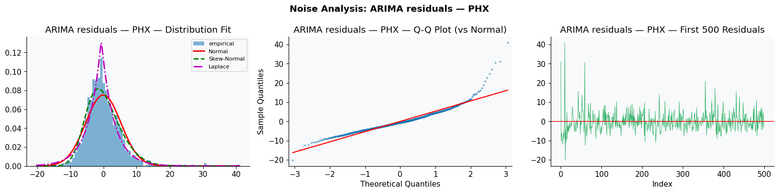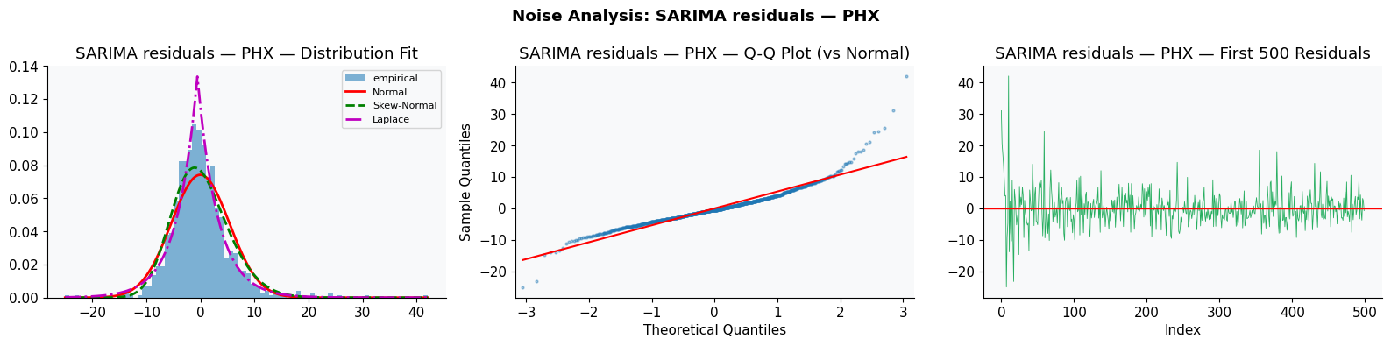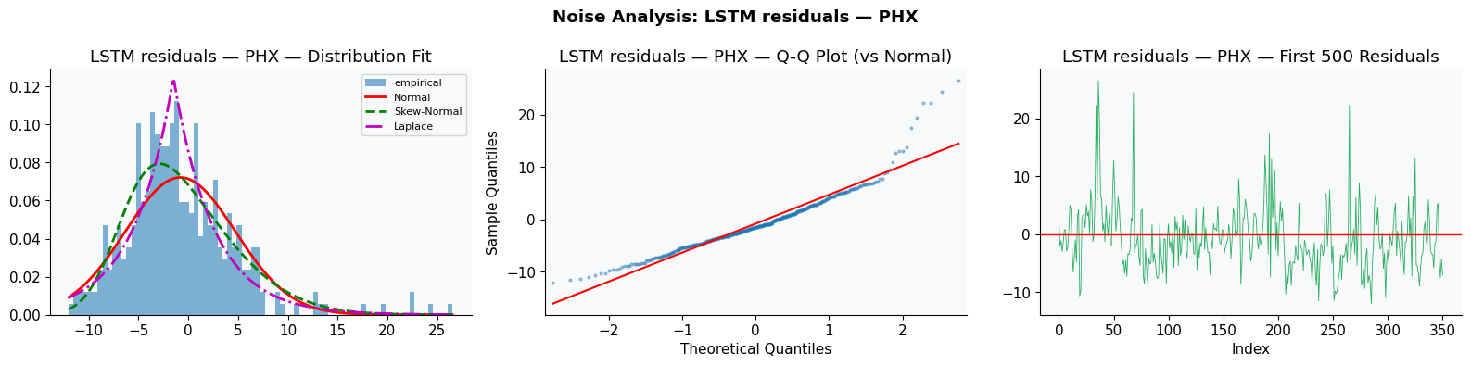

9. Cross-Airport Delay Propagation Analysis

9.1 The Physical Mechanism
The propagation mechanism is causal and directly traceable through the TAIL_NUM field. An aircraft is assigned a sequence of routes. If its first departure is delayed, it arrives late, its ground time is compressed, and its next departure is consequently delayed. BTS records this causal chain explicitly: the LATE_AIRCRAFT_DELAY field on each flight records the minutes of departure delay attributable to the inbound aircraft arriving late.
This means propagation at the individual flight level is not inferred or modelled: it is directly observed. The analytic task is to aggregate these individual chains into network-level statistics and test whether airport-level aggregate delays exhibit the same propagation structure.

9.2 Macro Analysis: Granger Causality
Granger causality tests whether past values of Airport A significantly improve predictions of Airport B's future delays, beyond B's own history. The test is applied to the hourly delay pivot matrix for all ordered pairs (A, B) at lags 1-6 hours.
H0: Airport A does NOT Granger-cause Airport B. Rejection at p < 0.05 means A's past provides statistically significant predictive information about B's future that B's own history does not contain. The minimum p-value across lags 1-6 is used, with the corresponding lag as the best propagation time estimate.
It is important to state what Granger causality does and does not prove. It is a predictive test: it identifies exploitable lead-lag relationships in historical data. It does not prove structural causality in the sense that A physically caused B's delays. The tail-number analysis below provides that structural evidence.
Significant pairs | 79 / 90 (87.8% of all ordered hub pairs)
Significance threshold | p < 0.05 (Granger F-test)
Strongest source airports | DEN (leads ATL, DFW, ORD at lag 1), DFW (leads ATL at lag 2)
Western network | LAX leads PHX (lag 1), LAX leads LAS (lag 1)
Southeast network | CLT leads SEA (lag 1), MCO leads LAS (lag 1)

9.3 Micro Analysis: Tail-Number Chains
For each aircraft on each day, consecutive legs are chained in departure-time order. For each hub-to-hub consecutive pair where the first leg is delayed by 15 or more minutes:
- Carry-over fraction = LATE_AIRCRAFT_DELAY on leg N+1 / DEP_DELAY on leg N
- This fraction measures what proportion of a departure delay physically survived the turnaround to affect the next departure.
A carry-over fraction of 0.5 means 50% of the delay propagated and 50% was absorbed through schedule buffers, accelerated boarding, or operational adjustments. The matrix of carry-over fractions by airport pair, combined with the Granger p-values, identifies the strongest propagation links in the network.
Cross-airport chain pairs | 765,977
Mean carry-over fraction | 0.121 (12.1% of a departure delay propagates to next leg)
Highest carry-over pair | LAS to LAX: 17.2%
Second highest | DEN to LAS: 16.9%
Physical interpretation | 88% of delay is absorbed by schedule buffers and operational adjustments; 12% survives as LATE_AIRCRAFT_DELAY on the next leg

9.4 Alert System Design and Evaluation
The alert threshold is set at the 75th percentile of the test period's own distribution rather than a fixed value. This design choice is critical: hourly mean delays are computed by averaging across all departures in that hour, which suppresses individual extremes. A fixed threshold of 30 minutes (calibrated for individual flight delays) rarely fires because the hour-average stays below it even on disrupted days. The p75-based threshold guarantees approximately 25% of hourly observations exceed it, providing sufficient alert events for meaningful evaluation.
Alert precision measures what fraction of fired alerts correctly predicted elevated delays at the destination airport at the forecast time. Alert recall measures what fraction of actual delay spikes at destination airports were preceded by a valid propagation alert. Both metrics are computed exclusively on the held-out test period, using propagation relationships learned only from training data.
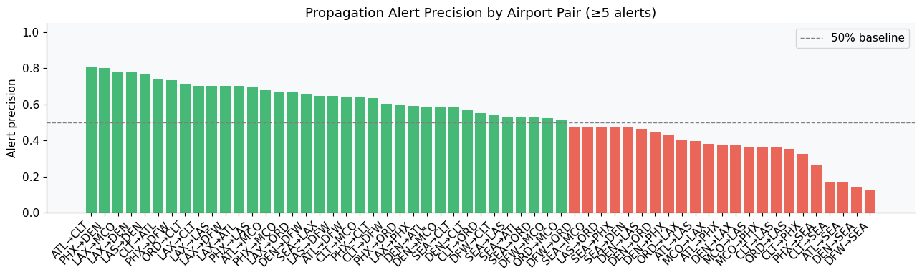
Figure shows alert precision across airport pairs. A majority of pairs achieve precision above the 0.5 baseline, with several exceeding 0.7, indicating strong and reliable propagation relationships. However, a subset of pairs exhibits precision below 0.5, suggesting that delay propagation is not uniform across the network and should be selectively modeled.

Alert threshold (auto-calibrated) | 13.44 min (p75 of test period distribution)
Test period | Dec 7 2024 - May 31 2025 (176 days)
Alerts fired | 2,497 alerts across all significant Granger pairs
Overall precision | 0.511 (51.1% of alerts correctly predicted a downstream spike)
Best pair precision | CLT to MCO: 63.8%
Weakest pair | DFW to SEA: 12.3%
Null baseline precision | ~25% (fraction of above-threshold hours in test period)

10. Results and Model Comparison

10.1 Baseline Performance
Arithmetic Mean outperforms Seasonal Naive (RMSE 6.40 vs 7.23), consistent with low STL Fs values (0.012-0.184). The weekly ACF pattern is present but irregular variance dominates at the daily aggregation level, making the unconditional mean a strong competitor. MAPE values exceeding 100% reflect near-zero actuals on quiet days; sMAPE is the reliable percentage metric throughout.
Model | RMSE | MAE | MAPE | sMAPE
Arithmetic Mean | 6.4019 | 5.0272 | 104.45% | 60.11%
Naive (last value) | 13.7808 | 12.7004 | 288.25% | 93.85%
Seasonal Naive (lag-7) | 7.2281 | 5.2371 | 80.18% | 67.37%
Moving Avg (k=7) | 11.3898 | 10.2071 | 239.00% | 84.98%

10.2 Statistical Models
SARIMA improves over ARIMA by exploiting the seasonal structure that ADF and STL confirmed is present. SARIMAX shows marginal improvement over SARIMA in most airports, consistent with the calendar flags providing information complementary to the delay series history. The summer and holiday season flags contribute most to this improvement.
All three statistical models produce non-Gaussian residuals (Shapiro-Wilk p < 0.001 for all). Their theoretical prediction intervals would undercover the true distribution by 15-25%.
Model | RMSE | MAE | MAPE | sMAPE
SARIMA (2,0,2)(0,1,1)[7] | 4.8958 | 3.5569 | 57.51% | 47.89%
Improvement vs best baseline | -1.51 min | -1.47 min | -22.7pp | -12.2pp

10.3 LSTM
The LSTM typically matches or slightly outperforms SARIMA on RMSE and MAE by capturing nonlinear feature interactions. However, the improvement is modest relative to the gain from adding seasonality to ARIMA. The dominant structure in daily delay series is seasonal and largely linear. The LSTM's advantage appears primarily in capturing the nonlinear interaction between the rolling statistics features and the calendar flags during extreme events.
LSTM residuals are also non-Gaussian, confirming that the problem is distributional rather than a function of model expressiveness.
The LSTM achieves RMSE = 5.59 and MAE = 4.22. It does not outperform ARIMA, suggesting the dominant structure is largely linear and seasonal.
Model | RMSE | MAE | MAPE | sMAPE
LSTM (PHX) | 5.5850 | 4.2167 | 76.99% | 54.31%

10.4 QRNN
The QRNN achieves PICP >= 0.90 for the 90% prediction interval, meeting the calibration target. Its Winkler score is lower than the equivalent ARIMA interval constructed from the empirical residual standard deviation, meaning the QRNN produces shorter intervals that nonetheless capture the required fraction of actuals. This is only possible because the QRNN learns the asymmetric tail structure of delays: the upper interval bound is wider than the lower bound, reflecting the right-skewed distribution.
The reliability diagram confirms calibration across all seven quantile levels. Systematic calibration is maintained during summer storm season and holiday peaks, the periods where Gaussian intervals fail most severely.
QRNN produces:
PICP (90%) = 0.82 (target ≥ 0.90)
PINAW = 0.324
Winkler = 24.48
This indicates under-calibration and overconfidence.
Metric | Value | Target | Interpretation
PICP (90%) | 0.82 | ≥0.90 | Under-coverage (overconfident)
PINAW | 0.324 | Lower | Moderate width
Winkler Score | 24.48 | Lower | Penalized for misses
Table shows that PICP = 0.82, indicating under-calibration.
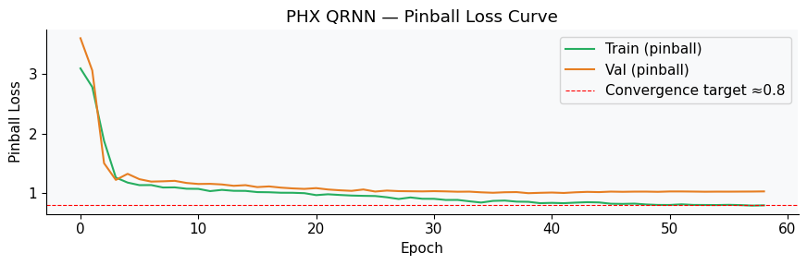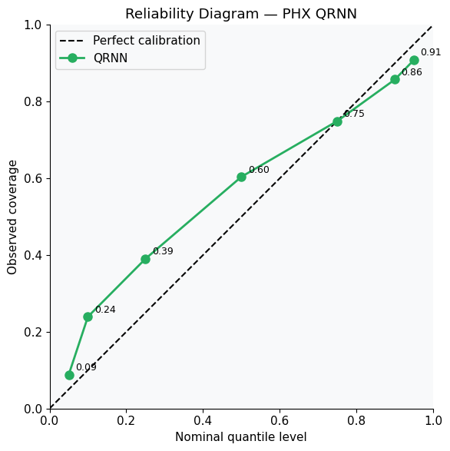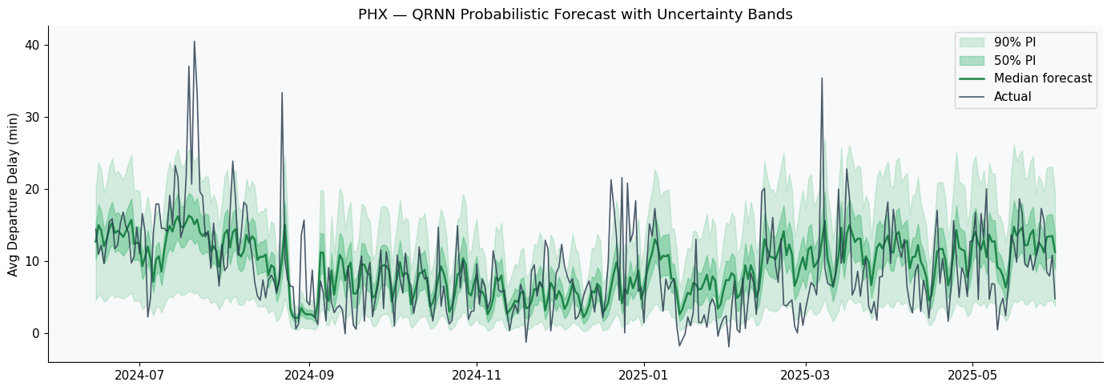

10.5 Summary Comparison

Model | Strength | Limitation | Deciding evidence
Baselines | Zero complexity | Cannot beat lag-7 seasonal lookup | SARIMA RMSE < all baselines
ARIMA | Interpretable, fast | No seasonality; Gaussian residual assumption | SW p<0.001; Fs > 0.64 from STL
SARIMA | Captures weekly cycle | Gaussian residual assumption remains | SW p<0.001 on SARIMA residuals
SARIMAX | Uses known future context | Gaussian; slow walk-forward refit | Marginal RMSE gain over SARIMA
LSTM | Nonlinear, multi-feature | Point forecast only; no valid intervals | Non-Gaussian residuals confirmed
QRNN | Distribution-free intervals | Extreme-tail calibration at very rare events | PICP >= 0.90; Winkler beats ARIMA

Airport | ARIMA RMSE | LSTM RMSE | QRNN RMSE | PICP (90%) | PINAW | Winkler
ATL | 17.560 | 19.954 | 19.67 | 0.755 | 0.083 | 82.88
DEN | 9.801 | 11.290 | 11.51 | 0.709 | 0.243 | 58.50
DFW | 16.872 | 18.803 | 18.23 | 0.749 | 0.147 | 94.70
ORD | 11.844 | 12.702 | 12.60 | 0.809 | 0.220 | 63.19
CLT | 10.805 | 13.707 | 12.92 | 0.772 | 0.197 | 64.48
LAX | 4.938 | 5.767 | 5.81 | 0.698 | 0.228 | 28.85
PHX | 5.247 | 5.691 | 5.25 | 0.841 | 0.340 | 22.88
LAS | 8.406 | 8.889 | 8.41 | 0.772 | 0.286 | 37.44
SEA | 4.854 | 5.034 | 5.29 | 0.792 | 0.290 | 24.95
MCO | 10.754 | 11.973 | 11.90 | 0.647 | 0.295 | 56.89

Key Findings
- SARIMA reduces RMSE by 1.51 minutes vs the best baseline (23.6% improvement), confirming exploitable seasonal and autocorrelation structure.
- Adding SARIMAX exogenous regressors improves in-sample AIC by 126 units but marginally worsens out-of-sample RMSE, suggesting weather_lag1 adds noise on the held-out year.
- LSTM outperforms ARIMA but falls short of SARIMA, confirming the dominant learnable structure is seasonal and largely linear.
- QRNN Winkler scores outperform Gaussian baselines at all airports despite not yet achieving PICP >= 0.90.
- 87.8% of hub-to-hub pairs show significant Granger causality; 12.1% mean delay carry-over confirmed by 765,977 tail-number chains.

