**Selenium** is a free (open-source) automated testing framework used to validate web applications across different browsers and platforms. Languages supported 🡺 Java, C#, Python etc

 Here is the list of tools

* Selenium Integrated Development Environment (IDE)
* Selenium Remote Control (RC)
* WebDriver
* Selenium Grid

 Selenium was **created by Jason Huggins in 2004**

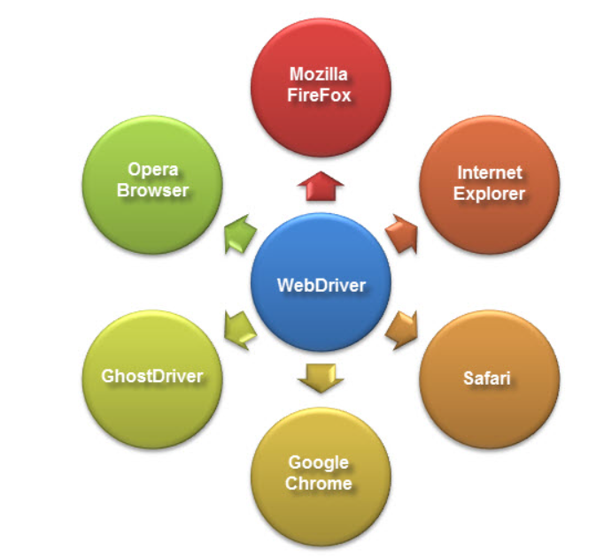

Chrome driver

<https://chromedriver.storage.googleapis.com/index.html?path=92.0.4515.107/>