CS 255 Business Requirements Document

System Components and Design

Purpose
What is the purpose of this project? Who is the client and what do they want their system to be able to do?
- DriverPass is a driver-training company seeking to improve how students prepare for their local Department of Motor Vehicles (DMV) driving examinations.
- The purpose of the system is to provide DriverPass with a web-based platform through which customers can access online classes and practice tests, purchase training packages, schedule driving lessons, and manage their appointments.
- The system will also support DriverPass employees by providing tools for managing customer information, driving reservations, drivers, vehicles, packages, and system accounts.
- The system will allow the DriverPass owner to access business information and activity records remotely whilst maintaining appropriate controls over employee and customer access.
- The system will connect with the DMV so that DriverPass can receive current rules, policies, and sample questions and be notified when relevant information changes.

System Background
What does DriverPass want the system to do? What is the problem they want to fix? What are the different components needed for this system?
- DriverPass identified a need for better preparation for driving examinations because many students fail their DMV tests after relying primarily on previous examination questions.
- The system will provide three training packages:
- Package One: six hours of in-car training with a trainer.
- Package Two: eight hours of in-car training with a trainer plus an in-person lesson covering DMV rules and policies.
- Package Three: twelve hours of in-car training with a trainer, an in-person lesson covering DMV rules and policies, and access to online course material and practice tests.
- Each driving session will last two hours, meaning the system must account for multiple sessions when a customer purchases a package containing several hours of training.
- Customers must be able to schedule, cancel, and modify driving appointments online, whilst the secretary must also be able to make appointments on behalf of customers.
- The system must track the customer, assigned driver, assigned vehicle, lesson time, and appointment information.
- DriverPass currently has 10 cars, with each car assigned to a driver.
- The system must support different user roles, including the owner, IT officer, secretary, and customer.
- The system must permit the IT officer to manage accounts, reset passwords, and block access when required.
- The system must maintain an activity history showing who created, cancelled, or modified reservations.
- The system should operate through the web, preferably using a cloud-based environment, with backup and security handled as part of the system environment.

Objectives and Goals
What should this system be able to do when it is completed? What measurable tasks need to be included in the system design to achieve this?
- The system shall provide customers with access to online classes and practice tests associated with their purchased training package.
- The system shall allow customers to create and manage driving lesson reservations through their accounts.
- The system shall allow the secretary to schedule appointments for customers who make reservations by telephone or in person.
- The system shall track the driver, vehicle, customer, date, and time associated with each driving lesson.
- The system shall allow customers to cancel or modify eligible appointments online.
- The system shall allow the owner to review activity records identifying users who created, cancelled, or modified reservations.
- The system shall allow the IT officer to reset passwords and block or restore account access as required.
- The system shall allow the owner to access reports and information remotely and download suitable information for use in applications such as Microsoft Excel.
- The system shall allow DriverPass to disable a training package so that new customers cannot register for it.
- The system shall provide notifications when the connected DMV information is updated.
- The system shall display online-test progress, including test name, time taken, score, and status such as not taken, in progress, failed, or passed.
- The system shall provide driver notes containing lesson times and comments made by the assigned driver.

Requirements

Nonfunctional Requirements
In this section, you will detail the different nonfunctional requirements for the DriverPass system. You will need to think about the different things that the system needs to function properly.

Performance Requirements
What environments (web-based, application, etc.) does this system need to run in? How fast should the system run? How often should the system be updated?
- The system shall be web-based so that authorised users can access it remotely through an internet-connected computer or mobile device.
- The system shall support access to business data from different locations without requiring users to be physically present at the DriverPass office.
- The system shall allow authorised users to retrieve customer, appointment, package, and activity information without requiring local access to the DriverPass office.
- The system shall allow reports and selected information to be downloaded for subsequent work in applications such as Microsoft Excel.
- The system shall provide online access to current information whilst preventing offline users from modifying or updating the central data.
- The system should minimise technical problems for DriverPass employees so that the business can remain focused on providing driver-training services.

Platform Constraints
What platforms (Windows, Unix, etc.) should the system run on? Does the back end require any tools, such as a database, to support this application?
- The system shall operate through a web interface and should preferably be hosted in a cloud-based environment.
- The system shall be accessible from computers and mobile devices through a web browser.
- The system shall use a central database or equivalent centralised data store so that authorised users work with current information rather than maintaining separate copies that could create data redundancy.
- The system shall support storage of customer information, appointment records, package information, driver information, vehicle information, test progress, driver notes, and activity records.
- The system shall provide a central environment in which backups and security can be managed without requiring DriverPass employees to maintain the underlying technical infrastructure.

Accuracy and Precision
How will you distinguish between different users? Is the input case-sensitive? When should the system inform the admin of a problem?
- The system shall distinguish users according to their assigned roles, including owner, IT officer, secretary, and customer.
- The system shall associate each reservation with the correct customer, driver, vehicle, date, and time.
- The system shall maintain accurate records of reservation creation, cancellation, and modification.
- The system shall record online-test information including the test name, time taken, score, and current status.
- The system shall accurately record driver comments and the start and end times of driving lessons.
- The system shall prevent duplicate or conflicting appointment information from causing an incorrect assignment of a customer, driver, vehicle, or time slot.
- The system shall notify appropriate users when relevant DMV information is updated so that training material and practice information can remain current.

Adaptability
Can you make changes to the user (add/remove/modify) without changing code? How will the system adapt to platform updates? What type of access does the IT admin need?
- The system shall allow authorised personnel to add, modify, or remove customer accounts without changing the underlying program code.
- The system shall allow the IT officer to reset passwords and block user accounts when necessary.
- The system shall allow DriverPass to disable an existing training package without requiring the entire system to be redesigned.
- The system shall support future changes to training packages, although adding or removing complete system modules will require developer or systems-analyst involvement in a future release.
- The system shall use a web-based architecture so that changes to the underlying platform can be managed centrally rather than requiring changes to individual customer devices.
- The system shall permit authorised administrators to manage user access according to employee responsibilities.

Security
What is required for the user to log in? How can you secure the connection or the data exchange between the client and the server? What should happen to the account if there is a “brute force” hacking attempt? What happens if the user forgets their password?

- The system shall require users to authenticate before accessing account-specific information or functions.
- The system shall enforce role-based access so that customers, secretaries, the owner, and the IT officer receive only the permissions associated with their responsibilities.
- The IT officer shall have sufficient privileges to reset passwords and block access to employee accounts when required.
- The system shall protect customer registration information, including names, addresses, telephone numbers, and payment-card information.
- The system shall provide a secure connection between users and the web-based system.
- The system shall maintain records identifying users who make significant changes to reservations or other relevant records.
- The system shall prevent unauthorised users from modifying central business data whilst offline.
- The system shall support backup and security controls appropriate to the cloud-based environment requested by DriverPass.

Functional Requirements
Using the information from the scenario, think about the different functions the system needs to provide. Each of your bullets should start with “The system shall . . .” For example, one functional requirement might be, “The system shall validate user credentials when logging in.”
- The system shall allow customers to register an account using their first name, last name, address, telephone number, and state.
- The system shall allow authorised personnel to record the customer's credit-card number, expiration date, and security code during registration.
- The system shall record the customer's pickup location and drop-off location.
- The system shall allow customers to log in to their accounts.
- The system shall provide an automatic password-reset function for customers who forget their passwords.
- The system shall allow customers to select an available training package.
- The system shall allow DriverPass to disable a package so that new customers cannot register for it.
- The system shall allow customers to schedule two-hour driving lessons online.
- The system shall allow customers to cancel and modify eligible driving appointments online.
- The system shall allow the secretary to create appointments for customers.
- The system shall associate each driving appointment with a customer, driver, vehicle, date, and time.
- The system shall maintain information about the 10 DriverPass vehicles and their assigned drivers.
- The system shall record driver notes, lesson start times, lesson end times, and driver comments.
- The system shall provide online classes and practice tests to customers whose selected package includes those services.
- The system shall display a customer's online-test history, including test name, time taken, score, and status.
- The system shall allow the owner to review activity records identifying who created, cancelled, or modified reservations.
- The system shall allow authorised users to generate and download reports and other information.
- The system shall allow the IT officer to reset user passwords.
- The system shall allow the IT officer to block user accounts when access must be removed.
- The system shall connect with the DMV to receive current rules, policies, and sample questions.
- The system shall notify DriverPass when relevant DMV information is updated.
- The system shall provide a contact page through which users can contact DriverPass.
- The system shall provide a mechanism for DriverPass personnel to contact students.

User Interface
What are the needs of the interface? Who are the different users for this interface? What will each user need to be able to do through the interface? How will the user interact with the interface (mobile, browser, etc.)?
- The system shall provide a web-based interface accessible through computers and mobile devices.
- The customer interface shall allow customers to register, log in, reset forgotten passwords, select packages, schedule appointments, cancel appointments, and modify appointments.
- The customer interface shall provide access to online classes and practice tests when included in the customer's selected package.
- The customer interface shall display test progress using the requested fields: test name, time taken, score, and status.
- The secretary interface shall provide access to customer information and appointment functions needed to schedule lessons on behalf of customers.
- The owner interface shall provide access to business information, reports, activity records, package controls, driver notes, and relevant customer information.
- The IT officer interface shall provide account-management functions, including password resets and blocking user access.
- The driver-related interface shall provide lesson times and a mechanism for recording driver comments.
- The system shall provide an input form for entering student information, including first name, last name, address, and other registration information.
- The system shall provide a contact page for communication between DriverPass and its customers.
- The interface shall clearly identify appointment, test-progress, and driver-note information so that users can distinguish current, completed, cancelled, and in-progress activities.

Assumptions
What things were not specifically addressed in your design above? What assumptions are you making in your design about the users or the technology they have?
- DriverPass will provide users with access to an internet-connected computer or mobile device capable of accessing the web-based system.
- DriverPass will maintain an internet connection for users who need to modify or update central system information.
- DriverPass will designate the IT officer as the authorised administrator responsible for account management and system maintenance.
- DriverPass will maintain accurate information about its customers, drivers, vehicles, packages, and appointments.
- DriverPass will continue to operate the 10 vehicles and their associated drivers described during the interview unless the business changes its operating model.
- The DMV will provide a suitable mechanism through which DriverPass can receive updates concerning rules, policies, and sample questions.
- DriverPass will determine which employees require owner, IT officer, secretary, or customer-level access.
- DriverPass will provide the business information and content required for its online classes and practice tests.
- Offline access will be limited to viewing or working with downloaded information; changes to central data will require an online connection. This assumption follows the distinction made during the interview between accessing data offline and modifying central data.

Limitations
Any system you build will naturally have limitations. What limitations do you see in your system design? What limitations do you have as far as resources, time, budget, or technology?
- The initial system will not allow nondevelopers to add or remove complete system modules. Future module changes will require developer or systems-analyst involvement.
- The system cannot update central business data whilst a user is offline because allowing offline modifications could create duplicate or inconsistent data.
- The system's access to current DMV rules, policies, and sample questions will depend upon the DMV providing an appropriate connection or update mechanism.
- The system will depend upon internet availability for users who need to access or modify current online information.
- The initial release is focused on the requirements identified during the DriverPass interview and does not include unspecified future features.
- DriverPass has requested that the system minimise its own technical responsibilities by using a cloud-based environment, meaning the organisation will depend upon the selected hosting environment for infrastructure, backup, and security services.
- The system must work within the project schedule established by the consulting team, including requirements collection, design, customer approval, implementation, database integration, business logic, testing, delivery, and final sign-off.
- The project cannot assume unlimited development time or resources; therefore, future enhancements beyond the agreed requirements should be addressed through later releases.

Gantt Chart
Please include a screenshot of the GANTT chart that you created with Lucidchart. Be sure to check that it meets the plan described by the characters in the interview.

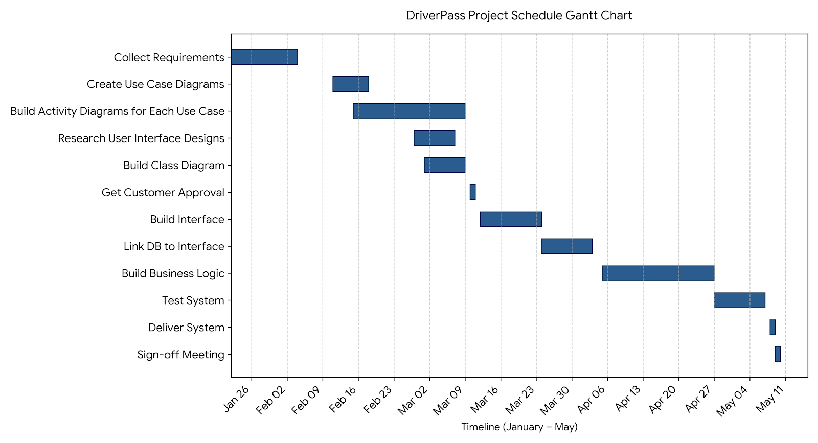
The Gantt chart presents the DriverPass project schedule from requirements collection through final sign-off. The schedule incorporates overlapping activities where dependencies permit parallel work, including use-case development, activity-diagram development, user-interface research, and class-diagram development. Customer approval functions as a formal approval gate before interface development begins. The later implementation activities follow a more sequential dependency structure, progressing from interface development to database integration, business logic, system testing, delivery, and final sign-off. This schedule reflects the timeline and dependencies established during the DriverPass project planning discussion.

