CS 255 System Design Document

UML Diagrams

UML Use Case Diagram
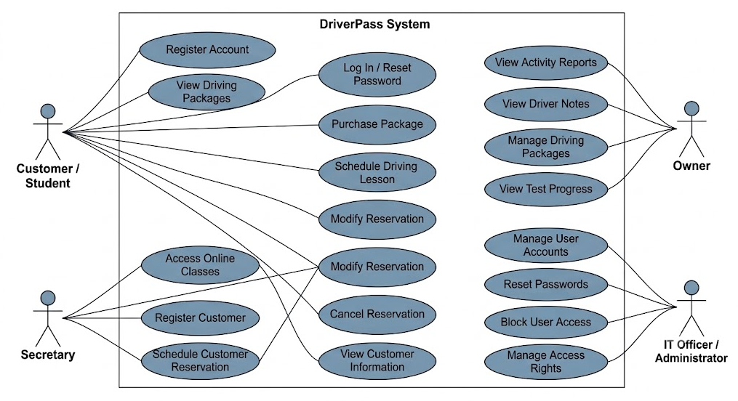

UML Activity Diagrams

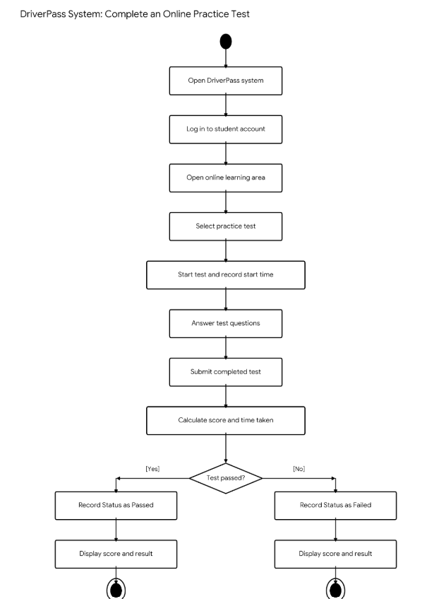

UML Sequence Diagram
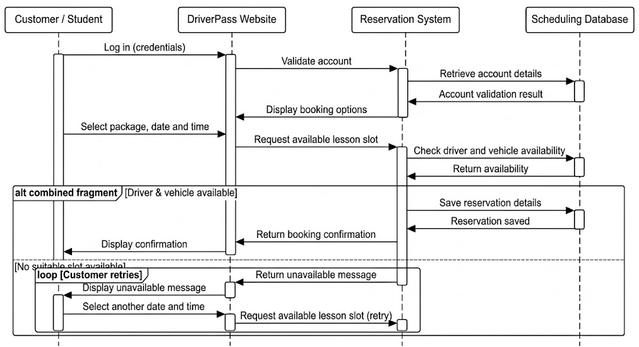

UML Class Diagram
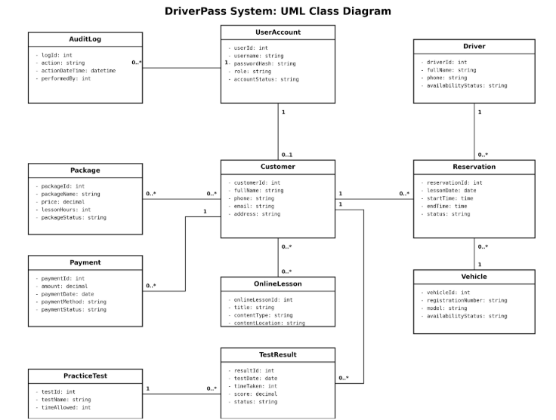

Technical Requirements

The proposed DriverPass system will require a secure, web-based infrastructure that enables customers to access driving packages, purchase services, schedule driving lessons, complete online practice tests, and review their learning progress. The system must also support the secretary's reservation-management responsibilities, the owner's reporting requirements, and the IT officer's account and access-management duties.

Hardware Requirements

Customers and staff will need a computer, tablet, or compatible smartphone with a supported web browser and an internet connection to access the system. DriverPass will require reliable server or cloud-hosting resources to run the application, store customer and reservation records, maintain practice-test results, and support concurrent users. Staff will also need suitable devices to access administrative functions and review reports. The system should be designed to accommodate extra users and records as the business expands.

Software Requirements

The system will require a web application accessible through current, supported browsers. A server-side application will process account authentication, package purchases, reservation requests, availability checks, and practice-test submissions. A database management system will store customer information, user accounts, driving packages, drivers, vehicles, reservations, payment records, online learning resources, test results, and audit logs. The application must validate information before saving changes and prevent a reservation from being confirmed until the required driver and vehicle availability has been checked.

Tools and Development Requirements

The development team will use Lucidchart to maintain the UML use case, activity, sequence, and class diagrams. A suitable software development environment, version-control system, and testing tools will support implementation, debugging, and maintenance. Testing should cover account access, reservation creation and modification, cancellation, availability checks, package management, practice-test scoring, reporting, and access permissions. The team should also test invalid inputs, failed login attempts, and situations in which two customers attempt to reserve the same available time slot.

Security Requirements

The system must authenticate users and apply role-based permissions so that customers, secretaries, the owner, and the IT officer can access only the functions appropriate to their responsibilities. Passwords must be stored securely using appropriate password-hashing techniques rather than as plain text. Data transmitted between users and the application must be protected through HTTPS. Audit logs should record relevant administrative and account activities to support accountability and troubleshooting. Customer information and payment-related records must be protected against unauthorised access, alteration, and disclosure.

Network and Infrastructure Requirements

Cloud hosting is suitable for providing remote access to the DriverPass system and centralising its data. The infrastructure should include database backups, monitoring, recovery procedures, and appropriate availability protections. Because the business requires records to be accessible offline while updates can be made only when online, the design should distinguish between viewing previously synchronised information and submitting changes. Any offline viewing capability must be limited to authorised information already stored locally; reservations, account changes, and other updates must be synchronised with the central system when connectivity is restored. The application should clearly indicate when information is offline or awaiting synchronisation.

Reliability, Maintenance, and Scalability

The system should be designed to preserve the accuracy and consistency of reservations, customer records, package information, and test results. It should prevent conflicting bookings by checking availability when a reservation is submitted and saved. Regular backups, error logging, security updates, and recovery testing will help maintain reliability. The architecture should also allow extr customers, drivers, vehicles, packages, and learning resources to be added without requiring a complete redesign.

These technical requirements provide the foundation for implementing the proposed DriverPass system while supporting the client's operational needs, security expectations, and future growth.

