**HW5 - Final Report**

Submitted by Nikita Thakur

Steps 1-5 have been completed as part of the python implementation below, delineated by comments.

import numpy as np

import matplotlib.pyplot as plt

#initializations of x and y

x = np.random.uniform(0.0,1.0,300)

v = np.random.uniform(-0.1,0.1,300)

#calculation of di = sin(20xi) + 3xi + νi

d = np.sin(20*x) + 3*x + v

#plotting function d against x

fig, ax = plt.subplots(figsize=(10,10))

plt.scatter(x=x,y=d, c = '#d62728', alpha = 0.5)

plt.xlabel('xi',fontsize=13)

plt.ylabel('di = sin(20xi) + 3xi + νi',fontsize=13)

plt.title('Data Set Visualization')

plt.show()

#activation functions

#feed-forward

activation_inp = lambda x : np.tanh(x)

activation_out = lambda x : x

#feed-back

d_activation_inp = lambda x : 1 - np.tanh(x)**2

d_activation_out = lambda x : 1

#Mean Square Error

mse = lambda d,y : (d-y)**2

#weight and bias initializations

w_inp = np.random.uniform(-5,5,size = 24)

w_out = np.random.uniform(-5,5,size = 24)

b_inp = np.random.uniform(-1,1,size = 24)

w_fin = np.random.uniform(-1,1,1)

n = 300

N = 24

eta = 8

#calculation of MSE while BP learning

MSE_records = []

itr = 0

while(True):

U,Y,Alphas,Betas = [],[],[],[]

#calculation of Alpha and Beta parameters

for i in range(n):

V = []

hold = []

for j in range(N):

alpha = (x[i]*w_inp[j]) + b_inp[j]

hold.append(alpha)

V.append(activation_inp(alpha))

Alphas.append(hold)

U.append(V)

beta = np.matmul(np.array(U[i]),w_out) + w_fin

Betas.append(beta[0])

Y.append(activation_out(beta[0]))

e = -2*eta*((d[i]-Y[i]))/n

w_out_grad,w_inp_grad,w_inp_bias_grad,w_fin_grad = [],[],[],[]

w_fin_grad.append(-e)

#Calculation of delta weights

for j in range(N):

change_U = e*U[i][j]

change_w = e*x[i]*w_out[j]*d_activation_inp(Alphas[i][j])

change_bias = e*w_out[j]*d_activation_inp(Alphas[i][j])

w_out_grad.append(change_U)

w_inp_grad.append(change_w)

w_inp_bias_grad.append(change_bias)

#performing weight updates

w_inp = np.subtract(w_inp,np.array(w_inp_grad))

w_out = np.subtract(w_out,np.array(w_out_grad))

b_inp = np.subtract(b_inp,np.array(w_inp_bias_grad))

w_fin = np.subtract(w_fin,np.array(w_fin_grad))

#Calculation of Mean Square Error for each epoch

mean_square_error = 0

for i in range(n):

mean_square_error += mse(d[i],Y[i])

mean_square_error /= n

MSE_records.append(mean_square_error)

print("eta: ",eta," MSE: ",mean_square_error," iteration: ",itr)

#updating Eta if MSE increases in any consecutive epoch

if MSE_records[itr] > MSE_records[itr-1]:

eta = eta*0.9

#Stop learning when MSE is less than 0.01

if MSE_records[-1] < 0.01:

break

itr+=1

#plotting the MSE vs Epoch graph

fig, ax = plt.subplots(figsize=(10,10))

plt.xlabel('Number of Epochs')

plt.ylabel('Mean Square Error (MSE)')

plt.legend(loc = 'upper right')

plt.scatter(range(len(MSE_records)), MSE_records, c = '#d62728', label = 'MSE')

plt.show()

#calculating the fit

u = []

y = []

A = []

B = []

for l in range(n):

v = []

hold = []

for m in range(N):

a = x[l]*w_inp[m] + b_inp[m]

hold.append(a)

v.append(activation_inp(a))

A.append(hold)

u.append(v)

b = np.matmul(np.array(u[l]),w_out) + w_fin

B.append(b)

y.append(activation_out(b[0]))

#plotting the dataset against the fit generated by Backpropagation Online Learning

fig, ax = plt.subplots(figsize=(10,10))

plt.ylabel('d')

plt.xlabel('x')

plt.scatter(x=x,y=d, c = 'magenta', alpha = 0.5, label = 'Actual Data')

plt.scatter(x=x,y=y, c = 'purple', label = 'fit',alpha = 0.5)

plt.legend(loc = 'upper right')

plt.show()

Pseudocode of the Algorithm:

Below Pseudocode is for a 1×N ×1 neural network.

**Assumptions:**

X →List Input data points

n → number of data points in X

V → List Constants

F(X) → Function of X

D → Set of values calculated by calculation F(X) for each data point in X

Y → Values of F(X) predicted by the learning algorithm

N → Number of Neurons in the hidden layer

A_inp() → Activation function for the input layer; A_inp(v) = tanh(v)

A_out() → Activation function of the hidden layer; A_out(v) = v

delta_A_inp() → Activation function during feedback from hidden layer to input layer;

delta_A_inp(v) = 1 - tanh(v)^2

delta_A_out() → Activation function during feedback from output layer to hidden layer;

delta_A_out(v) = 1

Backpropagation():

Initialize N Weights randomly for input and hidden layers as W_inp and W_out

Initialize N biases for input layer as B_inp and 1 bias of output layer as B_out

Initialize the Learning Rate as eta randomly

Initialize empty lists to store alphas,betas,U and Y

While condition → True, perform:

For i = 1...n and j in range 1...N, perform:

Calculate alpha as X(i)*W_in(j) + b_inp(j)

V → A_inp(alpha)

Alphas → append alpha

U→ append V

beta = U(i)*W_out + B_out

Betas → append beta

Y → append A_out(beta)

Calculate e as -2 * eta *( d(i) - y(i) ) / n

Initialize W_out_update,W_inp_update,Bias_inp_update,Bias_out_update as

Empty lists

For range 1...N

Bias_out_update → append -e

W_out_update → append e*U(i)(j)

W_inp_update → append e*x(i)*W_out(j)*delta_A_inp(Alphas(i)(j))

Bias_inp_update → append e*W_out(j)*delta_A_inp(Alphas(i)(j))

W_inp = W_inp - W_inp_update

W_out = W_out - W_out_update

B_inp = B_inp - Bias_inp_update

B_out = B_out - Bias_out_update

For all inputs(i) in range 1..n:

Calculate MSE(i) → (d(i) - y(i)^2

Calculate Mean Square Error as MSE/n

Maintain a list of MSE for each epoch in MSE_LIST

if MSE(iteration+1) > MSE(iteration) → update eta as eta*0.9

If MSE of last update < 0.01 → break the outer loop

Iteration = iteration + 1

Graphs:

Step 3 : data set visualization

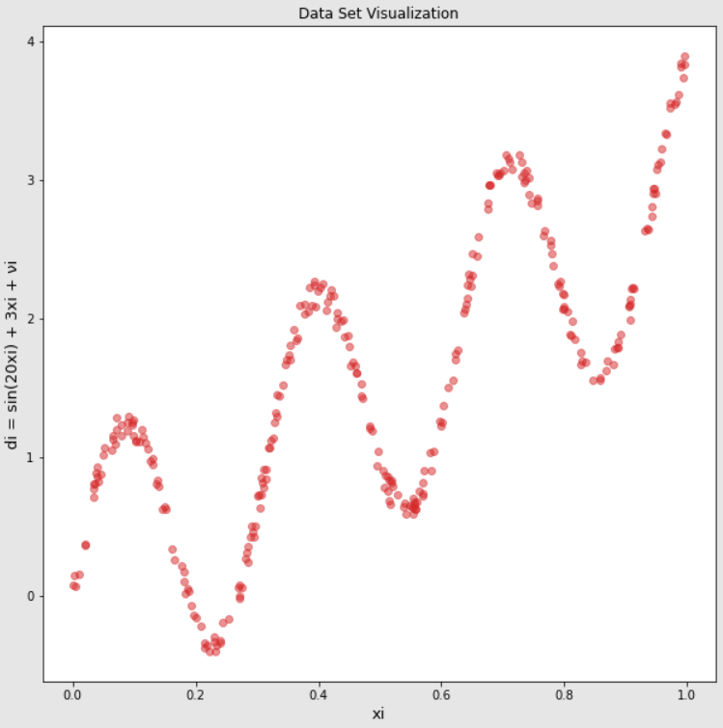

Step 4: MSE vs EPOCH

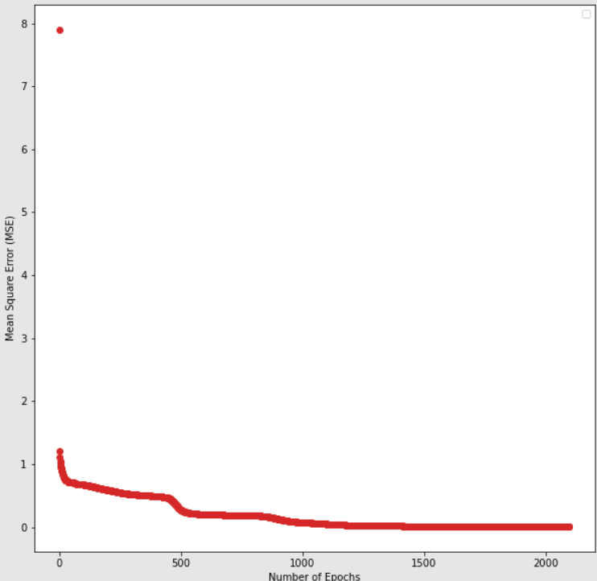

Step 5: The good fit:

