**Aim:** To understand Static Analysis SAST process and learn to integrate Jenkins SAST to SonarQube/GitLab.

1. Open up Jenkins on port 8080

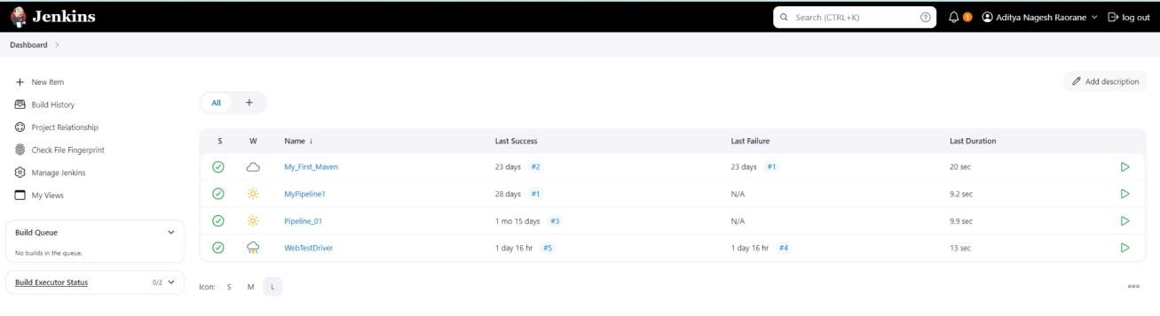

1. In a Docker container run SonarQubez using this command :

a] docker -v

b] docker pull sonarqube

c] docker run -d --name sonarqube -e

SONAR_ES_BOOTSTRAP_CHECKS_DISABLE=true -p 9000:9000 sonarqube:latest

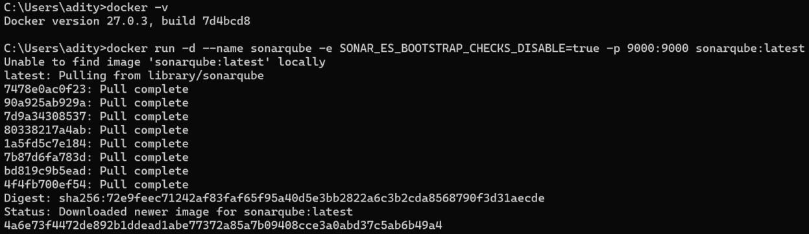

1. Once the container is up and running, you can check the status of

SonarQube at **localhost port 9000**. The login id is “**admin**” and the password is “**aditya**”.

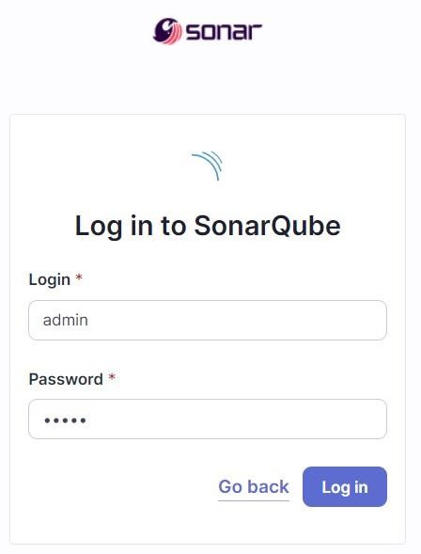

1. **Create a local project in SonarQube** with the name **sonarqube**

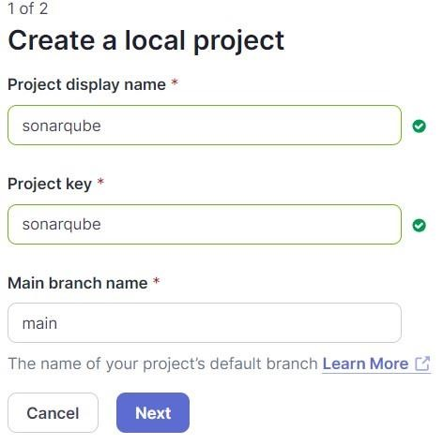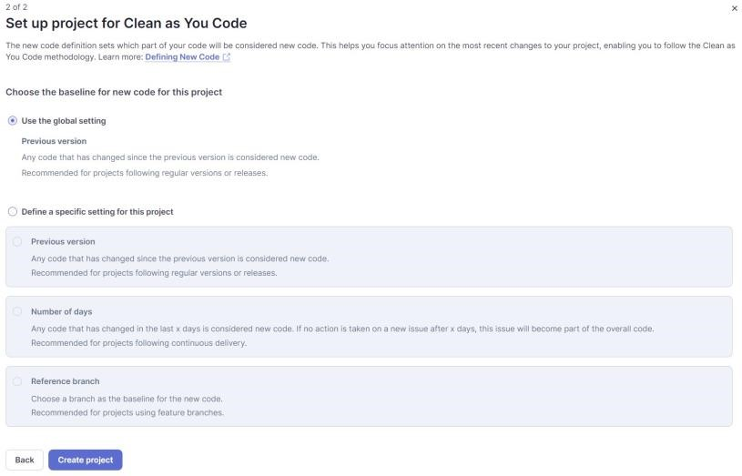

1. Setup the project and come back to Jenkins Dashboard. Go to **Manage Jenkins**

**→ Plugins** and search for **SonarQube Scanner** in **Available Plugins** and install it.

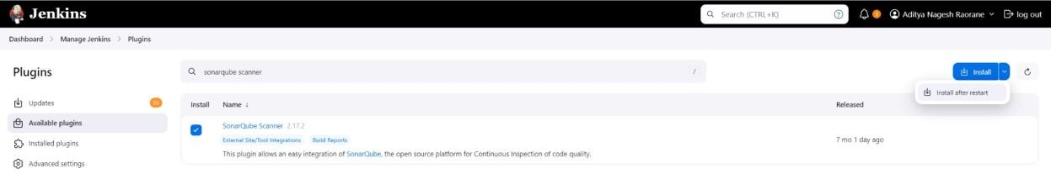

1. Under ‘**Manage Jenkins → System**’, look for **SonarQube Servers** and enter these details.

Name : sonarqube

Server URL : http://localhost:9000

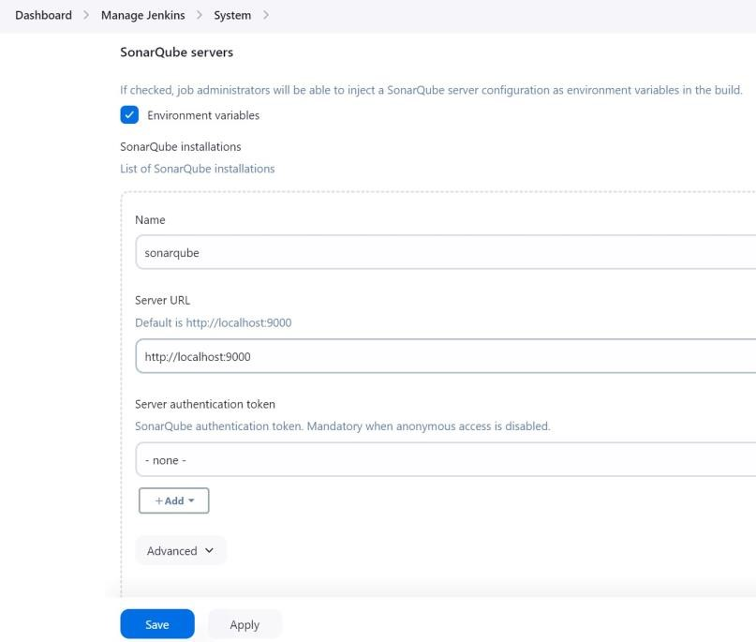

1. Search for SonarQube Scanner under Global Tool Configuration. Choose the latest configuration and choose Install automatically.

**Manage Jeknins → Tools → SonarQube Scanner Installation**

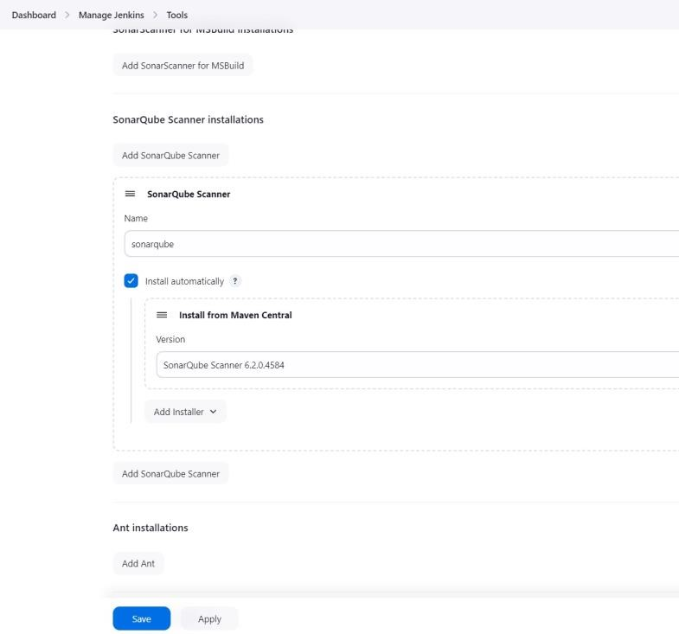

1. After the configuration, create a **New Item** in Jenkins, choose a **freestyle**

**project** named **sonarqube**.

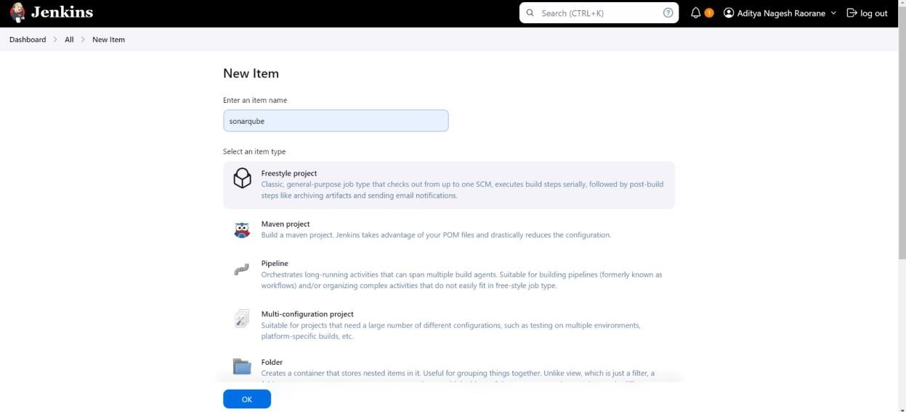

1. Choose this GitHub repository in **Source Code Management**. https://github.com/shazforiot/MSBuild_firstproject.git

It is a sample hello-world project with no vulnerabilities and issues, just to test the integration.

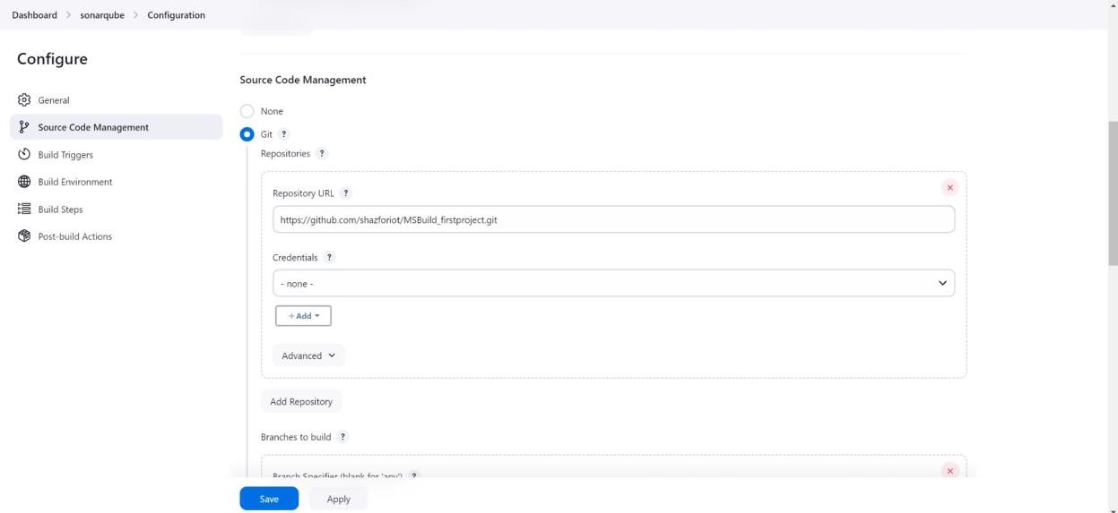

1. Under **Build-> Execute SonarQube Scanner**, enter these **Analysis Properties**. Mention the SonarQube Project Key, Login, Password, Source path and Host URL. sonar.projectKey=sonarqube sonar.login=admin sonar.password=aditya sonar.sources=.

sonar.host.url=http://localhost:9000

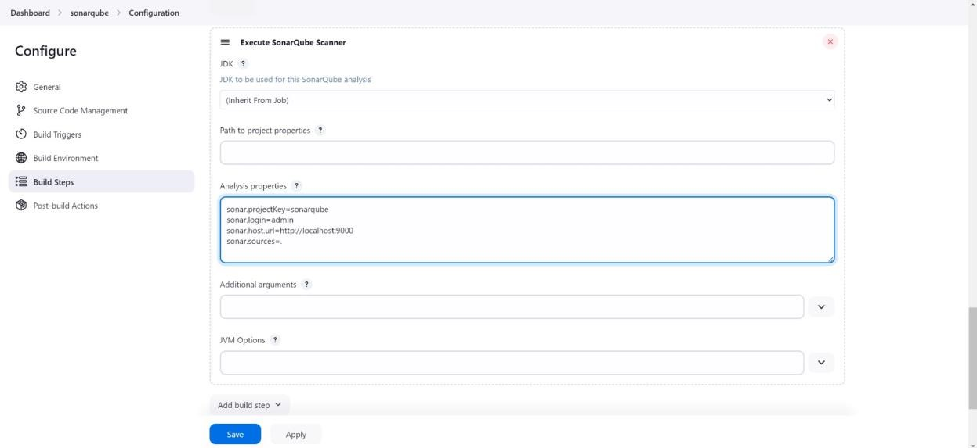

1. Go to http://localhost:9000/admin/permissions and allow Execute Permissions to the Admin user.

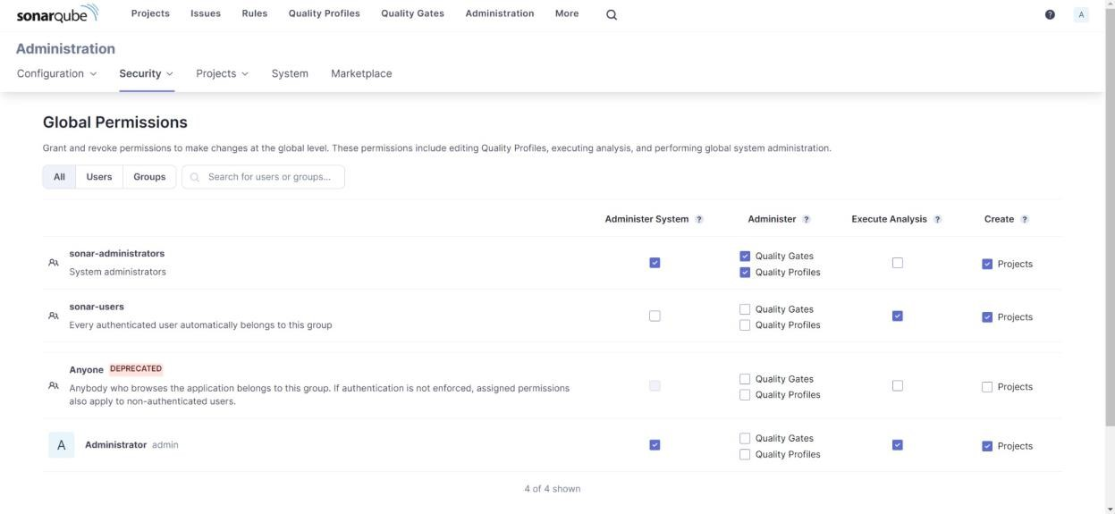

1. Run The **Build** and check the **console output**.

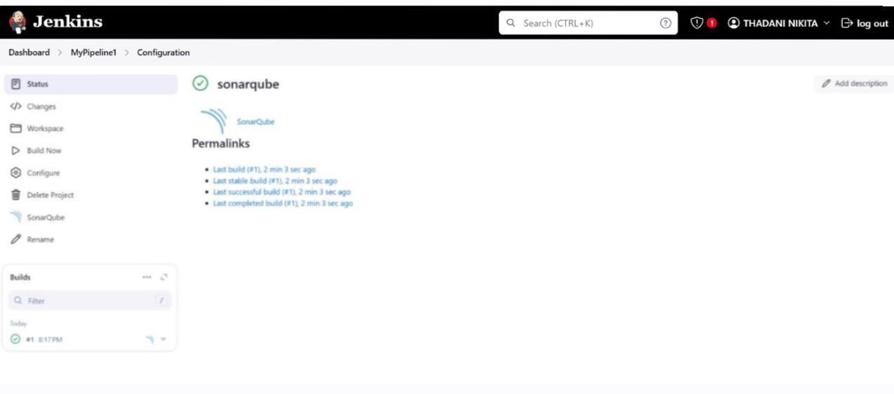

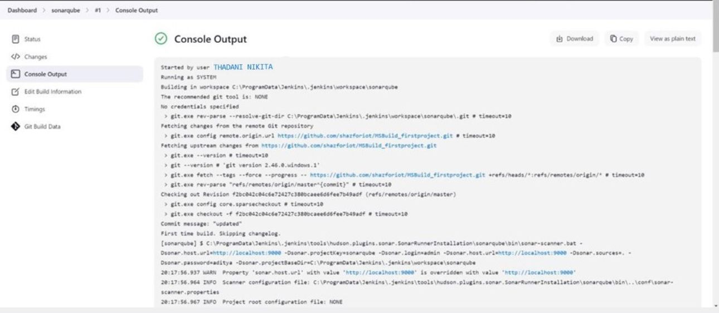

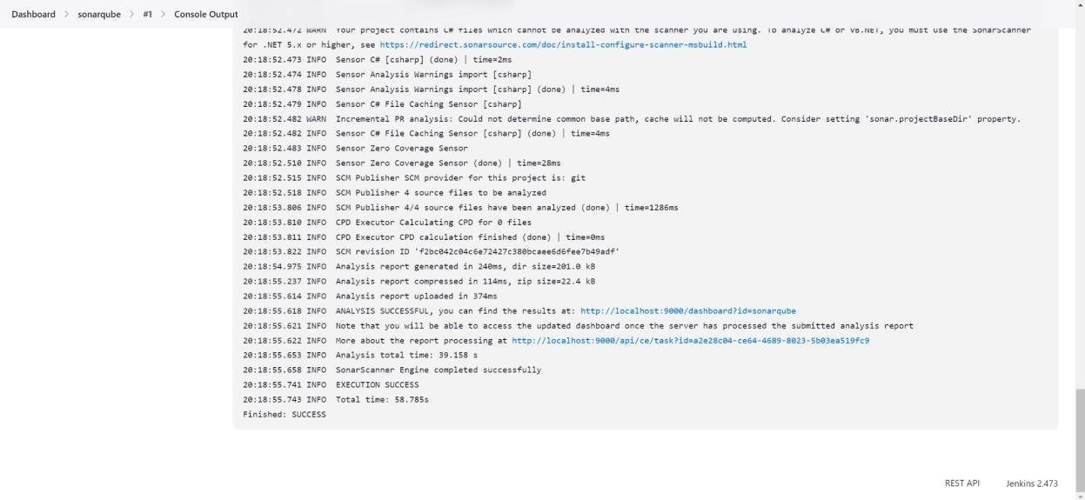

1. Once the build is complete, check the project in SonarQube.

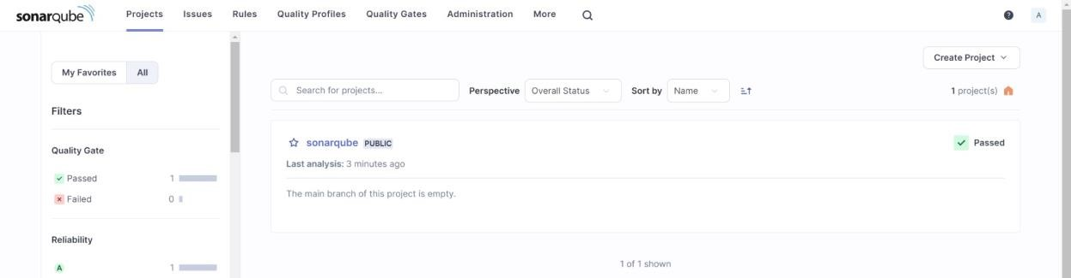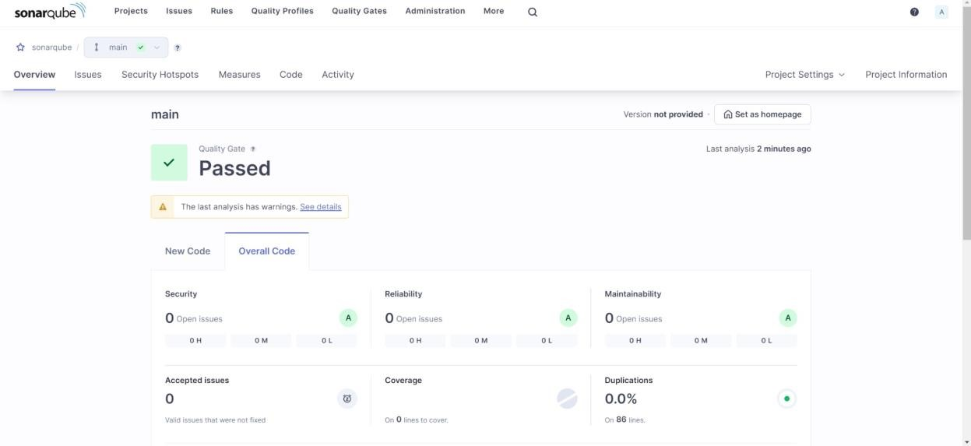

In this way, we have integrated Jenkins with SonarQube for SAST.

**Conclusion:**

In this experiment, we have understood the importance of SAST and have successfully integrated Jenkins with SonarQube for Static Analysis and Code Testing.