**ASSIGNMENT 2**

**AIM :** Creating Address Book using Shell Script.

**THEORY:**

A Shell provides you with an interface to the Unix system. It gathers input from

you and executes programs based on that input. When a program finishes

executing, it displays that program&#39;s output.

Shell is an environment in which we can run our commands, programs, and shell

scripts. There are different flavors of a shell, just as there are different flavors of

operating systems. Each flavor of shell has its own set of recognized commands

and functions.

SHELL is a program which provides the interface between the user and an

operating system. When the user logs in OS starts a shell for user. Kernel controls

all essential computer operations, and provides the restriction to hardware access,

coordinates all executing utilities, and manages Resources between process. Using

kernel only user can access utilities provided by operating system.

**Types of Shell:**

**1. The C Shell –**

Denoted as csh

Bill Joy created it at the University of California at Berkeley. It incorporated

features such as aliases and command history. It includes helpful programming

features like built-in arithmetic and C-like expression syntax.

● In C shell:

Command full-path name is /bin/csh,

Non-root user default prompt is hostname %,

Root user default prompt is hostname #.

**2. The Bourne Shell –**

Denoted as sh

It was written by Steve Bourne at AT&amp;T Bell Labs. It is the original UNIX shell. It

is faster and more preferred. It lacks features for interactive use like the ability to

recall previous commands. It also lacks built-in arithmetic and logical expression

handling. It is default shell for Solaris OS.

For the Bourne shell the:

Command full-path name is /bin/sh and /sbin/sh,

Non-root user default prompt is $,

Root user default prompt is #.

**3. The Korn Shell**

It is denoted as ksh

It Was written by David Korn at AT&amp;T Bell LabsIt is a superset of the Bourne

shell.So it supports everything in the Bourne shell.It has interactive features. It

includes features like built-in arithmetic and C-like arrays, functions, and string-

manipulation facilities.It is faster than C shell.

For the Korn shell the:

Command full-path name is /bin/ksh,

Non-root user default prompt is $,

Root user default prompt is #.

**4. GNU Bourne-Again Shell –**

Denoted as bash

It is compatible to the Bourne shell. It includes features from Korn and Bourne

shell

For the GNU Bourne-Again shell the:

Command full-path name is /bin/bash,

Default prompt for a non-root user is bash-g.gg$

(g.ggindicates the shell version number like bash-3.50$),

Root user default prompt is bash-g.gg#.

**Diagram:**

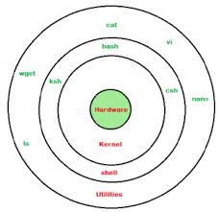

**CODE:**

**add.sh**

echo "Enter the name"

read name #to take input from user #

echo "Enter the roll no"

read roll_no

echo "Enter the phone number"

read phone

echo "$name","$roll_no","$phone" >> address.txt #to save input in address file#

**main.sh**

echo "Press 1 :To add" #to print add#

echo "Press 2 :To show"

echo "Press 3 :To search"

echo "Press 4 :To delete"

echo "Press 5 :To quit"

read choice

while [ $choice != 5 ];do

case $choice in

1) sh add.sh;; #to open add file#

2) sh list.sh;; #to open list file#

3) sh find.sh;; #to open find file#

4) sh delete.sh;; #to open delete file#

esac

echo "Press 1 :To add"

echo "Press 2 :To show"

echo "Press 3 :To search"

echo "Press 4 :To delete"

echo "Press 5 :To quit"

read choice

done

**list.sh**

echo "The list of student is"

cat address.txt #To open address file#

**find.sh**

echo "Enter the roll_no to search"

read roll_no

grep $roll_no address.txt #To search roll no in address file#

**delete.sh**

echo "Enter the roll_no you want to delete"

read roll_no

sed /$roll_no/d address.txt >> ad1.txt #sed command to delete the roll no and copy rest part in file ad1.txt#

:>address.txt #to clear the entire file#

cp ad1.txt address.txt #to copy content of ad1.txt back to address.txt#

:>ad1.txt #to delete ad1.txt#

**OUTPUT:**

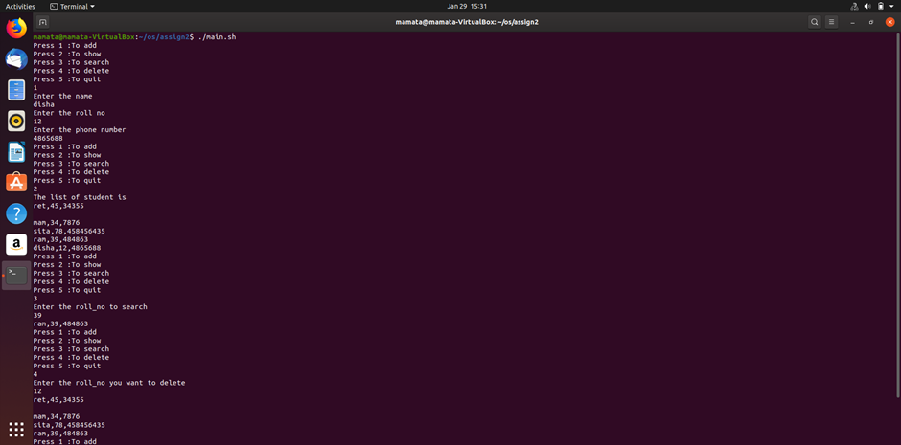

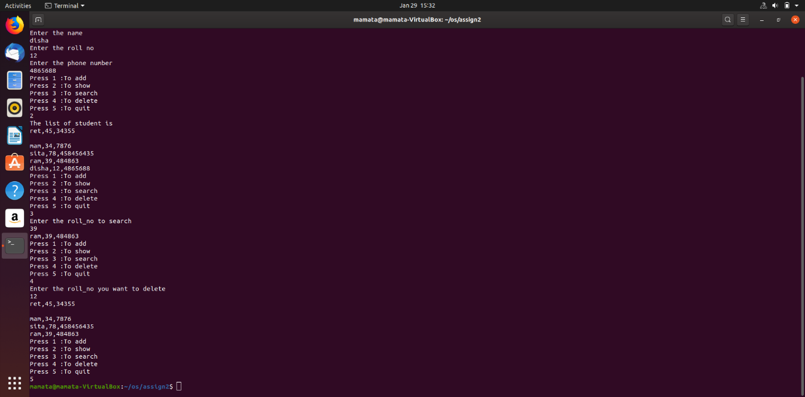

**address.txt file**

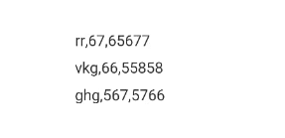

**Conclusion:**

Here we study about shell programming language and how shell operates in our operating system.