# BI & DA

# **SCE Activity**

# Activity:

SCE activity is based on **opinion mining** content.

Take opinion/feedback on any chosen topic and infer the topic.

# Topic: YouTube Usage Survey

As Indian viewers are hooked on their smartphones to consume more and more video content, Google-owned video-streaming service YouTube is crossing new milestones year-on-year. The service has recorded 265 million monthly active users and over 1200 channels from Indian creators have crossed the 1 million subscriber mark in 2019, from about 300 in 2018.

Read more at:  
<https://economictimes.indiatimes.com/industry/media/entertainment/youtube-in-india-has-over-265-mn-monthly-active-users-1200-channels-with-1-mn-subs/articleshow/72456212.cms?utm_source=contentofinterest&utm_medium=text&utm_campaign=cppst>

At its annual flagship event, Brand cast, YouTube shared insights on the exponential growth of online video ecosystem and how it is interlinked to India's Internet growth story.

"India is now both our biggest audience and one of our fastest growing audiences in the world. YouTube today has become the first stop for users to consume content, whether they're looking for entertainment or information.

In the past one year, YouTube's consumption on mobile has increased to 85%, with 60% of the watch time coming from outside of the six largest metros in the country.

YouTube creators have become effective storytellers, with more than 1,200 Indian creators crossing the one million subscriber-milestone, while just five years ago, there were only two creators with a million subscribers on the platform.

**Opinion/Feedback Source:** Google Forms

**Google Form Layout:**

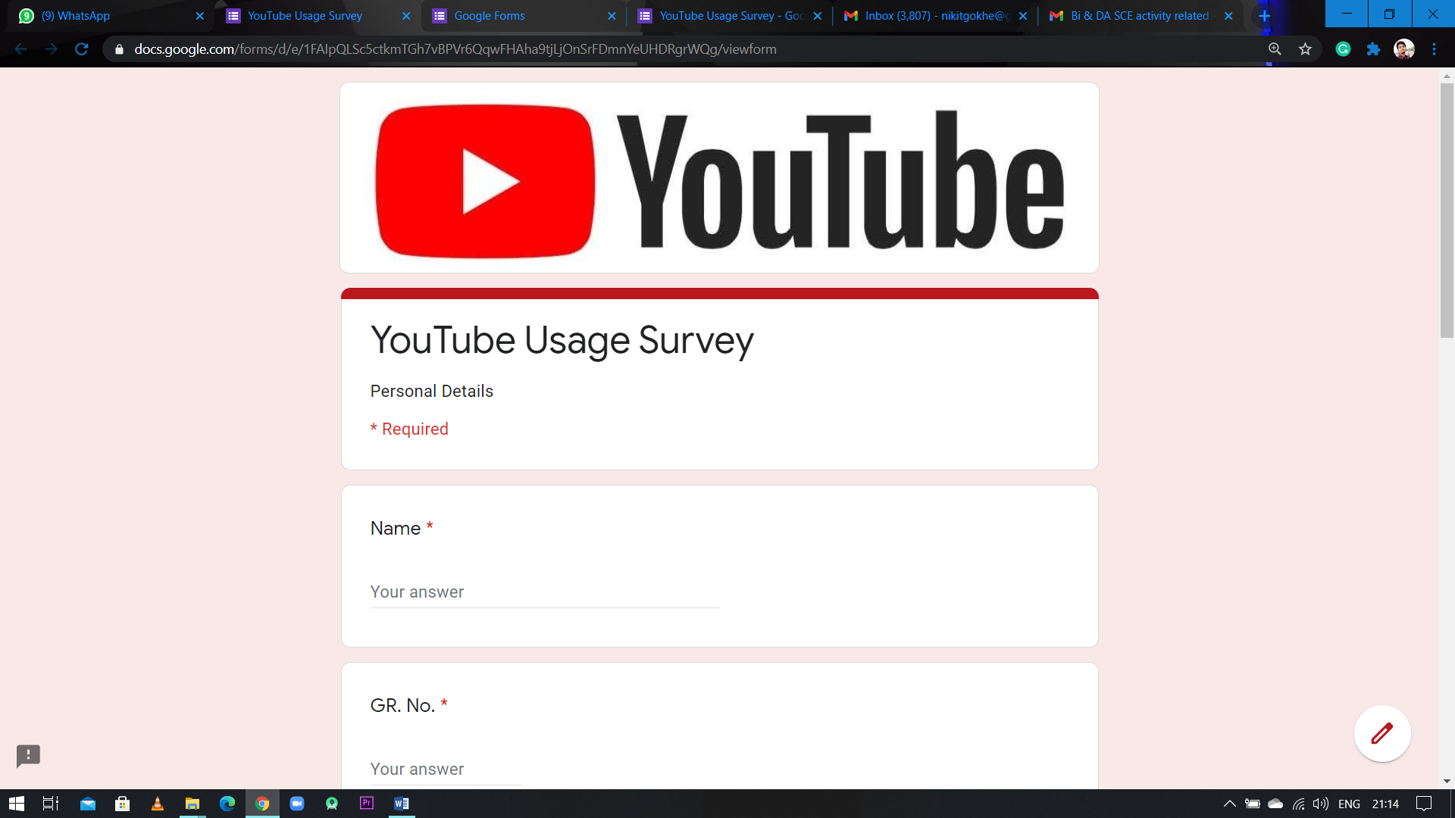

**Questions Included in Opinion Mining Activity:**

1. What is your gender?

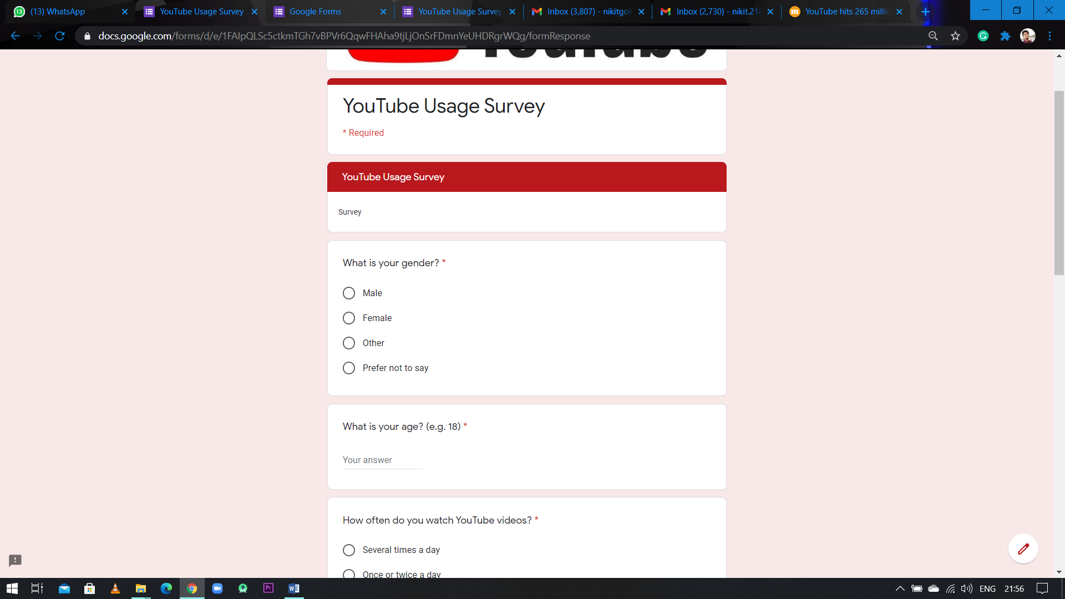

1. What is your age? (e.g. 18)



1. How often do you watch YouTube videos?

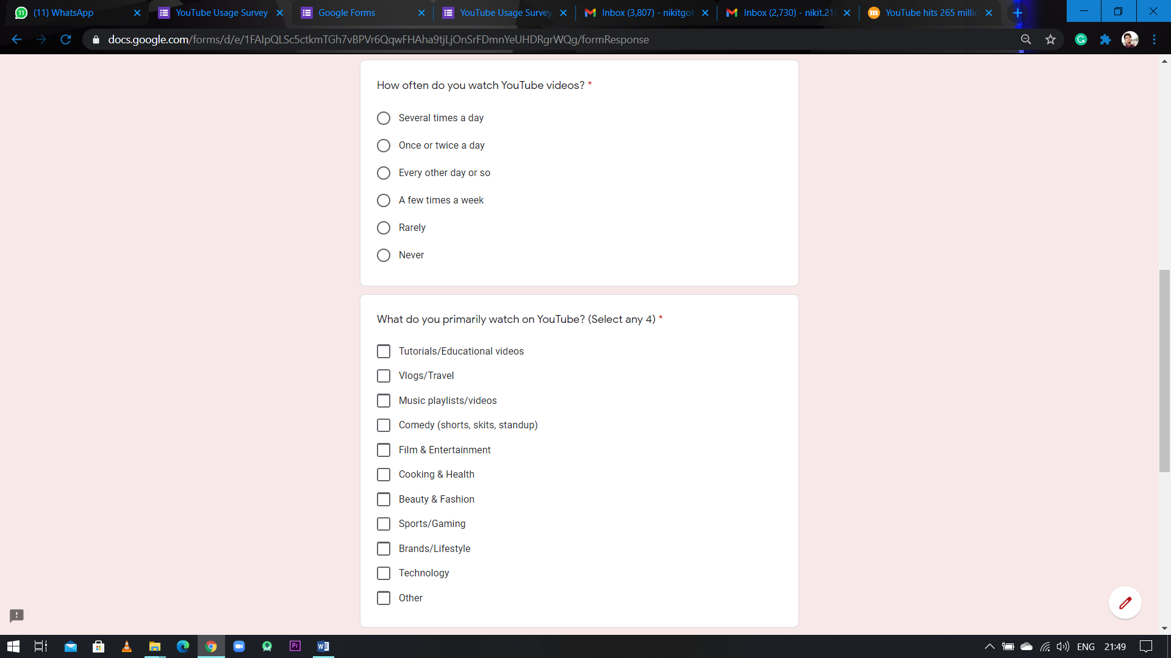

1. What do you primarily watch on YouTube?



1. How many hours do you spend on YouTube per day?

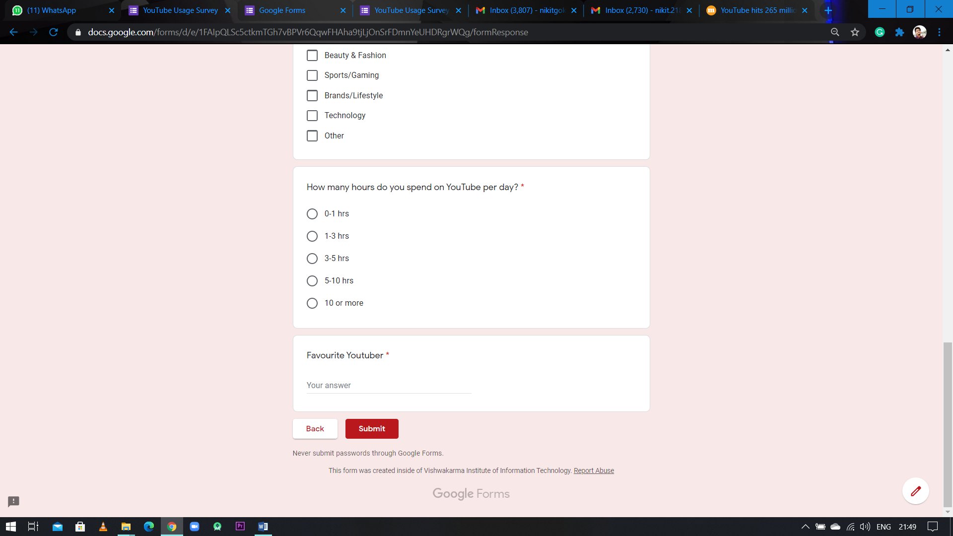

1. Favourite YouTuber?



# Analysis & Results:

For responses we got after the survey, we analysed it and created a dashboard for the same.

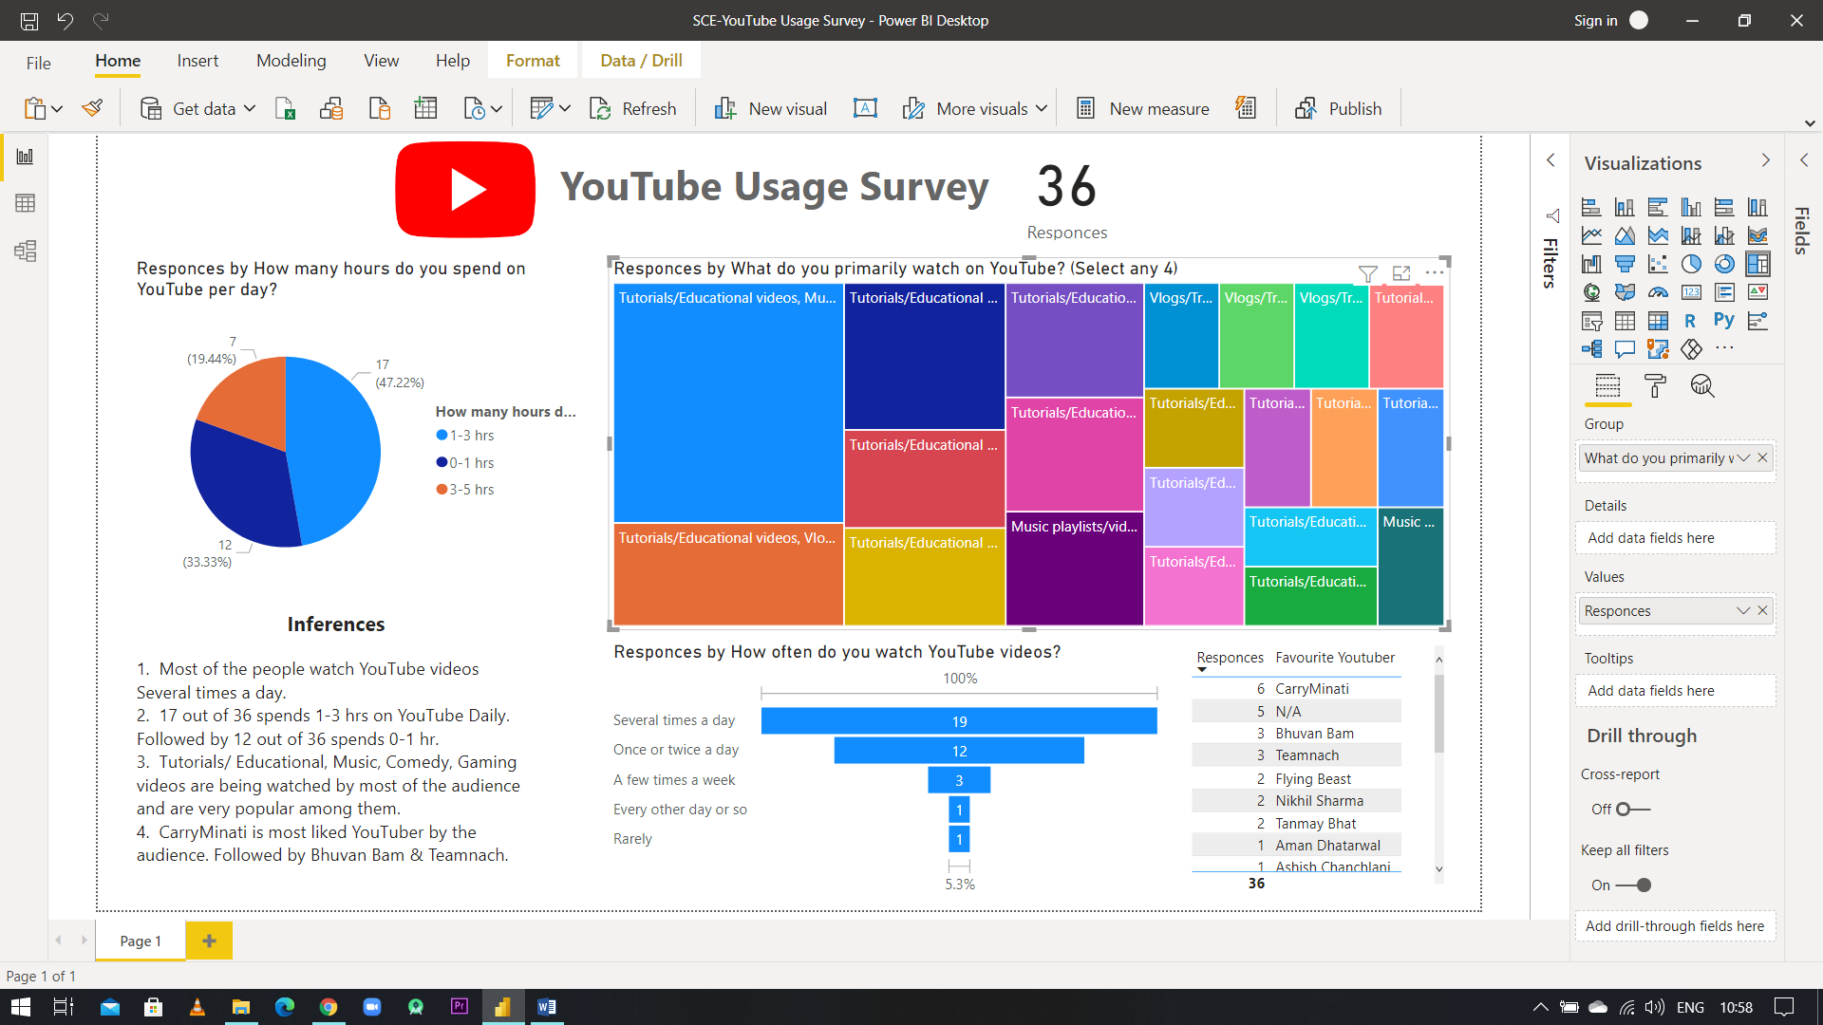

**Visualizations Used:**

1. Card
2. Pie Chart
3. Treemap
4. Funnel
5. Table

# Inferences:

1. Most of the people watch YouTube videos **Several times a day**, which means YouTube platform is used for **Entertainment & Learning** purposes on **daily basis** in India.
2. **Tutorials/ Educational, Music, Comedy, Gaming videos** are being watched by most of the audience and are very popular among them. If you **want to start** your YouTube Channel these are the **preferable category** you can go with **depending on your skills.**
3. 17 out of 36 i.e. around 47% Population **spends 1-3 hrs** on YouTube Daily. So YouTube is one of the bests platform for **Advertising Purpose.**
4. **CarryMinati** is most liked YouTuber by the audience. Followed by **Bhuvan Bam & Teamnach**. You can **watch their content** as reference if are struggling content creator and **learn dos & don’ts.**