LAB ACTIVITY-2
6. Implement a C program to eliminate left recursion.
Code:
#include <stdio.h>
#include <string.h>
void eliminateLeftRecursion(char nonTerminal, char alpha[], char beta[]) {
printf("\nGrammar after Eliminating Left Recursion:\n");
printf("%c -> %s%c'\n", nonTerminal, beta, nonTerminal);
printf("%c' -> %s%c' | e\n", nonTerminal, alpha, nonTerminal);
}
int main() {
char nonTerminal;
char alpha[20], beta[20];
printf("Enter the non-terminal: ");
scanf(" %c", &nonTerminal);
printf("Enter the recursive part (a): ");
scanf("%s", alpha);
printf("Enter the non-recursive part (ß): ");
scanf("%s", beta);
printf("\nGiven Grammar:\n");
printf("%c -> %c%s | %s\n", nonTerminal, nonTerminal, alpha, beta);
eliminateLeftRecursion(nonTerminal, alpha, beta);
return 0;
}
Output:
Enter the non-terminal: A
Enter the recursive part (a): X
Enter the non-recursive part (▀): Y

Given Grammar:
A -> AX | Y

Grammar after Eliminating Left Recursion:
A -> YA'
A' -> XA' | e
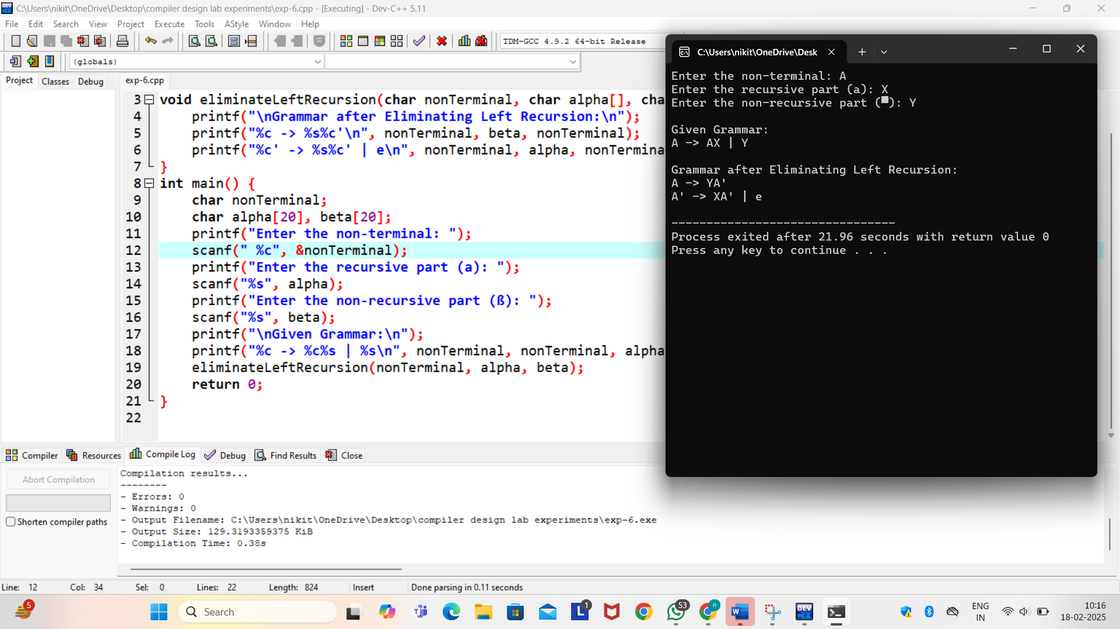
7. Implement a C program to eliminate left factoring.
Code:
#include <stdio.h>
#include <string.h>
void eliminateLeftFactoring(char nonTerminal, char commonPrefix[], char suffix1[], char suffix2[]) {
printf("\nGrammar after Eliminating Left Factoring:\n");
printf("%c -> %s%c'\n", nonTerminal, commonPrefix, nonTerminal);
printf("%c' -> %s | %s\n", nonTerminal, suffix1, suffix2);
}
int main() {
char nonTerminal;
char commonPrefix[20], suffix1[20], suffix2[20];
printf("Enter the non-terminal: ");
scanf(" %c", &nonTerminal);
printf("Enter the common prefix: ");
scanf("%s", commonPrefix);
printf("Enter first suffix: ");
scanf("%s", suffix1);
printf("Enter second suffix: ");
scanf("%s", suffix2);
printf("\nGiven Grammar:\n");
printf("%c -> %s%s | %s%s\n", nonTerminal, commonPrefix, suffix1, commonPrefix, suffix2);
eliminateLeftFactoring(nonTerminal, commonPrefix, suffix1, suffix2);
return 0;
}
Output:
Enter the non-terminal: a+b(8*c)
Enter the common prefix: Enter first suffix: a+b
Enter second suffix: 8*c
Given Grammar:
a -> +b(8*c)a+b | +b(8*c)8*c
Grammar after Eliminating Left Factoring:
a -> +b(8*c)a'
a' -> a+b | 8*c
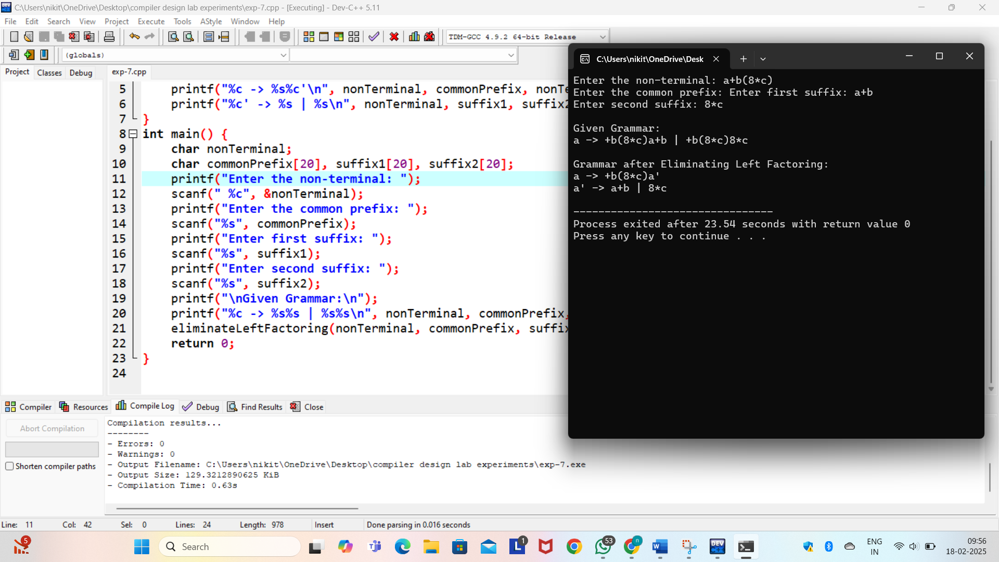
8.Implement a C program to perform symbol table operations.
Code:
#include <stdio.h>
#include <string.h>
#define MAX 10
struct Symbol {
char name[20];
char type[10];
} table[MAX];
int count = 0;
void insert() {
if (count < MAX) {
printf("Enter symbol name: ");
scanf("%s", table[count].name);
printf("Enter symbol type: ");
scanf("%s", table[count].type);
count++;
} else {
printf("Symbol table is full!\n");
}
}
void display() {
printf("\nSymbol Table:\n");
for (int i = 0; i < count; i++) {
printf("%s -> %s\n", table[i].name, table[i].type);
}
}
int main() {
int choice;
do {
printf("\n1. Insert\n2. Display\n3. Exit\nEnter choice: ");
scanf("%d", &choice);
if (choice == 1) insert();
else if (choice == 2) display();
} while (choice != 3);
return 0;
}
Output:
1. Insert
2. Display
3. Exit
Enter choice: 1
Enter symbol name: +
Enter symbol type: int

1. Insert
2. Display
3. Exit
Enter choice: 2

Symbol Table:
+ -> int

1. Insert
2. Display
3. Exit
Enter choice: 3
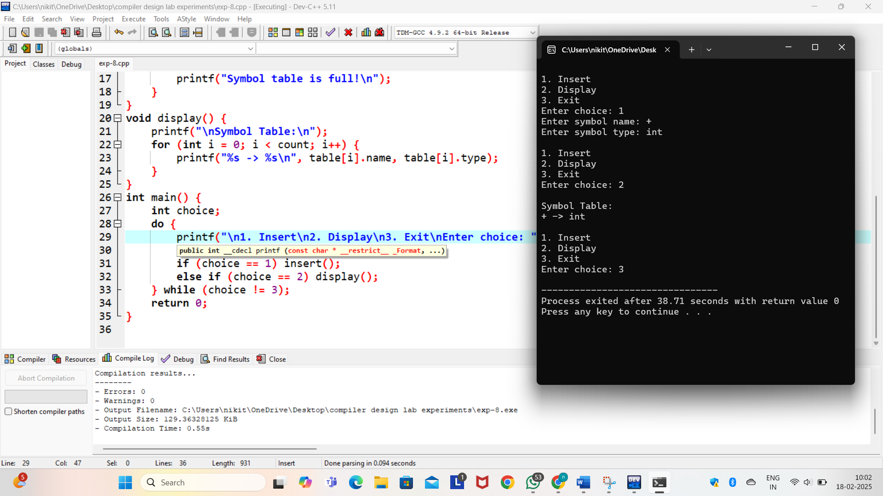
9. All languages have Grammar. When people frame a sentence we usually say whether the sentence is framed as per the rules of the Grammar or Not. Similarly use the same ideology, implement to check whether the given input string is satisfying the grammar or,not .
Code:
#include <stdio.h>
#include <string.h>
int isValidGrammar(char str[]) {
int i, len = strlen(str);
int countA = 0, countB = 0;
for (i = 0; i < len && str[i] == 'a'; i++)
countA++;
for (; i < len && str[i] == 'b'; i++)
countB++;
if (i == len && countA == countB && countA > 0)
return 1;
return 0;
}
int main() {
char str[20];
printf("Enter a string: ");
scanf("%s", str);
if (isValidGrammar(str))
printf("The string follows the grammar!\n");
else
printf("The string does NOT follow the grammar!\n");
return 0;
}
Output: Enter a string: aabb
The string follows the grammar!
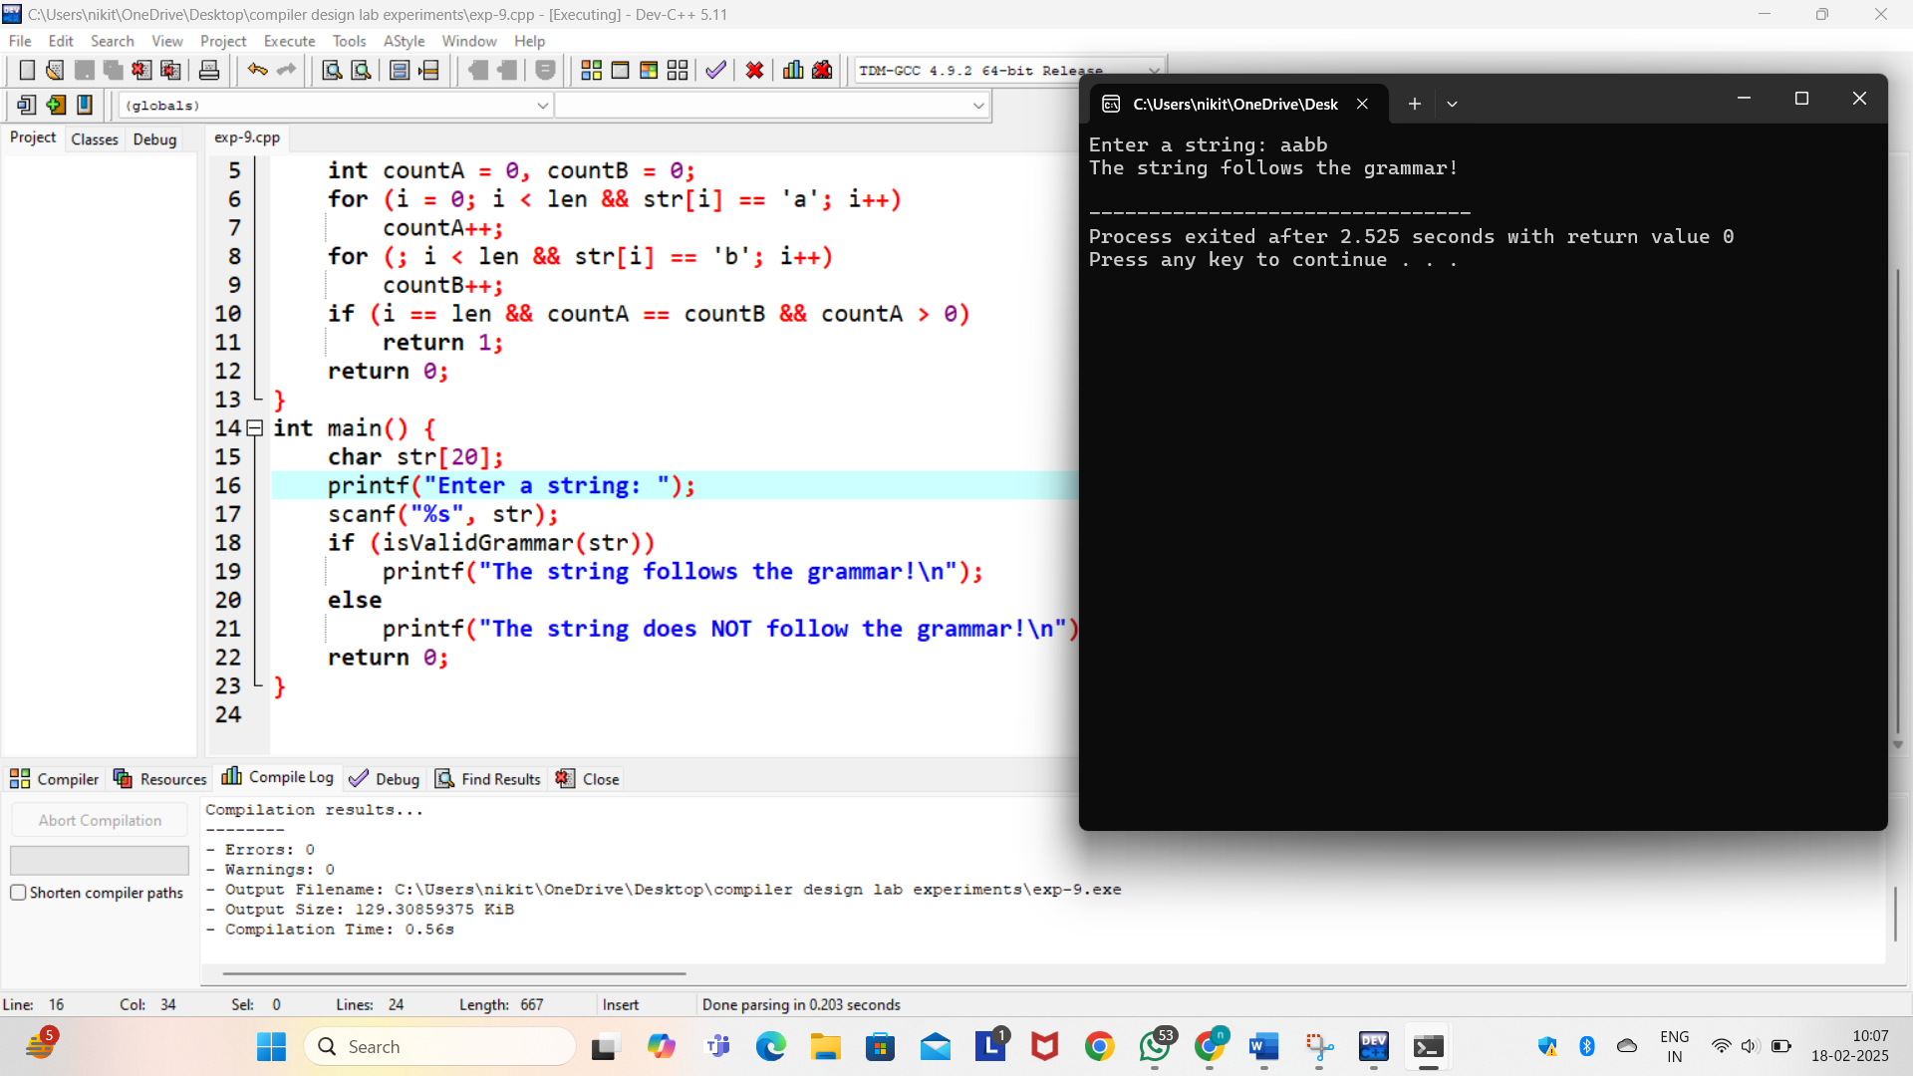
10. Write a C program to construct recursive descent parsing.
Code:
#include <stdio.h>
#include <string.h>
#include <ctype.h>
char input[20];
int pos = 0;
void E();
void EPrime();
void T();
void TPrime();
void F();

void E() {
T();
EPrime();
}
void EPrime() {
if (input[pos] == '+') {
pos++;
T();
EPrime();
}
}
void T() {
F();
TPrime();
}
void TPrime() {
if (input[pos] == '*') {
pos++;
F();
TPrime();
}
}
void F() {
if (input[pos] == '(') {
pos++;
E();
if (input[pos] == ')')
pos++;
else {
printf("Error: Missing closing parenthesis!\n");
return;
}
} else if (isalnum(input[pos])) {
pos++;
} else {
printf("Error: Invalid token!\n");
}
}
int main() {
printf("Enter an expression: ");
scanf("%s", input);
E();
if (input[pos] == '\0')
printf("Valid Expression!\n");
else
printf("Error: Invalid Expression!\n");
return 0;
}
Output:
Enter an expression: a+b*(c+d)
Valid Expression!
