6. Create an R list containing vectors, matrices, and functions; display contents.
CODE:
vec <- c(1,2,3,4,5)
mat <- matrix(1:9, nrow=3)
fun <- function(x) x^2
my_list <- list(Vector=vec, Matrix=mat, Function=fun)
print(my_list)
OUTPUT:
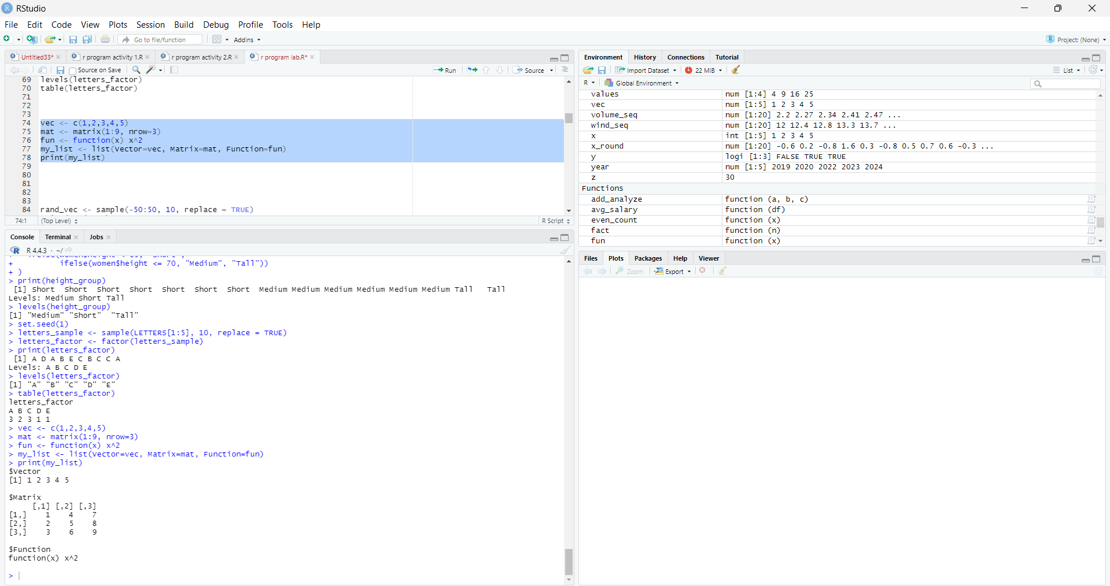
7. Write R programs for basic tasks: Factors of a number, generate a vector of 10 random integers
between -50 and 50, print numbers 1–100 with FizzBuzz logic.
CODE:
rand_vec <- sample(-50:50, 10, replace = TRUE)
print(rand_vec)
for(i in 1:100){
if(i %% 3 == 0 && i %% 5 == 0){
print("FizzBuzz")
} else if(i %% 3 == 0){
print("Fizz")
} else if(i %% 5 == 0){
print("Buzz")
} else {
print(i)
}
}
OUTPUT:
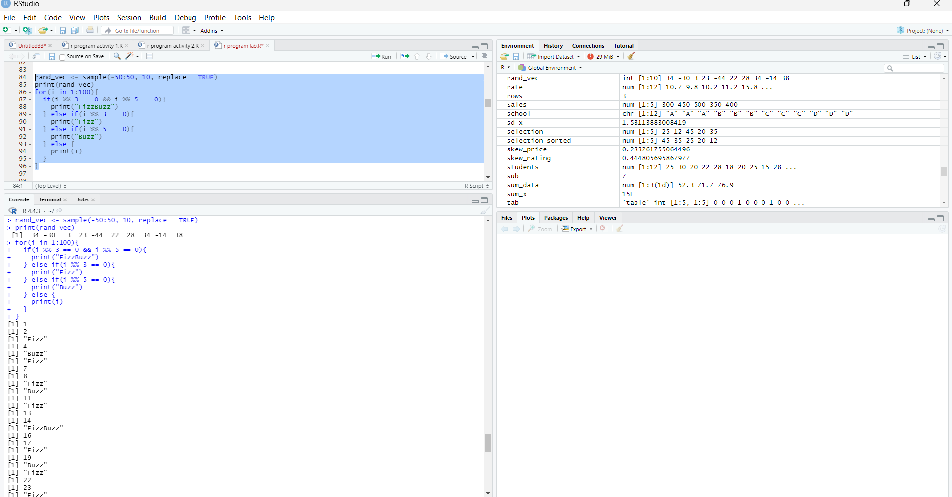
8. Generate random numbers from a normal distribution; count occurrences.
CODE:
set.seed(1)
x <- rnorm(20, mean = 0, sd = 1)
print(x)
x_round <- round(x, 1)
freq <- table(x_round)
print(freq)
OUTPUT:
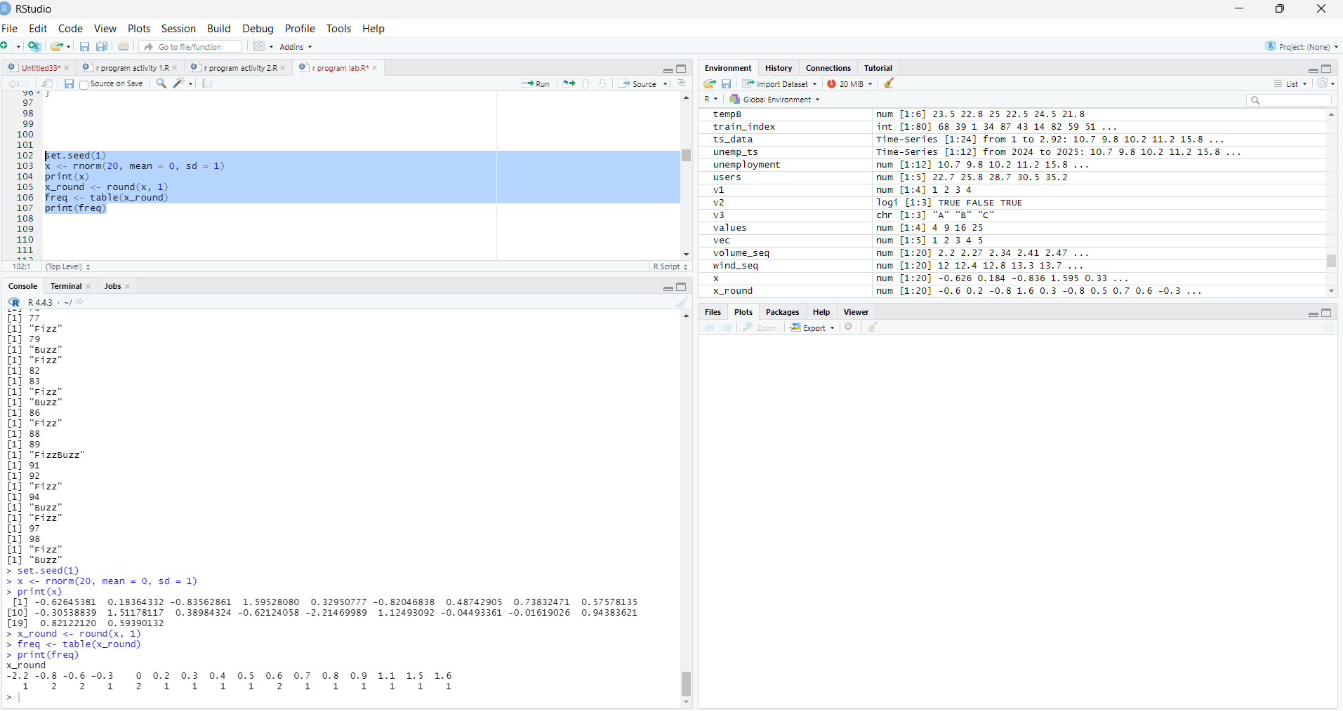
9. Create empty plots with specified axis limits.
CODE:
plot(1, type = "n",
xlim = c(0, 10),
ylim = c(0, 20),
xlab = "X-Axis",
ylab = "Y-Axis",
main = "Empty Plot")
OUTPUT:
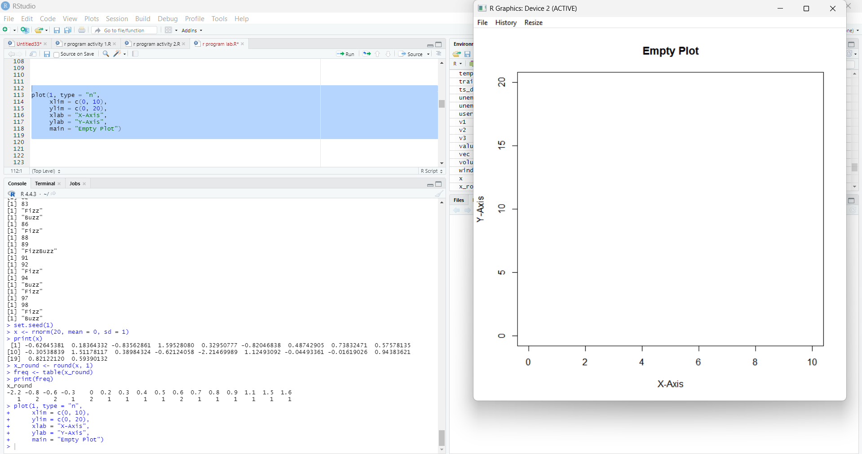
10. Create and explore a data frame exam_data with name, score, attempts, and qualify fields. Perform
extract, add row/column, sort, save to file.
CODE:
exam_data <- data.frame(
name = c("niki", "navya", "Chandu", "Divya"),
score = c(85, 72, 90, 65),
attempts = c(1, 2, 1, 3),
qualify = c(TRUE, TRUE, TRUE, FALSE)
)
print(exam_data)
print(exam_data$score)
print(exam_data[1:2, ])
new_row <- data.frame(
name = "Esha",
score = 88,
attempts = 1,
qualify = TRUE
)
exam_data <- rbind(exam_data, new_row)
exam_data$grade <- c("B", "C", "A", "D", "B")
print(exam_data)
sorted_data <- exam_data[order(-exam_data$score), ]
print(sorted_data)
write.csv(exam_data, "exam_data.csv", row.names = FALSE)
OUTPUT:
