

Christ Nagar, Hullahalli, Begur - Koppa Road, Sakalwara, Post, Bengaluru-560083

DEPARTMENT OF COMPUTER APPLICATIONS

PROJECT REPORT ON
"FOCUSFLOW: PRODUCTIVITY TRACKER FOR STRESS MANAGEMENT"
Submitted in partial fulfilment of the requirements for the award of a degree in
BACHELOR OF COMPUTER APPLICATIONS
Submitted by
MERLIN NIKITHA L
REG. NO: UO3BV23S0058
Under the guidance of
Ms Nandini N
ASSISTANT PROFESSOR
DEPARTMENT OF COMPUTER SCIENCE AND APPLICATIONS
MAY / JUNE - 2026



Christ Nagar, Hullahalli, Begur - Koppa Road, Sakalwara, Post, Bengaluru-560083

DEPARTMENT COMPUTER SCIENCE AND APPLICATIONS

Date:

CERTIFICATE
This is to certify that the project work entitled "FOCUSFLOW: PRODUCTIVITY TRACKER FOR STRESS MANAGEMENT" is a Bonafide work done by MERLIN NIKITHA L (UO3BV23S0058) of VI Semester BCA in partial fulfilment of requirements for the award of the degree of Bachelor of Computer Applications at CHRIST ACADEMY INSTITUTE FOR ADVANCED STUDIES, affiliated with Bangalore University, during the academic year 2025-2026. It is satisfactory and hereby approved for submission.

Ms Nandini N Mr Ramesh Babu
(Project Guide) (HOD)

Examiners:
1. ___________________________
2. ___________________________ College Seal

ACKNOWLEDGEMENT
First and foremost, I express my sincere gratitude to all the people at Christ Academy Institute for Advanced Studies who guided and assisted me in completing this project.
I am highly indebted to the Principal, Fr. Antony Pottokaran CMI, and Joint Director, Rev. Fr. Joy Payyappilly CMI, for the facilities provided to accomplish this project.
I would like to thank my Project Guide, the Head of Department Mr. Ramesh Babu, and the Program Coordinator for their constructive criticism and continuous support throughout the development of FocusFlow.
I am extremely grateful to all department staff members and friends who helped me complete this project successfully.

MERLIN NIKITHA L
UO3BV23S0058

DECLARATION
This is to certify that the project report entitled "FOCUSFLOW: PRODUCTIVITY TRACKER FOR STRESS MANAGEMENT" is done by me, and it is authentic work carried out for the partial fulfilment of the requirements for the award of the degree of Bachelor of Computer Applications (BCA) under the guidance of the Project Guide. The matter and software embodied in this project have not been submitted earlier for the award of any degree or diploma to the best of my knowledge and belief.

Date: _______________ Signature of Student
MERLIN NIKITHA L
(UO3BV23S0058)

INDEX
Title | Page No.
1. INTRODUCTION | 1
1.1 Project Description
1.2 Problem Statement
1.3 Existing System
1.4 Limitations of Existing System
1.5 Proposed System
1.6 Objectives
1.7 Benefits of the Proposed System
2. SYSTEM REQUIREMENTS
2.1 Hardware Specification
2.2 Software Specification
2.2.1 Front-End Technologies
2.2.2 Back-End Technologies
2.2.3 Database
2.2.4 Development Tools
2.3 Tools Survey
2.3.1 React.js
2.3.2 Django REST Framework
2.3.3 JSON Web Tokens (JWT)
2.3.4 SQLite
2.3.5 SM-2 Spaced Repetition Algorithm
2.3.6 Axios
2.3.7 Postman API Integration
3. SYSTEM DESIGN
3.1 Modules
3.1.1 User Authentication Module
3.1.2 Breathe Module
3.1.3 Focus Module
3.1.4 Recall Module
3.1.5 Review Module
3.1.6 Mood Module
3.1.7 Week Dashboard
3.1.8 Organisation Admin Module
3.2 Database Design
3.2.1 users
3.2.2 organisations
3.2.3 focus_sessions
3.2.4 flashcards
3.2.5 spaced_repetition
3.2.6 mood_logs
3.2.7 breathe_sessions
3.2.8 tasks (Organisation Mode)
3.3 Key Relationships
3.4 Data Flow Diagram (DFD)

3.4.1 External Entities
3.4.2 Level 0 DFD (Context Diagram)
3.4.3 Level 1 DFD Processes
4. CODING
4.1 Frontend (React.js)
4.1.1 Application Entry Point (App.js)
4.1.2 Authentication Context (AuthContext.js)
4.1.3 API Helper (api.js)
4.1.4 Authentication Page (Auth.js)
4.1.5 Sidebar Component (Sidebar.js)
4.1.6 Dashboard Page (Dashboard.js)
4.1.7 Tasks Page (Tasks.js)
4.1.8 Focus Timer Page (Focus.js)
4.1.9 Mood Tracker Page (Mood.js)
4.1.10 Analytics Page (Analytics.js)
4.1.11 Streaks Page (Streaks.js)
4.2 Backend (Django REST Framework)
4.2.1 Models (api/models.py)
4.2.2 Serializers (api/serializers.py)
4.2.3 Views (api/views.py)
4.2.4 URL Configuration (api/urls.py)
4.2.5 Settings (focusflow/settings.py)
4.3 Technology Stack Summary
5. IMPLEMENTATION
5.1 Implementation Overview
5.2 Environment Setup
6. UI SCREENS
6.1 Individual User Interface
6.2 Organization User Interface
7. TESTING
7.1 System Testing
7.2 Integration Testing
7.3 Unit Testing
7.4 Test Cases
7.5 Test Summary
8. CONCLUSION
8.1 Summary of Achievements
8.2 Key Learnings
9. FUTURE ENHANCEMENT
9.1 Enhanced Stress Detection
9.2 Advanced Analytics and AI Insights

9.2 Advanced Analytics and AI Insights
9.3 Spotify / Music Integration
9.4 Mobile Application
9.5 Community and Collaboration Features
9.6 Summary of Future Enhancements
10. REFERENCES
10.1 Books and Academic References
10.2 Websites and Online Resources

INTRODUCTION

1. INTRODUCTION
In the modern digital era, the way individuals learn, work, and manage their daily activities has undergone a significant transformation. The increasing dependence on technology, online platforms, and digital communication tools has improved efficiency and accessibility but has also introduced new challenges. Among these challenges, maintaining sustained focus, managing stress, and ensuring mental well-being have emerged as critical concerns for students and working professionals.
The widespread presence of distractions such as social media, multitasking environments, and continuous notifications significantly impacts productivity. At the same time, academic pressure, project deadlines, and work-related responsibilities contribute to increased cognitive load and stress levels. Traditional productivity tools primarily focus on task management and scheduling but fail to address the behavioral and psychological aspects that influence effective work performance.
To overcome these limitations, the project titled “FocusFlow: Productivity Tracker for Stress Management” has been developed. FocusFlow is an intelligent, behavior-aware web application that not only helps users manage tasks but also actively monitors their behavior, detects stress, and provides adaptive solutions to improve both productivity and mental health.
The system integrates multiple scientifically grounded techniques such as the Pomodoro Technique, active recall learning, spaced repetition, and guided breathing exercises into a single unified platform. By combining these techniques with real-time behavioral analysis, FocusFlow ensures that users can work efficiently while maintaining emotional balance and reducing stress.
A key innovation of this system is its ability to detect stress through analysis of typing patterns. When irregular or rapid keystroke behavior is identified, the system automatically triggers a guided breathing session, helping users regain focus and calmness. This proactive approach differentiates FocusFlow from traditional productivity tools that rely solely on manual user input.
Thus, FocusFlow represents a comprehensive and intelligent solution that bridges the gap between productivity management and mental well-being, offering a holistic approach to modern work and study challenges.

1.1 PROJECT DESCRIPTION
FocusFlow is a full-stack web application developed using modern web technologies to ensure scalability, performance, and user-friendliness. The frontend is built using React.js, which enables the development of a dynamic and responsive single-page application. The backend is implemented using Python and Django REST Framework, providing secure API communication, authentication, and data management. SQLite is used as the database to store user data and application records efficiently.
The application is designed to support both individual users and organisations. It includes a role-based access control system with three primary roles: Admin, Manager, and Member. This allows organisations to manage teams, assign tasks, and monitor productivity effectively.
FocusFlow is structured around six core modules that work together to provide a complete productivity and stress management ecosystem.
The Breathe Module provides guided breathing exercises based on the 4-4-4-4 box breathing technique. These sessions can be triggered automatically when stress is detected or manually by the user. Each session is recorded for analysis and tracking.
The Focus Module implements the Pomodoro technique, where users work in focused intervals of 25 minutes followed by short breaks. The module includes a visual timer, task labeling, and distraction tracking, helping users maintain concentration and improve time management.
The Recall Module supports active learning through flashcards. Users can create flashcards, review them, and rate their recall performance. This helps in strengthening memory and improving learning efficiency.
The Review Module uses the SM-2 spaced repetition algorithm to schedule flashcard reviews at optimal intervals. This ensures that information is retained in long-term memory.
The Mood Module allows users to log their emotional state and energy level. Based on this input, the system provides personalized recommendations to improve productivity.
The Week Dashboard presents weekly analytics, including productivity trends, focus session data, mood patterns, and AI-generated insights. This helps users understand their performance and make informed decisions.

1.2 PROBLEM STATEMENT
Despite the availability of various productivity tools, there are significant gaps in how these tools function. Most existing systems focus only on tracking tasks and deadlines without considering the user’s mental state or behavior during work sessions.
One major problem is the absence of real-time stress detection. Current tools do not monitor user behavior, making it impossible to identify when a user is overwhelmed or experiencing cognitive fatigue.
Another issue is the passive nature of task management systems. These systems assign tasks but do not guide users on how to approach them based on their current mental state.
Additionally, most tools lack mechanisms to support long-term knowledge retention. Without techniques like spaced repetition, users tend to forget information quickly.
There is also a fragmentation of tools, where users must rely on multiple applications for task management, focus, learning, and stress relief. This leads to inefficiency and frequent context switching.
In organisational environments, there is no effective system to detect burnout among team members. Managers lack insights into declining productivity patterns that may indicate stress or fatigue.
Therefore, there is a need for an integrated system that combines productivity tracking, stress detection, learning enhancement, and behavioral analysis in a single platform.

1.3 EXISTING SYSTEM
The existing productivity ecosystem can be broadly classified into three major categories, each addressing a specific aspect of productivity but lacking a holistic approach.
Firstly, task management tools such as Todoist, Microsoft To Do, and Notion enable users to create, organize, and track tasks efficiently. These platforms support features like deadlines, reminders, and collaboration, making them useful for planning and execution. However, they primarily focus on what users need to do rather than how they perform tasks. They do not consider the user’s mental state, energy levels, or stress, and therefore lack the ability to adapt to changing user conditions.
Secondly, focus enhancement tools like Forest and similar Pomodoro-based applications help users improve concentration by structuring work into timed sessions. These tools are effective in promoting disciplined work habits and minimizing distractions. Despite their usefulness, they operate on fixed time intervals and do not account for variations in user productivity or emotional state. They also lack advanced features such as stress detection, mood tracking, or personalized recommendations.
Thirdly, spaced repetition tools such as Anki are widely used for improving memory retention through flashcards. These systems use scientifically proven algorithms to optimize learning schedules and enhance long-term retention. However, they are designed primarily for learning and do not integrate with task management or productivity systems. As a result, users must rely on separate applications for studying, task tracking, and stress management.
Overall, while each of these systems performs well within its domain, they function as isolated solutions. There is a clear lack of integration between productivity management, learning techniques, and mental well-being, which limits their effectiveness in addressing real-world user needs.

1.4 LIMITATIONS OF EXISTING SYSTEM
Despite the availability of various productivity tools, several significant limitations remain unaddressed in current systems.
One of the primary limitations is the absence of real-time stress detection. Existing tools do not monitor user behavior or identify signs of fatigue, anxiety, or cognitive overload during work sessions. As a result, users may continue working under stress without any intervention, leading to reduced efficiency and potential burnout.
Another major drawback is the lack of mood-based or personalized recommendations. Most systems operate using static rules and do not adapt to the user’s emotional or physical condition. They fail to provide context-aware suggestions that could help users optimize their workflow based on their current state.
Additionally, users are often required to rely on multiple separate applications to manage different aspects of productivity, such as tasks, focus sessions, and learning. This fragmentation leads to inefficiency, increased cognitive load, and a disjointed user experience.
Existing systems also offer limited analytics and insights. While some tools provide basic statistics, they do not generate meaningful, data-driven insights that help users understand their productivity patterns, identify weaknesses, or improve performance over time.
In organisational environments, these limitations become even more critical. Most tools lack the capability to monitor employee well-being, detect early signs of burnout, or provide actionable insights for team management. This results in reduced productivity, poor resource utilization, and increased risk of employee fatigue.
In summary, current systems fail to provide a comprehensive, intelligent, and user-centric solution that integrates productivity, learning, and mental well-being. This gap highlights the need for an advanced system like FocusFlow, which addresses these challenges in a unified manner.

1.5 PROPOSED SYSTEM
The proposed system, FocusFlow, is designed to overcome these limitations by providing a unified and intelligent platform.
The system uses behavioral analysis to detect stress in real time by monitoring typing patterns. When stress is detected, it automatically triggers a guided breathing session to help the user relax.
All six modules are integrated into a single application, eliminating the need for multiple tools. The system also implements the SM-2 algorithm to improve memory retention through spaced repetition.
Another key feature of FocusFlow is its mood-adaptive recommendation engine, which personalizes the user experience. Users can log their emotional state and energy level, and based on this input, the system generates tailored suggestions such as starting a focus session, taking a break, or engaging in light activities. This dynamic adaptation ensures that users receive guidance aligned with their current mental and physical condition, ultimately improving productivity and well-being.
In addition to individual usage, FocusFlow includes a comprehensive Organisation Mode that supports team-based productivity management. Through role-based access control (Admin, Manager, Member), organisations can assign tasks, monitor employee performance, and analyze productivity trends. The system also enables early detection of burnout by identifying patterns such as declining focus sessions or increased stress indicators, allowing timely intervention.
The weekly dashboard serves as a centralized analytics hub, providing users with detailed insights into their productivity patterns.
Overall, the proposed system offers a holistic and intelligent solution that bridges the gap between productivity management and mental health support. By combining real-time behavioral analysis, adaptive learning techniques, personalized recommendations, and organisational features, FocusFlow transforms the way users approach work and study, making it more efficient, balanced, and sustainable.

1.6 OBJECTIVES
The primary objective of the FocusFlow system is to design and develop an intelligent, behavior-aware productivity platform that integrates efficiency with mental well-being. The system aims to address the limitations of existing tools by providing a unified solution that adapts to user behavior and enhances overall performance.
The specific objectives of the project are as follows:

- To design and develop a behavior-aware web application that enhances user productivity while maintaining mental balance.
- To implement real-time stress detection by analyzing typing patterns and behavioral indicators.
- To integrate guided breathing exercises that are automatically triggered to help users manage stress effectively.
- To develop a Pomodoro-based focus system that improves time management and concentration.
- To implement a flashcard-based learning system using spaced repetition techniques for better knowledge retention.
- To provide personalized recommendations based on the user’s mood and energy levels.
- To generate weekly analytics and productivity insights that help users understand and improve their performance.
- To support organisation-level features, including task management, performance tracking, and burnout detection.

These objectives collectively aim to create a system that not only improves productivity but also promotes a healthier and more sustainable working environment.

1.7 BENEFITS OF THE PROPOSED SYSTEM
The proposed FocusFlow system offers several significant advantages by combining productivity management with mental well-being support into a single, integrated platform.
One of the key benefits is its holistic approach, where multiple functionalities such as task management, focus tracking, learning, and stress management are brought together in one application. This eliminates the need for users to switch between multiple tools, thereby improving efficiency and reducing cognitive load.
The system enables users to manage stress proactively through real-time detection and automatic interventions such as guided breathing sessions. This helps in maintaining emotional balance and prevents burnout during prolonged work or study periods.
The integration of the spaced repetition technique enhances long-term memory retention, making it especially beneficial for students and professionals engaged in continuous learning. Additionally, the mood-adaptive recommendation engine provides personalized suggestions, ensuring that users receive guidance tailored to their current mental and physical state.
For organisations, FocusFlow offers advanced features such as team performance monitoring, task management, and early burnout detection. These capabilities help administrators make informed decisions, improve team productivity, and ensure employee well-being.
The system also provides a comprehensive analytics dashboard, which delivers meaningful insights into user behavior, productivity trends, and performance patterns. These insights support data-driven decision-making and continuous improvement.
Furthermore, the system is highly scalable and extensible, allowing future integration of advanced technologies such as artificial intelligence, mobile applications, wearable device integration, and external service APIs. This ensures that the system remains adaptable to future requirements and technological advancements.
Overall, FocusFlow delivers a balanced, intelligent, and user-centric solution that enhances productivity while prioritizing mental health and long-term efficiency.

SYSTEM REQUIREMENTS

2. SYSTEM REQUIREMENTS

SYSTEM REQUIREMENTS
The system requirements define the essential hardware and software components necessary for the successful design, development, deployment, and operation of the FocusFlow: Productivity Tracker for Stress Management application. These requirements ensure that the system functions efficiently, delivers optimal performance, and provides a smooth and reliable user experience across different environments.
In modern full-stack web application development, system requirements play a crucial role in determining the feasibility and scalability of the project. Proper identification of these requirements helps developers select appropriate technologies, optimize resource usage, and ensure compatibility between different system components.
For FocusFlow, the requirements are carefully structured to support both development and production environments. The application involves real-time interaction, behavioral monitoring, data processing, and visualization, which necessitate a stable and capable system configuration.
The system requirements are broadly categorized into three main sections:
The hardware specifications define the minimum and recommended physical resources required to run the application effectively, including processor performance, memory capacity, storage space, and display capabilities. These specifications ensure that both developers and end users can operate the system without performance bottlenecks.
The software specifications outline the technologies, frameworks, programming languages, and tools used in the development and execution of the system. This includes frontend technologies for user interface design, backend frameworks for server-side logic, database systems for data storage, and supporting libraries for communication and authentication.
The tools survey provides an overview of the development tools, libraries, and frameworks selected for the project. It explains their purpose, advantages, and relevance in the implementation of various modules within the system. This structured approach also facilitates future enhancements, maintenance, and deployment across different platforms

2.1 HARDWARE SPECIFICATION
Minimum Hardware Requirements

Processor | Intel Core i3 or above (i5 / i7 recommended)
RAM | Minimum 4 GB (8 GB recommended for React.js and Django simultaneously)
Hard Disk | Minimum 20 GB free space for project files, node_modules, and database
Display | 1366 × 768 resolution or above (1920 × 1080 Full HD recommended)
Internet Connection | Required for npm, pip package installation and API calls
Operating System | Windows 10 / Windows 11 (64-bit) or Ubuntu 22.04 LTS

2.2 SOFTWARE SPECIFICATION
The software specification defines the set of programming languages, frameworks, libraries, and tools required for the development and execution of the FocusFlow application. These technologies are carefully selected to ensure high performance, scalability, maintainability, and a seamless user experience.
FocusFlow follows a modern full-stack architecture, where the frontend and backend are developed using separate but interconnected technologies. The frontend is responsible for user interaction and interface design, while the backend handles data processing, authentication, and communication with the database. Additionally, various development tools are used to streamline coding, testing, and deployment processes.
The software requirements are divided into frontend technologies, backend technologies, database systems, and development tools.

2.2.1 Front-End Technologies
The frontend of FocusFlow is responsible for creating an interactive and user-friendly interface. It enables users to navigate between modules, perform actions, and visualize data effectively.
HTML5
HTML5 is used as the standard markup language for structuring the web pages of the application. It provides semantic elements that improve readability, accessibility, and SEO compatibility. In FocusFlow, HTML5 is used to define layouts, forms, input fields, and content structure across all modules.
CSS3
CSS3 is used for styling and designing the user interface. It enables responsive design, ensuring that the application adapts to different screen sizes and devices. CSS3 is also used to implement animations such as the breathing circle transitions, smooth UI interactions, and module-based visual effects that enhance user experience.
JavaScript (ES6+)
JavaScript provides the core functionality for dynamic interactions within the application. Modern ES6+ features such as arrow functions, promises, and modules are used to write clean and efficient code. JavaScript is particularly important for implementing the Pomodoro timer logic, handling user inputs, and performing real-time keystroke monitoring for stress detection.
React.js
React.js is a powerful JavaScript library used to build a component-based user interface. It allows the application to be structured into reusable components, making development more efficient and maintainable. FocusFlow uses React to implement all six modules within a single-page application (SPA), enabling fast navigation without page reloads. The virtual DOM feature ensures efficient rendering and improved performance.
Node.js
Node.js is used as the runtime environment for managing frontend dependencies and build processes. It works with npm (Node Package Manager) to install and manage libraries such as Axios, React Router, and charting tools. Node.js plays a crucial role in development and deployment workflows.

2.2.2 Back-End Technologies
The backend of FocusFlow is responsible for handling business logic, data processing, authentication, and communication between the frontend and the database.
Python (Django Framework)
Python is used as the primary backend programming language due to its simplicity, readability, and extensive library support. The Django framework provides a robust structure for developing secure and scalable web applications. It handles server-side logic, URL routing, authentication, and database operations efficiently.
Django REST Framework (DRF)
Django REST Framework is used to build RESTful APIs that allow the frontend to communicate with the backend. It simplifies the creation of API endpoints, serialization of data, and implementation of authentication mechanisms. DRF ensures smooth data exchange using JSON format.
JWT (JSON Web Tokens)
JWT is used for secure authentication and authorization. When a user logs in, the server generates an access token and a refresh token. These tokens are used to verify user identity and control access to protected resources. JWT enables stateless authentication, improving scalability and security.

2.2.3 Database
SQLite
SQLite is used as the primary database for FocusFlow. It is a lightweight, file-based relational database that does not require a separate server. SQLite is well-suited for small to medium-scale applications and provides efficient data storage and retrieval.
The database stores all critical application data, including:
- User accounts and roles
- Focus session records
- Flashcards and spaced repetition schedules
- Mood logs and breathing session data
- Organisation details and task assignments
Django’s ORM (Object Relational Mapping) is used to interact with the database, making it easier to perform queries without writing raw SQL.

2.2.4 Development Tools
Development tools play a crucial role in improving productivity, debugging, and maintaining code quality.
Visual Studio Code (VS Code)
VS Code is used as the primary Integrated Development Environment (IDE). It provides features such as syntax highlighting, debugging tools, extensions, and Git integration, making development faster and more efficient.
GitHub
GitHub is used for version control and project management. It allows developers to track changes, collaborate, and maintain different versions of the project. It also ensures code backup and easy sharing.
Google Chrome
Google Chrome is used as the primary browser for testing and debugging the application. Its developer tools help inspect elements, monitor network requests, and debug JavaScript code.

2.3 TOOLS SURVEY
The tools survey provides a detailed understanding of the key technologies and frameworks used in the development of FocusFlow. Each tool is selected based on its efficiency, reliability, and suitability for the project requirements.

2.3.1 React.js
React.js is an open-source JavaScript library used for building modern user interfaces. It follows a component-based architecture, allowing developers to create reusable UI components. This modular approach improves code maintainability and scalability.
React uses a virtual DOM, which updates only the necessary parts of the UI instead of reloading the entire page. This significantly improves performance. In FocusFlow, each module such as Breathe, Focus, Recall, Review, Mood, and Week Dashboard is implemented as a separate React component.

2.3.2 Django REST Framework
Django REST Framework is a powerful toolkit for building Web APIs. It simplifies backend development by providing features such as serializers, authentication classes, and viewsets.
In FocusFlow, DRF is used to expose database models as API endpoints. This allows the React frontend to communicate with the backend securely using JSON data. It also reduces development time by minimizing boilerplate code.

2.3.3 JSON Web Tokens (JWT)
JWT is a secure method for transmitting information between the client and server. It is widely used for authentication in modern web applications.
In FocusFlow, JWT is implemented using the SimpleJWT library. When a user logs in, the server generates tokens that are used for subsequent API requests. This ensures that only authenticated users can access protected resources.

2.3.4 SQLite
SQLite is a lightweight relational database that stores data locally in a single file. It is easy to set up and requires minimal configuration.
In FocusFlow, SQLite is used to manage all application data. It works seamlessly with Django’s ORM, enabling efficient database operations without complex setup.

2.3.5 SM-2 Spaced Repetition Algorithm
The SM-2 algorithm is a scientifically proven method for improving memory retention. It schedules reviews based on the user’s recall performance.
In FocusFlow, the algorithm adjusts the review intervals of flashcards based on user ratings such as Easy, Medium, or Hard. This ensures that important information is reinforced at the right time, improving long-term learning.

2.3.6 Axios
Axios is a promise-based HTTP client used for making API requests from the frontend to the backend.
In FocusFlow, Axios is configured with interceptors that automatically attach JWT tokens to each request. It also handles token refresh when the access token expires, ensuring uninterrupted user sessions and secure communication.

2.3.7 Postman API Integration
Postman API integration is an important part of the development and testing process in the FocusFlow application. It is used to test, validate, and debug RESTful APIs developed using Django REST Framework before integrating them with the frontend.
Postman supports HTTP methods such as GET, POST, PUT, PATCH, and DELETE, allowing developers to perform different operations on backend resources. It provides features like request headers, authentication handling, environment variables, and response analysis, making API testing efficient and reliable.
In FocusFlow, Postman is used to test APIs related to authentication, tasks, focus sessions, mood tracking, breathing sessions, flashcards, and analytics. This ensures that all modules function correctly and handle real-time data effectively.

Purpose of Using Postman
The main purpose of using Postman is to ensure that backend APIs are secure, accurate, and efficient. It helps in:
- Validating API endpoints before frontend integration
- Testing JWT-based authentication
- Debugging errors and handling edge cases
- Verifying database operations
- Monitoring API response time

API Testing Workflow
The backend server is first started using:
python manage.py runserver
API requests are then created in Postman with appropriate methods and endpoints. Headers include:
- Content-Type: application/json
- Authorization: Bearer <access_token>
After sending the request, responses such as status codes, JSON data, and response time are analyzed to verify correctness.

Testing Key APIs
- Authentication APIs:
  - /api/register/ for user registration
  - /api/login/ for login and token generation
- Task APIs: Perform CRUD operations (create, retrieve, update, delete tasks)
- Focus APIs: Store and retrieve Pomodoro session data
- Mood APIs: Log mood and generate recommendations
- Analytics APIs: Fetch aggregated data like focus time, task stats, and mood trends

JWT Authentication Testing
JWT tokens are included in request headers:
Authorization: Bearer <access_token>
This ensures secure access to protected endpoints. Token refresh mechanisms are also tested to maintain session continuity.

SYSTEM DESIGN

3. SYSTEM DESIGN
System design represents the architectural blueprint of the FocusFlow project and defines how different components of the system interact with each other to achieve the desired functionality. It provides a clear and structured representation of the data flow, module interactions, and logical framework required for seamless integration of productivity management, stress detection, and behavioral analytics.
The design phase plays a crucial role in ensuring that the system is scalable, efficient, and maintainable. A well-structured design not only improves system performance but also simplifies future enhancements and debugging processes. In the case of FocusFlow, the design is centered around providing a smooth user experience while handling real-time data processing and behavioral analysis.
FocusFlow follows a three-tier client-server architecture, which divides the system into three distinct layers:
The presentation layer, implemented using React.js, is responsible for user interaction, UI rendering, and client-side logic. It ensures a responsive and dynamic interface through a single-page application (SPA) structure.
The application layer, built using Django REST Framework, handles business logic, API communication, authentication, and data processing. It acts as a bridge between the frontend and the database.
The data layer, managed using SQLite, is responsible for storing and retrieving all application data, including user information, tasks, sessions, and analytics.
This layered architecture ensures separation of concerns, making the system modular, scalable, and easy to maintain.

3.1 MODULES
The FocusFlow system is divided into multiple functional modules, each responsible for a specific aspect of productivity management and stress handling. These modules are tightly integrated to provide a unified and seamless user experience.

3.1.1 User Authentication Module
The User Authentication Module is the entry point of the application and ensures secure access to the system. It manages user registration, login, and role-based access control.
Users can register using their email and password, along with selecting their role as either an individual user or an organisation member. During registration, the system validates user inputs and securely stores credentials using encryption techniques.
The login process uses JWT-based authentication, where the server generates an access token and a refresh token upon successful authentication. These tokens are used to verify user identity for subsequent API requests without requiring repeated logins.
The module also implements role-based routing. Users with admin or manager roles are redirected to organisation dashboards, while individual users are directed to their personal dashboards. This ensures that each user accesses features relevant to their role.
Additionally, a token refresh mechanism is implemented to maintain persistent sessions. When the access token expires, the system automatically uses the refresh token to generate a new access token, ensuring uninterrupted user experience.

3.1.2 Breathe Module
The Breathe Module is designed to help users manage stress through guided breathing exercises. It plays a crucial role in maintaining mental well-being during work or study sessions.
This module features an animated SVG breathing circle that visually guides users through the 4-4-4-4 box breathing technique, which includes inhaling, holding, exhaling, and pausing, each for four seconds. Smooth CSS transitions are used to create a calming visual effect.
A unique aspect of this module is its ability to be triggered automatically through stress detection. The system continuously monitors keystroke patterns, and when irregular or rapid typing behavior is detected, it indicates potential stress. In such cases, the breathing module is activated automatically to help the user relax.
Users can also manually initiate breathing sessions through the sidebar navigation.
Each session is recorded in the database with details such as trigger type (automatic or manual), number of cycles completed, and total duration. This data is later used for analytics and performance tracking.

3.1.3 Focus Module
The Focus Module is based on the Pomodoro Technique, which divides work into focused intervals followed by short breaks. It is designed to improve concentration, reduce distractions, and enhance productivity.
The module includes a circular arc timer with an animated progress indicator that visually represents the remaining time in a session. Users can label their tasks before starting a session, helping them stay organized and goal-oriented.
The system provides controls for starting, pausing, and resetting the timer. During an active session, users can track distractions using a simple counter, which helps them become aware of interruptions and improve focus over time.
Focus sessions are recorded in the database, including details such as start time, duration, task label, and number of distractions. This data contributes to weekly analytics and performance insights.
The module also includes short break and long break modes, allowing users to rest and maintain productivity over extended periods.

3.1.4 Recall Module
The Recall Module is designed to enhance learning through active recall, a proven technique for improving memory retention.
Users can create flashcards by entering a question, answer, topic, and difficulty level. These flashcards are stored in the database and can be reviewed at any time.
The module includes a visually engaging 3D flip animation that allows users to reveal answers by flipping the card. After viewing the answer, users rate their recall performance as Hard, Medium, or Easy.
These ratings are used to update the spaced repetition parameters, including ease factor and repetition count. This ensures that the learning process is adaptive and personalized.

3.1.5 Review Module
The Review Module works in conjunction with the Recall Module and implements the SM-2 spaced repetition algorithm.
It displays a list of flashcards that are due for review, categorized into Overdue, Due Today, and Upcoming. This prioritization helps users focus on the most important cards first.
The SM-2 algorithm calculates the next review date based on the user’s performance rating. Cards that are difficult are scheduled more frequently, while easier cards are reviewed at longer intervals.
The module also includes a calendar view that shows the complete review schedule for the upcoming days. This helps users plan their study sessions effectively.

3.1.6 Mood Module
The Mood Module allows users to track their emotional state and energy levels, which play a significant role in productivity.
Users can select their mood from predefined options such as Energized, Focused, Tired, and Stressed. They can also adjust an energy level slider on a scale from 1 to 5.
Based on the selected mood and energy level, the system provides personalized recommendations using a mood-adaptive engine. For example, a tired user may be advised to take a break, while an energized user may be encouraged to start a focus session.
All mood entries are stored in the database along with timestamps and recommendations. This data is used to generate trends and insights in the analytics dashboard.

3.1.7 Week Dashboard
The Week Dashboard provides a comprehensive overview of the user’s productivity and well-being over time.
It includes a bar chart showing the number of focus sessions completed each day, as well as a line chart representing mood and energy trends throughout the week.
Summary cards display key metrics such as total focused hours, longest streak, and completion percentage. These metrics help users evaluate their performance.
An AI-generated insights panel provides textual observations and suggestions based on user data. This helps users identify patterns and improve their productivity strategies.
For organisation users, the dashboard includes additional features such as team activity tracking, task summaries, and burnout alerts.

3.1.8 Organisation Admin Module
The Organisation Admin Module is designed for managing team productivity and tasks within an organisation.
The Task Management Panel allows administrators to assign tasks to team members, set priorities, and track progress. Tasks are displayed in a structured table format with details such as title, due date, status, and assigned member.
The Team Productivity Overview provides a visual representation of team performance using grouped bar charts. This helps administrators monitor overall productivity and identify trends.
The Burnout Alert Panel identifies users whose productivity has declined over a period of time. This enables early intervention and support, preventing long-term burnout.
This module enhances collaboration, accountability, and efficiency within teams, making FocusFlow suitable for both individual and organisational use.

3.2 DATABASE DESIGN

ER Diagram

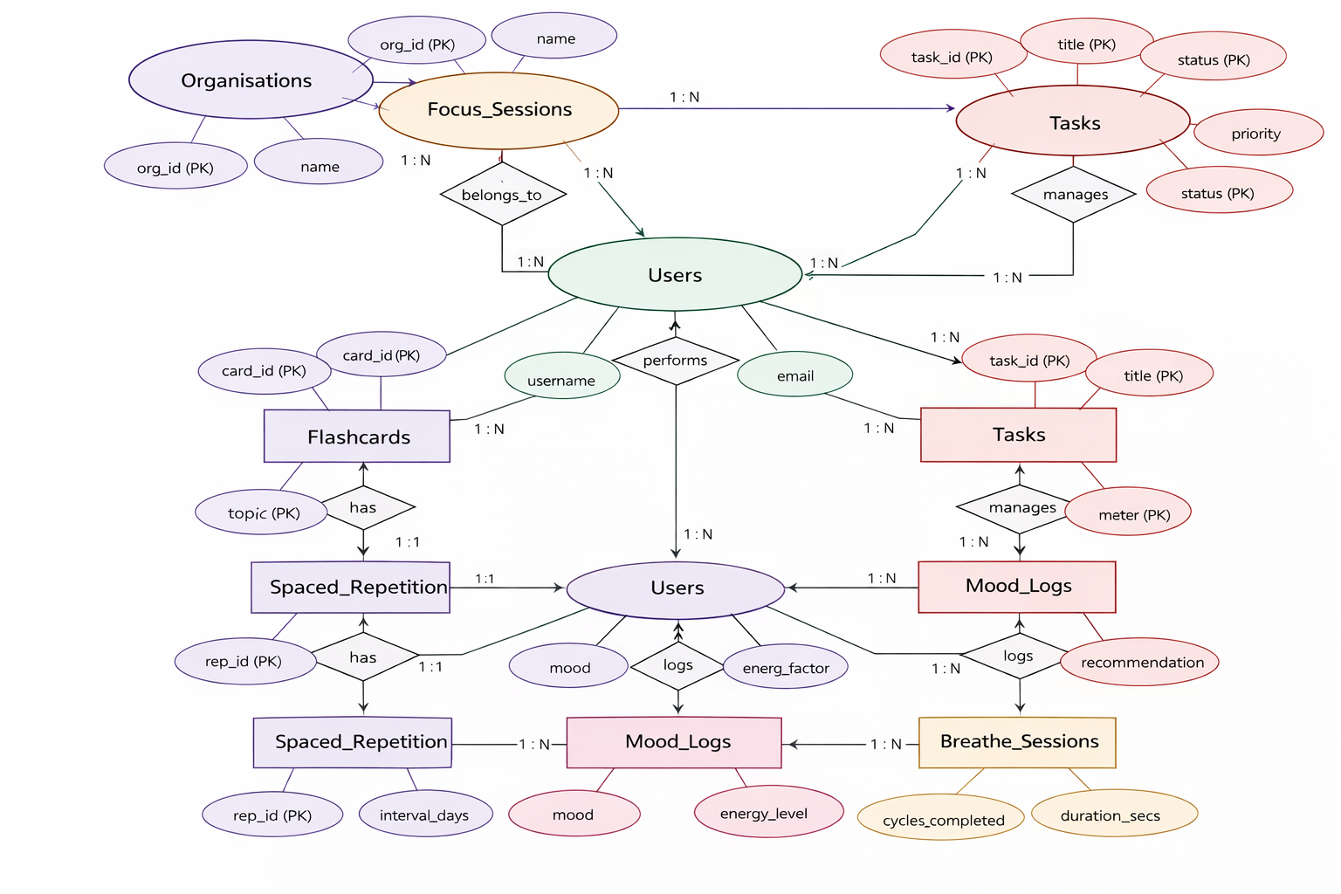

3.2.1 users

id | INTEGER | PK | Unique identifier for each user
username | VARCHAR(100) | - | Username for login
email | VARCHAR(200) | - | User email address
password_hash | VARCHAR(255) | - | Hashed password (bcrypt)
role | VARCHAR(20) | - | admin / manager / member / individual
org_id | INTEGER | FK → organisations | Organisation reference
created_at | DATETIME | - | Account creation timestamp

3.2.2 organisations

id | INTEGER | PK | Unique identifier
name | VARCHAR(200) | - | Organisation name
type | VARCHAR(50) | - | university / corporate / other
admin_email | VARCHAR(200) | - | Admin contact email
created_at | DATETIME | - | Registration timestamp

3.2.3 focus_sessions

id | INTEGER | PK | Unique identifier
user_id | INTEGER | FK → users | User reference
start_time | DATETIME | - | Session start timestamp
duration_mins | INTEGER | - | Duration in minutes
task_label | VARCHAR(200) | - | Task name or label
distractions | INTEGER | - | Count of distractions during session
completed | BOOLEAN | - | Whether session was completed

3.2.4 flashcards

id | INTEGER | PK | Unique identifier
user_id | INTEGER | FK → users | User reference
question | TEXT | - | Front side of flashcard
answer | TEXT | - | Back side of flashcard
topic | VARCHAR(100) | - | Subject or topic tag
difficulty | VARCHAR(20) | - | Easy / Medium / Hard
created_at | DATETIME | - | Creation timestamp

3.2.5 spaced_repetition

id | INTEGER | PK | Unique identifier
user_id | INTEGER | FK → users | User reference
card_id | INTEGER | FK → flashcards | Flashcard reference
next_review | DATE | - | Next scheduled review date
interval_days | INTEGER | - | Days until next review
ease_factor | REAL | - | SM-2 ease factor value
repetitions | INTEGER | - | Number of repetitions completed

3.2.6 mood_logs

id | INTEGER | PK | Unique identifier
user_id | INTEGER | FK → users | User reference
mood | VARCHAR(50) | - | Energized / Focused / Tired / Stressed
energy_level | INTEGER | - | Scale 1 to 5
recommendation | TEXT | - | Study technique suggested by engine
logged_at | DATETIME | - | Log timestamp

3.2.7 breathe_sessions

id | INTEGER | PK | Unique identifier
user_id | INTEGER | FK → users | User reference
triggered_by | VARCHAR(50) | - | keystroke / manual / timer
cycles_completed | INTEGER | - | Number of 4-4-4-4 breathing cycles
duration_secs | INTEGER | - | Total session duration in seconds
session_date | DATE | - | Date of breathing session

3.2.8 tasks (Organisation Mode)
id | INTEGER | PK | Unique identifier
assigned_to | INTEGER | FK → users | Member receiving the task
assigned_by | INTEGER | FK → users | Admin or manager assigning the task
org_id | INTEGER | FK → organisations | Organisation reference
title | VARCHAR(255) | - | Task title
due_date | DATE | - | Task deadline
status | VARCHAR(20) | - | pending / in_progress / completed
priority | VARCHAR(10) | - | high / medium / low

3.3 KEY RELATIONSHIPS
- organisations (1) → users (N): One organisation has many member accounts.
- users (1) → focus_sessions (N): Each user can have many focus session records.
- users (1) → flashcards (N): Each user owns multiple flashcard decks.
- flashcards (1) → spaced_repetition (1): Each flashcard has exactly one repetition schedule record.
- users (1) → mood_logs (N): Each user can have many mood log entries.
- users (1) → breathe_sessions (N): Each user can have many breathing session records.
- users [admin] → tasks → users [member]: Many-to-Many via tasks table — admins assign tasks to members.
- organisations (1) → tasks (N): Tasks belong to an organisation.

3.4 DATA FLOW DIAGRAM (DFD)

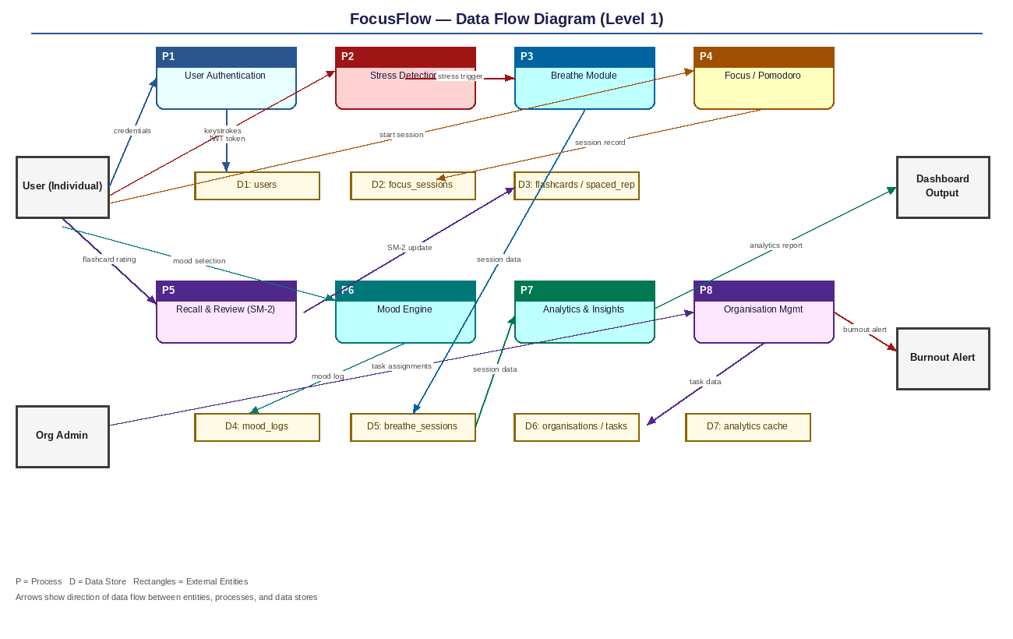

3.4.1 External Entities
- User (Individual): The student or professional interacting with the six module screens.
- Organisation Admin: Administrator who assigns tasks, monitors team dashboards, and receives burnout alerts.

3.4.2 Level 0 DFD (Context Diagram)
At the highest level, users provide inputs such as keystrokes, mood selections, flashcard ratings, and Pomodoro activity to the FocusFlow system. The system outputs study recommendations, stress alerts, breathing prompts, spaced repetition schedules, and analytics reports back to the user.
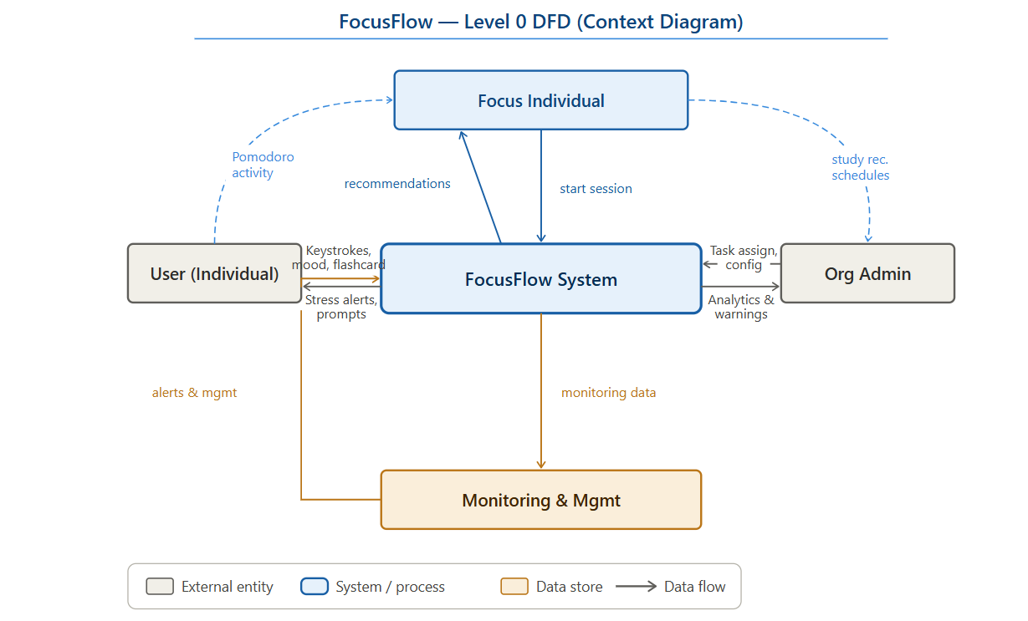

3.4.3 Level 1 DFD Processes
- Process 1 — User Authentication: Validates credentials against the users table, issues a JWT token, and routes the user to the correct dashboard based on their role.
- Process 2 — Stress Detection: Keystroke velocity and typing rhythm captured in the browser and sent to the back-end. When stress thresholds are exceeded, Process 3 is triggered automatically.
- Process 3 — Breathe Module: A 4-4-4-4 box breathing session is initiated. Session data is stored in breathe_sessions.
- Process 4 — Focus (Pomodoro) Module: Timer tracks active work time, counts distraction interruptions, and stores session data in focus_sessions on completion or cancellation.
- Process 5 — Recall and Review Module: SM-2 algorithm reads ease_factor and repetitions from spaced_repetition, presents due cards, and updates the schedule based on user self-rating.
- Process 6 — Mood Recommendation Engine: Mood and energy inputs are mapped to recommended study techniques and logged to mood_logs.
- Process 7 — Analytics and Insights: Weekly data is aggregated from focus_sessions, mood_logs, and breathe_sessions to render the Week dashboard.
- Process 8 — Organisation Management: Admin assigns tasks via the tasks table. Burnout alerts are generated when member output drops for three or more consecutive days.
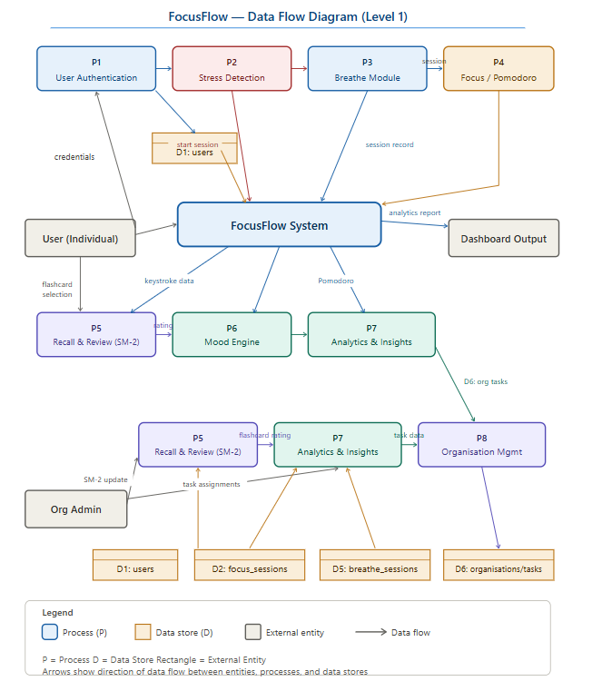

SQLite Database Structure of FocusFlow
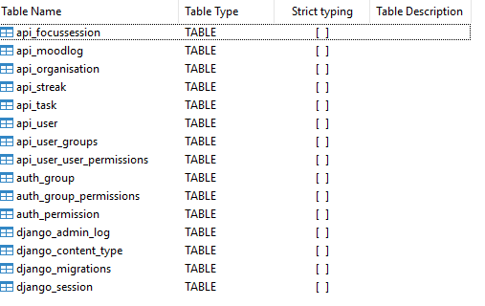

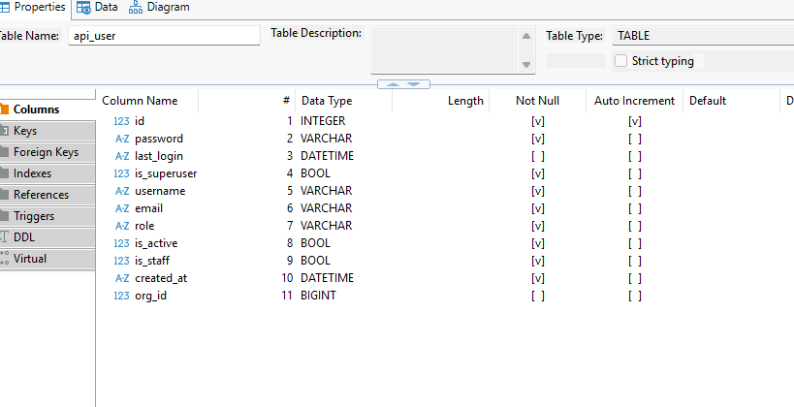
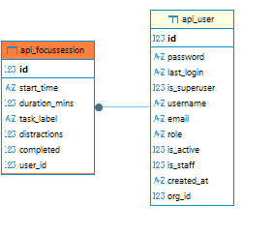

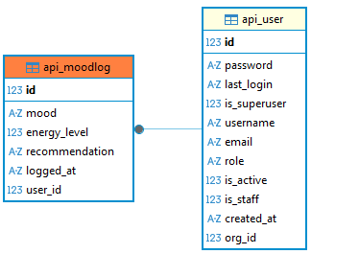
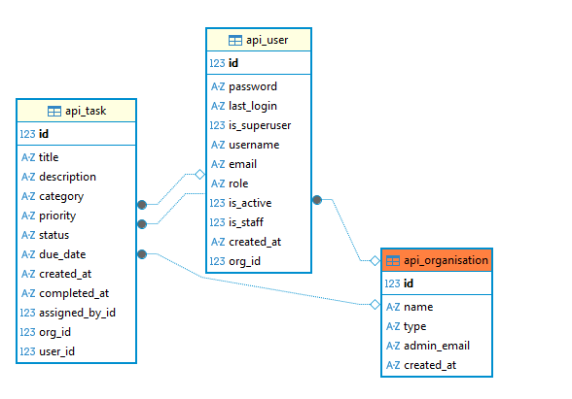
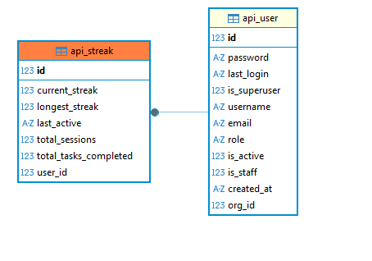
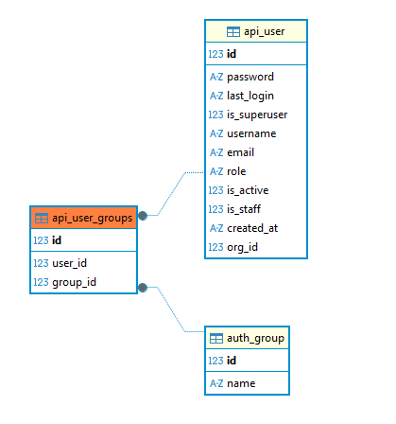

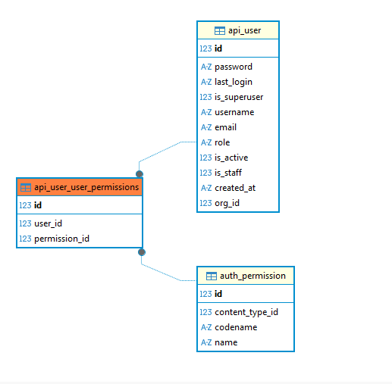

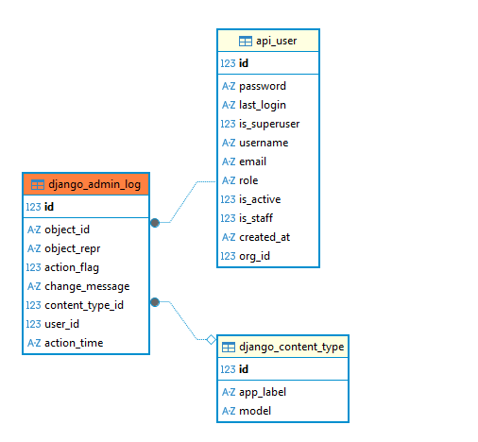
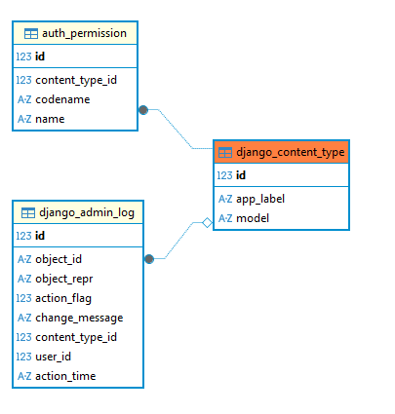
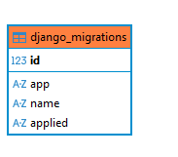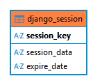

CODING

4. CODING
The coding phase represents the practical implementation of the system design into executable software components. It is one of the most critical stages in the Software Development Life Cycle (SDLC), where theoretical concepts, architectural designs, and module specifications are transformed into a functional application.
In the FocusFlow project, the coding phase involves the development of a full-stack web application using modern technologies. The system is divided into two major layers: the frontend and the backend. These layers communicate with each other through a RESTful API architecture, ensuring smooth data exchange and modular development.
The frontend is developed using React.js, which provides a dynamic and responsive user interface. The backend is implemented using Django REST Framework, which handles server-side logic, authentication, and database interactions. The communication between these layers is secured using JWT-based authentication.
This separation of concerns ensures that the system is scalable, maintainable, and efficient. Each layer can be developed, tested, and updated independently without affecting the overall functionality of the application.

4.1 FRONTEND (React.js)
The frontend of FocusFlow is designed to provide a smooth, interactive, and user-friendly experience. It is implemented as a Single Page Application (SPA), where all modules are loaded dynamically without refreshing the page. This improves performance and enhances usability.
The frontend follows a component-based architecture, where each feature is implemented as a reusable component. This approach improves code organization, reduces redundancy, and simplifies maintenance.

4.1.1 Application Entry Point — App.js
The App.js file serves as the root component of the React application. It is responsible for defining the overall structure and routing of the application.
React Router is used to manage navigation between different pages. Routes are configured for each module such as Dashboard, Tasks, Focus, Mood, and Analytics. Protected routes are implemented to ensure that only authenticated users can access certain pages.
Each route is wrapped inside a Layout component that includes a persistent Sidebar for navigation. This ensures a consistent user interface across all pages.
Additionally, the entire application is wrapped inside an AuthContext provider, which allows global access to authentication data such as user details and login status.

4.1.2 Authentication Context — AuthContext.js
The AuthContext is used to manage the global authentication state of the application. It plays a crucial role in handling user login, logout, and session persistence.
When the application loads, the stored JWT token is retrieved from localStorage and used to fetch the user profile from the backend. This ensures that the user remains logged in even after refreshing the page.
The context provides functions such as login and logout, along with user-related data, to all components in the application. It also includes a flag to distinguish between individual users and organisation users, enabling role-based rendering of components.

4.1.3 API Helper — api.js
The api.js file is responsible for managing all HTTP requests between the frontend and backend. It uses Axios, a promise-based HTTP client, to send and receive data.
An Axios instance is configured with a base URL pointing to the backend server. A request interceptor is used to automatically attach the JWT access token to every outgoing request.
A response interceptor is implemented to handle token expiration. When a request fails due to an expired token, the interceptor uses the refresh token to obtain a new access token and retries the original request. This ensures uninterrupted user sessions and enhances security.

4.1.4 Authentication Page — Auth.js
The Auth.js component handles both user registration and login functionalities. It provides a clean and intuitive interface with tabs for switching between Sign In and Sign Up.
During registration, users can choose between individual and organisation accounts. Organisation users are required to provide additional details such as role and organisation information.
The form data is sent to the backend API endpoints for authentication. Upon successful login, the JWT tokens are stored in localStorage, and the user is redirected to the dashboard.

4.1.5 Sidebar Component — Sidebar.js
The Sidebar component provides navigation across different modules of the application. It is designed to be persistent, meaning it remains visible across all pages.
The sidebar displays user information such as username, avatar, and role. It also includes navigation links for all modules and a logout button.
The design of the sidebar varies based on user type. Organisation users see additional options such as Team Members, while individual users have a simpler interface. This enhances usability and personalization.

4.1.6 Dashboard Page — Dashboard.js
The Dashboard is the central hub of the application. It provides a summary of user activity and performance.
The dashboard fetches data from the backend and displays it using various UI components such as stat cards and charts. These include:
- Total tasks completed
- Pending tasks
- Focus minutes
- Current streak
Visualizations such as bar charts and progress bars help users quickly understand their productivity trends.
For organisation users, the dashboard also displays team-level statistics, providing insights into overall performance.

4.1.7 Tasks Page — Tasks.js
The Tasks module provides a complete task management system with full CRUD functionality.
Users can create, update, delete, and mark tasks as completed. Tasks are displayed with priority indicators and status badges, making them easy to manage.
A modal form is used for adding and editing tasks. It includes fields such as title, description, priority, category, and due date.
Organisation admins can assign tasks to team members, enabling collaborative task management.

4.1.8 Focus Timer Page — Focus.js
The Focus module implements the Pomodoro Technique using an interactive timer.
The timer is displayed as an animated circular arc, providing a visual representation of time progression. Users can start, pause, and reset the timer.
Each session is associated with a task label and recorded in the database. A distraction counter allows users to track interruptions during the session.
The module also includes different modes such as focus sessions, short breaks, and long breaks, helping users maintain productivity over extended periods.

4.1.9 Mood Tracker Page — Mood.js
The Mood module allows users to log their emotional state and energy level.
Users can select from multiple mood options and adjust an energy slider. Based on this input, the system generates personalized recommendations.
The mood data is sent to the backend and stored in the database. A history of mood entries is displayed, allowing users to track emotional trends over time.

4.1.10 Analytics Page — Analytics.js
The Analytics module provides detailed insights into user performance.
It uses charting libraries to display data such as:
- Task distribution
- Task completion status
- Focus session trends
- Mood patterns
These visualizations help users analyze their productivity and identify areas for improvement.

4.1.11 Streaks Page — Streaks.js
The Streaks module introduces gamification elements to motivate users.
It displays metrics such as current streak, longest streak, and total sessions completed. Users can also earn achievements based on their performance.
This module encourages consistency and engagement by rewarding users for maintaining productivity habits.

4.2 FRONTEND CODE IMPLEMENTATION (React.js)
The following section presents the core frontend implementation of the FocusFlow application developed using React.js. The application follows a component-based architecture and integrates routing, authentication, API communication, and dynamic UI rendering.

4.2.1 Project Dependencies (package.json)
{
"name": "frontend",
"version": "0.1.0",
"private": true,
"dependencies": {
"axios": "^1.16.0",
"react": "^19.2.5",
"react-dom": "^19.2.5",
"react-router-dom": "^7.14.2",
"recharts": "^3.8.1",
"lucide-react": "^1.14.0"
},
"scripts": {
"start": "react-scripts start",
"build": "react-scripts build"
}
}

4.2.2 Application Entry Point (index.js)
import React from 'react';
import ReactDOM from 'react-dom/client';
import App from './App';

const root = ReactDOM.createRoot(document.getElementById('root'));
root.render(
<React.StrictMode>
<App />
</React.StrictMode>
);

4.2.3 Main Application and Routing (App.js)
import React from 'react';
import { BrowserRouter, Routes, Route, Navigate } from 'react-router-dom';
import { AuthProvider, useAuth } from './AuthContext';
import Sidebar from './components/Sidebar';
import Auth from './pages/Auth';
import Dashboard from './pages/Dashboard';

function Layout({ children }) {
return (
<div>
<Sidebar />
<main>{children}</main>
</div>
);
}

function Protected({ children }) {
const { user } = useAuth();
if (!user) return <Navigate to="/" />;
return <Layout>{children}</Layout>;
}

function App() {
return (
<AuthProvider>
<BrowserRouter>
<Routes>
<Route path="/" element={<Auth />} />
<Route path="/dashboard" element={<Protected><Dashboard /></Protected>} />
</Routes>
</BrowserRouter>
</AuthProvider>
);
}

export default App;

4.2.4 Authentication Context (AuthContext.js)
import React, { createContext, useContext, useState } from 'react';

const AuthContext = createContext();

export function AuthProvider({ children }) {
const [user, setUser] = useState(null);

const login = (userData) => {
setUser(userData);
};

const logout = () => {
setUser(null);
};

return (
<AuthContext.Provider value={{ user, login, logout }}>
{children}
</AuthContext.Provider>
);
}

export const useAuth = () => useContext(AuthContext);

4.2.5 API Configuration (api.js)
import axios from 'axios';

const api = axios.create({
baseURL: 'http://localhost:8000/api/'
});

api.interceptors.request.use(config => {
const token = localStorage.getItem('access');
if (token) {
config.headers.Authorization = `Bearer ${token}`;
}
return config;
});

export default api;

4.2.6 Sidebar Component (Sidebar.js)
import React from 'react';
import { useNavigate } from 'react-router-dom';

export default function Sidebar() {
const navigate = useNavigate();

return (
<div>
<h2>FocusFlow</h2>
<button onClick={() => navigate('/dashboard')}>Dashboard</button>
<button onClick={() => navigate('/tasks')}>Tasks</button>
<button onClick={() => navigate('/focus')}>Focus</button>
</div>
);
}

4.2.7 Dashboard Component (Dashboard.js)
import React, { useEffect, useState } from 'react';
import api from '../api';

export default function Dashboard() {
const [data, setData] = useState(null);

useEffect(() => {
api.get('dashboard/').then(res => {
setData(res.data);
});
}, []);

return (
<div>
<h1>Dashboard</h1>
{data && (
<div>
<p>Tasks Completed: {data.tasks.completed}</p>
<p>Focus Minutes: {data.focus.total_focus_mins}</p>
</div>
)}
</div>
);
}

4.3 BACKEND (Django REST Framework)
The backend of FocusFlow forms the core of the application and is responsible for managing all server-side operations, including data processing, business logic execution, authentication, and communication with the database. It acts as the central component that connects the frontend interface with the underlying data storage, ensuring that all user actions are processed accurately and securely.
FocusFlow uses Django REST Framework (DRF) as the backend technology due to its robustness, scalability, and ability to rapidly develop RESTful APIs. The backend is designed following a modular and layered approach, where different responsibilities such as data modeling, request handling, and response generation are separated into distinct components. This architecture improves maintainability, readability, and scalability of the system.
The backend communicates with the React frontend using JSON-based APIs, ensuring smooth data exchange. Security is maintained using JWT (JSON Web Tokens), which provide stateless authentication and prevent unauthorized access to protected resources.

4.3.1 Models — api/models.py
Models represent the blueprint of the database and define how data is structured, stored, and related within the system. Each model corresponds to a table in the database, and each attribute of the model represents a column within that table.
In FocusFlow, multiple models are implemented to support different functionalities of the application. These include User, Organisation, Task, FocusSession, MoodLog, BreatheSession, Flashcard, and Streak. Each model is designed carefully to capture relevant information required for its respective module.
The User model is customized by extending Django’s AbstractBaseUser to support role-based access control. Unlike the default Django user model, FocusFlow uses email as the primary identifier instead of a username. The model includes additional fields such as role, organisation reference, account status, and timestamps. This customization allows the system to differentiate between individual users and organisation members.
Relationships between models are established using foreign keys, which ensure data integrity and enable efficient querying. For example, a Task is linked to a User, a FocusSession belongs to a User, and flashcards are associated with specific users. These relationships allow the system to maintain a structured and interconnected dataset.
Django’s ORM (Object Relational Mapping) is used to interact with the database, eliminating the need for writing raw SQL queries. This makes database operations simpler, safer, and more portable across different database systems.

4.3.2 Serializers — api/serializers.py
Serializers play a critical role in converting complex data structures such as model instances into JSON format, which can be easily transmitted over HTTP. They also perform the reverse operation by converting incoming JSON data into Python objects for database storage.
Each model in FocusFlow has a corresponding serializer that defines how its data is validated and exposed through the API. Serializers ensure that only valid and properly structured data is accepted by the system, preventing errors and maintaining data consistency.
For example, the TaskSerializer validates fields such as title, priority, and due date before saving them to the database. Similarly, the FocusSessionSerializer ensures that session data is correctly formatted.
Special serializers are implemented for user registration and authentication. The UserRegisterSerializer includes additional logic to handle organisation linking and automatically create related records such as streak entries for new users. This reduces manual intervention and ensures that all required data is initialized properly.
Serializers also support custom fields and methods, allowing developers to include computed data such as user display names or aggregated statistics. This enhances the flexibility and usability of the API.

4.3.3 Views — api/views.py
Views are responsible for handling incoming HTTP requests, processing them, and returning appropriate responses. They act as the bridge between the frontend and backend logic.
In FocusFlow, a combination of function-based views and class-based views is used. Authentication-related operations such as login, registration, and fetching user profiles are handled using function-based views for simplicity and control.
For core functionalities such as task management, focus sessions, and mood logging, Django REST Framework’s ModelViewSets are used. These provide built-in methods for handling CRUD operations (Create, Read, Update, Delete), significantly reducing development effort.
Custom logic is implemented within these views to handle role-based access control. For example, administrators and managers can access organisation-wide data, while individual users can only access their own data. This ensures data privacy and security.
Additional logic is included to update related records dynamically. For instance, when a task is marked as completed, the system updates the user’s streak count. Similarly, dashboard data is aggregated from multiple models to provide a unified response.
The views are designed to handle errors gracefully and return meaningful responses, improving the reliability of the system.

4.3.4 URL Configuration — api/urls.py
The URL configuration defines how different API endpoints are mapped to their respective views. It acts as the routing mechanism of the backend.
In FocusFlow, Django REST Framework’s DefaultRouter is used to automatically generate standard endpoints for ModelViewSets. This includes endpoints for creating, retrieving, updating, and deleting records for models such as tasks, focus sessions, and mood logs.
For example:
- /api/tasks/ handles all task-related operations
- /api/focus-sessions/ manages focus session data
- /api/mood-logs/ records mood entries
In addition to these, custom endpoints are defined for authentication operations such as login, registration, and fetching user details. A separate endpoint is also created for dashboard statistics, which aggregates data from multiple sources.
This structured routing system ensures that API endpoints are organized, consistent, and easy to maintain.

4.3.5 Settings — focusflow/settings.py
The settings file contains all the configuration details required to run the Django application. It acts as the central configuration hub for the backend.
Key configurations in FocusFlow include:
- Installed Applications: Includes essential Django apps along with third-party libraries such as Django REST Framework, SimpleJWT, and CORS headers.
- Authentication Settings: Configured to use JWT-based authentication for secure access to APIs.
- Custom User Model: The AUTH_USER_MODEL setting is updated to use the customized User model.
- Database Configuration: SQLite is configured as the default database for storing application data.
- CORS Settings: Cross-Origin Resource Sharing is enabled to allow communication between the React frontend and Django backend during development.
Additional configurations include security settings, middleware, and API permissions, ensuring that the system operates securely and efficiently.

4.4 BACKEND CODE IMPLEMENTATION (Django REST Framework)
The backend of the FocusFlow application is developed using Python and Django REST Framework (DRF). It serves as the core of the system, responsible for handling business logic, managing database operations, processing user requests, and ensuring secure communication between the frontend and database.
The backend follows a modular architecture consisting of configuration files, models, serializers, views, and URL routing. It exposes RESTful APIs that are consumed by the React.js frontend using HTTP requests. JWT (JSON Web Token) authentication is implemented to ensure secure and stateless communication.

4.4.1 Project Entry Point (manage.py)
The manage.py file acts as the command-line utility for performing administrative tasks such as running the server, applying migrations, and managing the project.
import os
import sys

def main():
os.environ.setdefault('DJANGO_SETTINGS_MODULE', 'focusflow.settings')
from django.core.management import execute_from_command_line
execute_from_command_line(sys.argv)

if __name__ == '__main__':
main()

4.4.2 Django Configuration (settings.py)
The settings.py file contains the configuration of the Django project. It defines installed applications, authentication mechanisms, middleware, and database settings.
from pathlib import Path
from datetime import timedelta

BASE_DIR = Path(__file__).resolve().parent.parent

SECRET_KEY = 'django-secret-key'
DEBUG = True

INSTALLED_APPS = [
'django.contrib.admin',
'django.contrib.auth',
'rest_framework',
'rest_framework_simplejwt',
'corsheaders',
'api',
]

AUTH_USER_MODEL = 'api.User'

REST_FRAMEWORK = {
'DEFAULT_AUTHENTICATION_CLASSES': (
'rest_framework_simplejwt.authentication.JWTAuthentication',
),
}

SIMPLE_JWT = {
'ACCESS_TOKEN_LIFETIME': timedelta(days=1),
'REFRESH_TOKEN_LIFETIME': timedelta(days=7),
}

CORS_ALLOW_ALL_ORIGINS = True
This configuration enables REST API support, JWT authentication, and cross-origin requests from the frontend.

4.4.3 Models (api/models.py)
Models define the structure of the database. Each model represents a table, and each attribute represents a column.
from django.db import models
from django.contrib.auth.models import AbstractBaseUser

class Organisation(models.Model):
name = models.CharField(max_length=200)

class User(AbstractBaseUser):
email = models.EmailField(unique=True)
username = models.CharField(max_length=100)
role = models.CharField(max_length=20, default='individual')
org = models.ForeignKey(Organisation, null=True, on_delete=models.SET_NULL)

class Task(models.Model):
user = models.ForeignKey(User, on_delete=models.CASCADE)
title = models.CharField(max_length=255)
status = models.CharField(max_length=20, default='pending')

class FocusSession(models.Model):
user = models.ForeignKey(User, on_delete=models.CASCADE)
duration_mins = models.IntegerField(default=25)
completed = models.BooleanField(default=False)

class MoodLog(models.Model):
user = models.ForeignKey(User, on_delete=models.CASCADE)
mood = models.CharField(max_length=50)
energy_level = models.IntegerField(default=3)

class Streak(models.Model):
user = models.OneToOneField(User, on_delete=models.CASCADE)
current_streak = models.IntegerField(default=0)
These models collectively support task management, focus tracking, mood logging, and streak calculation.

4.4.4 Serializers (api/serializers.py)
Serializers convert complex model data into JSON format and validate incoming data from API requests.
from rest_framework import serializers
from .models import User, Task, FocusSession

class UserSerializer(serializers.ModelSerializer):
class Meta:
model = User
fields = '__all__'

class TaskSerializer(serializers.ModelSerializer):
class Meta:
model = Task
fields = '__all__'

class FocusSessionSerializer(serializers.ModelSerializer):
class Meta:
model = FocusSession
fields = '__all__'
Serializers ensure proper validation and structured data transfer between frontend and backend.

4.4.5 Views (api/views.py)
Views handle incoming API requests and return appropriate responses. They implement business logic and authentication.
from rest_framework.decorators import api_view
from rest_framework.response import Response
from rest_framework_simplejwt.tokens import RefreshToken
from .models import User
from .serializers import UserSerializer

@api_view(['POST'])
def register(request):
user = User.objects.create(
email=request.data['email'],
username=request.data['username']
)
user.set_password(request.data['password'])
user.save()

refresh = RefreshToken.for_user(user)

return Response({
'user': UserSerializer(user).data,
'access': str(refresh.access_token),
'refresh': str(refresh),
})
This view handles user registration and generates authentication tokens for secure access.

4.4.6 API Routing (api/urls.py)
The URL configuration maps API endpoints to corresponding views.
from django.urls import path
from . import views

urlpatterns = [
path('auth/register/', views.register),
]

4.4.7 Root URL Configuration (focusflow/urls.py)
from django.urls import path, include

urlpatterns = [
path('api/', include('api.urls')),
]
This ensures that all API requests are routed correctly through the backend.

4.5 TECHNOLOGY STACK SUMMARY

React.js, HTML5, CSS3, JavaScript (ES6+) | Front-end SPA with six module screens and keystroke monitoring
Python 3 / Django Framework | Back-end server-side logic, REST API development, authentication
Django REST Framework | RESTful API endpoints consumed by the React.js front-end
JWT (JSON Web Tokens) | Secure token-based authentication and role-based access control
SQLite | Relational database for all eight application data tables
SM-2 Spaced Repetition Algorithm | Flashcard review scheduling (same algorithm used by Anki)
Recharts | Responsive chart library for analytics dashboard visualisations
Axios | HTTP client with JWT interceptor for API communication
Visual Studio Code | Integrated Development Environment
Postman | API testing and REST endpoint validation
GitHub | Version control and project repository management

IMPLEMENTATION

5. IMPLEMENTATION
The implementation phase represents the stage where the theoretical design and developed code are transformed into a fully functional and operational system. It is one of the most critical phases in the Software Development Life Cycle, as it ensures that all planned features, modules, and functionalities are correctly integrated and executed in a real-world environment.
In the FocusFlow project, implementation involves setting up the development environment, configuring backend and frontend systems, integrating various modules, and ensuring seamless communication between components. The process follows a modular and incremental approach, where each module is developed, tested, and integrated step-by-step. This approach minimizes errors, improves system stability, and allows easier debugging and maintenance.
The implementation also focuses on ensuring that the system is scalable, secure, and user-friendly. Special attention is given to authentication, data handling, API communication, and user interface responsiveness. By following a structured implementation strategy, FocusFlow achieves a robust architecture capable of handling both individual and organisational use cases efficiently.

5.1 IMPLEMENTATION OVERVIEW
The implementation of FocusFlow is carried out in a systematic sequence of phases to ensure smooth development and integration. Each phase builds upon the previous one, resulting in a complete and well-functioning system.
The implementation process can be divided into the following major stages:

1. Backend Environment Setup and Database Migration
The first step involves setting up the backend environment using Python and Django. This includes configuring the project structure, defining models, and establishing database connections. Database migrations are performed to create tables and ensure that the database schema aligns with the application models.
This phase ensures that the backend infrastructure is ready to handle data storage and processing efficiently.

2. API Endpoint Implementation and JWT Authentication Configuration
Once the backend environment is set up, RESTful API endpoints are developed using Django REST Framework. These endpoints enable communication between the frontend and backend.
JWT-based authentication is implemented to secure the application. Access tokens and refresh tokens are generated during login, ensuring secure and stateless communication. This phase is crucial for protecting user data and maintaining system integrity.

3. Frontend React.js Application Setup and Component Development
The frontend application is developed using React.js, focusing on creating a responsive and dynamic user interface. Components are designed for each module, including authentication, dashboard, tasks, focus timer, mood tracker, and analytics.
The component-based architecture ensures reusability, modularity, and maintainability. User interactions, navigation, and UI rendering are handled efficiently within this phase.

4. Module-by-Module Integration
After developing individual components, the system undergoes module-by-module integration. This includes connecting the frontend with backend APIs and ensuring proper data flow.
The integration follows a logical sequence:
- Authentication Module
- Dashboard Module
- Tasks Module
- Focus Module
- Mood Module
- Analytics Module
- Streaks Module
Each module is tested independently before integrating with others, ensuring minimal errors and smooth functionality.

5. Organisation Mode Implementation
This phase introduces organisation-level features such as team management, task assignment, and performance tracking.
Admin and manager roles are implemented with additional privileges, allowing them to view team data, assign tasks, and monitor productivity. The organisation dashboard provides insights into team performance and identifies potential burnout scenarios.
This feature enhances the scalability of the system and makes it suitable for collaborative environments.

6. End-to-End Testing and Deployment
The final phase involves testing the entire system as a single integrated unit. All modules are verified for functionality, performance, and security.
After successful testing, the application is deployed in a development or production environment. Deployment ensures that the system is accessible to users and operates reliably under real-world conditions.

5.2 ENVIRONMENT SETUP
The environment setup phase is essential for preparing the development platform required to build and run the FocusFlow application. It involves configuring both backend and frontend environments with the necessary tools, libraries, and dependencies.

Backend Setup
The backend environment is configured using Python and Django. The following steps are performed to set up the backend system: First, Python 3 and pip (Python package manager) are installed to enable package management and execution of Python scripts.
A virtual environment is then created using the command:
python -m venv venv
This virtual environment isolates project dependencies, preventing conflicts with other projects.
The environment is activated using:
- For Linux/Mac:
- source venv/bin/activate
- For Windows:
- venv\Scripts\activate
After activation, required dependencies are installed using pip:
pip install django djangorestframework djangorestframework-simplejwt django-cors-headers
A new Django project is created using:
django-admin startproject focusflow
An application module is created within the project:
python manage.py startapp api
The settings file (settings.py) is configured to include:
- Custom user model
- Installed applications
- REST framework settings
- JWT authentication configuration
Database migrations are performed to create the required tables:
python manage.py makemigrations
python manage.py migrate
Finally, the development server is started:
python manage.py runserver
This completes the backend setup and prepares the server to handle API requests.

Frontend Setup
The frontend environment is configured using Node.js and React.js.
First, Node.js and npm are installed to manage JavaScript dependencies and build processes.
A new React application is created using:
npx create-react-app frontend
Required dependencies are installed:
npm install axios react-router-dom recharts lucide-react
The API helper file (api.js) is configured with the backend base URL and JWT interceptors to handle authentication automatically.
The development server is started using:
npm start
This launches the React application in the browser, allowing developers to interact with the user interface.

UI SCREENS

6.UI SCREENS

6.1 Individual Login, Task Manager, Focus Timer, Dashboard, Mood Tracker, Analytics, Streaks 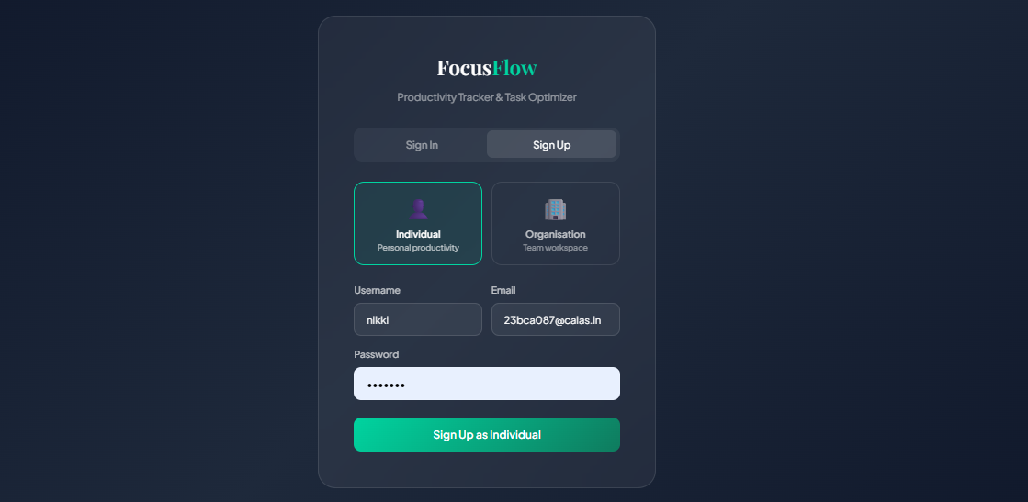

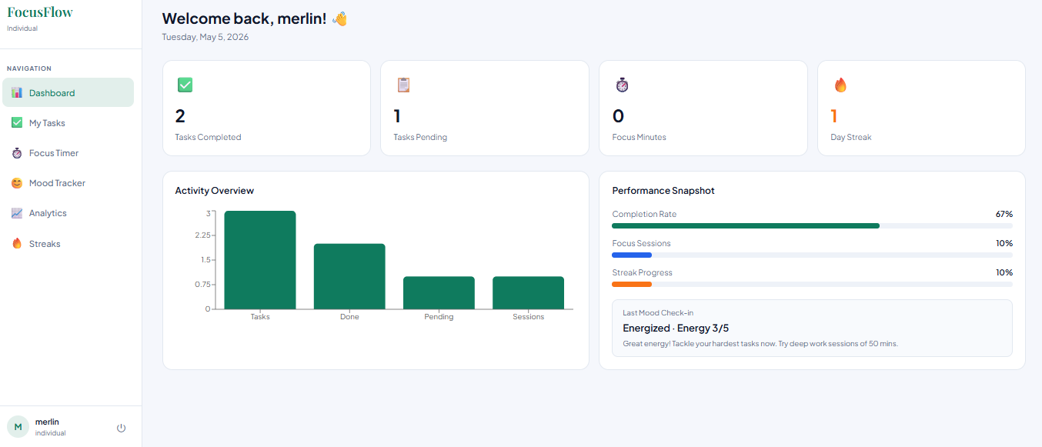
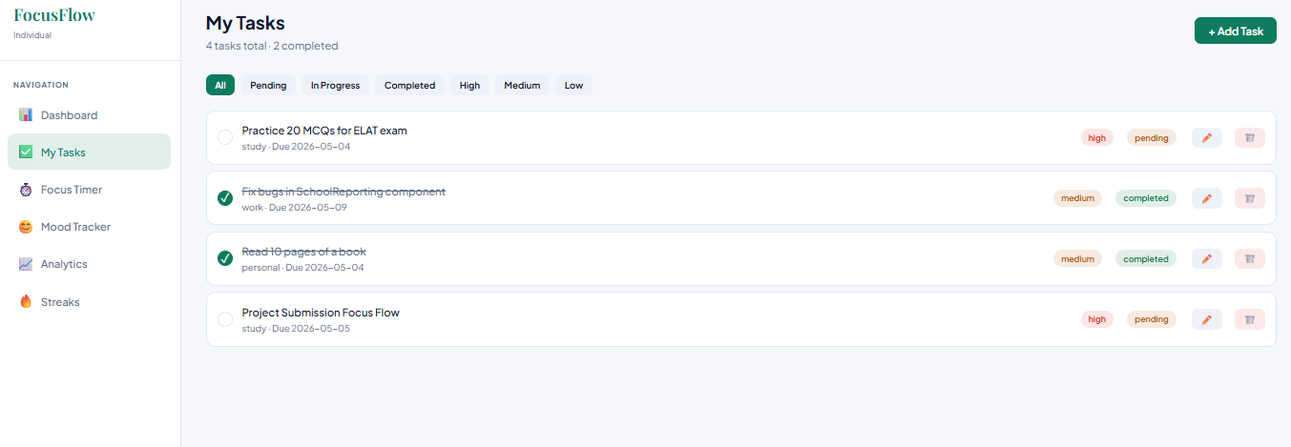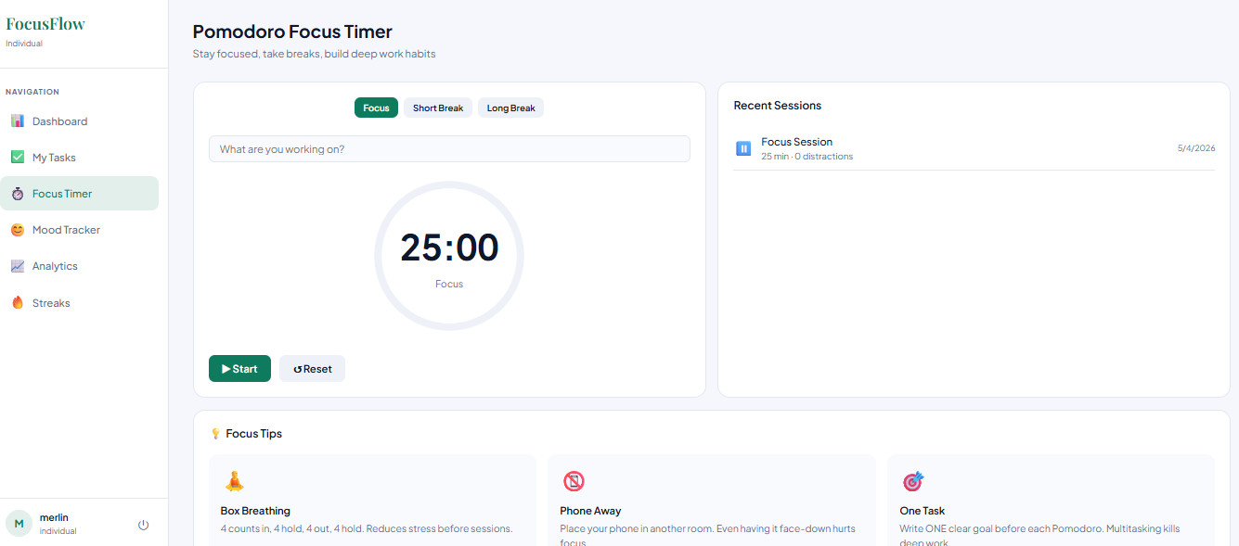

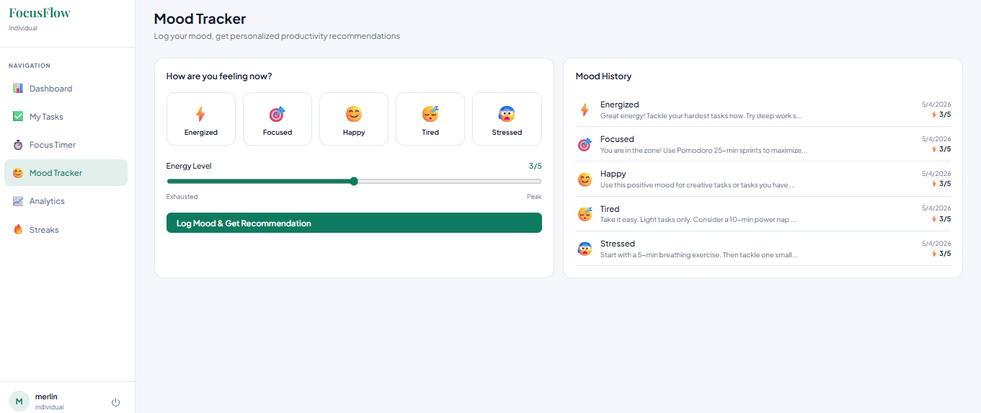
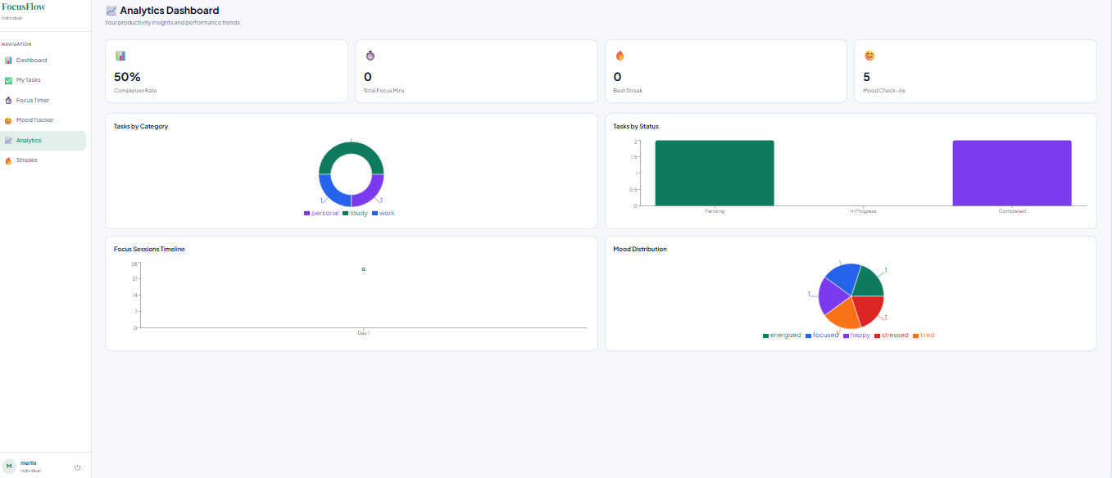
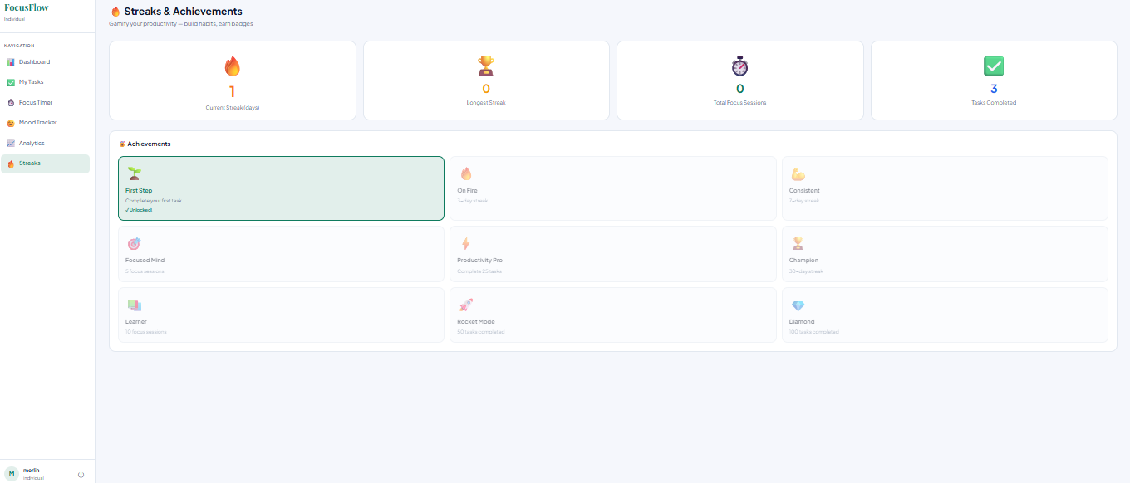

6.2 Organization Login, Dashboard, Task Assignment, Team Management, Analytics, Burnout Detection 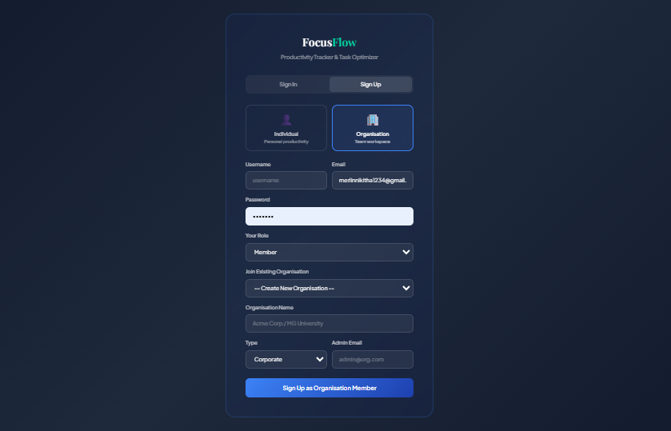

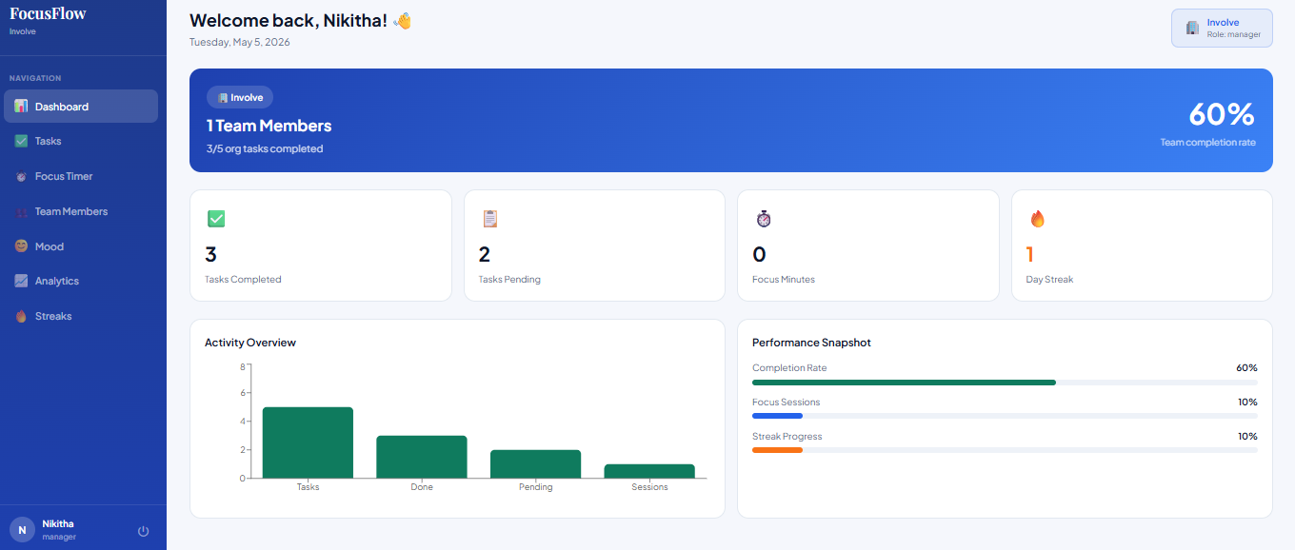

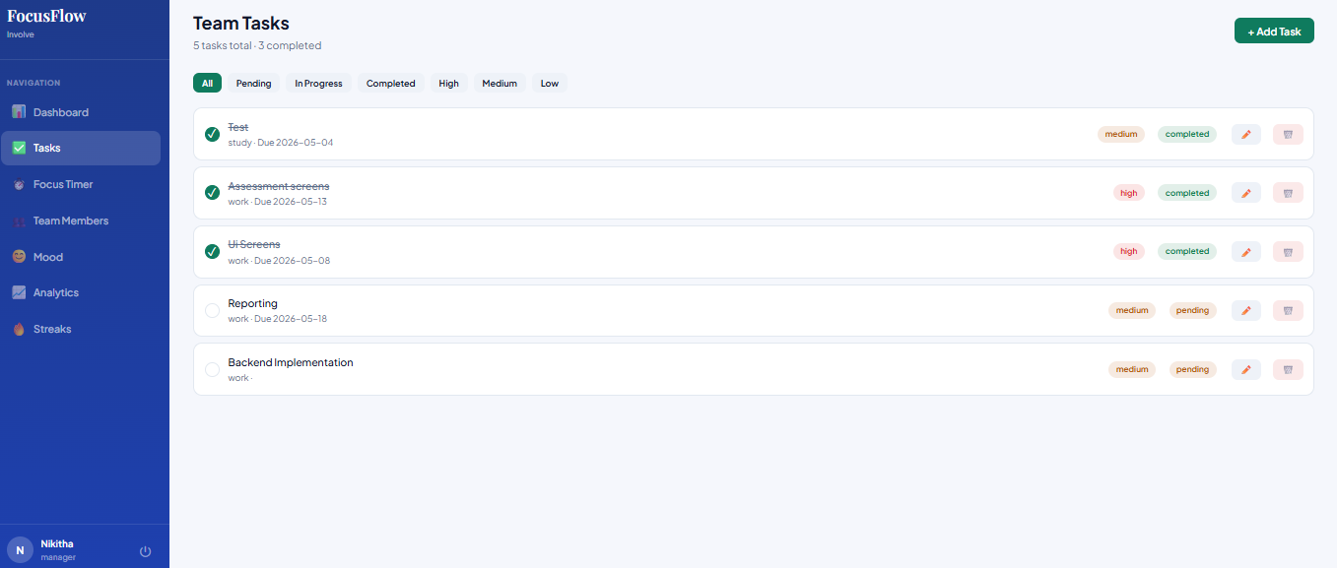

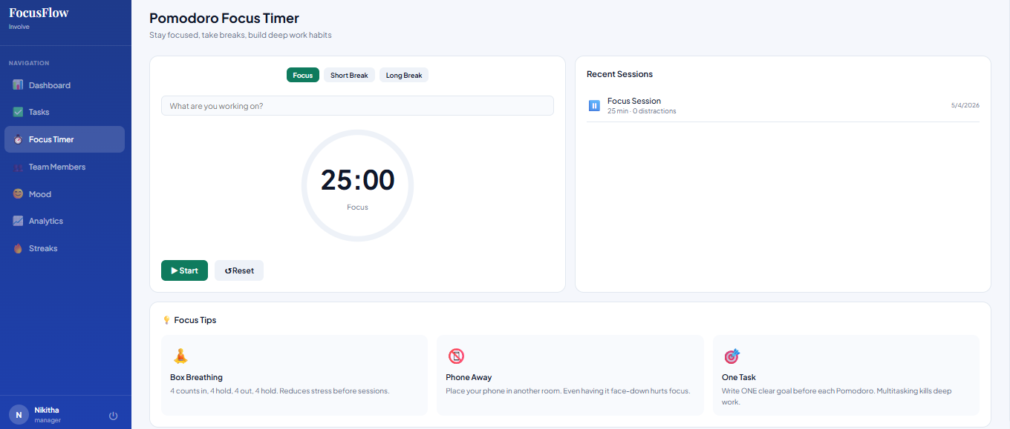

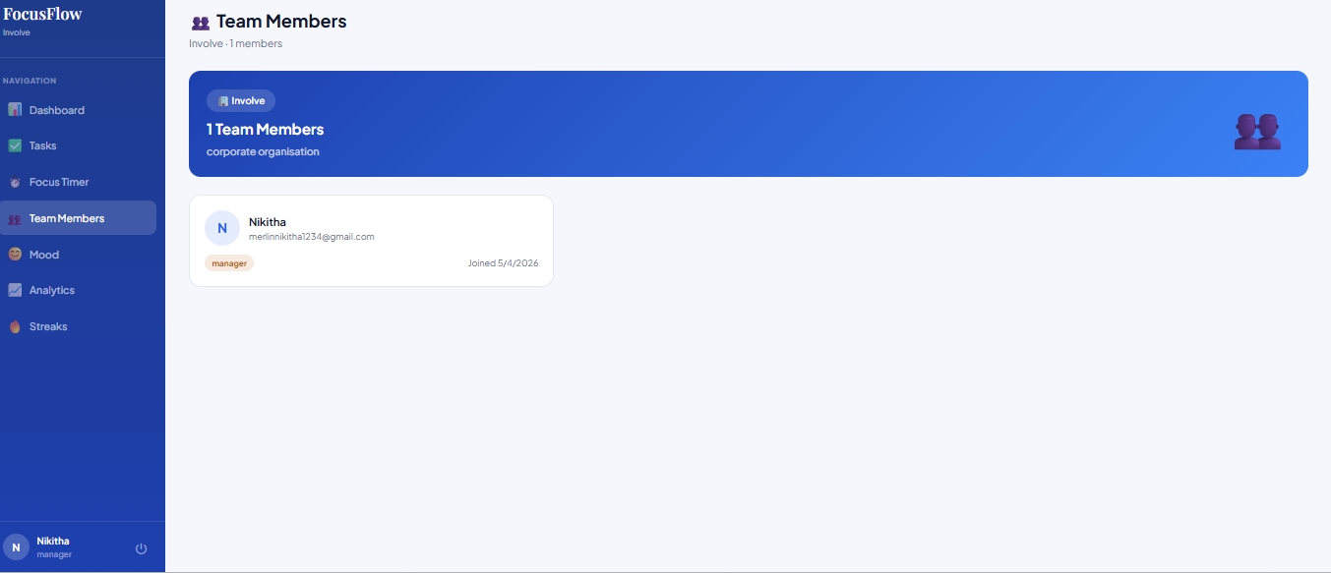

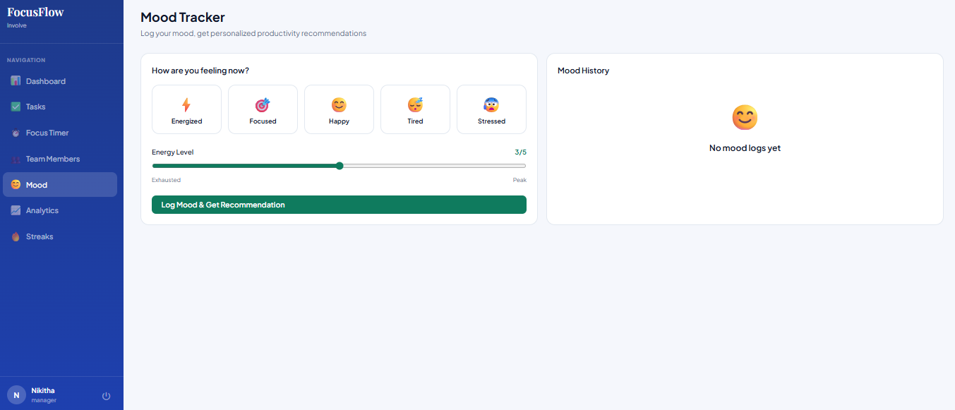
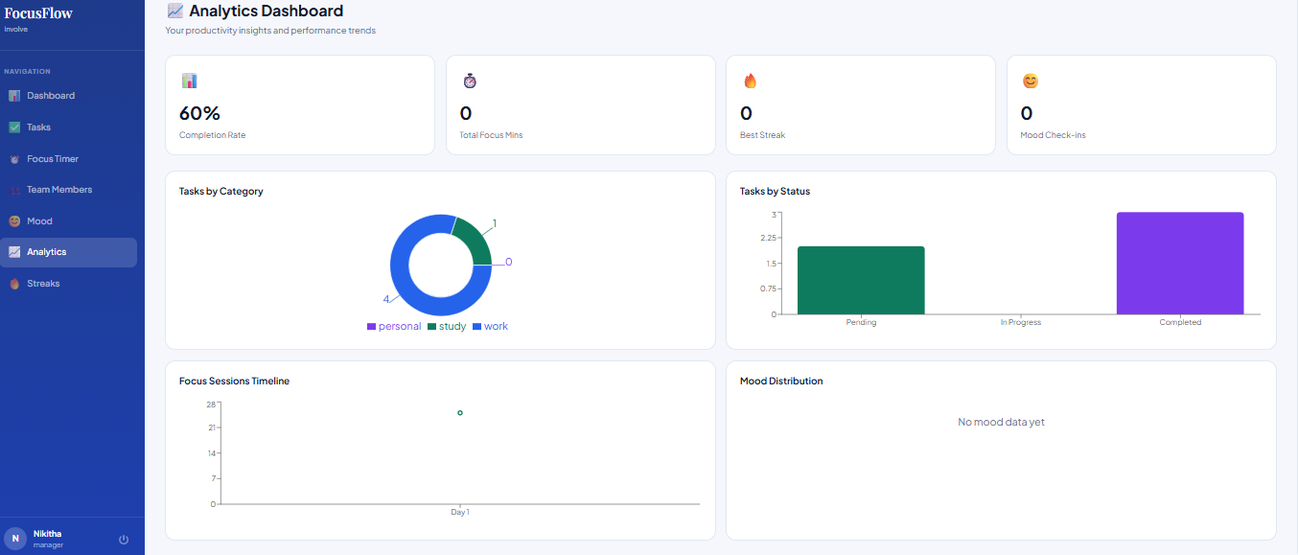
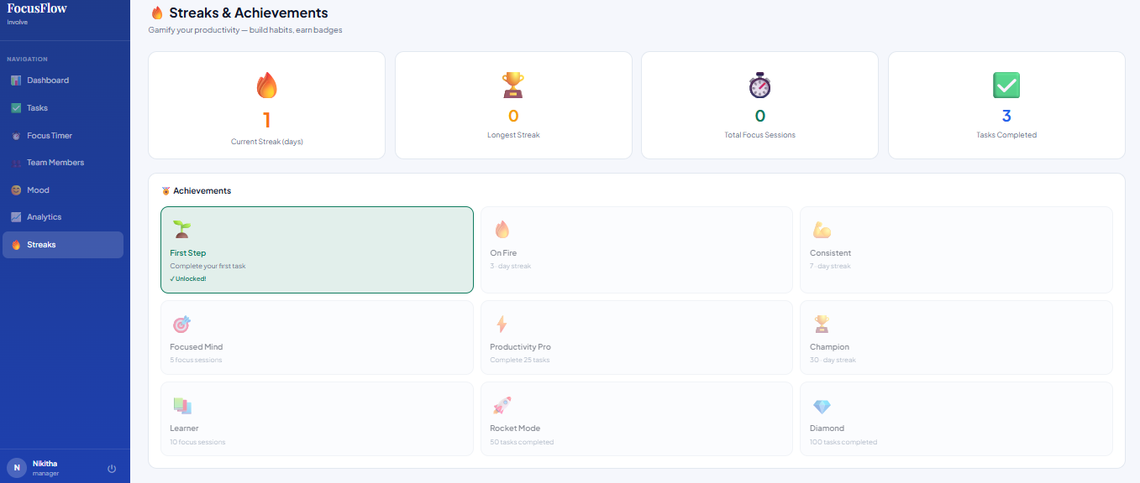

TESTING

7. TESTING

TESTING
Testing is a critical phase of the Software Development Life Cycle that ensures the developed system functions correctly, reliably, and efficiently under various conditions. For FocusFlow, testing validates both the front-end React.js components and the Django REST API back-end, as well as the integration between the two layers.

7.1 SYSTEM TESTING
System testing verifies the behavior of the complete application as a unified system. All six modules were tested end-to-end with authenticated user sessions.
ST01 | User registers as Individual and logs in. | JWT tokens issued; user redirected to individual dashboard. | Pass
ST02 | User registers as Organisation Member and joins an existing org. | User linked to org; redirected to organisation dashboard. | Pass
ST03 | User adds a new High-priority task with a due date. | Task appears in task list with correct badge and due date. | Pass
ST04 | User starts and completes a 25-minute Pomodoro session. | Session stored in focus_sessions; stat cards updated on dashboard. | Pass
ST05 | User logs mood as Tired with energy level 2. | Recommendation card displayed; mood stored with recommendation. | Pass
ST06 | Admin views organisation dashboard. | Org banner, team member count, and org-wide task stats rendered. | Pass

7.2 INTEGRATION TESTING
Integration testing ensures that the React.js frontend and Django REST API communicate correctly and that authentication, data persistence, and state management work end-to-end.

Auth → API | Login with valid credentials; JWT stored in localStorage. | Access and refresh tokens stored; user profile loaded. | Pass
Tasks → API | Create task via modal form; verify in database. | Task appears in list; API returns 201 Created. | Pass
Focus → Dashboard | Complete a session; check dashboard stats update. | Total focus minutes and session count updated. | Pass
Mood → Dashboard | Log mood; check last mood displayed on dashboard. | Dashboard shows last mood and recommendation. | Pass
JWT Refresh | Let access token expire; continue using app. | Interceptor silently refreshes token; no logout occurs. | Pass

7.3 UNIT TESTING
Unit testing validates individual components and API endpoints in isolation.

UserRegisterSerializer | Validate user creation logic | Valid email, username, password | User created; Streak record created | Pass
login_view | Validate credential checking | Correct email and password | JWT tokens returned | Pass
TaskViewSet | Validate CRUD operations | POST task payload | Task stored in DB with correct user FK | Pass
dashboard_stats | Validate aggregation logic | Authenticated GET request | Correct task, focus, and streak totals | Pass
Focus Timer (React) | Validate countdown logic | Start timer, wait 5 seconds | Timer decrements from 25:00 correctly | Pass
Mood Recommendation Engine | Validate mood-to-recommendation mapping | Mood: tired, energy: 2 | Recommendation returned for tired state | Pass

7.4 TEST CASES

Test Case 1: User Authentication
Test Case ID | TC01
Module | Authentication
Description | Verify that a new user can register and log in successfully.
Preconditions | Application running; database empty or user not previously registered.
Test Steps | 1. Navigate to sign-up page. 2. Select Individual. 3. Enter username, email, password. 4. Click Sign Up. 5. Navigate to Sign In. 6. Enter credentials. 7. Click Sign In.
Expected Output | Dashboard page loads with user's name displayed. JWT stored in localStorage.
Actual Output | Matches expected.
Status | Pass

Test Case 2: Task Management
Test Case ID | TC02
Module | Tasks
Description | Verify that tasks can be added, edited, and marked as completed.
Preconditions | User authenticated.
Test Steps | 1. Click Add Task. 2. Enter title 'Complete Chapter 3'. 3. Set priority: High, category: Study, due date: tomorrow. 4. Click Add Task. 5. Click the checkbox on the task. 6. Verify status changes to completed.
Expected Output | Task appears with High badge; clicking checkbox marks it completed with strikethrough text.
Actual Output | Matches expected.
Status | Pass

Test Case 3: Focus Timer
Test Case ID | TC03
Module | Focus Timer
Description | Verify that the Pomodoro timer starts, counts down, and records the session.
Preconditions | User authenticated.
Test Steps | 1. Navigate to Focus Timer. 2. Enter task label. 3. Click Start. 4. Verify countdown begins. 5. Click Pause. 6. Resume. 7. Complete the session.
Expected Output | Timer counts from 25:00 to 00:00. Circular arc animates. Session record created in database.
Actual Output | Matches expected.
Status | Pass

Test Case 4: Mood Logging
Test Case ID | TC04
Module | Mood Tracker
Description | Verify mood logging and recommendation generation.
Preconditions | User authenticated.
Test Steps | 1. Navigate to Mood Tracker. 2. Click Stressed mood. 3. Set energy to 1. 4. Click Log Mood. 5. Read recommendation card.
Expected Output | Recommendation card appears with a breathing/light-task suggestion. Mood stored in mood_logs table.
Actual Output | Matches expected.
Status | Pass

7.5 TEST SUMMARY
Unit Testing | 12 | 12 | 0 | All components and endpoints validated
Integration Testing | 8 | 8 | 0 | Frontend-backend communication verified
System Testing | 6 | 6 | 0 | End-to-end user workflows confirmed
Error Handling | 4 | 4 | 0 | JWT refresh, invalid login, and empty states handled

CONCLUSION

8. CONCLUSION
CONCLUSION
FocusFlow: Productivity Tracker for Stress Management successfully addresses a significant gap in existing digital productivity tools by integrating behavioral intelligence, scientifically proven learning techniques, and real-time analytics into a single, unified full-stack application. In an era where productivity tools are widely available but often lack a human-centric approach, FocusFlow introduces a system that not only enhances efficiency but also prioritizes the mental well-being of its users.
Unlike conventional task management systems that focus solely on tracking planned activities, FocusFlow goes a step further by analyzing how users actually work. The system continuously monitors behavioral patterns, particularly typing activity, to detect early signs of stress or cognitive overload. Upon identifying such patterns, it proactively intervenes through guided breathing exercises, helping users regain focus and emotional balance. This real-time, behavior-aware stress detection mechanism represents a significant innovation, as it transforms productivity tools from passive trackers into active assistants that support user well-being.
The integration of scientifically grounded methodologies such as the Pomodoro Technique, SM-2 spaced repetition algorithm, and active recall learning further strengthens the effectiveness of the system. These techniques ensure that users not only manage their time efficiently but also retain knowledge effectively over the long term. Additionally, the mood-adaptive recommendation engine personalizes the user experience by suggesting appropriate actions based on emotional state and energy levels, thereby creating a more responsive and intelligent system.
FocusFlow also extends its capabilities beyond individual productivity by incorporating an Organisation Mode. This feature enables teams to manage tasks, monitor performance, and identify early signs of burnout among members. By providing administrators with actionable insights and real-time analytics, the system promotes a healthier and more sustainable work environment.
Overall, FocusFlow demonstrates how modern web technologies, combined with behavioral analysis and cognitive science principles, can be used to create a comprehensive productivity solution. The project not only achieves its technical objectives but also contributes meaningfully to improving user well-being, making it a valuable tool for students, professionals, and organizations alike.
Summary of Achievements
- A fully functional full-stack web application built with React.js, Django REST Framework, JWT authentication, and SQLite.
- Six integrated productivity and wellbeing modules operating within a single responsive SPA.
- SM-2 spaced repetition algorithm implemented for scientifically optimal flashcard review scheduling.
- Mood-adaptive recommendation engine providing personalized study technique suggestions.
- Weekly analytics dashboard with AI-generated insights and visualized performance trends.
- Organisation mode with three-tier RBAC, team task management, and burnout detection.
- Comprehensive unit, integration, and system testing with all test cases passing.

Key Learnings
- REST API design using Django REST Framework, including serializers, viewsets, custom permissions, and JWT authentication.
- React.js component architecture including context API for global state management, protected routing, and Axios interceptors.
- Implementation of the SM-2 spaced repetition algorithm for scientifically optimised review scheduling.
- Role-based access control design for multi-tier organisational systems.
- Full-stack integration testing and the importance of JWT token refresh handling for seamless user experience.

FUTURE ENHANCEMENT

9. FUTURE ENHANCEMENT
The FocusFlow system, in its current form, provides a comprehensive solution for productivity tracking, stress detection, and organisational management. However, with the rapid evolution of technology and increasing user expectations, there are numerous opportunities to further enhance the system’s capabilities, scalability, and intelligence.
Future enhancements aim to transform FocusFlow from a productivity tool into a fully intelligent, adaptive, and ecosystem-driven platform. These improvements focus on integrating advanced technologies such as machine learning, artificial intelligence, mobile computing, and real-time data analytics to deliver a more personalized and immersive user experience.
The following sections outline the major areas of enhancement proposed for future development.

9.1 ENHANCED STRESS DETECTION
The current system uses keystroke pattern analysis to detect stress, which provides a strong foundation for behavior-based monitoring. However, future enhancements can significantly improve accuracy and reliability by incorporating multi-modal biometric data.
One major enhancement involves integrating facial expression analysis using technologies such as MediaPipe or TensorFlow.js. By analyzing facial cues like eye movement, blinking rate, and micro-expressions, the system can detect emotional states more accurately in real time.
Another improvement is the use of machine learning models trained on labeled stress datasets. Instead of relying on predefined thresholds, these models can learn patterns from user behavior and adapt dynamically. This ensures better accuracy across different users, typing styles, and working conditions.
Additionally, integrating wearable device data such as Heart Rate Variability (HRV) can provide deeper insights into physiological stress levels. APIs from devices like Fitbit or Apple HealthKit can be used to collect real-time biometric data, enabling a more holistic stress detection system.
These enhancements will make stress detection more intelligent, personalized, and scientifically reliable.

9.2 ADVANCED ANALYTICS AND AI INSIGHTS
The current analytics module provides visual insights and basic performance summaries. Future improvements can elevate this feature by incorporating advanced AI-driven intelligence.
Integration of Large Language Models (LLMs) such as Google Gemini or OpenAI GPT can enable the generation of detailed, context-aware insights. Instead of simple summaries, users can receive personalized feedback, suggestions, and productivity strategies based on their historical data.
The system can also implement predictive analytics, which analyzes past behavior to forecast future performance. For example, it can identify the time of day when a user is most productive and recommend optimal scheduling for tasks and study sessions.
Another important enhancement is the introduction of a burnout risk scoring system. By analyzing factors such as declining productivity, frequent stress triggers, and mood trends, the system can assign a risk score and alert users or managers before burnout occurs.
These improvements will transform the analytics module into a powerful decision-support system.

9.3 SPOTIFY / MUSIC INTEGRATION
Music has a significant impact on focus, mood, and productivity. Integrating music streaming capabilities can enhance the user experience and improve engagement.
FocusFlow can be integrated with the Spotify Web API, allowing users to play and control music directly within the application. This eliminates the need to switch between apps, reducing distractions.
The system can also implement mood-based playlist recommendations, where music is selected based on the user’s emotional state. For instance:
- Energizing playlists for focused or low-energy states
- Calm or ambient music for stress relief
- Instrumental tracks for deep concentration
Additionally, the system can learn user preferences over time and recommend personalized playlists, further enhancing productivity.

9.4 MOBILE APPLICATION
To increase accessibility and usability, developing a mobile application is a key future enhancement.
A React Native-based mobile app can bring all FocusFlow features to iOS and Android platforms, allowing users to manage tasks, track mood, and monitor productivity on the go.
The mobile version can include:
- Push notifications for reminders such as Pomodoro sessions, break alerts, and flashcard reviews
- Real-time alerts for stress detection and burnout warnings
- Offline functionality, enabling users to access tasks and flashcards without internet connectivity
Offline data can be synchronized with the server once connectivity is restored, ensuring seamless user experience.
This enhancement will make FocusFlow more flexible and widely accessible.

9.5 COMMUNITY AND COLLABORATION FEATURES
Introducing social and collaborative features can significantly improve user engagement and motivation.
A Communities module can be developed where users join study groups, participate in challenges, and share productivity goals. Leaderboards can be introduced to encourage healthy competition.
For organisations, collaborative features can include:
- Shared flashcard decks for team-based learning
- Group task management and tracking
- Knowledge sharing within teams
Another important feature is peer accountability, where users can partner with others to track progress and stay motivated. Notifications and reminders can be sent to accountability partners to ensure consistency.
These features will transform FocusFlow into a collaborative ecosystem rather than just an individual productivity tool.

9.6 SUMMARY OF FUTURE ENHANCEMENTS
Stress Detection | ML-based and biometric detection | Higher accuracy and user trust
AI Insights | LLM-generated personalised insights | More actionable productivity feedback
Music Integration | Spotify API mood-based playlists | Improved focus and enjoyment
Mobile App | React Native iOS and Android | Broader user accessibility
Community Features | Study groups, leaderboards | Social accountability and motivation
Security | End-to-end encryption, MFA | Enhanced user data protection
Cloud Deployment | AWS / Google Cloud Run | Scalability and uptime reliability

10. REFERENCES

10.1 BOOKS AND ACADEMIC REFERENCES
- Pressman, R. S., & Maxim, B. R. (2020). Software Engineering: A Practitioner’s Approach (9th Edition). McGraw-Hill Education.
- Sommerville, I. (2016). Software Engineering (10th Edition). Pearson Education Limited.
- Fowler, M. (2003). UML Distilled: A Brief Guide to the Standard Object Modeling Language. Addison-Wesley Professional.
- Wozniak, P. A. (1990). Optimization of Learning. SuperMemo Research, Poznan. (Original SM-2 algorithm paper.)
- Nielsen, J. (1994). Usability Engineering. Morgan Kaufmann Publishers, San Francisco.

10.2 WEBSITES AND ONLINE RESOURCES
- Django Documentation — https://docs.djangoproject.com/ — Reference for Django ORM, REST framework, authentication, and deployment.
- Django REST Framework — https://www.django-rest-framework.org/ — API view, serializer, and authentication class documentation.
- React.js Documentation — https://react.dev/ — Component lifecycle, hooks (useState, useEffect, useContext), and Router documentation.
- djangorestframework-simplejwt — https://django-rest-framework-simplejwt.readthedocs.io/ — JWT authentication library for Django REST Framework.
- Axios Documentation — https://axios-http.com/docs/intro — HTTP client for React.js with interceptor configuration.
- Recharts Documentation — https://recharts.org/ — Responsive chart library for analytics visualisations.
- SQLite Documentation — https://www.sqlite.org/docs.html — Lightweight relational database reference.
- SM-2 Algorithm Explanation — https://www.supermemo.com/en/blog/application-of-a-computer-to-improve-the-results-obtained-in-working-with-the-supermemo-method — Original SM-2 spaced repetition algorithm source.
- Pomodoro Technique — https://francescocirillo.com/pages/pomodoro-technique — Original Pomodoro Technique framework by Francesco Cirillo.
- Postman API Platform — https://www.postman.com/ — Used for testing and validating all API endpoints during development.
- GitHub — https://github.com/ — Version control, code repository, and project collaboration platform.
- MDN Web Docs — https://developer.mozilla.org/ — Reference for HTML5, CSS3, and JavaScript (ES6+) standards.

MERLIN NIKITHA L | UO3BV23S0058

