*Steps to create ARFF file*

* Fill the details in a notepad and save it with .arff extension .
* Open the weka file now.
* Select the attributes and notice the values and bar chart.
* Below is the sample data.

@ relation student_data

@attribute rollno numeric

@attribute name string

@attribute sec string

@attibute dept{cse,ece,it,eee}

@attribute ph number numeric

@attribute examstatus{pass,fail}

@attribute age numeric

@data

502,nikitha,a,cse,736955442,pass,20

504,radha,b,ece,8025865478,fail,21

509,rani,c,eee,9633693690,fail,19

507,anitha,d,it,7411471471,pass,24

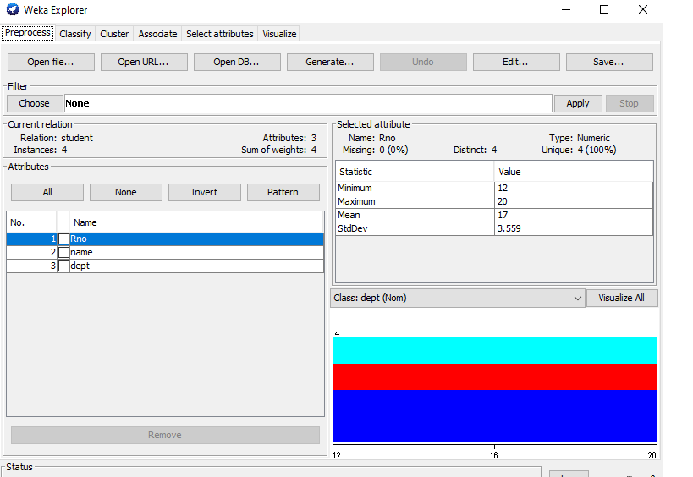

* Now select visualize all button. After visualizing it shows the piechart of all the attributes.

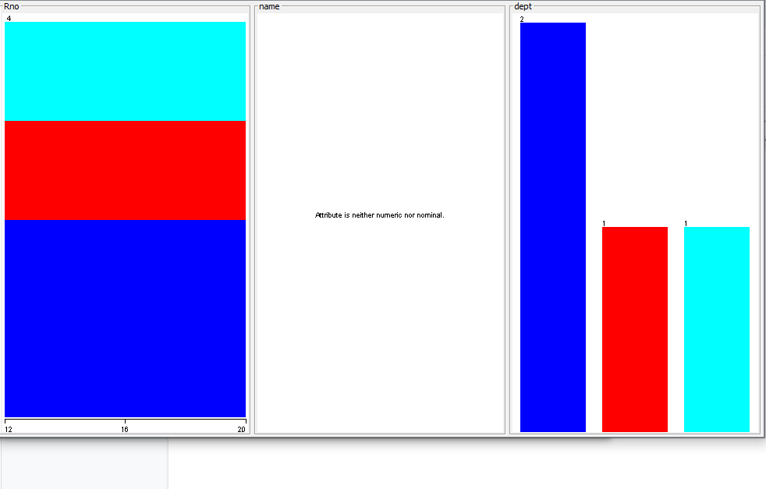

* The histogram chart is shown above.