**GIT HANDSON-2**

**Checkout my Gitlab:** [**https://gitlab.com/nikithapotluri/GitDemo/-/tree/master?ref_type=heads**](https://gitlab.com/nikithapotluri/GitDemo/-/tree/master?ref_type=heads)

**.gitignore** is a special file in a Git repository that tells Git *which files or folders it should ignore*.

This means **Git will not track** these ignored files, and they will not show up in git status, nor will they be added in commits.

**How to ignore unwanted files step by step**

Create a file named .gitignore in your project root: touch .gitignore

Open the file in your editor: notepad++ .gitignore

Add the patterns you want to ignore, for example:

*.log

*.tmp

backup/

Save and close the file.

Confirm what is being ignored: git status

Any files matching .gitignore will no longer show up as untracked.

**Step 1:** Open Git Bash and Navigate to Your Repo

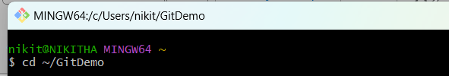

**Step 2:** Create a Sample .log File and a log/ Folder

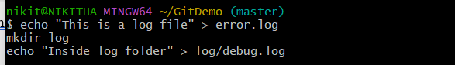

**Step 3:** Confirm Files Are Untracked by Git

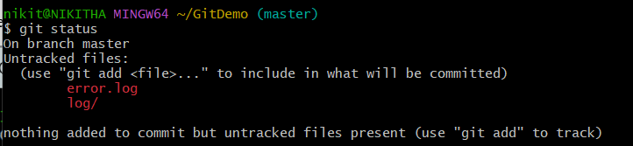

**Step 4:** Create a .gitignore File



**Step 5:** Edit .gitignore File to Ignore .log Files and log/ Folder

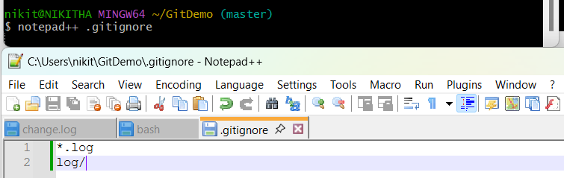

**Step 6:** Confirm Git Is Ignoring Those Files

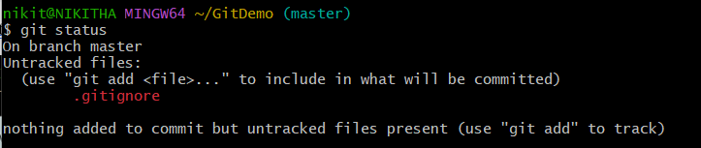

**Step 7:** Track and Commit .gitignore

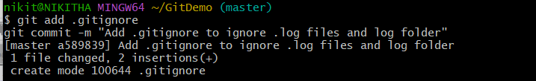

**Step 8**: Push to GitLab

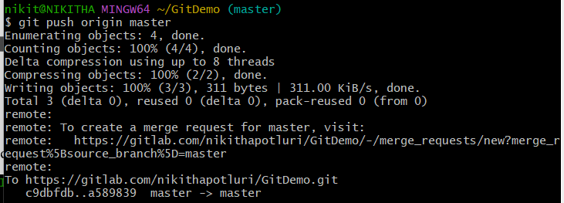  
  
**Step 9:** Verification

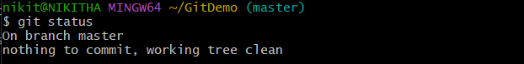

**Final “GitDemo” Repository:**  
