**GIT HANDSON-4**

**Checkout my Gitlab:** [**https://gitlab.com/nikithapotluri/GitDemo/-/tree/master?ref_type=heads**](https://gitlab.com/nikithapotluri/GitDemo/-/tree/master?ref_type=heads)

**How to resolve conflicts during a merge**

Step one: Merge

Step two: Identify the files having merge conflicts

Step three: Open the conflicted file

Step four: Edit the file to fix it.

Step five: Add the fixed

Step six: Complete the merge.

Step seven: Push the result to the end.

**LAB HANDSON:**

Verify if master is in clean state



Create a new branch GitWork and switch to it

  
  
Add a file hello.xml with some content



Check status and commit the change

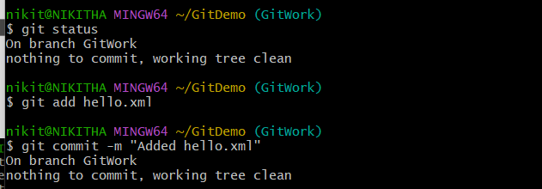

Switch to master

  
  
Add a different hello.xml in master  
  
  
Commit the file in master  
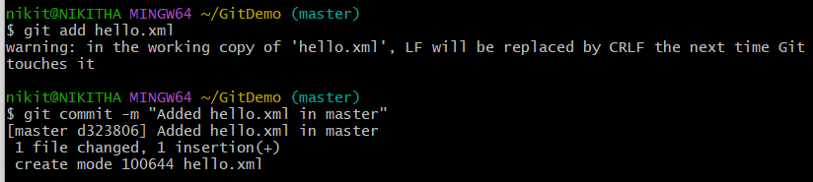  
  
View logs with graph

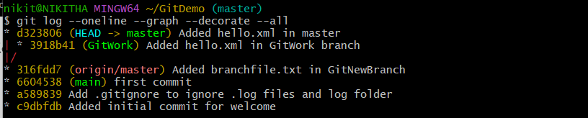  
  
Check the differences between master and GitWork

  
  
Visual difference



Merge GitWork branch into master  
  
  
Stage and commit the resolved file

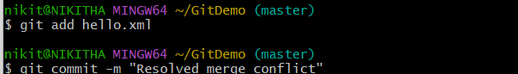  
  
Add backup merge file to .gitignore

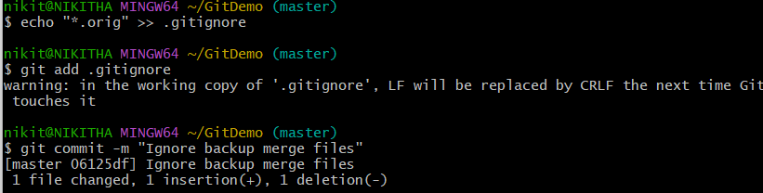  
  
List all branches

  
  
Delete the GitWork branch



Final log graph

