**SOFTWARE ENGINEERING**

Project Plan Document for Admin Portal

Student Name : NIKITHA REDDY PASSYA

Student Id : 999900435

**TABLE OF CONTENTS** **APPENDICES**

Project scope 3

Risk analysis and recommendations 3

Resourcing plan 4

Implementation plan 4

Project schedule 5

Solution architecture 5

User Stories / Scenarios 6

Testing plan 7

Quality measurement plan 8

Deployment plan 8

Maintenance plan 8

# INTRODUCTION

The Project defines the following:

* Project scope
* Risk analysis and recommendations
* Resourcing plan
* Implementation plan (discuss development methodology, technologies, etc)
* Project schedule
* Solution architecture
* User Stories / Scenarios with effort estimate (large, medium, low), resources count (developer + tester), target release for each story. I recommend using a table.
* Testing plan
* Quality measurement plan
* Deployment plan
* Maintenance plan

## 1. Project Scope :

## The main purpose of the project is to fulfill the requirements of the user and attain the end output. We are intending to assemble an application called Admin Portal for an organization which enables its inward representatives to get to the gateway and perform administrator works for the benefit of organization customers.

**2. Risk analysis and recommendations :**

Risk examination incorporates taking a gander at how result results and targets may change in light of the impact of the risk event. At the point when the perils are recognized, they are analyzed to perceive the emotional and quantitative impact of the risk on the endeavor with the objective that appropriate advances can be taken to ease them.

**3. Resourcing plan :**

The assets required for this task will rely upon the extent of venture. As this is inner task for organization workers it ought to require Project Manager will's identity in charge of dealing with his group in regards to the culmination of every client story that is allocated to group, additionally the Project Manager will lead week by week meeting for advancement status of venture. A SME (Subject Matter Expert) will be required who will dissect the prerequisites of task, the business destinations and objectives and furthermore gives assistance in hazard investigation and execution of venture. The Project Manager will shape distinctive groups, for example, Development, Testing and so forth. Each group will be of 1-5 individuals relying on the venture conveyance range. On the off chance that the task conveyance length is low, more colleagues will be required.

**4. Implementation plan (discuss development methodology, technologies, etc) :**

To pick up a comprehension of usage procedure, we should initially characterize a key arrangement. A vital arrangement is the way toward characterizing the technique by which you (or a group or association) will achieve certain objectives or decide. Associations make key arrangements to control authoritative heading, a specific division's endeavors, or any undertaking or activity. Usage procedure is the way toward characterizing how to breath life into the key arrangement. To execute the goals laid out in the vital arrangement, you should characterize how you will actualize every viewpoint, from subsidizing and staff to association and expectations. Subsequently, without an execution procedure, it very well may be hard to recognize how you will accomplish every one of your expressed objectives and destinations.

**5. Project schedule :**

The endeavor plan is the gadget that passes on what work ought to be performed, which resources of the affiliation will play out the work and the time distributions in which that work ought to be performed. The endeavor timetable should reflect most of the business related with passing on the endeavor on time. Without a full and complete arrangement, the endeavor boss will be not capable pass on the whole effort, to the extent cost and resources, essential to pass on the endeavor. Online undertaking the board programming permits venture directors to follow venture plans, assets, spending plans and task related resources progressively. The task timetable can be seen and refreshed by colleagues related with the undertaking, keeping everybody very much educated on the general venture status.

**6. Solution Architecture :**

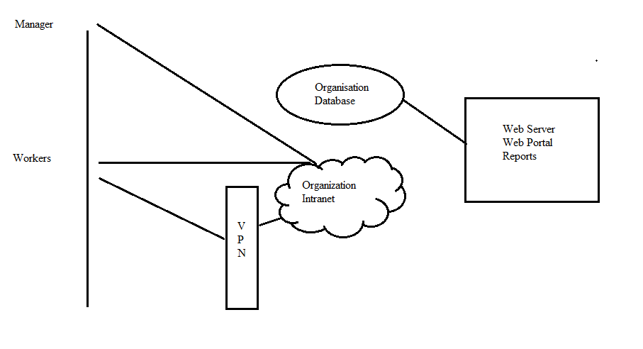

The general arrangement design of this venture is about the light-footed engineering working based on the spry systems. For this general design we will utilize the multi-level or n-level engineering. MVC parts into three intelligent segments they are model, view and controller. The model handles the rationale, see goes about as UI for the application and controller is interface among model and view to perform activities dependent on the client through yield. MVC is a customer server adaptation of design. It is essentially utilized for normal measured tasks including couple of designers however multi-level is utilized for the greater activities including the customer side and server side independently and playing out every single activity through their very own premise and looking up with the customer for any progressions and updates. Multi-level doesn't stir up the tasks and their information elements and maps them as needs be through isolated levels. The favorable position for the multi-level is we can refresh the innovation stack without disturbing others by giving our customer side clients less hazel. And furthermore the groups can independently keep up the codes as indicated by the business rationale. We likewise have a backend level for the numerous databases as opposed to being screwed over thanks to one to scale up the execution.

**7. User Stories / Scenarios with effort estimate (large, medium, low), resources count (developer + tester), target release for each story. I recommend using a table :**

Client stories are characterized to catch venture usefulness frame the client's point of view. The objectives and goals which were characterized better than as the gateway will be available just on organization's system. The following is the client story table for administrator entrance application.

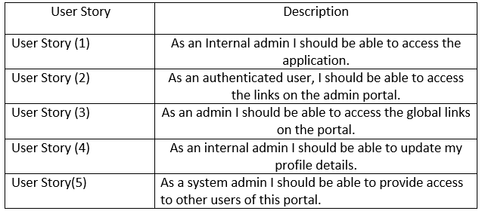

**8. Testing Plan :**

The application is tried by testing group as for every client story characterized previously.

For instance think about the client story (1): The administrator entryway ought to be open just on organization's system not on outside of association. So here the advancement will build up the Authentication passage, for example, single sign on with the goal that just association clients can get to the gateway. The single sign on confirmation approves the client so that the gateway approves the client dependent on the windows accreditation or say the extraordinary username and secret key the client used to login. The testing approves these by making an experiment to test this usefulness and that the application takes a shot at just association's system. Client Story Description User Story (1) User Story (2) User Story (3) User Story (4) User Story(5) As an Internal administrator I ought to have the capacity to get to the application. As a confirmed client, I ought to have the capacity to get to the connections on the administrator gateway As an administrator I ought to have the capacity to get to the worldwide connections on the entryway. As an inside administrator I ought to have the capacity to refresh my profile points of interest. As a framework administrator I ought to have the capacity to give access to different clients of this gateway.

**9. Quality Measurement Plan :**

The QAT (Quality affirmation group) will test the administrator entrance application for keeping the deformities in created application before conveying it to the client. The QAT group distinguishes the deformities created in the application and afterward counsel that imperfection and makes a deformity log report which contains data, for example, the recurrence of event of imperfection, regardless of whether this deformity is application related, strides to determine the imperfection and so forth. The application will be sent on QA condition so the QAT group will test the application there and distinguishes the bug and report them to the individual group. The QA condition is same as creation yet it is for QAT testing group.

**10. Deployment Plan :**

In the wake of testing the application by the Testing group and QAT group, an arrangement plan will be made to convey the application on live condition or say the creation condition. A calendar will be made for item sending on the creation condition.

**11. Maintenance Plan :**

In the wake of conveying the application on generation condition a Support group will be made to report a bug or deformity that is holding on the customer side. The procedure is to such an extent that customer report bug to the help group an episode will at that point be made for the bug and its need will be characterized whether the occurrence is of high, low and medium effect. The help group will relegate the occurrence to separate group and the further procedure will stream until the point when the episode is settled.