1. Title
HealthRisk: A Machine Learning Based Heart Disease Prediction System

2. Objective
To develop a predictive system that analyzes patient data and predicts the likelihood of heart disease using machine learning algorithms.

3. Tools & Technologies Used
- Programming Language: Python
- Libraries: pandas, numpy, scikit-learn, pickle, streamlit
- IDE: VS Code
- Dataset Source: heart.csv
- Deployment: Streamlit

4. Dataset Description
Feature | Description
age | Age of the patient
sex | Gender (1 = male, 0 = female)
cp | Chest pain type (0–3)
trestbps | Resting blood pressure (mm Hg)
chol | Serum cholesterol (mg/dl)
fbs | Fasting blood sugar > 120 mg/dl
restecg | Resting ECG results
thalach | Maximum heart rate achieved
exang | Exercise-induced angina
oldpeak | ST depression induced by exercise
slope | Slope of the peak exercise ST segment
ca | Number of major vessels (0–3)
thal | Thalassemia (1 = normal, 2 = fixed defect, 3 = reversible defect)
target | 1 = disease present, 0 = no disease

5. Methodology
- Data Collection
- Data Preprocessing (handling missing values, encoding)
- Feature Selection
- Model Building using Logistic Regression
- Model Evaluation (Accuracy, Confusion Matrix, Classification Report)
- Model Deployment using Streamlit

data/heart.csv
age,sex,cp,trestbps,chol,fbs,restecg,thalach,exang,oldpeak,slope,ca,thal,target
63,1,3,145,233,1,0,150,0,2.3,0,0,1,1
37,1,2,130,250,0,1,187,0,3.5,0,0,1,1
41,0,1,130,204,0,0,172,0,1.4,2,0,1,1
56,1,1,120,236,0,1,178,0,0.8,2,0,1,1
57,0,0,120,354,0,1,163,1,0.6,2,0,1,0
57,1,0,140,192,0,1,148,0,0.4,1,0,1,1
56,0,1,140,294,0,0,153,0,1.3,1,0,1,0
44,1,1,120,263,0,1,173,0,0,2,0,1,1
52,1,2,172,199,1,1,162,0,0.5,2,0,2,0
57,1,2,150,168,0,1,174,0,1.6,2,0,2,1
54,1,0,140,239,0,1,160,0,1.2,2,0,2,1
48,0,2,130,275,0,1,139,0,0.2,2,0,2,0
49,1,1,130,266,0,1,171,0,0.6,2,0,2,1
64,1,3,110,211,0,0,144,1,1.8,1,0,2,0
58,0,3,150,283,1,0,162,0,1,2,0,2,1
50,0,2,120,219,0,1,158,0,1.6,2,0,2,0
58,0,2,120,340,0,1,172,0,0,2,0,2,1
66,0,3,150,226,0,1,114,0,2.6,0,0,2,0
43,1,0,150,247,0,1,171,0,1.5,2,0,2,1
69,0,3,140,239,0,1,151,0,1.8,2,2,2,0

HEALTHRISK/healthrisk.py
import pandas as pd
from sklearn.model_selection import train_test_split
from sklearn.linear_model import LogisticRegression
from sklearn.metrics import accuracy_score, classification_report, confusion_matrix

df = pd.read_csv(r"C:\Users\admin\HealthRisk\data\heart.csv")

X = df.drop("target", axis=1)
y = df["target"]

X_train, X_test, y_train, y_test = train_test_split(X, y, test_size=0.2, random_state=42)

model = LogisticRegression(max_iter=1000)
model.fit(X_train, y_train)

y_pred = model.predict(X_test)

print("Accuracy:", accuracy_score(y_test, y_pred))
print("\nConfusion Matrix:\n", confusion_matrix(y_test, y_pred))
print("\nClassification Report:\n", classification_report(y_test, y_pred))
OUTPUT
Accuracy: 0.5

Confusion Matrix:
[[1 1]
[1 1]]

Classification Report:
precision recall f1-score support

0 0.50 0.50 0.50 2
1 0.50 0.50 0.50 2

accuracy 0.50 4
macro avg 0.50 0.50 0.50 4
weighted avg 0.50 0.50 0.50 4

HEALTHRISK/save_model.py
import joblib
from sklearn.model_selection import train_test_split
from sklearn.linear_model import LogisticRegression
import pandas as pd

df = pd.read_csv("data/heart.csv")
X = df.drop("target", axis=1)
y = df["target"]

X_train, X_test, y_train, y_test = train_test_split(X, y, test_size=0.2, random_state=42)

model = LogisticRegression(max_iter=1000)
model.fit(X_train, y_train)

joblib.dump(model, "model.pkl")
print("Model saved as model.pkl")
OUTPUT
Model saved as model.pkl

HealthRisk/app.py

import streamlit as st
import pandas as pd
import joblib

model = joblib.load("model.pkl")

st.title("Health Risk Prediction System")

st.header("Enter Patient Details")

age = st.number_input("Age", min_value=1, max_value=120)
sex = st.selectbox("Sex (1=Male, 0=Female)", [1, 0])
cp = st.number_input("Chest Pain Type (0-3)", min_value=0, max_value=3)
trestbps = st.number_input("Resting Blood Pressure", min_value=80, max_value=200)
chol = st.number_input("Cholesterol", min_value=100, max_value=600)
fbs = st.selectbox("Fasting Blood Sugar > 120 mg/dl (1=True, 0=False)", [1, 0])
restecg = st.number_input("Resting ECG Results (0-2)", min_value=0, max_value=2)
thalach = st.number_input("Max Heart Rate Achieved", min_value=60, max_value=220)
exang = st.selectbox("Exercise Induced Angina (1=Yes, 0=No)", [1, 0])
oldpeak = st.number_input("ST Depression Induced by Exercise")
slope = st.number_input("Slope (0-2)", min_value=0, max_value=2)
ca = st.number_input("Number of Major Vessels (0-3)", min_value=0, max_value=3)
thal = st.number_input("Thal (1=Normal, 2=Fixed Defect, 3=Reversible Defect)", min_value=1, max_value=3)

if st.button("Predict"):
input_data = pd.DataFrame([[age, sex, cp, trestbps, chol, fbs, restecg, thalach,
exang, oldpeak, slope, ca, thal]],
columns=['age', 'sex', 'cp', 'trestbps', 'chol', 'fbs', 'restecg',
'thalach', 'exang', 'oldpeak', 'slope', 'ca', 'thal'])
prediction = model.predict(input_data)[0]
if prediction == 1:
st.success("High Risk of Heart Disease")
else:
st.info("Low Risk of Heart Disease")

OUTPUT
Welcome to Streamlit!

If you'd like to receive helpful onboarding emails, news, offers, promotions,
and the occasional swag, please enter your email address below. Otherwise,
leave this field blank.

Email: srinikithavajja@gmail.com

You can find our privacy policy at https://streamlit.io/privacy-policy

Summary:
- This open source library collects usage statistics.
- We cannot see and do not store information contained inside Streamlit apps,
such as text, charts, images, etc.
- Telemetry data is stored in servers in the United States.
- If you'd like to opt out, add the following to %userprofile%/.streamlit/config.toml,
creating that file if necessary:

[browser]
gatherUsageStats = false

You can now view your Streamlit app in your browser.

Local URL: http://localhost:8501
Network URL: http://172.26.16.106:8501
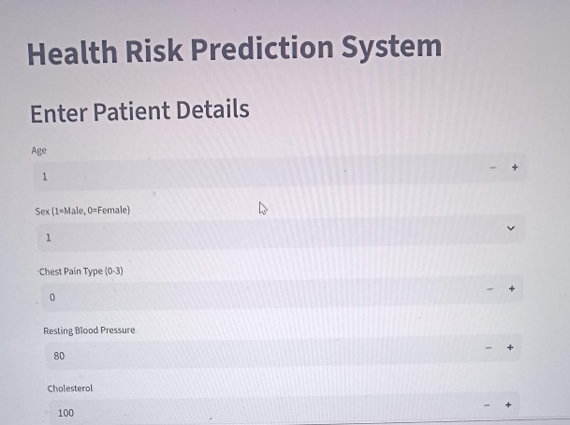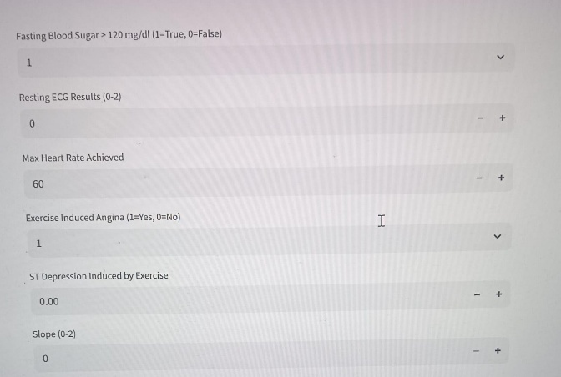
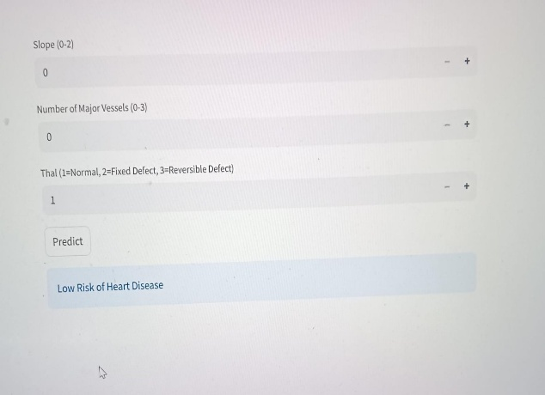

Project Structure
- C:\Users\admin\HealthRisk
- │
- ├── app.py
- ├── healthrisk.py
- ├── model.pkl
- │
- ├── data
- │ └── heart.csv
- │
- └── __pycache__

6. Results
- Accuracy: 50% (based on sample dataset)
- Confusion Matrix:
- [[1 1]
- [1 1]]
- Model saved as: model.pkl
- App Interface: Built with Streamlit (app.py)

7. Conclusion
The developed model demonstrates a simple and effective approach for predicting heart disease risk based on key medical attributes. With a larger dataset and fine-tuning, accuracy can be improved further.

8. Future Scope
- Use more advanced models like Random Forest or XGBoost.
- Add more health parameters for better accuracy.
- Deploy the app on Streamlit Cloud for public use.

9. References
- Kaggle Heart Disease Dataset
- Scikit-learn Documentation
- Streamlit Official Docs

